A
Seminar
On
HEPATIS B VIRUS AND HEPATITIS D VIRUS
By
OLAOYE, OLUFUNBI JOSEPHINE
17/SCI05/009
To

Department of Biological Sciences

MCB 304: Introductory Virology
Afe Babalola University Ado-Ekiti
Ekiti State.

APRIL 2020

Abstract 5
CHAPTER ONE: HEPATITIS B
1.1 Viral Profile 6
1.2 Background 6
1.3 Nature of virus 7
1.3.1 Virus classification 7
1.3.2 Structure 7
1.3.3 Viral genome 8
1.3.5 Immune response 10
1.3.6 Viral life cycle 10
1.4 Epidemiology 12
1.5 Mode of Transmission 12
1.5.1 People at risk 13
1.6 Diagnosis 13
1.7 Symptoms 15
1.8 Control and Prevention 16
1.9 Treatment 16
CHAPTER TWO: HEPAPTITIS D
2.1 Viral Profile 18
2.2 Background 19
2.3 Nature of virus 20
2.3.1 Virus classification 20
2.3.2 Structure 20
2.3.3 d Antigen 21
2.3.4 Replication 22
2.3.5 Pathogenesis 23
2.3.6 Immunity 23
2.4 Epidemiology 24
2.5 Mode of Transmission 24
2.6 Symptoms 24
2.7 Diagnosis 25
2.8 Control and Prevention 25
2.9 Treatment 26
Conclusion and Recommendation 27
REFERENCES 28

Abstract

Inflammation of the liver is called hepatitis. The Hepatitis B Virus (HBV) and Hepatitis D Virus (HDV) are two of five known hepatitis viruses: A, B, C, D, and E.
Hepatitis B Virus (HBV) is a major cause of chronic liver disease and hepatocellular carcinoma worldwide. Chronic hepatitis B virus (HBV) infection affects over 350 million people worldwide and over 1 million die annually of HBV-related chronic liver disease. The prolonged immunologic response to HBV infection leads to the development of cirrhosis, liver failure, or hepatocellular carcinoma (HCC) in patients.
Hepatitis D is a liver disease in both acute and chronic forms caused by the hepatitis D virus (HDV) that requires HBV for its replication. Hepatitis D infection cannot occur in the absence of hepatitis B virus.
HBV can be transmitted sexually, by blood, blood products or vertically (mother to child). HDV is spread only to person who are already infected with HBV (super infection) or to individuals who get HBV and HDV at once (co-infection).A vaccine against hepatitis B is the only method to prevent HDV infection
HDV-HBV co-infection is considered the most severe form of chronic viral hepatitis due to more rapid progression towards liver-related death and hepatocellular carcinoma.
This paper discusses Hepatitis B and D in details putting the background, nature of virus, Epidemiology, Mode of transmission, Diagnosis, Control and Prevention, Treatment into consideration.

Chapter one

Hepatitis B

1.1 Viral Profile
Name | Hepatitis B Virus
Discovery | 1966
Family | Hepadnaviridae
Genus | Orthohepadnavirus
Genome | Double stranded DNA virus
Virion | 22-27 nm in diameter
Transmission | Blood, body secretions, from mother to child, needles, sexually
Epidemiology | Endemic in China, Southeast Asia, and Africa
Incubation | 30 to 180 days
Symptoms | Jaundice, fatigue, anorexia, nausea, vomiting, hepatic tenderness
Outcome | Acute hepatitis, chronic liver disease, cirrhosis, fulminant hepatitis, hepatocellular carcinoma
Prevention | Hepatitis B vaccination. Avoid risky sexual behavior.
Treatment | Antiviral medication(tenofovir, interferon), liver transplantation
Vaccine | Hepatitis B vaccine

1.2 Background
The hepatitis B virus (HBV), discovered in 1966, infects more than 350 million people worldwide. HBV can cause acute and chronic liver disease. Long-term complications of hepatitis B include cirrhosis and hepatocellular carcinoma.
The hepatitis B virus can survive outside the body for at least 7 days. During this time, the virus can still cause infection if it enters the body of a person who is not protected by the vaccine. The incubation period of the hepatitis B virus is 75 days on average, but can vary from 30 to 180 days. The virus may be detected within 30 to 60 days after infection and can persist and develop into chronic hepatitis B.

1.3 Nature of virus
1.3.1 Virus classification
(unranked): | Virus
Realm: | Riboviria
Kingdom: | Pararnavirae
Phylum: | Artverviricota
Class: | Revtraviricetes
Order: | Blubervirales
Family: | Hepadnaviridae
Genus: | Orthohepadnavirus
Species: | Hepatitis B virus

1.3.2 Structure
HBV is a double-stranded DNA virus of the Hepadnaviridae family. The genome of HBV is a partially double stranded, circular DNA molecule of 3200 nucleotides. A hepadnavirus is 22 to 27 nm in diameter and consists of a central core of double-stranded DNA with nucleocapsid DNA. An envelope containing the hepatitis B surface antigen (HBsAg) is 7 nm wide and contains a 27-nm diameter central core, also referred to as the Dane particle, which contains the hepatitis B core antigen (HBcAg) and e antigen (HBeAg). The viral particles may form spherules and tubules. It is an exceedingly resistant virus, capable of withstanding extreme temperatures and humidity. HBV can survive when stored for 15 years at –20°C, for 24 months at –80°C, for 6 months at room temperature, and for 7 days at 44°C.

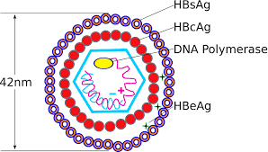
Figure 1: Structure of Hepatitis B virus
Source: Microbiologyinfo.com

1.3.3 Viral genome
The viral genome of hepatitis B consists of a partially double-stranded, circular DNA molecule of 3.2 kilobase (kb) pairs that encodes the following 4 overlapping open reading frames:
- S (the surface, or envelope, gene): Encodes the pre-S1, pre-S2, and S proteins
- C (the core gene): Encodes the core nucleocapsid protein and the e antigen; an upstream region for the S (pre-S) and C (pre-C) genes has been found
- X (the X gene): Encodes the X protein
- P (the polymerase gene): Encodes a large protein promoting priming ribonucleic acid (RNA) ̶ dependent and DNA-dependent DNA polymerase and ribonuclease H (RNase H) activities
Surface gene
The S gene encodes the viral envelope. There are 5 mainly antigenic determinants: (1) a, common to all hepatitis B surface antigens (HBsAg), and (2-5) d, y, w, and r, which are epidemiologically important and identify the serotypes.
Core gene
The core antigen, HBcAg, is the protein that encloses the viral DNA. It can also be expressed on the surface of the hepatocytes, initiating a cellular immune response.
The e antigen, HBeAg, which is also produced from the region in and near the core gene, is a marker of active viral replication. It serves as an immune decoy and directly manipulates the immune system; it is thus involved in maintaining viral persistence. HBeAg can be detected in patients with circulating serum HBV DNA who have “wild type” infection. As the virus evolves over time under immune pressure, core promotor and precore mutations emerge, and HBeAg levels fall until the level is not measurable by standard assays.
Individuals who are infected with the wild type virus often have mixed infections, with core and precore mutants in up to 50% of individuals. They often relapse with HBeAg-negative disease after treatment.
X gene
The role of the X gene is to encode proteins that act as transcriptional transactivators that aid viral replication. Evidence strongly suggests that these transactivators may be involved in carcinogenesis.
Antibody production
The production of antibodies against HBsAg (anti-HBs) confers protective immunity and can be detected in patients who have recovered from HBV infection or in those who have been vaccinated.
Antibody to HBcAg (anti-HBc) is detected in almost every patient with previous exposure to HBV and indicates that there is a minute level of persistent virus, as demonstrated by the risk of reactivation in individuals who undergo immune suppression regardless of their anti-HBs status.
The immunoglobulin M (IgM) subtype of anti-HBc is indicative of acute infection or reactivation, whereas the IgG subtype is indicative of chronic infection. The activity of the disease cannot be understood using this marker alone, however.
Antibody to HBeAg may be suggestive of a nonreplicative state if there is undetectable HBV DNA or the emergence of the core/precore variants and of chronic HBV HBeAg-negative disease.
1.3.4 Variants of HBV
With the newest polymerase chain reaction (PCR) assay techniques, scientists are able to identify variations in the HBV genome (variants) as far back as 1995, even in patients who are positive for HBeAg. Mutations of various nucleotides such as the 1896, 1764, and 1768 (precore/core region) processing the production of the HBeAg have been identified (HBeAg-negative strain). ^{[16]}
The prevalence of the HBeAg-negative virus varies from one region to another. Estimates indicate that among patients with chronic HBV infection, 50-60% of those from Southern Europe, the Middle East, Asia, and Africa, as well as 10-30% of patients in the United States and Europe, have been infected with this strain.

1.3.5 Immune response
The pathogenesis and clinical manifestations of hepatitis B infection are due to the interaction of the virus and the host immune system. The immune system attacks HBV and causes liver injury, the result of an immunologic reaction when activated CD4⁺ and CD8⁺ lymphocytes recognize various HBV-derived peptides on the surface of the hepatocytes. Impaired immune reactions (e.g., cytokine release, antibody production) or a relatively tolerant immune status results in chronic hepatitis. In particular, a restricted T-cell–mediated lymphocytic response occurs against the HBV-infected hepatocytes.
The final state of HBV disease is cirrhosis. With or without cirrhosis, however, patients with HBV infection are likely to develop hepatocellular carcinoma (HCC). In the United States, the most common presentation of these patients with HCC is that they are of Asian origin and acquired HBV disease as newborns (vertical transmission).

1.3.6 Viral life cycle
The 5 stages that have been identified in the viral life cycle of hepatitis B infection are briefly discussed below. Different factors have been postulated to influence the development of these stages, including age, sex, immunosuppression, and coinfection with other viruses.
Stage 1: Immune tolerance
This stage, which lasts approximately 2-4 weeks in healthy adults, represents the incubation period. For newborns, the duration of this period is often decades. Active viral replication is known to continue despite little or no elevation in the aminotransferase levels and no symptoms of illness.
Stage 2: Immune active/immune clearance
In the immune active stage, also known as the immune clearance stage, an inflammatory reaction with a cytopathic effect occurs. HBeAg can be identified in the sera, and a decline in the levels of HBV DNA is seen in some patients who are clearing the infection. The duration of this stage for patients with acute infection is approximately 3-4 weeks (symptomatic period). For patients with chronic infection, 10 years or more may elapse before cirrhosis develops, immune clearance takes place, HCC develops, or the chronic HBeAg-negative variant emerges.
Stage 3: Inactive chronic infection
In the third stage, the inactive chronic infection stage, the host can target the infected hepatocytes and HBV. Viral replication is low or no longer measurable in the serum, and anti-HBe can be detected. Aminotransferase levels are within the reference range. It is most likely at this stage that an integration of the viral genome into the host's hepatocyte genome takes place. HBsAg still is present in the serum.
Stage 4: Chronic disease
The emergence of chronic HBeAg-negative disease can occur from the inactive chronic infection stage (stage 3) or directly from the immune active/clearance stage (stage 2).
Stage5: Recovery
In the fifth stage, the virus cannot be detected in the blood by DNA or HBsAg assays, and antibodies to various viral antigens have been produced. The image below depicts the serologic course of HBV infection.
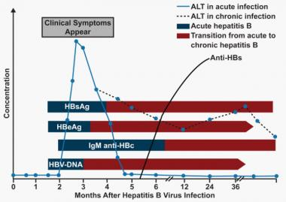
Figure 2: Serologic course of hepatitis b infection
Source: Medscape.com
The flat bars show the duration of seropositivity in self-limited acute HBV infection. The pointed bars show that HBV DNA and e antigen (HBeAg) can become undetectable during chronic infection. Only immunoglobulin G (IgG) antibodies to the HBV core antigen (anti-HBc) are predictably detectable after resolution of acute hepatitis or during chronic infection. Antibody to hepatitis B surface antigen (anti-HBs) is generally detectable after resolution of acute HBV infection but may disappear with time. It is only rarely found in patients with chronic infection and does not indicate that immunologic recovery will occur or that the patient has a better prognosis. ALT = alanine transaminase.

1.4 Epidemiology
HBV infects more than 350 million people worldwide. Approximately 5% of the world's population has chronic HBV infection and it is the leading cause of chronic hepatitis, cirrhosis, and hepatocellular carcinoma worldwide. Hepatitis B is endemic in China, Southeast Asia, and Africa. Most people in the region become infected with HBV during childhood. In these regions, 8-10% of the adult population is chronically infected, which is the result of either neonatal transmission (vertical) or transmission from one individual to another (horizontal). In the Middle East and Indian subcontinent, an estimated 2-5% of the general population is chronically infected. High rates of chronic infections are also found in the Amazon region of South America and the southern parts of eastern and central Europe. Less than 1% of the population in Western Europe and North America is chronically infected, mostly as a result of horizontal transmission among young adults.
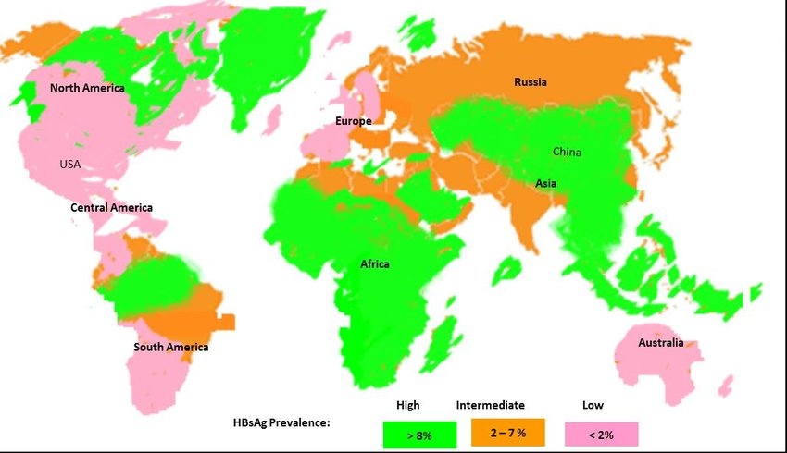
Figure 3: Geographic distribution of hepatitis B virus
Source: researchgate.net

1.5 Mode of Transmission
- From mother to child at birth (perinatal transmission)
- Through horizontal transmission (exposure to infected blood), especially from an infected child to an uninfected child during the first 5 years of life.
- Needle sticks injury, tattooing, piercing through the use of razors and similar objects that are contaminated with infected blood.
- Exposure to infected blood and body fluids, such as saliva and, menstrual, vaginal, and seminal fluids.
- Sexual transmission of hepatitis B may occur, particularly in unvaccinated men who have sex with men and heterosexual persons with multiple sex partners or contact with sex workers.

1.5.1 People at risk
The likelihood that infection becomes chronic depends on the age at which a person becomes infected. Children less than 6 years of age who become infected with the hepatitis B virus are the most likely to develop chronic infections.
In infants and children:
- 80–90% of infants infected during the first year of life develop chronic infections; and
- 30–50% of children infected before the age of 6 years develop chronic infections.
In adults:
- less than 5% of otherwise healthy persons who are infected as adults will develop chronic infections; and
- 20–30% of adults who are chronically infected will develop cirrhosis and/or liver cancer.

1.6 Diagnosis
- Blood tests. Blood tests can detect signs of the hepatitis B virus in the body and tell whether it's acute or chronic.
- Liver ultrasound. A special ultrasound called transient elastography shows the amount of liver damage.
- Liver biopsy. A small sample of the liver is tested (liver biopsy) to check for liver damage. During this test, a tissue sample of the liver is used for laboratory analysis.
The physical examination findings in hepatitis B disease vary from minimal to impressive (in patients with hepatic decompensation), according to the stage of the disease.
Examination in patients with acute hepatitis may demonstrate the following:
- Low-grade fever
- Jaundice (10 days after appearance of constitutional symptomatology; lasts 1-3 mo)
- Hepatomegaly (mildly enlarged, soft liver)
- Splenomegaly (5-15%)
- Palmar erythema (rarely)
- Spider nevi (rarely)
Signs of chronic liver disease include the following:
- Hepatomegaly
- Splenomegaly
- Muscle wasting
- Palmar erythema
- Spider angiomas
- Vasculitis (rarely)
Patients with cirrhosis may have the following findings:
- Ascites
- Jaundice
- History of variceal bleeding
- Peripheral edema
- Gynecomastia
- Testicular atrophy
- Abdominal collateral veins (caput medusa)
Laboratory studies
The following laboratory tests may be used to assess the various stages of hepatitis B disease:
- Alanine aminotransferase and/or aspartate aminotransferase levels
- Alkaline phosphatase levels
- Gamma-glutamyl transpeptidase levels
- Total and direct serum bilirubin levels
- Albumin level
- Hematologic and coagulation studies (eg, platelet count, complete blood count [CBC], international normalized ratio)
- Ammonia levels
- Erythrocyte sedimentation rate
- Serologic tests
The serologic tests should include the following laboratory studies:
- Hepatitis B surface antigen (HBsAg)
- Hepatitis B e antigen (HBeAg)
- Hepatitis B core antibody (anti-HBc) immunoglobulin M (IgM)
- anti-HBc IgG
- Hepatitis B e antibody (anti-HBe)
- hepatitis B virus (HBV) deoxyribonucleic acid (DNA)
Imaging studies
The following radiologic studies may be used to evaluate patients with hepatitis B disease:
- Abdominal ultrasonography
- Abdominal computed tomography (CT) scanning
- Abdominal magnetic resonance imaging (MRI)

1.7 Symptoms
Most people do not experience any symptoms when newly infected. However, some people have acute illness with symptoms that last several weeks, including yellowing of the skin and eyes (jaundice), dark urine, extreme fatigue, nausea, vomiting and abdominal pain. A small subset of persons with acute hepatitis can develop acute liver failure, which can lead to death.
In some people, the hepatitis B virus can also cause a chronic liver infection that can later develop into cirrhosis (a scarring of the liver) or liver cancer.

1.8 Control and Prevention
- The hepatitis B vaccine is the mainstay of hepatitis B prevention.
- Implementation of blood safety strategies, including quality-assured screening of all donated blood and blood components used for transfusion can prevent transmission of HBV.
- Safer sex practices, including minimizing the number of partners and using barrier protective measures (condoms), also protect against transmission.

1.9 Treatment
Treatment to prevent hepatitis B infection after exposure
Injection of immunoglobulin (an antibody) is given within 12 hours of exposure to the virus. This may help protect the individual from getting sick with hepatitis B. This treatment only provides short-term protection.
Treatment for acute hepatitis B infection
If the hepatitis B infection is acute (it is short-lived and will go away on its own) treatment may not be needed. Rest, proper nutrition and plenty of fluids while your body fights the infection may be recommended. In severe cases, antiviral drugs or a hospital stay is needed to prevent complications.
Treatment for chronic hepatitis B infection
Most people diagnosed with chronic hepatitis B infection need treatment for the rest of their lives. Treatment helps reduce the risk of liver disease and prevents the passing of the infection to others. Treatment for chronic hepatitis B may include:
- Antiviral medications. Several antiviral medications — including entecavir (Baraclude), tenofovir (Viread), lamivudine (Epivir), adefovir (Hepsera) and telbivudine (Tyzeka) — can help fight the virus and slow its ability to damage the liver. These drugs are taken orally.
- Interferon injections. Interferon alfa-2b (Intron A) is a man-made version of a substance produced by the body to fight infection. It's used mainly for young people with hepatitis B who wish to avoid long-term treatment or women who might want to get pregnant within a few years, after completing a finite course of therapy. Interferon should not be used during pregnancy. Side effects may include nausea, vomiting, difficulty breathing and depression.
- Liver transplant. If the liver has been severely damaged, a liver transplant may be an option. During a liver transplant, the surgeon removes the damaged liver and replaces it with a healthy liver. Most transplanted livers come from deceased donors, though a small number come from living donors who donate a portion of their livers.

CHAPTER TWO

HEPATITIS D VIRUS

2.1 Viral Profile
Name | Hepatitis Delta Virus
Discovery | 1977 by Italian researcher, Mario Rizzetto
Family | incertae sedis
Genus | Deltavirus
Genome | Small, circular ssRNA
Virion | Approx same size as HBV virion (35-37 nm in diameter)
Replication | Requires co-infection with Hepatitis B virus
Transmission | Blood, semen and vaginal secretions, from mother to child
Epidemiology | Endemic in Central Africa, South America, and the Mediterranean Basin
Incubation | 3 to 12 weeks
Symptoms | Jaundice, fatigue, anorexia, nausea, vomiting, hepatic tenderness
Outcome | Acute hepatitis, chronic liver disease, cirrhosis, fulminant hepatitis, hepatocellular carcinoma
Prevention | Hepatitis B vaccination. Avoid risky sexual and IV drug use behavior.
Treatment | Interferon-alfa
Vaccine | No HDV vaccine. Hepatitis B vaccine can prevent HDV/HBV coinfection.

2.2 Background
In 1977, a gastroenterologist in Turin, Italy, named Mario Rizzetto, first detected delta agent in hepatocytes of patients with chronic hepatitis B infections. This previously unrecognized nuclear antigen resembled Hepatitis B core antigen (HBcAg) and was thought to be a Hepatitis B-specific antigen.
Hepatitis D virus (HDV) is structurally unrelated to the hepatitis A (HAV), hepatitis B (HBV), and hepatitis C (HCV) viruses. HDV causes a unique infection that requires the assistance of HBV viral particles to replicate and infect hepatocytes. Its clinical course is varied and ranges from acute, self-limited infection to acute, fulminant liver failure. Chronic liver infection can lead to end-stage liver disease and associated complications (including accelerated fibrosis, liver decompensation, and hepatocellular carcinoma).
Hepatitis D is a liver disease in both acute and chronic forms caused by the hepatitis D virus (HDV) that requires HBV for its replication.
HDV is classified into three genotypes, I, II, and III, based on genetic sequences.
Genotype I is found more frequently in the United States, Europe, Asia, Southern Pacific, and Mediterranean Basin.
Genotype II has been associated with outbreaks in Asia, including Japan and Taiwan.
Genotype III is found in South America.
Figure 4: World Geographical distribution of HDV genotypes
Source: web.standford.edu

2.3 Nature of virus
2.3.1 Virus classification
(unranked): | Virus
Realm: | incertae sedis
Kingdom: | incertae sedis
Phylum: | incertae sedis
Class: | incertae sedis
Order: | incertae sedis
Family: | incertae sedis
Genus: | Deltavirus
Species: | Hepatitis delta virus

2.3.2 Structure
HDV RNA genome is single-stranded, negative sense, and small (approximately 1700 nucleotides) and consists of covalently closed circular RNA that is rod-shaped due to extensive base pairing. The genome is surrounded by a d antigen core encoded by HDV that is subsequently encased in an envelope embedded with Hepatitis B antigens (HBsAg). The virion measures 35-37 nm in diameter, approximately the same size as the HBV virion.

HDV is considered to be a subviral satellite because it can propagate only in the presence of the hepatitis B virus (HBV). Transmission of HDV can occur either via simultaneous infection with HBV (coinfection) or superimposed on chronic hepatitis B or hepatitis B carrier state (superinfection).
The HDV is a small, spherical virus with a 36 nm diameter. It has an outer coat containing three kinds of HBV envelope protein – large, medium, and small hepatitis B surface antigens – and host lipids surrounding an inner nucleocapsid. The nucleocapsid contains single-stranded, circular RNA of 1679 nucleotides and about 200 molecules of hepatitis D antigen (HDAg) for each genome. The central region of HDAg has been shown to bind RNA. Several interactions are also mediated by a coiled-coil region at the N terminus of HDAg. The hepatitis D circular genome is unique among animal viruses because of its high GC nucleotide content. The HDV genome exists as an negative sense, single-stranded, closed circular RNA. Its nucleotide sequence is 70% self-complementary, allowing the genome to form a partially double-stranded, rod-like RNA structure.With a genome of approximately 1700 nucleotides, HDV is the smallest "virus" known to infect animals. It has been proposed that HDV may have originated from a class of plant pathogens called viroids, which are much smaller than viruses.
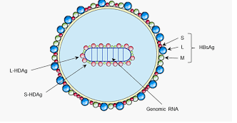
Figure 5:Diagram of hdv
Research gate.net

2.3.3 d Antigen
The d antigen exists as a small (24kDa) or large (24kDa) form. S-HDAg is required for RNA replication and is present in the infecting cell before replication begins. L-HDAg is formed from an RNA editing event in one-third of antigenomic templates that translated beyond the normal stop codon used for the synthesis of S-HDAg. Produced later in infection, the large d antigen suppresses RNA genomic synthesis, limits cell destruction, and leads to encapsidation of RNA in progeny virions.
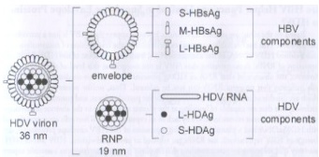
Figure 6: Schematic diagram of HDV particles found in infectious seru
Source: Sureau, Camille. Hepatitis Delta Virus: HDV-HBV Interactions. Hepatitis Delta Virus (2006).

2.3.4 Replication
Hepatitis Delta virus replication strategy is unique among all other animal viruses. After infection, HDV RNA is transferred to the nucleus, where replication and mRNA synthesis occur with the help of host cell DNA-dependent RNA polymerase II. Genomic RNA serves as a template to produce two RNAs: (1) a linear, polyadenylated mRNA that is translated into HDAg and (2) a covalently closed circular, positive-sense RNA that is complementary to the genomic RNA (antigenomic).
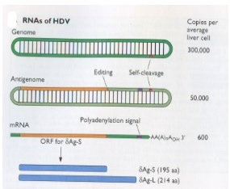
Figure 7: RNAs of HDV
Source: web.standford.edu

2.3.5 Pathogenesis
Hepatitis D virus is hepatotropic. Replication within hepatocytes results in cytotoxicity and direct liver damage. Hepatocellular necrosis and inflammation that occurs as result of HDV infection present similarly to the pathology of other acute and chronic viral hepatitis.
Direct pathogenesis of HDV is poorly understood and controversy exists over the direct pathogenic effects of the virus on the liver versus immune-mediated liver damage.

2.3.6 Immunity
Both cellular and humoral immunity are induced by HDV co-infection and super infection. Antibodies are produced against HDV antigens and Hepatitis B virus surface antigens because HbsAg is the external antigen & viral attachment protein for HDV.
Re-infection with HDV have yet to be reported, which suggests some form of immunity after resolution of acute infection.
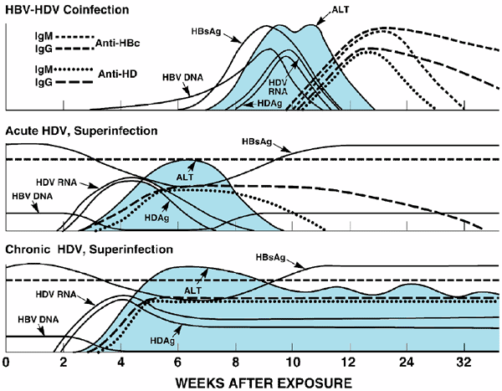
FIGURE 8: Serologic course of hepatitis D infection
Source: Fields Virology, 5th ed, 3039. Acute hepatitis D progressing to chronic hepatitis B virus infection.

2.4 Epidemiology
It is estimated that globally, approximately 5% of people with chronic HBV infection are co-infected with HDV, resulting in a total of 15 – 20 million persons infected with HDV worldwide. High-prevalence areas include Africa (Central and West Africa), Asia (Central and Northern Asia, Viet Nam, Mongolia, Pakistan, Japan, and Chinese Taipei), Pacific Islands (Kiribati, Nauru), Middle East (all countries), Eastern Europe (Eastern Mediterranean regions, Turkey), South America (Amazonian basin), and Greenland. However, the global estimation and geographic information are incomplete because many countries do not report the prevalence of HDV.

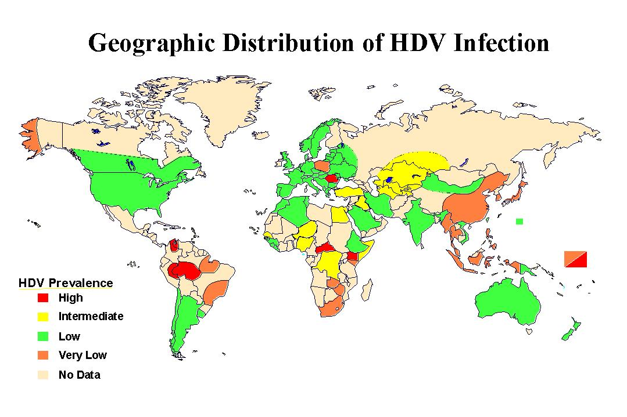
Figure 9: Geographical Distribution of HDV infection
Source: Virology-online.com

2.5 Mode of Transmission
- percutaneously
- sexually through contact with infected blood or blood products.
- Vertical transmission is possible but rare.

2.6 Symptoms
Hepatitis D doesn’t always cause symptomsTrusted Source. When symptoms do occur, they often include:
- yellowing of the skin and eyes, which is called jaundice
- joint pain
- abdominal pain
- vomiting
- loss of appetite
- dark urine
- fatigue
The symptoms of hepatitis B and hepatitis D are similar, so it can be difficult to determine which disease is causing your symptoms. In some cases, hepatitis D can make the symptoms of hepatitis B worse. It can also cause symptoms in people who have hepatitis B but who never had symptoms.

2.7 Diagnosis
Blood test- A blood test that can detect anti-hepatitis D antibodies in the blood is done by high titres of Immunoglobulin G (IgG) and Immunoglobulin M (IgM) anti-HDV, and confirmed by detection of HDV RNA in serum.
Liver function test-This is a blood test that evaluates the health of the liver by measuring the levels of proteins, liver enzymes, and bilirubin in the blood. Results from the liver function test will show whether the liver is stressed or damaged.

2.8 Control and Prevention
Prevention and control of HDV infection requires prevention of HBV transmission through:
- Vaccination-There’s a vaccine for hepatitis B that all children should receive. Adults who are at high risk for infection, such as those who use intravenous drugs, should also be vaccinated. The vaccination is usually given in a series of three injections over a period of six months.
- Use protection. Always practice safe sex by using a condom with all of your sexual partners. You should never engage in unprotected sex unless you’re certain your partner isn’t infected with hepatitis or any other sexually transmitted infection.
- Avoid or stop using recreational drugs that can be injected, such as heroin or cocaine. If you’re unable to stop using drugs, make sure to use a sterile needle each time you inject them. Never share needles with other people.
- Be cautious about tattoos and piercings. Go to a trustworthy shop whenever you get a piercing or tattoo. Ask how the equipment is cleaned and make sure the employees use sterile needles.

2.9 Treatment
Use of interferon- Current guidelines generally recommend Pegylated interferon alpha for at least 48 weeks irrespective of on-treatment response patterns. The overall rate of sustained virological response is low, however, this treatment is an independent factor associated with a lower likelihood of disease progression.
Liver transplantation- may be considered for cases of fulminant hepatitis and end-stage liver disease. New therapeutic agents and strategies are needed, and novel drugs, such as prenylation inhibitor or HBV entry inhibitors, have shown early promise

Conclusion and Recommendation

HBV and HDV are a leading cause of death worldwide and the primary cause of hepatic cirrhosis and HCC. Individuals coinfected with hepatitis D (delta) virus (HDV) are thought to have a higher rate of HCC and cirrhosis, with the virus reportedly increasing the risk for HCC 3-fold and mortality rates 2-fold in patients with HBV cirrhosis. Chronic HBV infection is an increasingly important public health problem. The natural history of chronic HBV and HDV infection is determined to a large extent by the level of HBV replication, as reflected in circulating levels of HBV DNA in serum.
Both super infection and co-infection with HDV result in more severe complications compared to infection with HBV alone. These complications include a greater likelihood of experiencing liver failure in acute infections and a rapid progression to liver cirrhosis, with an increased risk of developing liver cancer in chronic infections. In combination with hepatitis B virus, hepatitis D has the highest fatality rate of all the hepatitis infections, at 20%. HBV-HDV coinfection is the most aggressive form of viral hepatitis
Individuals with chronic hepatitis Band HDV require regular monitoring for viral activity, viral load reduction, drug resistance, and disease progression. Enhanced understanding of viral, host, and environmental factors that influence disease progression may ultimately improve the management of patients with chronic HBV and HDV infection. Ideally, prevention of hepatitis B through global vaccination programs and routinely applied neonatal and primary adulthood prophylaxis should be pursued.
I recommend that more awareness should be raised, partnerships with WHO and other countries should be promoted and evidence-based policies and data for action should be formulated especially in Africa.

REFERENCES

Centers for Disease Control and Prevention. (2015). Hepatitis B Fact Sheet. Retrieved from http://www.cdc.gov/ncidod/diseases/hepatitis/b/fact.htm
Elsevier B.V. (2018). Handbook of Liver Disease. (4th ed. Pp 51-65) Tram T. Tran MD
Erin Dizon.(2008).Humans and Viruses. Retrieved from https://web.stanford.edu/group/virus/delta/2008/MolBio.html
Hepatitis D: Symptoms, Daignosis, and Treatments. (2018). Retrieved May 4, 2020, from Healthline:https://www.healthline.com
Lavanchy, D. (2014) Hepatitis B virus epidemiology, disease burden, treatment, and current and emerging prevention and control measures. J Viral Hepat.
Sherwood, L., Wiley, J., Woolvertoon, C.J. (2017). Prescotts microbiology. (10th ed.). Singapore.WCB/McGraw-Hill.
Villeneuve, J.P. (2015)The natural history of chronic hepatitis B virus infection. J Clin Virol.
Vinod, R., Damaris C., Michelle B., Gillian Z. (2016) Update on chronic hepatitits B Journal for Nurse Practitioners. 2010;6(8):631-639 https://www.medscape.com/viewarticle/729402_1
World Health Organization.(2019). Hepatitis D. Retrieved from https://www.who.int

