HILLARY-EDJERE VWEDE PRISCILLA
BIO 102
NURSING
19/MHS02/061

ASSIGNMENT

- How are fungi important to mankind?

- Fungi are responsible for the mediation of decay of organic matter.
- Fungi are very important in the entire terrestrial ecosystem in material cycling and to man.
- Without Fungi and other microbes the surface of the earth would have been clogged up with dead matters with all the various elements locked up in them instead of returning into various cycles.
- Fungi e.g yeast (sacchanomyces spp.) are important in food industry.
- Mushrooms are eaten by many human societies species e.g Penicillium notatum produce important antibiotics.
- Some fungi are parasites to some certain horrible obnoxious pests e.g grasshoppers, houseflies, etc.

- Illustrate the cell structure of a unicellular fungus with a well labelled diagram.

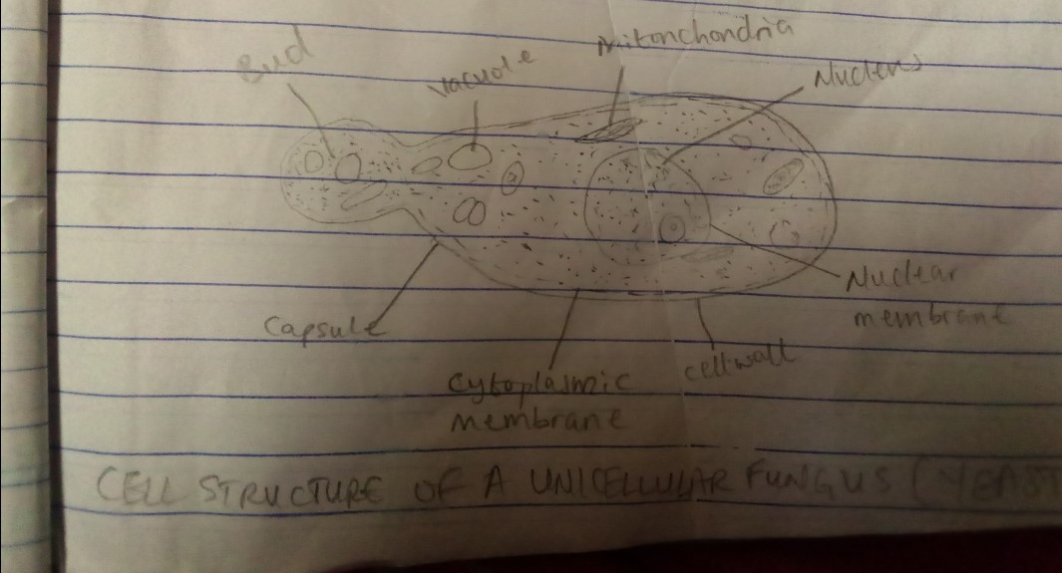
Diagram of a cell structure of a unicellular fungus (Yeast)

- Outline the sexual reproduction in a typical filamentous form of fungi?

- Rhizopus stolonifer is an example of a filamentous form of fungi.
- The sexual reproduction occurs when two mating types of hyphae grow in the same medium.
- Chemical interactions in the tow hyphae in opposite directions.
- These growths are delinomical by a wall such that many nuclei are isolated in what is called ‘gamentangium’.
- The two gamentangia fuse together (plasmogamy).
- Zygote is formed which may undergo prolonged dormany or resting stage.
- The nuclei in the zygote fuse in twos and undergo meiosis independently.
- The zygote develops under favorable conditions to produce a fruiting which at maturity liberates the haploid speres.

- How do Bryophytes adopt to their environment?

- Presence of definite structures for water and nutrient description from the soil.
- Presence of an aerial portion and a subterranean parts of the plant body. The subterranean portion is the rhizoid and is not as true as the case of land plants that are that are advanced.
- The aerial portion being exposed to the atmosphere prevents excessive loss of water through the body surface (i.e dessication).
- Presence of openings on the aerial parts of the plant that permits climination of excess water from the body and not only exchange of gases between the internal plant and the atmosphere.

- Describe with illustration the following terminologies:
- Eusteles
- Atactostele
- Siphonestele
- Dictyostele

- Eusteles: In herbaceous dicotyledonous plants, eusteles vascular bundles are discrete, concrete collateral bundles of xylem and phloem.
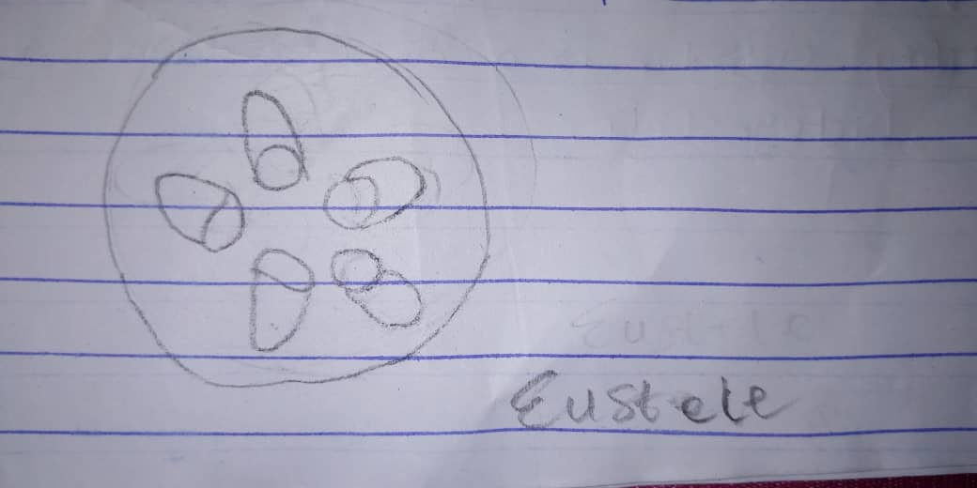
- Atactostele: This vascular system are found in grass and many monocotyledonous plants i.e their vascular bundles are scattered.
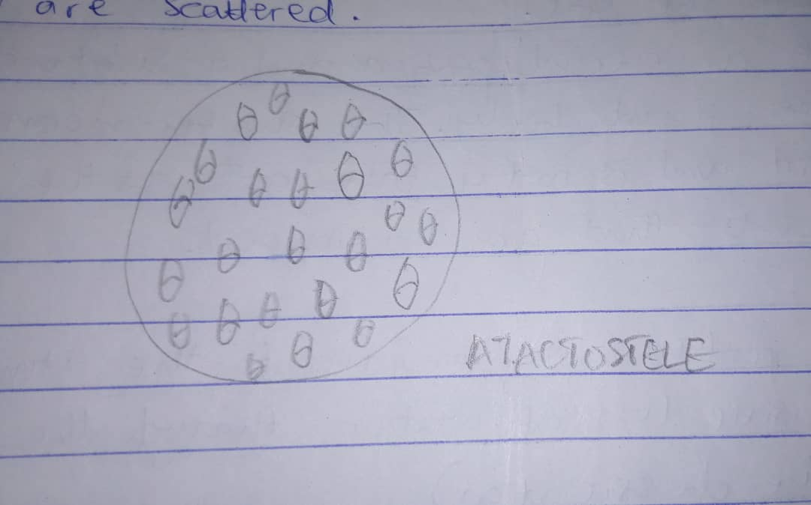
- Siphonostele: Usually found in the stems of ferns and higher vascular plants. It is a cylinder enclosing a parenchymatous pith.
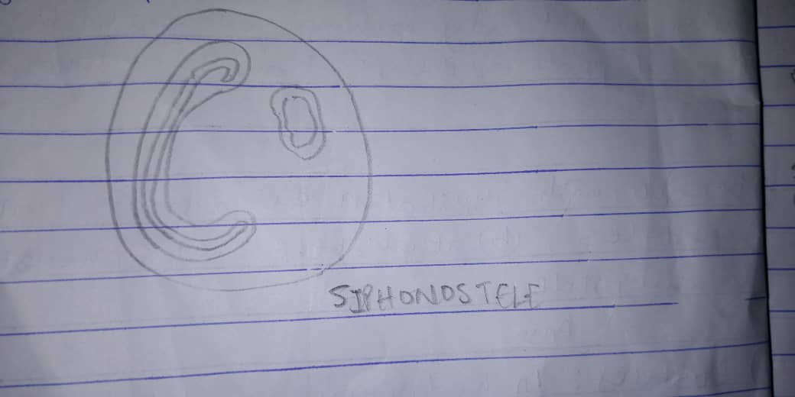
- Dictyostele: In siphonosteles, vascular supply to leaves is associated with leaf gaps and the conducting cylinder is a dissected one which is the Dictoyostele.
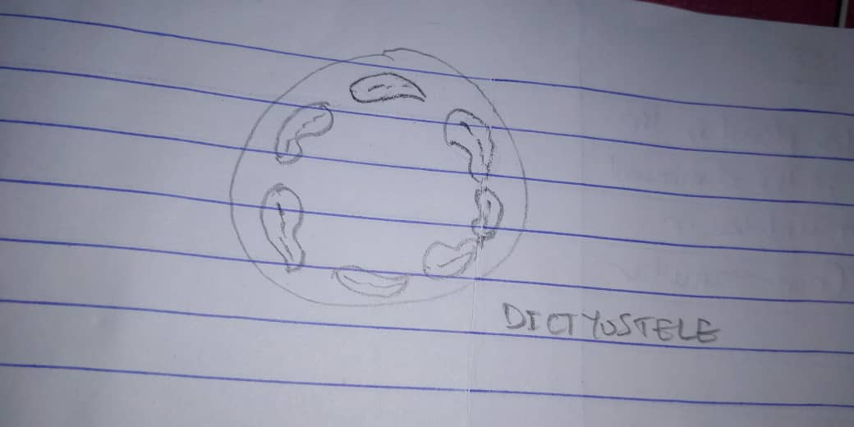

- Illustrate the life cycle of a primitive vascular plant.
