NAME: ALONGE KEHINDE WURAOLA
MATRIC NO: 19/MHS02/020
COLLEGE: MHS
DEPARTMENT: NURSING SCIENCE
COURSE CODE: BIO 102
- How are fungi important to mankind?
ANSWERS
- They are important decomposers in most ecosystems
- Fungi, as food, play a role in human nutrition in the forms of mush rooms
- Yeast (Saccharomyces cerevisiae) which is a fungi is used as an agent of fermentation in the production of bread, cheeses, alcoholic beverages and numerous other food preparation
- Fungi can be used for pest control
- Fungi can be used to produce critic acid
- They are model research organism
- The mycorrhizal relationship between fungi and plant roots is essential for the productivity of farm land.
- They are useful in the production of drugs such as Penicillin, an antibiotic drugs derived from a common fungus called Penicillium notatum
- They serve as source of income to those who cultivate them

- Illustrate the cell structure of a unicellular fungus with a well labelled diagram
ANSWER
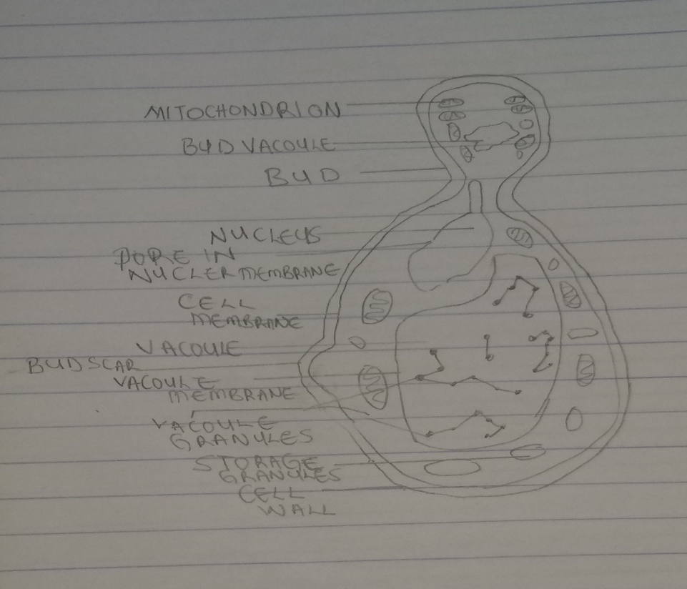
- Outline the sexual reproduction in a typical filamentous form of fungi
ANSWER
SEXUAL REPRODUCTION IN RHIZOPHUS STOLONIFER
Sexual reproduction is by conjugation. Hyphae belonging to different mating strains (plus and minus strains) come in close contact with one another. Tips of the hyphae are separated by septa from the rest of the hyphae. The two tips are called gametangia. The walls of the gametangia that are in contact dissolve away allowing the protoplast to fuse resulting in the formation of a zygote. The zygote develops into a zygospore which has a thick wall and is quiet resistant to unfavourable conditions. The zygospore undergoes meiosis, germinates to produce sporangium which release haploid spores. Each spore can germinate and continue the life cycle.

- How do bryophytes adapt to their environment?
ANSWERS
- A waxy cuticle that help to protect the plants tissue from dying out
- Gametangia provide further protection against drying out
- They have definite structures for water and nutrient absorption example Rhizoid
- The aerial portion that is exposed to the atmosphere is modified to prevent the loss of excessive water through the body surface
- Bryophytes also show embryonic development which is a significant adaptation that links them to vascular plants

- Describe with illustration the following terminologies: (a) eusteles (b) atactostele (c) siphonostele (d) dictyostele
ANSWERS
- Siphonostele: It is a cylinder enclosing parenchymatous pith. It is found in more advanced vascular system e.g stems of ferns and higher vascular plant
- Atactostele: The vascular bundles are scattered. The nature of the vascular supply to leaves is also a noteworthy element of the vascular system it can be found in grasses and many monocotyledon plant
- Eusteles: Their vascular bundles are discrete, concentric collateral bundles of xylem and phloem. They are found in herbaceous dicotyledons plant e.g flowering plants
- Dictyostele: It is siphonostele with overlapping gaps

- Illustrate the life cycle of a primitive vascular plant
ANSWER
LIFE CYCLE OF A PSILOTUM
The psilotum plant body is a sporophyte (Diploid 2n). The sporogenous cell that is in the sporangium produces haploid spores by meiosis. When the spores are liberated they germinate forming the gametophyte or prothallus. The gametophytes are saprophytic and cannot be seen with the naked eyes. At maturity the gametophyte bears the antheridia and archegonia. The antheridia produces multiflagellate sperm while the archegonia produces the egg. The sperm, when released from the ripe antheridia swims into the archegonia. Fertilization is oogamous. The resulting zygote divides to form embryonic sporophyte and later form mature plant body (Diploid psilotum sporophyte). And the same process is repeated again

