NAME: YUSUF DEBORAH DAMILOLA
DEPARTMENT: PHARMACY
COLLEGE: MHS
COURSE: BIO 102
1.
The importance of fungi to man:
- Fungi’s are responsible for the mediation of decay of organic matter
- Fungi e.g. yeast (Saccharomyces cerevisiae) are important In food industry.
- Mushrooms are eaten by many societies.
- Species e.g. Penicillium notatum produce important antibiotics.
- Many fungi species mediate the spoilage of wood, food, clothes and paper.
- Many are plant pathogens causing blights and smuts in cereals (Helm in this podium maydis and Ustilago zeac respiration).
- Some fungi are parasites to some certain horrible obnoxious (offensive unbearable) pests e.g. houseflies, grasshoppers and therefore constitute important biological control agents in regard to such pests.
- Medical and veterinary mycology deals with fungal diseases and infections in human beings and animals. Skin diseases e.g. ringworm and dermatitis are caused by fungal agents.
2.
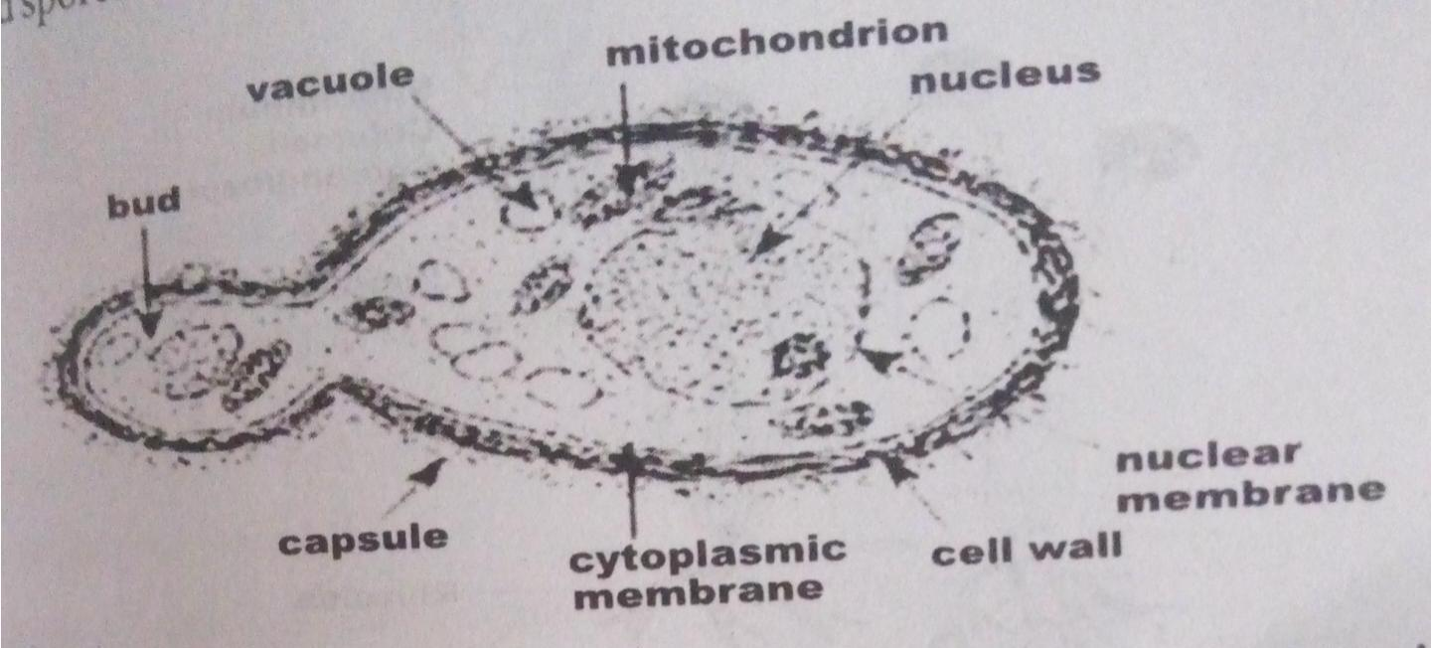

The structure of Saccharomyces cerevisae(Yeast) undergoing asexual reproduction (budding).

3.
Sexual reproduction in a typical filamentous form of fungi.
Sexual reproduction occurs when two mating types of hyphae grow In the same medium. Chemical interaction In the two mating types of hyphae induces growths are delimited by a wall such that many nuclei are isolated in what is called a gemetangium.
The two gemetangia fuse (plasmogamy) and a zygote is formed which may undergo prolonged dormancy or resting stage. The nuclei In the zygotes fuse In twos and undergo meiosis independently.
The zygote germinates under favourable conditions to produce a fruiting which at maturity librates the haploid spores.

4.
Ways in which Bryophytes adapt to their environment:
- They have definite structures for water and nutrient absorption from the soil; therefore the plant body is divided into two (an aerial portion and a subterranean portion). The subterranean Portion is the rhizoid and is not a true root as the case of land plants that are advanced.
- The aerial portion being exposed to the atmosphere demands some modifications that prevents excessive loss of water through the body surface (I.e. desiccation)
- Some other modifications that permit elimination of excess water from the plant body and not only exchange of gases between the internal parts of the plant and the atmosphere therefore openings are available on the aerial parts of the plant.
5. Eusteles: in herbaceous dicotyledonous plants in which the vascular bundles are discrete, concentric collateral bundles of xylem and pholem.
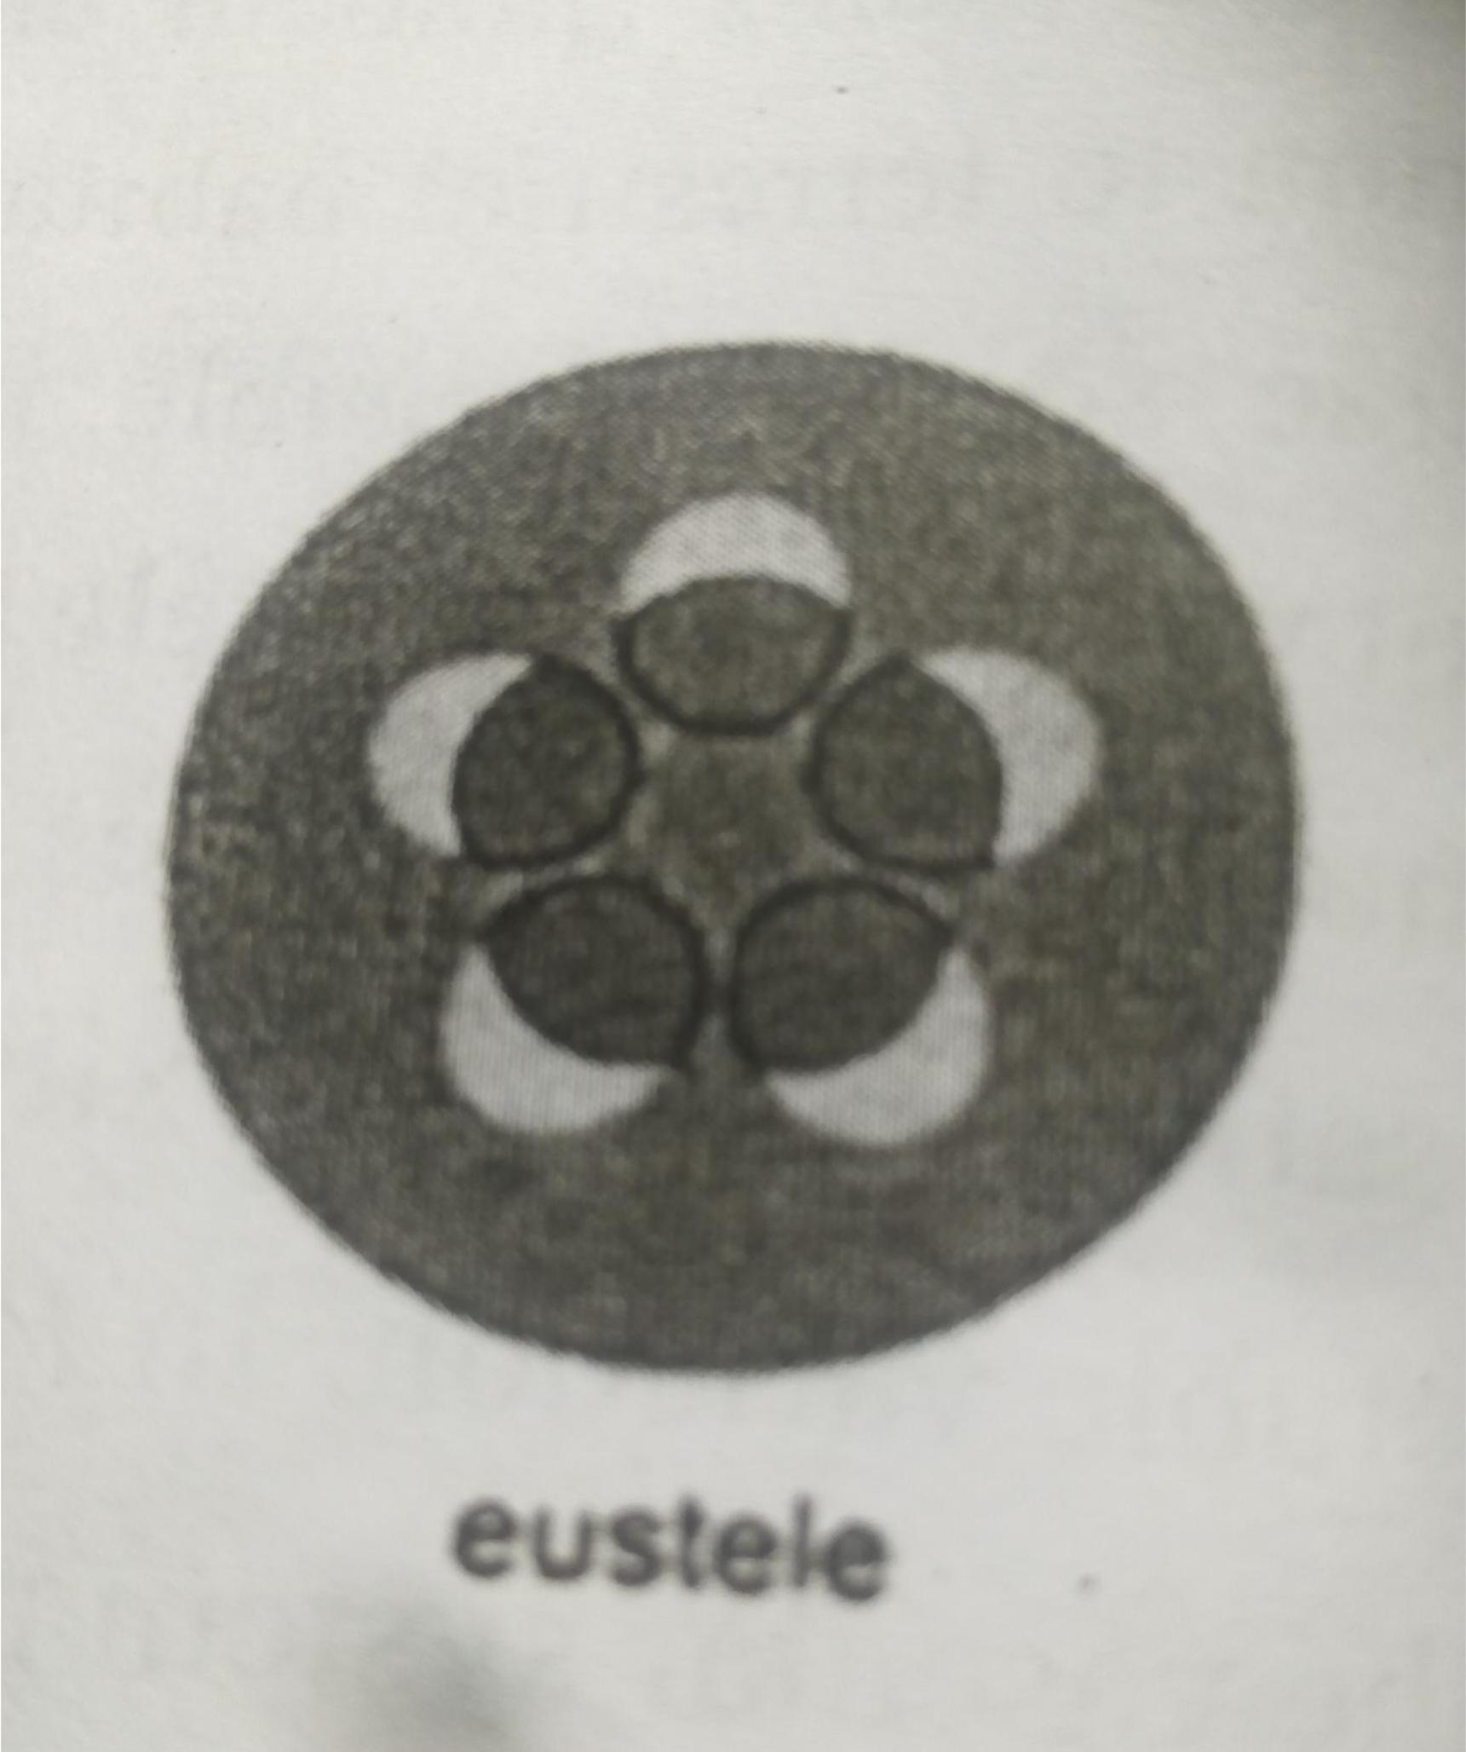

Atactostele: In grasses and many monocotyledonous plants the vascular bundles are scattered.
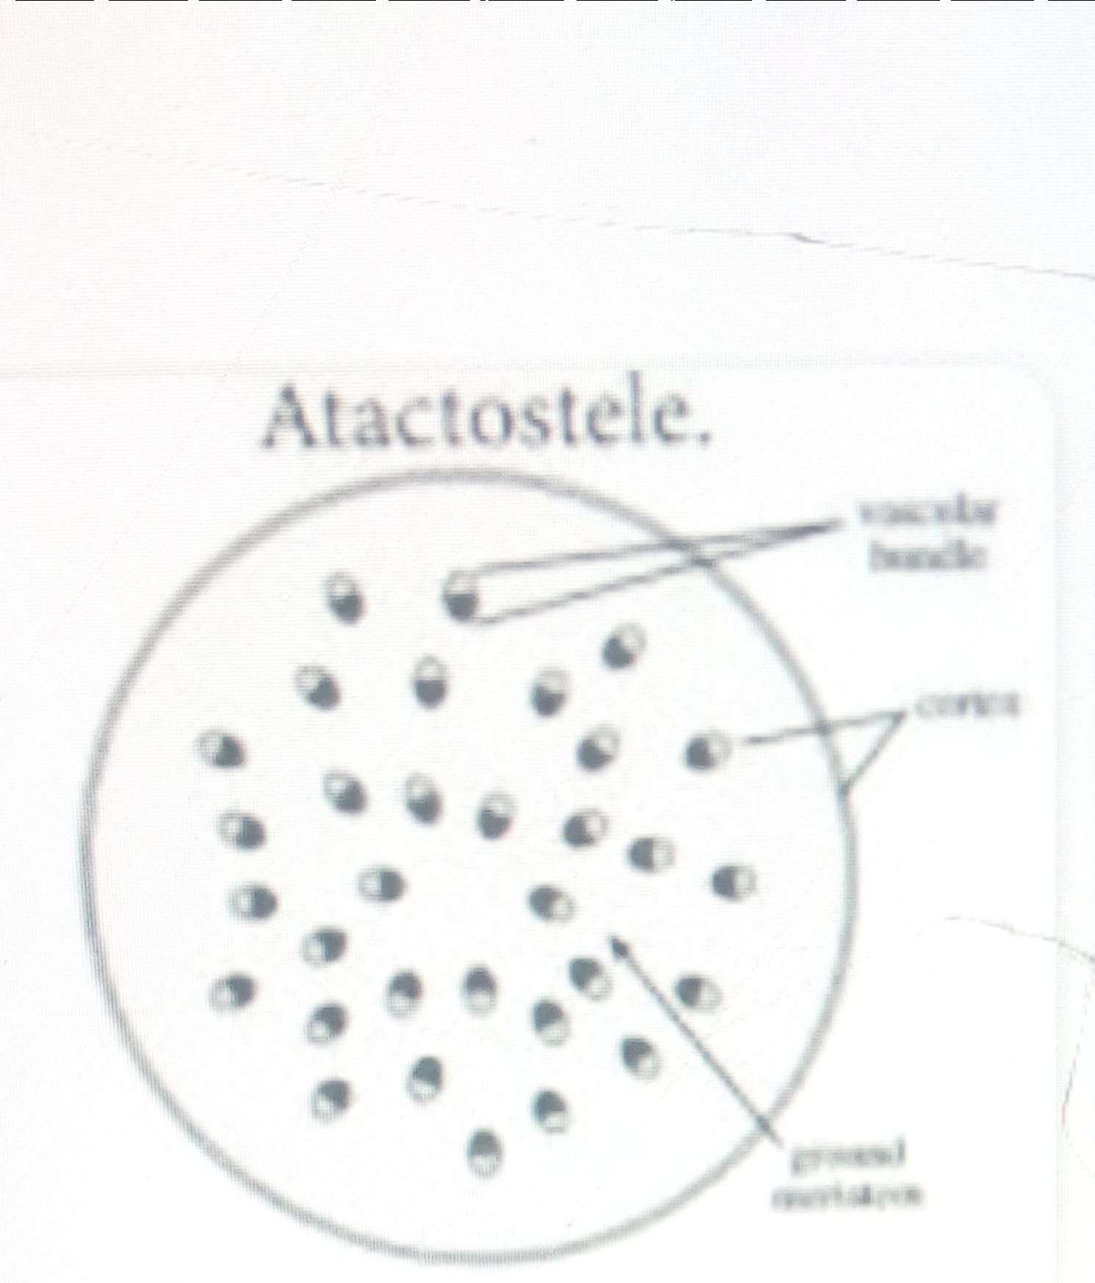

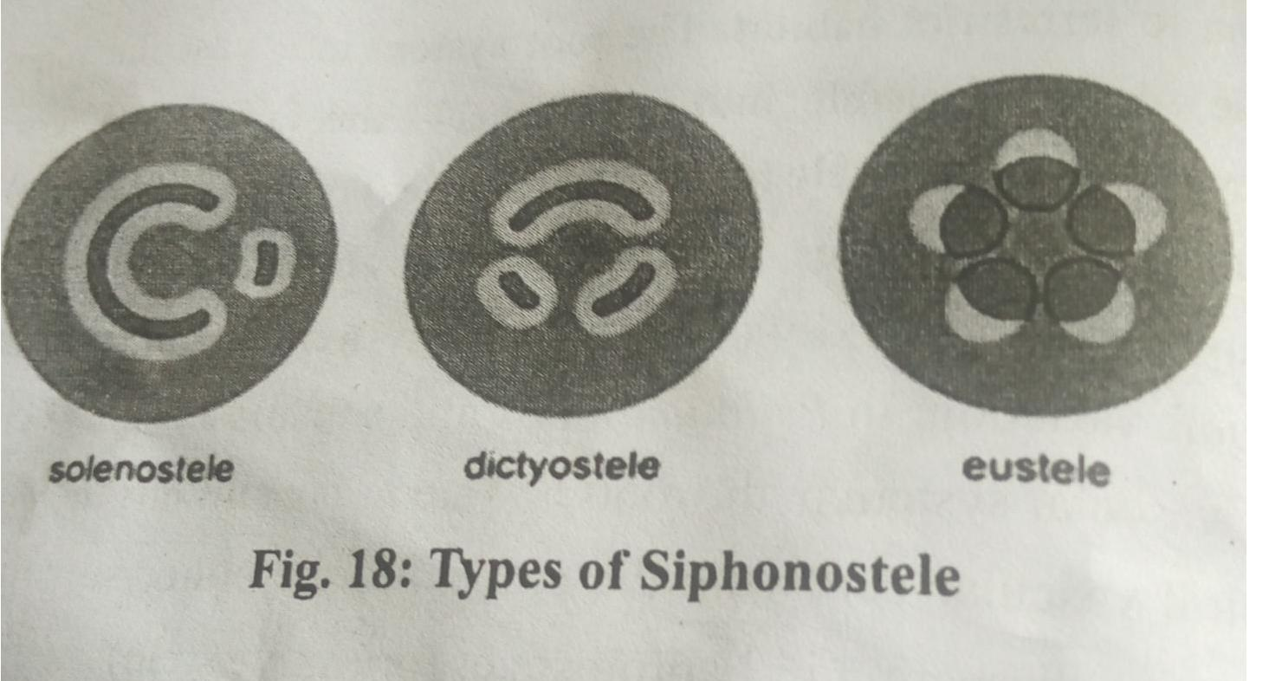
Siphonostele: In more advanced vascular systems e.g. stems of ferns and higher vascular plants, the stele is a cylinder enclosing a parenchymatous pitch.

Dictyostele: In siphonosteles, vascular supply to leaves is associated with leaf gaps and the conducting cylinder is a dissected one.

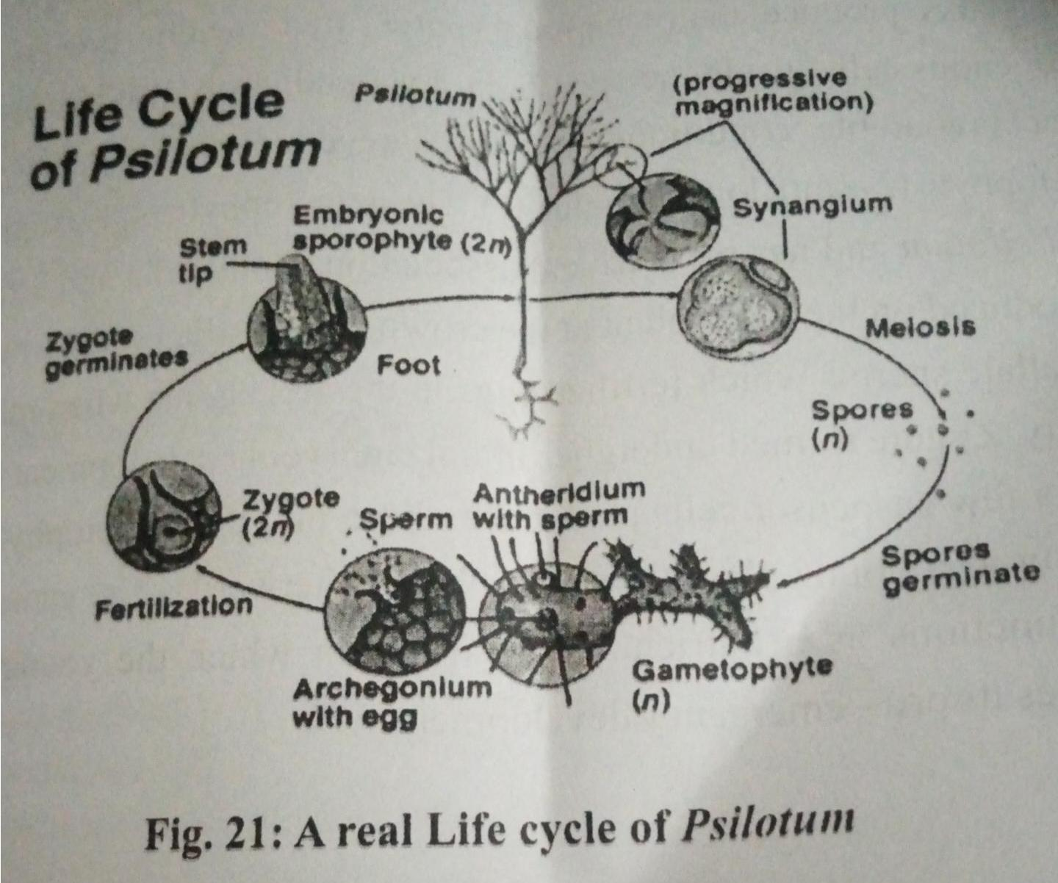
6.

