17/MHS06/049
Obikpo Chisom
Medical Biochemistry
BCH 313

Assignment
- Define the following terms
- Ketogenesis
- Keyoanemia
- Ketonuria
- Ketosis

- What are the consequences of ketosis?
- Write concisely on the management of keto acidosis

a-Ketogenesis: or better known as the formation of ketone bodies is a catabolic pathway of metabolism in which fatty acids and certain ketogenic amino acids are broken down to derive ketone bodies. It takes place mainly in the mitochondria of liver cells to produce the ketones namely: acetoacetate, acetone and beta-hydrobutyrate which are water soluble lipid molecules. Due to their solubility, they do not require lipoproteins for transportation across the membrane. Ketogenesis occurs primarily in the mitochondria of liver cells. Ketogenesis in steps:
- Fatty acids are brought into the mitochondria via carnitine palmitoyltransferase (CPT-1).
- They then broken down into acetyl CoA via beta-oxidation.
- Two acetyl-CoA molecules are converted into acetoacetyl-CoA via the enzyme thiolase; this is also known as acetyl coenzyme A acetyltransferase (ACAT).
- Afterward, acetoacetyl-CoA is converted to HMG-CoA ( 3-hydroxy-3-methylglutaryl-CoA) via the enzyme HMG-CoA synthase.
- HMG-CoA lyase then converts HMG-CoA to acetoacetate. Acetoacetate can be converted to either acetone through non-enzymatic decarboxylation, or to beta-hydroxybutyrate via beta-hydroxybutyrate dehydrogenase
- Of all three ketones, acetoacetone and beta-hydroxybutyrate are the acidic ones. .
Ketogenesis as a process is regulated by Insulin. Hormones such as glucagon, thyroid hormones, catecholamines, cortisol increase ketogenesis rate by stimulating the breakdown of free fatty acids.
Significance
Ketogenesis is important because it supplies tissues, muscles and brain with energy when the glycogen (carbohydrate) deposits are low. Ketogenesis plays a major role when carbohydrate stores are significantly decreased, or fatty acid concentration is increased and there tends to be an upregulation of the ketogenic pathway and an increased production of ketone bodies. This can be seen in conditions such as type 1 diabetes, alcoholism, and starvation. Most organs and tissues can use ketone bodies as an alternative source of energy. The brain uses them as a major source of energy during periods where glucose is not readily available. This is because, unlike other organs in the body, the brain has an absolute minimum requirement of glucose. The liver being the primary site of ketogenesis does not utilize the ketone bodies because there is the absence of an important enzyme, beta ketoacyl-CoA transferase
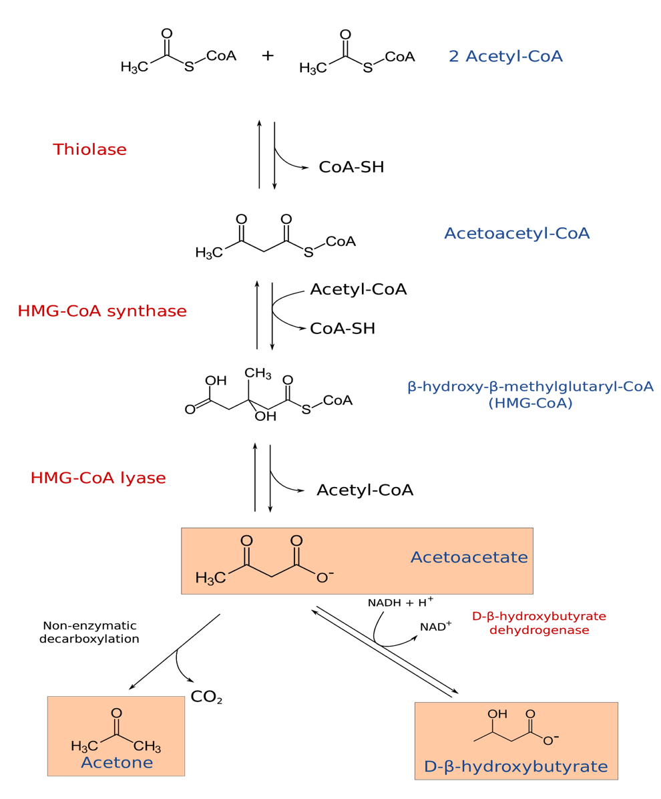
Ketonaemia- This is a situation when there are abnormally large concentrations of ketones in the plasma which is a physiological consequence of lipid metabolism.

Ketonuria- this is a medical condition in which there are ketone bodies present in urine. Ketonuria occurs when high levels of ketone bodies which occur when cells are broken down for energy are present in the urine. Ketonuria can be dangerous if ketones levels become high. This condition is also called ketoaciduria and acetonuria. Ketonuria is most common in individuals who have diabetes, particularly type 1 diabetes mellitus. It can also occur in women who are pregnant or breastfeeding, during starvation and even excess intake of ethanol.

Ketosis- is a natural metabolic state the body undergoes to keep supplying energy when glucose concentrations are low. The energy supplied is derived from the burning of fat deposit. In other words, it involves the body producing ketone bodies out of fat, and using them for energy instead of carbohydrates. However, this doesn't happen instantly. It takes your body and brain some time to "adapt" to burning fat and ketones instead of carbohydrates.

Consequences of ketosis
Ketosis being a natural metabolic state is safe which may have consequences on some individuals whereas some individuals may not experience any side effects. Some include:
- Bad breath
- Poor sleep
- Fatigue
- Nausea
- Increased appetite
- Headaches

Ketoacidosis management

Ketoacidosis also known as diabetic ketoacidosis (DKA) is a serious and potentially life-threatening complication of diabetes. It is a complex disordered metabolic state characterised by hyperglycaemia (elevated blood glucose), acidosis (pH imbalance) and ketonaemia (excess ketones in the blood).
Although the majority of patients presenting with DKA have type 1 diabetes, those with type 2 diabetes can also develop the condition, especially during acute illness. DKA usually occurs as a consequence of absolute or relative insulin deficiency that is accompanied by an increase in counter regulatory hormones (i.e., glucagon, cortisol, growth hormone, catecholamines). This type of hormonal imbalance enhances hepatic gluconeogenesis and glycogenolysis resulting in severe hyperglycaemia. Enhanced lipolysis increases serum free fatty acids that are then metabolised as an alternative energy
Source in the process of ketogenesis.

Management

The therapeutic goals of DKA management include optimization of
1) volume status
2) hyperglycemia and ketoacidosis
3) electrolyte abnormalities
4) potential precipitating factors.

The most important initial therapeutic intervention in DKA is appropriate fluid replacement followed by insulin administration.
The main aims for fluid replacement are:
- Restoration of circulatory volume
- Correction of hyperglycemia with insulin
- Clearance of ketones
- Correction of electrolyte imbalance
- Correction of acid base balance

Insulin therapy

Concerning insulin administration, insulin administration could be administered by either intravenous route or subcutaneous route where the later is said to be inferior to the former. Insulin administration is essential in DKA treatment because it promotes glucose utilization by peripheral tissues, diminishes glycogenolysis and gluconeogenesis, and suppresses ketogenesis. Intravenous infusion is a preferred route of insulin delivery in patients with DKA. The insulin acts mainly to supress ketogenesis, reduce blood glucose and to correct electrolyte imbalance. For administration of insulin, the weight of the patient should be estimated to help with administering a fixed rate of intravenous insulin infusion (FRIII).

In addition, It should also be noted that the administration of intravenous glucose is also essential
The management should be focused on clearing ketones as well as normalising blood glucose.
It is often necessary to administer an intravenous infusion of 10% glucose in order to avoid hypoglycaemia and permit the continuation of a FRIII to suppress ketogenesis.

Potassium, bicarbonate, and phosphate therapy

As one of the goals for DKA management, the correction of electrolyte imbalance is very vital so as to maintain normal functioning of the cells both intracellularly and extracellularly. Serum potassium should be closely monitored during DKA treatment. Insulin administration and correction of acidemia and hyperosmolality drive potassium intracellularly, resulting in hypokalemia that may lead to arrhythmias and cardiac arrest.

Bicarbonate therapy is not indicated in mild and moderate forms of DKA because metabolic acidosis will correct with insulin therapy. The use of bicarbonate in severe DKA is controversial due to a lack of prospective randomized studies. It is thought that the administration of bicarbonate may actually result in peripheral hypoxemia, worsening of hypokalemia, paradoxical central nervous system acidosis, cerebral edema in children and young adults, and an increase in intracellular acidosis.

