NAME: AFONJA OYINDUNMOLA
MATRIC NO.: 19/MHS11/016
DEPARTMENT: PHARMACY
COURSE: BIO 102

- Importance of fungi
- They can serve as food e.g mushrooms
- They naturally produce antibiotics e.g penicillin which is very beneficial to our health.
- They can be engineered to produce insulin and other human hormones.
- They can be used as biological pesticides.
- They are a major source of vitamin C (Citric acid).

- The cell structure of Fungi
Fungi are unicellular or multicellular thick-cell walled heterotroph decomposers that eat decaying matter. They are eukaryotes and have a complex cellular organization. Fungal cells have a membrane bound nucleus where the DNA is wrapped around histone proteins A few types of fungi have structures comparable to bacterial plasmids (loops of DNA). Fungal cells also contain cell wall, mitochondria and a complex system of internal membranes. They do not have chloroplast. The rigid layers of fungal cell walls contain complex polysaccharides called chitin and glucans.

- Sexual reproduction in a filamentous fungi
In scalariform conjugation, 2 filaments are lined side by side along the length of the filament. A cell from each filament produces a bump which elongates into a tube and fuses with the protuberance from the other cell, this is called conjugal canal. The cytoplasm from the male cell passes through the canal into the female cell followed by fusion of gametes and formation of a zygospore. The parallel filaments with the conjugal canal looks like a ladder hence the name scalariform. Lateral conjugation takes place in a single filament with adjacent cells forming a conjugation passage. The process of formation of gametes, conjugation tubes and zygospore is the same in both.
- Adaptation of Bryophytes to their environment
Two adaptations made the move from water to land possible for Bryophytes: a waxy cuticle and gametangia. The waxy cuticle helped to protect the plants tissue from drying out and the gametangia provided further protection against drying out specifically for the plants gametes
- Terms and definitions
- Eusteles: A stele typical of dicotyledonous plants that consists of vascular bundles of xylem and phloem strands with parenchymal cells between the bundles
- Actactostele: A type of eustele, found in monocots, in which the vascular tissue in the stem exists as scattered bundles.
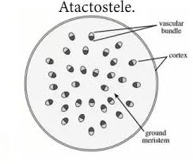
- Siphonostele: A stele consisting of a core of pith surrounded by concentric layers of xylem and phloem.
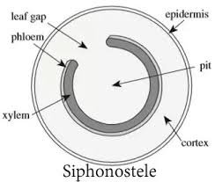
- Dictyostele: A stele in which the vascular cylinder is broken up into a longitudinal series or network of vascular strands around a central pith (as in many ferns)
- The life cycle of a primitive vascular plant.
