NAME:ANUGE ENOHI VANESSA

DEPARTMENT:MBBS

MATRIC NUMBER:19/MHS01/096

This is based on the njmber of hydrogen atoms attached to the carbon atom contained in the hydroxyl group.examples; CH₃OH 1⁰(methanol)

This is based on the number of hydroxyl group they possess.monohydric alcohol have one hydroxyl group present ,dihydric also known as glycol have two hydroxyl group present ,trihydric also known as triols have three hydroxyl group present and polyhydric or polyols have more than three hydroxyl groups.examples ;CH₃CH₂CH₂OH propanol(monohydric alcohol).

Lower alcohols with up to three carbon atoms in their molecules are soluble in water because these lower alcohols can form hydrogen bond with water molecules.the water solubility of alcohol decreases with increasing relative molecular mass.

All monohydric alcohols are soluble in organic solvents.the solubility of simple alcohols and polyhydric alcohols is largely due to the ability to form hydrogen bonds with water molecules.

3)2(C₆H₁₀O₅)n+nH₂O 60⁰/diastase nC₁₂H₂₂O₁₁

C₁₂H₂₂O₁₁+H₂O 15⁰/maltase 2C₆H₁₂O₆

C₆H₁₂O₆ 15⁰c/zymase 2CH₃CH₂OH +2CO₂

4.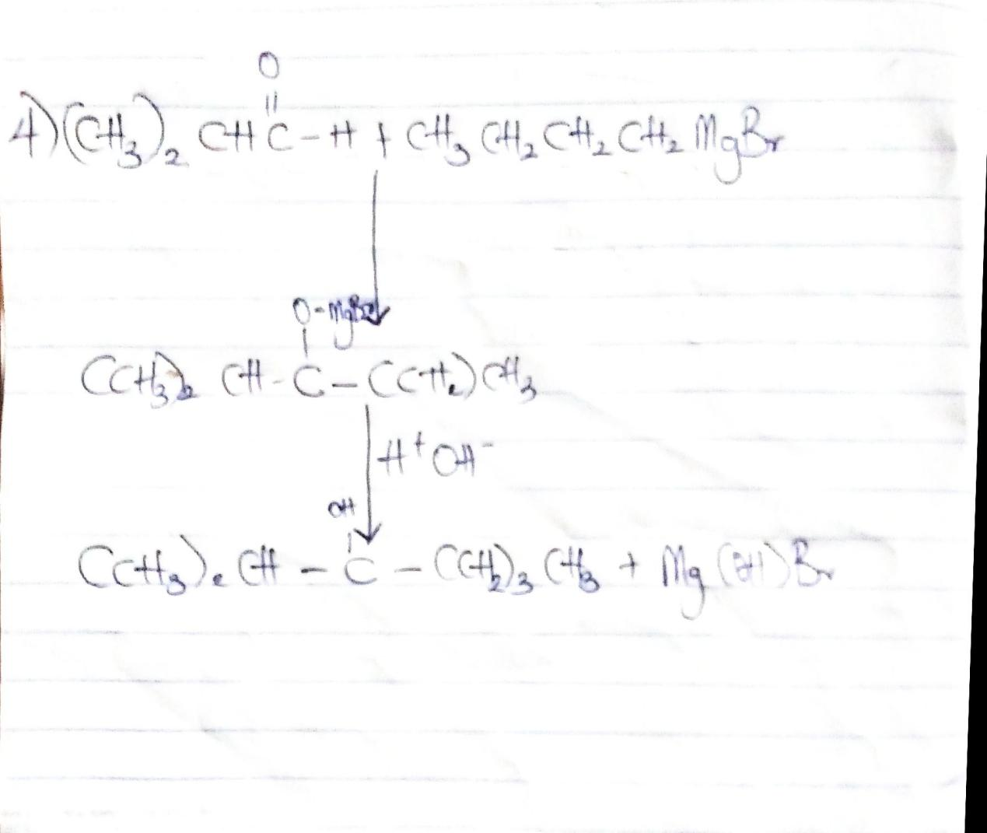

5.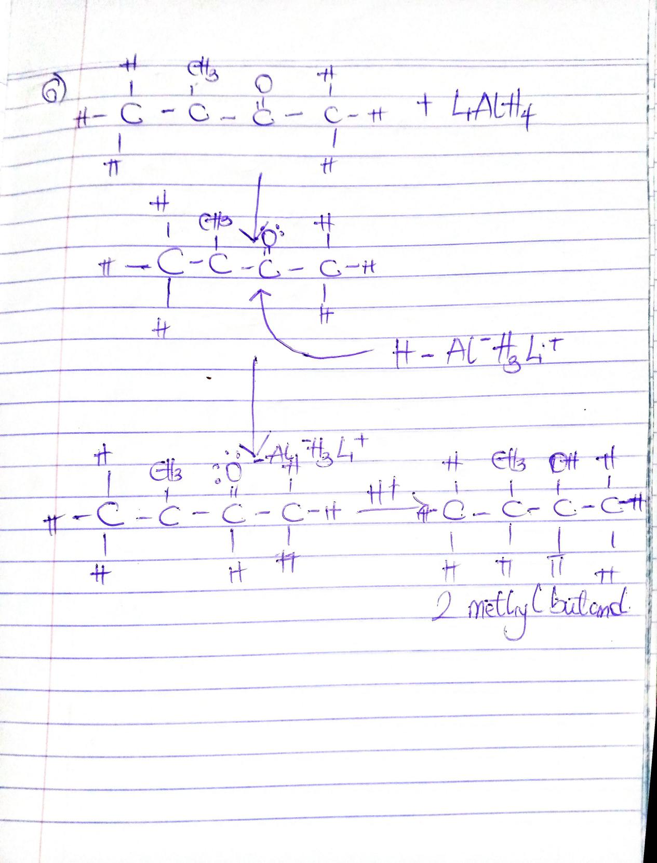

6.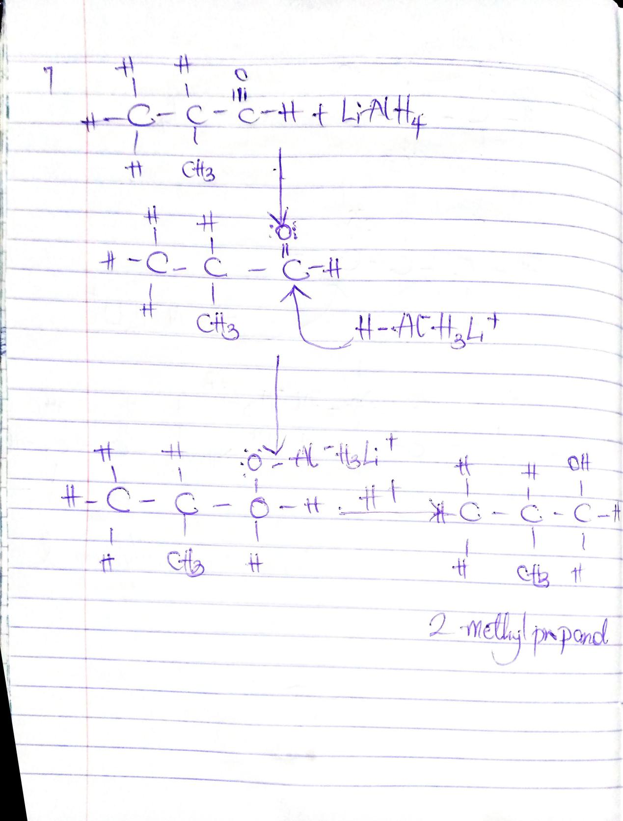

7.