Ajibola Taofeek Oluwatoba
19/mhs11/022
Pharmacy
Bio102

1. Importance of fungi

a) They are a major source of citric acid (vitamin C).

b) They produce antibiotics such as penicillin, which saves a lot of lives.

c) They can be engineered to produce insulin and other human hormones.

d) They can be eaten as food eg mushrooms

e) They can be used to control bacteria and insect pests on crops. Fungi compete with bacteria for nutrients and space, and they parasitize insects that eat plants.

2. Fungi Cell Structure
Fungi are unicellular or multicellular thick-cell-walled heterotroph decomposers that eat decaying matter. Fungi are eukaryotes and have a complex cellular organization. As eukaryotes, fungal cells contain a membrane-bound nucleus where the DNA is wrapped around histone proteins. A few types of fungi have structures comparable to bacterial plasmids (loops of DNA). Fungal cells also contain cell wall, mitochondria and a complex system of internal membranes, including the endoplasmic reticulum and Golgi apparatus. Unlike plant cells, fungal cells do not have chloroplasts or chlorophyll. The rigid layers of fungal cell walls contain complex polysaccharides called chitin and glucans. Chitin, also found in the exoskeleton of insects, gives structural strength to the cell walls of fungi.

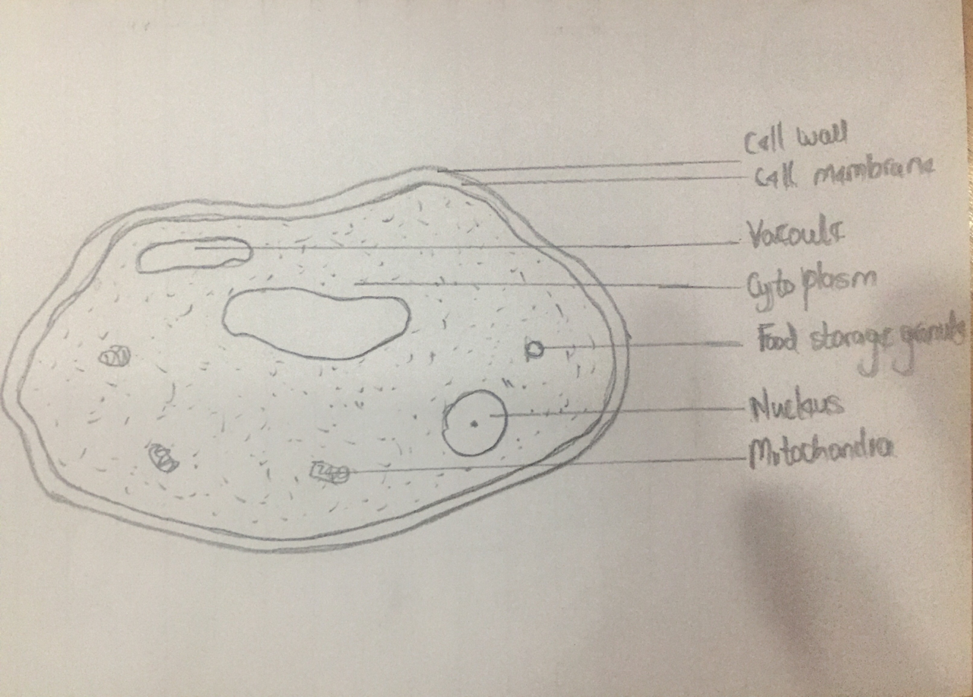
WELL LABELLED DIAGRAM OF THE CELL STRUCTURE OF A FUNGUS

3) Sexual reproduction in a filamentous fungi: In scalariform conjugation, 2 filaments are lined side by side along the length of the filament. A cell from each filament produces a bump which elongates into a tube and fuses with the protuberance from the other cell, this is called conjugal canal. The cytoplasm from the male cell passes through the canal into the female cell followed by fusion of gametes and formation of a zygospore. The parallel filaments with the conjugal canal looks like a ladder hence the name scalariform. Lateral conjugation takes place in a single filament with adjacent cells forming a conjugation passage. The process of formation of gametes, conjugation tubes and zygospore is the same in both.

4. Bryophytes environmental adaptations:
Two adaptations made the move from water to land possible for Bryophytes: a waxy cuticle and gametangia. The waxy cuticle helped to protect the plants tissue from drying out and the gametangia provided further protection against drying out specifically for the plants gametes

5. a)Eustele description:
Eustele is a type of siphonostele, in which the vascular tissue in the stem forms a central ring of bundles around a pith. A typical of dicotyledonous plants that consists of vascular bundles of xylem and phloem strands with parenchymal cells between the bundles.

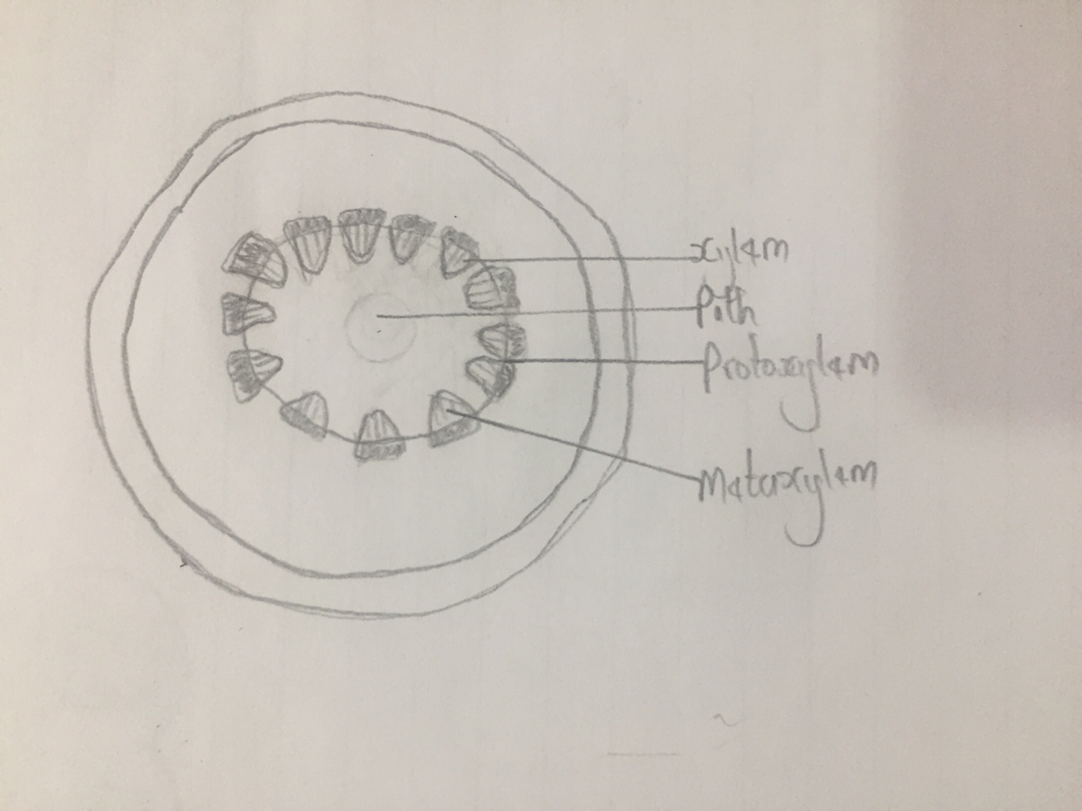

ILLUSTRATION OF THE EUSTELE

b) Atacotstele description:
Atactostele is a type of eustele found in monocots, in which the vascular tissue in the stem exists as scattered bundles unlike the Eustele it’s self.

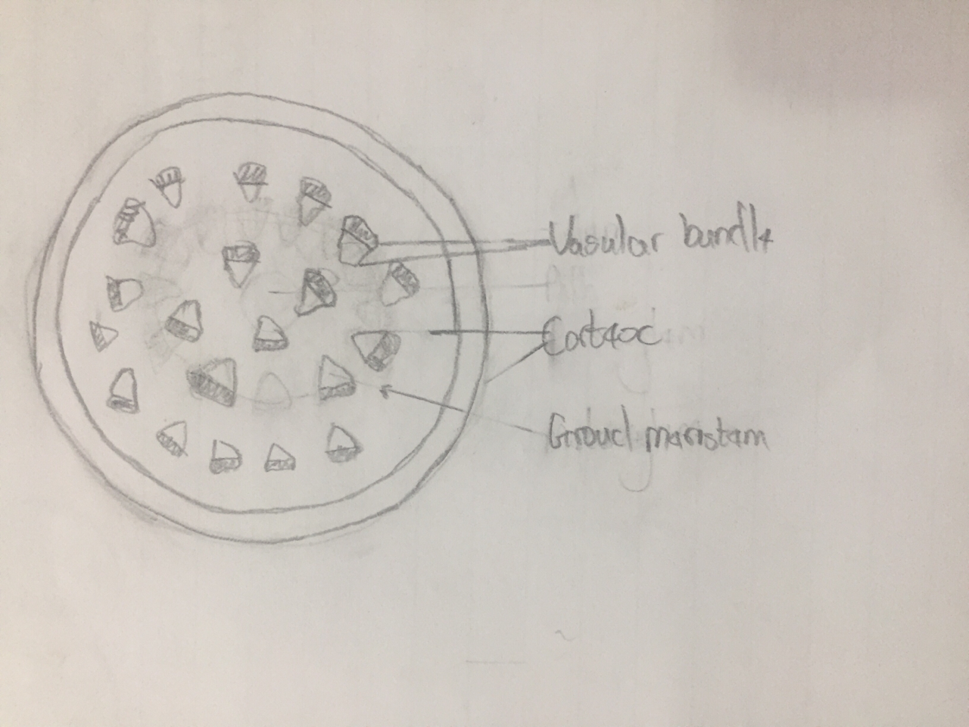

ILLUSTRATION OF ATACOTSTELE

c) Siphonostele description: Siphonostele is a stele in which the vascular tissue is in the form of a cylinder surrounding the pith, as in the stems of most ferns and other seedless vascular plants.
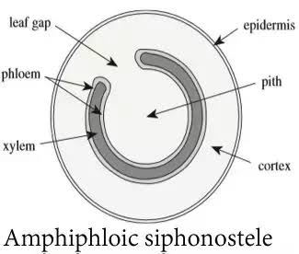

ILLUSTRATION OF SIPHONOSTELE

d) Dictyostele description:
Dictyostele is a stele in which the vascular cylinder is broken up into a longitudinal series or network of vascular strands around a central pith (as in many ferns)

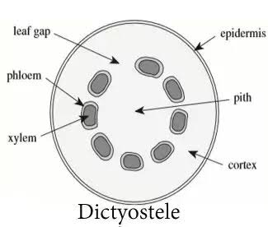
ILLUSTRATION OF DICTYOSTELE
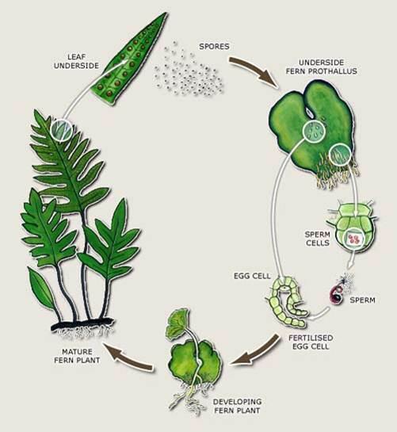
6. LIFE CYCLE OF A PRIMITIVE VASCULAR PLANT

