LEBILE CELINE MOTUNROLA
19/MHS01/235
MBBS
- Importance of fungi:
- They are responsible for breaking down organic matter and releasing carbon, oxygen, nitrogen, and phosphorus into the soil and the atmosphere, by the means of enzymes they produce.
- They are essential in food industries, where yeast could be used to make bread, and edible mushrooms are used in restaurants to serve as a garnish on foods.
- They are used in the production of antibiotics e.g. penicillin
- They mediate the spoilage of wood, food, clothes and paper
- Some fungi are parasites to household pest like housefly, grasshoppers, therefore can be used as a biological control against these pests.
- Unicellular form of fungus (yeast)
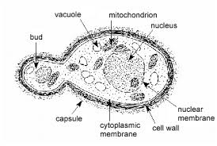
- Sexual reproduction in a typical filamentous form of fungi (Rhizopus stolonifera)
- It takes place by the fusion of multinucleate gametangia.
- Two fusing gametangia (male and female) are morphologically similar but physiologically different.
- Developing gametangia are known as progametangia. These are filled with cytoplasm and nuclei in their swollen tip.
- At the time of their fusion each gametangium is separated from the ‘suspensor’ with the help of a septum.
- Fusion of two gametangia takes place. The nuclei of the male gametangium fuse with those of female, and thus many diploid nuclei are formed. Around this fusion product, a thick, spiny wall develops, and now it is called zygospore.
- Zygospore germinates gradually by producing a long sporangiophore bearing a sporangium at the tip.
- How Bryophytes adapt to their environment:
- They have definite structures for water and nutrient absorption from the soil i.e. The plant is divided into two (aerial and subterranean portion)
- On land, the aerial portion, being exposed to the atmosphere, have waxy cuticles that prevents excessive loss of water through the body surface. It also has openings, that helps for gaseous exchange.
- Eustele is the arrangement of the xylem and phloem in discrete strands, separated by areas of parenchymatous tissue. I.e. vascular bundles are arranged in bundles around a pith.
- Atactotele is a type of eustele found in monocots, where the vascular tissues in the stem exists as scattered bundles.
- Siphonostele is a stele in which the vascular tissue is in the form of a cylinder surrounding the pith, as in the stems of most ferns and other seedless vascular plants. It is a hollow tube of vascular tissue enclosing a pith and embedded in ground tissue.
- Dictyostele is a stele in which the vascular cylinder is broken up into a longitudinal series or network of vascular strands separated by parenchymatous areas around a central pith
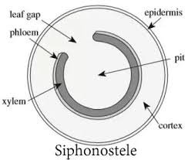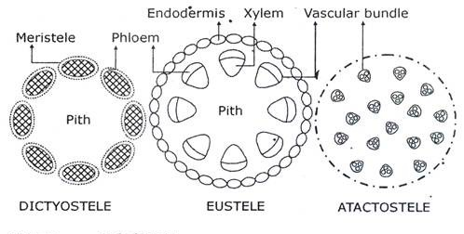
- Life cycle of a primitive vascular plant (Psilotum)
Psilotum plant body is a sporophyte (diploid 2n), Synangium is the spore bearing structure. In synangium, diploid spore mother cells undergo meiosis forming haploid spores(n). These spores germinate forming gametocyte (Monoecious both: Antheridia which produces sperm and archegonia which produces egg are present. The fertilization is oogamous. The zygote divides to form Embryonic sporophyte later from mature plant body.

