NAME: ADEYI OREOLUWA OLUWATAYOSE
DEPARTMENT: PHARMACOLOGY
COLLEGE: MEDICINE AND HEALTH SCIENCES
COURSE: BIO 102
MATRIC NO: 19/MHS07/002

1) How are fungi important to mankind?
- Fungi e.g. yeast are important in the food industry.
- They are responsible for the meditation of decay of organic matter.
- Fungi also play an important role in medicine yielding antibiotics.
- Biological insecticides: Fungi helps to control the population of damaging pests.
- They deal with fungal diseases and infections.
2) Illustrate the cell structure of a unicellular fungus with a well labelled diagram.
Unicellular fungus e.g. Saccharomyces cerevisiae (Yeast). The cell structure is very simple, though the organism is one of the more advanced fungal forms from the point of view of its spore-producing structures. Yeast cells are found on exposed sugary fluids e.g. palm wine where fermentation process is meditated. Cells exist in diploid/haploid states. Under favorable conditions environmental condition, in both states, they multiply rapidly by simple mitotic cell divisions- budding involving nuclear division and division of the cytoplasm in such a way that one segment of the constricted cytoplasm is smaller than the others.

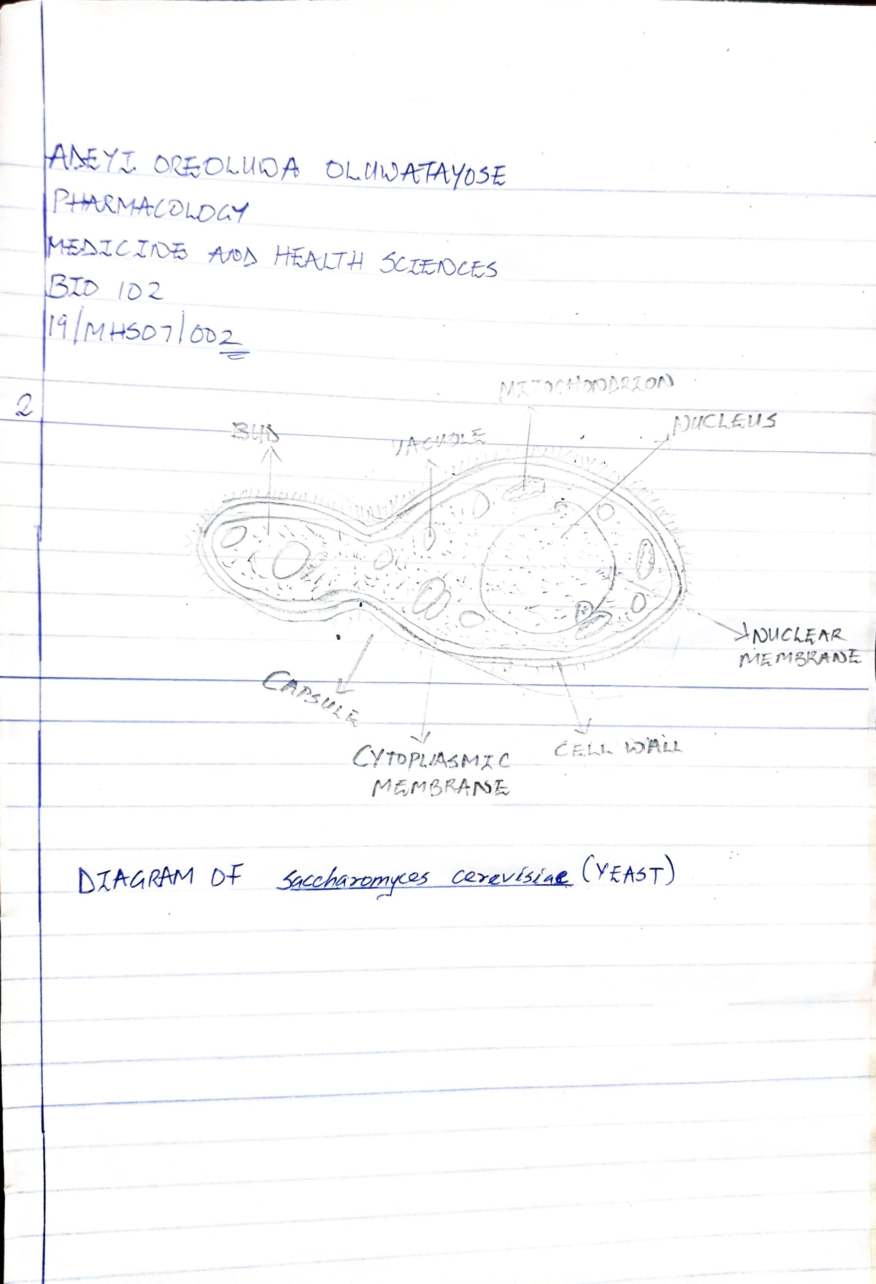
3) Outline the sexual reproduction in a typical filamentous form of fungi.
Sexual reproduction in the fungi consists of three sequential stages: plasmogamy, karyogamy, and meiosis. This occurs when two mating types of hyphae grow in the same medium. Chemical interaction in the two mating types of hyphae induces growth perpendicular to the hyphae in opposite directions. These growths are delimited by a wall such that many nuclei are isolated in what is called gametangium. The two gametangia fuse (plasmogamy) and a zygote is formed which may undergo prolonged dormancy or resting stage. The nuclei in the zygotes fuse in twos and undergo meiosis independently. The zygote germinates under a favorable condition to produce a fruiting which at maturity liberates the haploid spores.

4) How do Bryophytes adapt to their environment?
- They have definite structures for water and nutrient absorption from the soil; therefore, the plant body is divided into two (an aerial portion and a subterranean portion). The subterranean portion is the rhizoid and is not a true root as a case of land plants that are advanced.
- The aerial portion being exposed to the atmosphere demands some modifications that prevents excessive loss of water through the body surface (i.e. desiccation) and
- Some other modifications that permit elimination of excess water from the plant body and not only exchange gases between the internal parts of the plant and the atmosphere therefore openings are available on the aerial parts of the plant.

5) Describe with illustration the following terminologies:
- Eusteles.
- Atactostele.
- Siphonostele.
- Dictyostele.

- Eusteles: A stele typical of dicotyledonous plants that consists of vascular bundles which are discrete, concentric collateral bundles of xylem and phloem.
- Atactostele: A type of eustele, found in monocots, in which the vascular tissue in the stem exists as scattered bundles.
- Siphonostele: A stele in which the vascular tissue is in form of a cylinder enclosing a parenchymatous pith.
- Dictyostele: A type of siphonostele, in which vascular supply to leaves is associated with leaf gaps and the conducting cylinder is a dissected one.

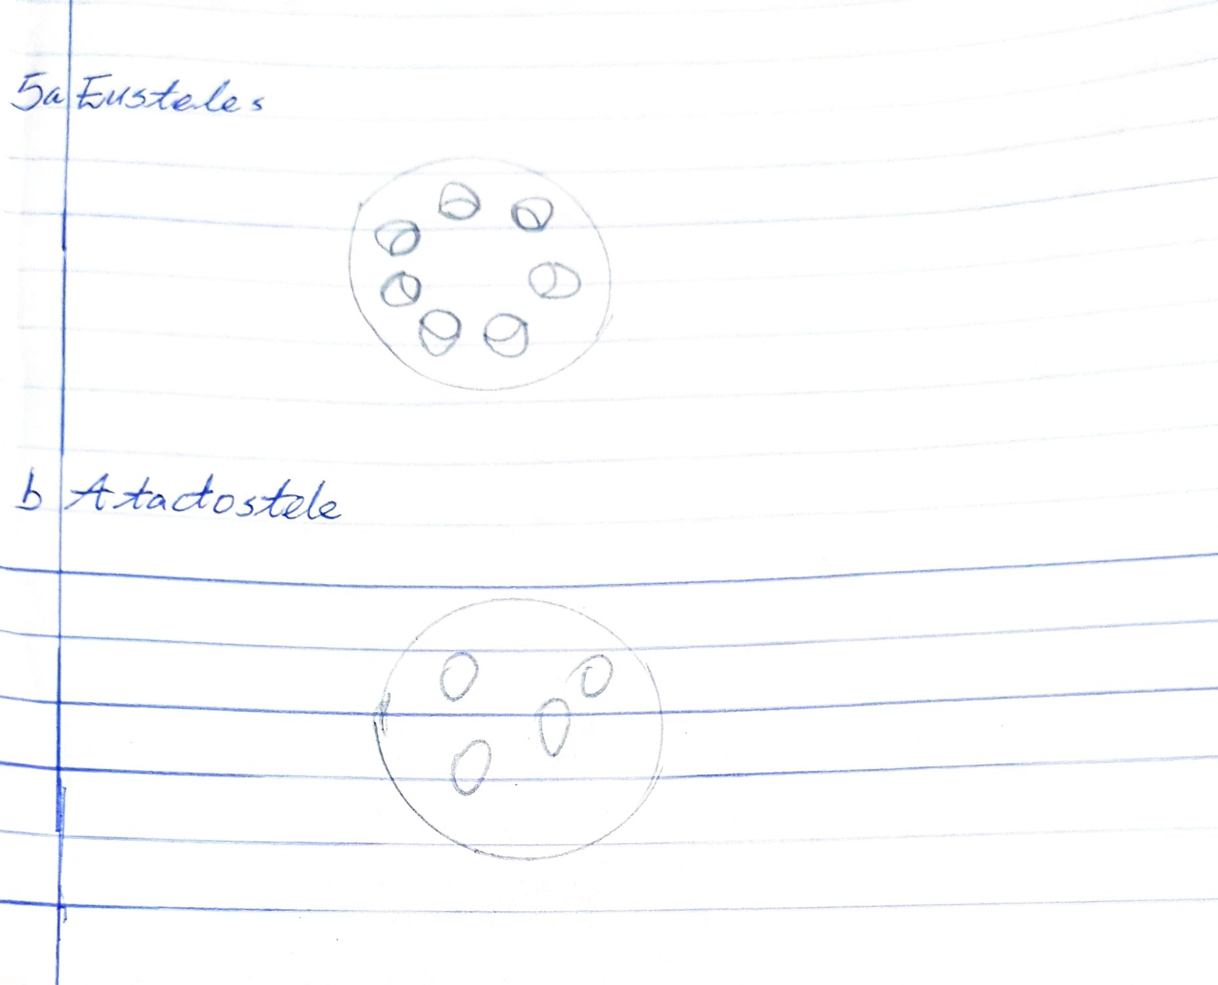

6) Illustrate the life cycle of a primitive vascular plant.

