NAME: ADEBIYI ITUNUNOLUWA ISAAC
MATRIC NO: 18/MHS01/013
DEPARTMENT: ANATOMY
COURSE: ANA 206

DEVELOPMENT OF THE LUNGS
Development of the respiratory system begins early in the fetus. It is a complex process that includes many structures, most of which arise from the endoderm. Towards the end of development, the fetus can be observed making breathing movements. Until birth, however, the mother provides all of the oxygen to the fetus as well as removes all of the fetal carbon dioxide via the placenta.

TIME LINE
The development of the respiratory system begins at about week 4 of gestation. By week 28, enough alveoli have matured that a baby born prematurely at this time can usually breathe on its own. The respiratory system, however, is not fully developed until early childhood, when a full complement of mature alveoli is present.

WEEKS 4–7
Respiratory development in the embryo begins around week 4. Ectodermal tissue from the anterior head region invaginates posteriorly to form olfactory pits, which fuse with endodermal tissue of the developing pharynx. An olfactory pit is one of a pair of structures that will enlarge to become the nasal cavity. At about this same time, the lung bud forms. The lung bud is a dome-shaped structure composed of tissue that bulges from the foregut. The foregut is endoderm just inferior to the pharyngeal pouches. The laryngotracheal bud is a structure that forms from the longitudinal extension of the lung bud as development progresses. The portion of this structure nearest the pharynx becomes the trachea, whereas the distal end becomes more bulbous, forming bronchial buds. A bronchial bud is one of a pair of structures that will eventually become the bronchi and all other lower respiratory structures.
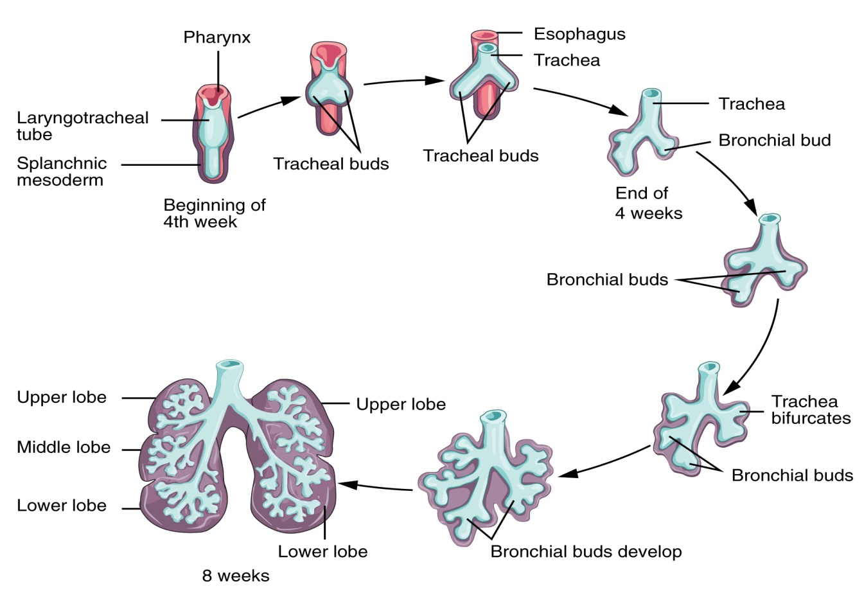 Figure 1. Development of the Lower Respiratory System.

WEEKS 7–16
Bronchial buds continue to branch as development progresses until all of the segmental bronchi have been formed. Beginning around week 13, the lumens of the bronchi begin to expand in diameter. By week 16, respiratory bronchioles form. The fetus now has all major lung structures involved in the airway.

WEEKS 16–24
Once the respiratory bronchioles form, further development includes extensive vascularization, or the development of the blood vessels, as well as the formation of alveolar ducts and alveolar precursors. At about week 19, the respiratory bronchioles have formed. In addition, cells lining the respiratory structures begin to differentiate to form type I and type II pneumocytes. Once type II cells have differentiated, they begin to secrete small amounts of pulmonary surfactant. Around week 20, fetal breathing movements may begin.

WEEKS 24–TERM
Major growth and maturation of the respiratory system occurs from week 24 until term. More alveolar precursors develop, and larger amounts of pulmonary surfactant are produced. Surfactant levels are not generally adequate to create effective lung compliance until about the eighth month of pregnancy. The respiratory system continues to expand, and the surfaces that will form the respiratory membrane develop further. At this point, pulmonary capillaries have formed and continue to expand, creating a large surface area for gas exchange. The major milestone of respiratory development occurs at around week 28, when sufficient alveolar precursors have matured so that a baby born prematurely at this time can usually breathe on its own. However, alveoli continue to develop and mature into childhood. A full complement of functional alveoli does not appear until around 8 years of age.

ROTATION OF THE STOMACH AND THE FORMATION OF THE OMENTAL BURSA
Rotation of the stomach:
The primordium of the primitive stomach is visible about the end of the fourth week. It is initially oriented in the median plane and suspended from the dorsal wall of the abdominal cavity by the dorsal mesentery or mesogastrium. During development the stomach rotates 90° in a clockwise direction along its longitudinal axis, placing the left vagus nerve along its anterior side and the right vagus nerve along its posterior side. Rotation of the stomach creates the omental bursa or lesser peritoneal sac.
Formation of the omental bursa:
The omental bursa (lesser peritoneal sac) CLEFTS develop between the cells of the dorsal mesogastrium which coalesce and eventually form a single cavity, the omental bursa. The cavity expands in all directions and comes to lie behind the stomach and to the right of the esophagus. The upper portion of the cranial extension of the sac is limited by the developing diaphragm, to form closed space or sac called the infracardiac bursa. The lower portion of the cranial extension of the sac persists as the superior recess of the lesser sac. As the stomach enlarges, the lesser sac expands into an inferior recess which forms between the layers of the elongating dorsal mesogastrium (greater omentum).The 4-layer greater omentum overhangs the developing small intestines . Most of the inferior recess of the lesser sac disappears as the layers of the greater omentum fuse. The omental bursa communicates with the main peritoneal cavity or greater peritoneal sac by way of the epiploic foramen or foramen of Winslow.
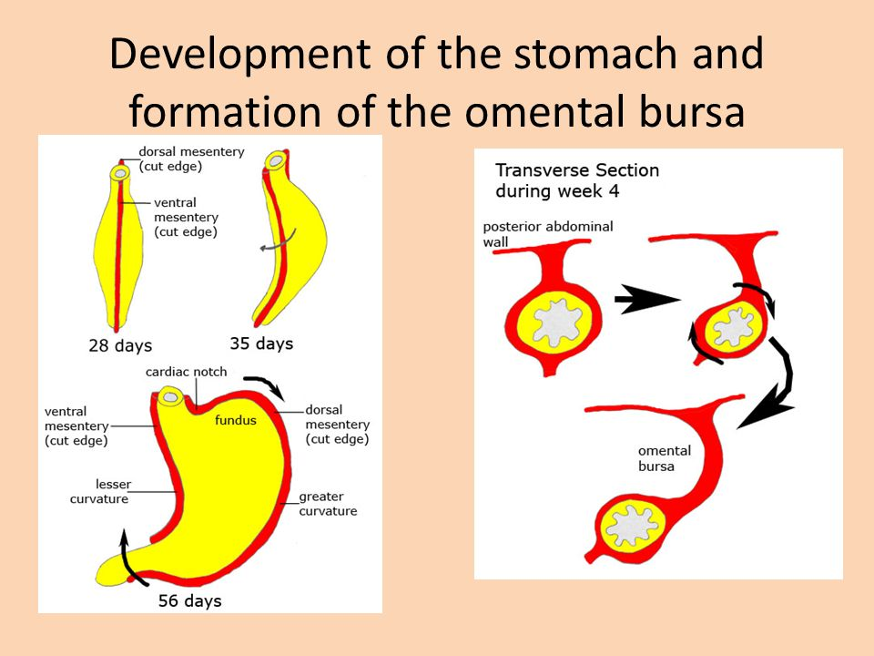
DEVELOPMENT OF THE ESOPHAGUS
The esophagus develops from the endodermal primitive gut tube. The ventral part of the embryo abuts the yolk sac. During the second week of embryological development, as the embryo grows, it begins to surround parts of the sac. The enveloped portions form the basis for the adult gastrointestinal tract.]The sac is surrounded by a network of vitelline arteries. Over time, these arteries consolidate into the three main arteries that supply the developing gastrointestinal tract: the celiac artery, superior mesenteric artery, and inferior mesenteric artery. The areas supplied by these arteries are used to define the midgut, hindgut and foregut.
The surrounded sac becomes the primitive gut. Sections of this gut begin to differentiate into the organs of the gastrointestinal tract, such as the esophagus, stomach, and intestines. The esophagus develops as part of the foregut tube. The innervation of the esophagus develops from the pharyngeal arches.
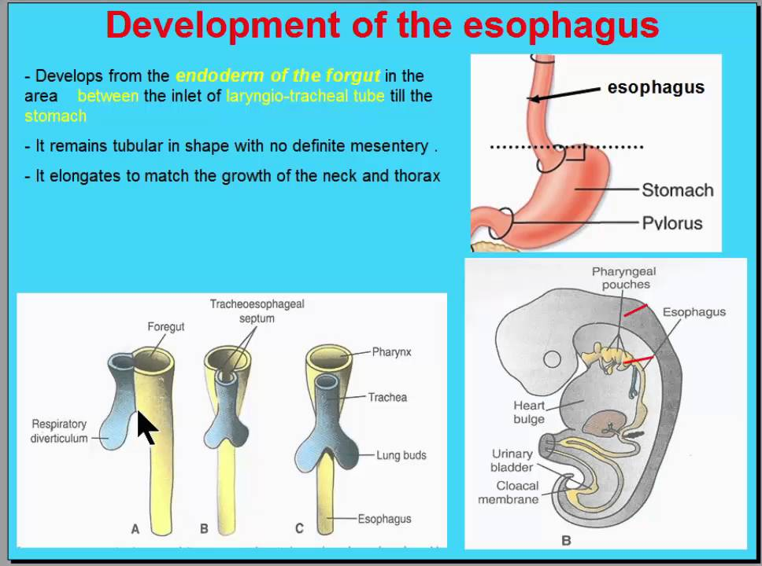

REFRENCES:
https://www.slideshare.net/najmussaharsyed/development-of-the-foregut-esophagus-and-stomach
https://opentextbc.ca/anatomyandphysiology/chapter/22-7-embryonic-development-of-the-respiratory-system/
https://en.wikipedia.org/wiki/Esophagus

