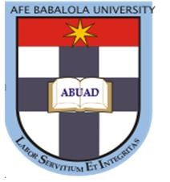
NAME: Obasi Chimere Grace

MATRIC NO. : 17/Law01/196

LEVEL: 300

COURSE TITLE & CODE: Law of Torts II (LPB 302)

LECTURER: Mrs. Apara Oyebanke

The Relevance of Passing Off as a Form of Economic Torts in the 21st Century Nigeria
Introduction:
The relevance of passing off as a form of economic torts in the 21st Century Nigeria cannot be underestimated. In an era where more start up businesses are emerging and almost everyone wants to bear the title of being an entrepreneur, in actuality most people are not willing to put in the work of bearing this title but instead seek to look for an easy but yet risky and unlawful medium of becoming one. This work shall seek to see how relevant passing off as a form of economic tort is in 21st century Nigeria.
First and Foremost, what is Economic Tort?
Economic torts are defined to mean tort claims that do not allege physical contact with the victim or his property or harm to such nonfinancial, or at least non-commercial, goods as business reputation and personal privacy. It is surprising that the economic literature on the economic torts is so sparse relative to the economic literature on the physical torts- torts involving personal injury or property damage- including the wrongful taking of property (conversion).
What then is Passing Off?
Passing off is a wrong, a common law tort which protects the goodwill of a trader from misrepresentation. Misleading the public into believing falsely, that the brand being projected was the same as a well-known brand is a wrong and is known as the tort of “passing off”. As held in the famous case of N. R. Dongre Vs. Whirlpool Corporation, “A man may not sell his own goods under the pretence that they are the goods of another man.”. Law aims to protect traders from this form of unfair competition.
Furthermore, We shall be looking at the relevance of passing off as a form of economic tort in the 21st century Nigeria in relation with their forms and some Nigerian cases as seen below:

- It seeks to redress the acts of individuals and organisations from trading under a name which is closely related to that of the claimant/ plaintiff such name being likely to mislead the public: - The well-established case on this is Hendriks v Montagu where the Universal Life Assurance Society were granted an injunction by the court in order to restrain the company of the defendant which was incorporated later on from carrying on business under the name “Universe Life Assurance Association”. In Nigeria, the court has decided a similar situation in Niger Chemists ltd. v. Nigeria Chemists [1961] 1 All NLR 171 where Palmer J. granted an injunction restraining the defendants from using the name “Nigeria Chemists” as it was calculated to deceive those who had the intention to deal with Niger Chemists. It is important to note that both parties in the suit were engaged in a similar business. Thus, where a name is made to deceive a consumer or the public due to its similarity with that of a plaintiff then that is a form of passing off and there exists a tort.
- To redress the actions of Individuals and companies of Trading under a name already given for goods of that kind by another company/individual or trading under a name so similar to that of another company as to be mistaken for it: - Where a trade name is already in use by the plaintiff for his goods and services, it will be actionable passing off for a defendant to trade under the name of the plaintiff. A trade name is a name under which goods and services are sold by a certain individual and which by established usage has become known to the public to the effect that the goods and services are that of the individual. Descriptive names such as ‘water’, ‘beer’ ‘stout’ are not protected unless the plaintiff can prove that the descriptive name has acquired a secondary name exclusively associated with the plaintiff’s own product.
- It seeks to redress direct statement by an individual/company that the goods and services are that of another prevailing individual/companies goods. :-Actionable passing off occurs where the defendant markets his products as that of the plaintiff. See Byron (Lord) v. Johnston
- To redress the act of where an individual/company trades under the trademark of an individual/company or any deceptive imitation of the latter’s mark. A trademark refers to a mark used by a trader in order to indicate a connection between the marked goods and the trader and also to show that the marked goods are the trader’s merchandise.
- For the Redress of imitating the get up or appearance of another individual/companies goods: - Where there are characteristics in the Get Up or appearance of the plaintiff’s goods which identifies the goods as those of the plaintiff, any adoption or imitation of the appearance or get up of the plaintiff’s goods by another in a manner likely to deceive will give rise to the tort of passing off. Thus, where the defendant imitates the get up or appearance of the plaintiff’s goods, the defendant is liable for passing off. See Trebor Nigeria ltd v. Associated Industries ltd (1972) NNLR 60 Suit no K/127/71 May 29 1972. Where the plaintiffs claimed that the defendants were guilty of passing off their products as that of the plaintiffs. The court per J. R. Jones (Senior PuisineJudge) held that the defendants had in every aspect from carton to tablet to manufacturingmarketed a product as similar as possible to that of the plaintiffs.

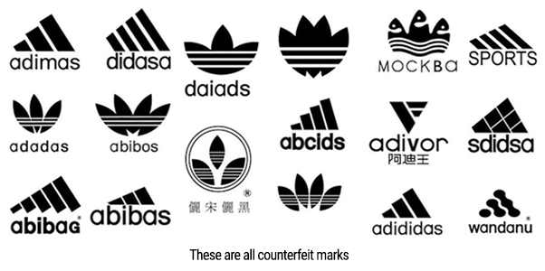
In conclusion, the relevance of passing off as a form of economic torts in the 21st Century Nigeria cannot be underestimated. In an era where more start up businesses are emerging and almost everyone wants to bear the title of being an entrepreneur, in actuality most people are not willing to put in the work of bearing this title but instead seek to look for an easy but yet risky and unlawful medium of becoming one.
In other words, in relation to what has been discussed above, it can be deduced from it that the relevance of the tort of passing off teaches one to:
- Be innovative
- To enable businesses continue to earn profit
- To protect the right of property that exists in good will
- For us not to deceive the public.
- Prevention of unfair competition
Bibliography:
Francis Ibekwe-Allagoa, “The Tort Of Passing Off In Nigeria” (academia. Edu)
Law Student, ‘Tort of Passing Off Project Assignment for Law of Torts’ (Law Teacher 2 February 2018) https://www.lawteacher.net/free-law-essays.php#ftn2
G. Kodilinye and O. Aluko, Nigerian Law of Torts (Spectrum Books Limited 1999)
E Smaranda Olarinde and Clement C Chigbo and Nnamdi G. Ikpeze, The Modern Law of Torts: A kaleidoscopic Perspective (First Published 2018)

E Smaranda Olarinde and Clement C Chigbo and Nnamdi G. Ikpeze, The Modern Law of Torts: A kaleidoscopic Perspective (First Published 2018)
[1881] 17 Ch.D 638
G. Kodilinye and O. Aluko, Nigerian Law of Torts (Spectrum Books Limited) 1999
R. F. V. Heuston, Salmond on the Law of Torts (16th edn, Sweet & Maxwell London, 1973)
[1816] 2 Mer. 29
R. F. V. Heuston, Salmond on the Law of Torts (16th edn, Sweet & Maxwell London, 1973)
Section 67(1) Trade Marks Act CAP T13 LFN 2004.
Ibid (n 10)
Nigerian Law Intellectual Property Watch Inc. https://nlipw.com/a-peek-into-passing-off-cases-in-Nigeria accessedon 20 September 2019

