A TERM PAPER ON
ADEQUATE WATER SUPPLY AND WASTEWATER MANAGEMENT IN BAYELSA STATE – IMPORTANT ASPECT OF SUSTAINABLE HEALTHCARE

PREPARED BY
ALLISON KELVIN TAUTOGU
MATRIC NO: 16/ENG03/056

SUBMITTED TO
THE DEPARTMENT OF CIVIL ENGINEERING,
COLLEGE OF ENGINEERING, AFE BABALOLA UNIVERSITY
ADO-EKITI, NIGERIA.
IN PARTIAL FULFILLMENT OF REQUIREMENT FOR THE AWARD OF BACHELOR OF ENGINEERING (B.ENG) DEGREE IN CIVIL ENGINEERING
APRIL, 2020

Table of Contents
CHAPTER ONE: INTRODUCTION 1
CHAPTER TWO: LITERATURE REVIEW 3
CHAPTER THREE: METHODOLOGY 4
CHAPTER FOUR: ANALYSIS OF RESULTS 6
CHAPTER FIVE: CONCLUSION AND RECOMMENDATION 8
CONCLUSION 8
REFERENCES 9

CHAPTER ONE: INTRODUCTION

Any water that has been adversely affected in quality due to human activities can be regarded as wastewater (Burton and Stensel, 2003). It includes domestic liquid waste from residences, industries or agriculture. It encompasses a wide range of contaminants which can be potentially harmful or concentrations that can lead to degradation in water quality. These potential contaminants include soaps and detergents from bathrooms, food scraps and oil from kitchens and other human activities that involve the use of water. Potable water becomes wastewater after getting contaminated with all or some of the above mentioned potential contaminants.
Wastewater that comes from human waste (feaces, urine or other body fluids), also known as blackwater, includes water from lavatories, septic tanks or soakaway, and washing water; while greywater is wastewater that comes from urban rainfall runoff from roads, roofs, and sidewalks. Wastewater can be contaminated with different components which mostly include pathogens, synthetic chemicals, organic matter, nutrients, organic compounds and heavy metals. These occur either in solutions or as particulate matter.
If wastewater is not properly managed it could become a point source of pollution which could be a hazard for the health of human populations and the environment. The environmental impact of wastewater degradation may result in physical changes to receiving waters, increased level of dissolved oxygen, bioaccumulation in aquatic life, release of toxic substances and increased ground water quality (Mahmood and Maqbool, 2006). Diseases caused by bacteria, viruses and protozoa are the most common health hazards associated with untreated wastewater. Many microbial pathogens in wastewater can cause chronic diseases with long-term effects such as degenerative heart disease and stomach ulcer (Paillard et al., 2005). These debilitating ailments can be fatal and have been known to impair human productivity. Wastewater also consists of vast quantities of bacteria, most of which are harmless to man. However, pathogenic forms that causes diseases such as typhoid, dysentery and other intestinal disorder may be present in the wastewater (Absar, 2005).
Urban growth impacts on infrastructure in developing countries are extremely pressing. In many cities of Asia, Africa and Latin America, engineered sewage collection systems and wastewater treatment facilities are often non-existent. For developing countries, particularly in arid areas, wastewater is simply too valuable to waste. It contains scarce water and valuable plant nutrients, and crop yields are higher when crops are irrigated with wastewater than with freshwater. Farmers use untreated wastewater out of necessity and, unfortunately, it is a reality that cannot be denied or effectively banned (Looker, 1998).
Wastewater is a complex resource that is both advantageous and inconveniencing in its use. It is a renewable resource that once used can be reclaimed and used again for different beneficial uses. The quality of the once used wastewater and the specific type of reuse determine the level of subsequent treatment needed. The reclaimed wastewater can be used for purposes, other than drinking, such as; irrigation of public parks, athletic fields, recreation centers, school yards and playing fields, reservations of highways, irrigation of landscaped area surrounding buildings, fire protection, as well as toilet and urinal flushing in public buildings (Hespanhol, 1992). This will greatly reduce the overstretching of potable water. The lack of freshwater resources large enough to meet the demand of a burgeoning population led to the emergence of International Journal of Development and Sustainability Vol.2 No.2 (2013): 1169-1182 ISDS www.isdsnet.com 1171 wastewater reclamation and reuse as components of wastewater management (Asano et al., 1998). Water conflicts arise mostly as a result of the need to manage the resource which is becoming scarcer with time. Benefits of water reclamation and reuse are recognized as a method of preventing the pollution of surface and ground waters (Hespanhol, 1992).
Even though wastewater and its nutrient contents can be used for crop production, thus providing significant benefits to the farming communities and society in general, its use could however also impose negative impacts on communities and on ecosystems. The use of wastewater containing toxic wastes coupled with the lack of adequate finances for treatment is likely to cause an increase in the incidence of water borne diseases as well as more rapid environmental degradation. Although the harmful effects of using contaminated wastewater effluents could go undetected for several years, it however adversely affects groundwater quality when nutrients leach down the soil into the groundwater system (Mahmood and Maqbool, 2006). Near surface aquifers in intensely irrigated areas using wastewater can indeed become polluted, thus reducing the aquifer potability

CHAPTER TWO: LITERATURE REVIEW
Pollution is a major threat to environmental sustainability. Environmental pollution is majorly caused due to anthropogenic activities and to lesser extent human activities in the environment. Probably due industrialization, urbanization and population growth, the activities of human in the environment have increased leading to impact on land/soil, air and aquatic ecosystem.
Aquatic ecosystem gets contaminated from direct activities in the ecosystem and indirectly through runoff after precipitation. Water could be contaminated indirectly when substances that could alter water quality parameter and affect the diversity/composition and abundance of fisheries and planktons. For instance, the use of pesticides close to aquatic ecosystem and/ or ruff of improper discharge of empty cans of pesticides could affect end up the water bodies nearby and may affect fisheries. Direct anthropogenic activities that affects water quality includes domestic and industrial effluents, dredging, oil and gas activities, food processing effluents such as oil palm, cassava processing, market etc.
Market activities generate several wastes stream predominant solid wastes. The wastes often lead to odor via decomposition. In Bayelsa state, most markets are located close to surface water. Most of the wastes generated from the marketing activities often end up in the water bodies. This waste has the tendency to affect water quality parameters including microbial, general physicochemistry and heavy metals. Depending on the composition of the wastes, it could also cause eutrophication and acidification. Others water structures such as sediment could be affected. Typically, sediment occurs as deposited or suspended sediment.
Typically, water is useful resources needed for the sustenance of life. Water is also a habitat for several biodiversity. Water is also essential for growth and development of the human body. Most of the water resources mostly utilized in developing country like Nigeria include surface, ground and rain water. The level of use of each type of water depends mainly on its availability.
Several studies have been carried out in some surface water in Bayelsa state. Some of these include Ikoli creek, Epie creek, Kolo creek, Igbedi creek, Nun river, Efi lake, Taylor creek, Sagbama creek. But due constant urbanization and increased anthropogenic activities in these water resources, there the need to frequently assess the water quality. Hence, the study updates the physicochemical characteristics of Epie creek, Niger Delta, Nigeria.

CHAPTER THREE: METHODOLOGY
Study Area Epie creek is one of the major essential surface water in Bayelsa state (Fig. 1). The creek is connected to several creeks in the region such as Ikoli creek and Taylor creek. The creek serves as a receiver of poorly managed wastes and the water is also used for drinking, bathing, recreational and transportation activities. Other activities carried out in the creek fishing, canoeing/boating. The creek is also receiver of several wastes stream.
Sample Techniques Water samples were collected from five direct locations of the creek stretching from Akenfa to Biogbolo between January and February 2016 (dry season) – May and June 2016 (wet season). Based on locations, there are major market activities aligning the water body apart from Biogbolo. The water samples were collected with 1 litre bottle. The samples were transported to the laboratory in an ice chest for laboratory analysis.
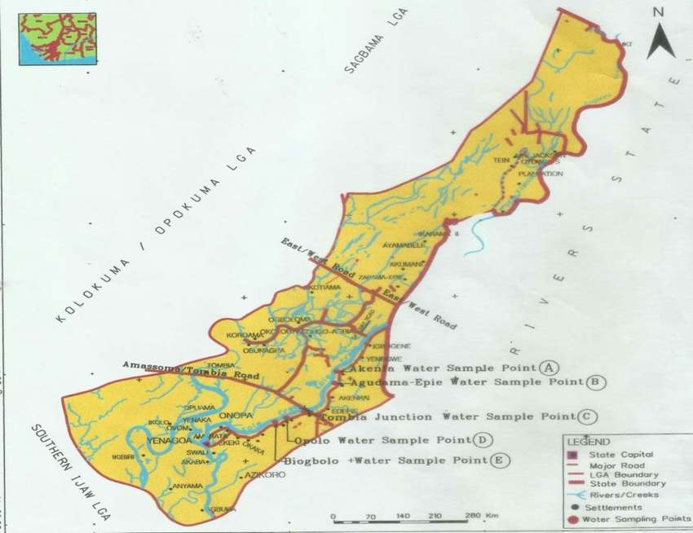
Figure 1:Map of Yenagoa local government area showing water sampling points along Epie
Analysis of Water Samples The water quality parameters were analyzed insitu viz: pH, conductivity, dissolved oxygen, salinity, turbidity, total dissolved solid, using multimeter. While Total suspended solid, nitrate, chloride, sulphate, bicarbonate, alkalinity, total hardness, calcium, potassium, magnesium, sodium, chemical and biological oxygen demand using the method previously described by APHA [43], Ademoroti [44]. Iron and manganese was analyzed using atomic adsorption spectrophotometer.
Statistical Analysis SPSS software version 20 was used to carry out the statistical analysis of the physicochemical parameters of the water samples. Two-way analysis of variance was carried out at P = 0.05, and Duncan’s multiple range test (DMR) was used to determine source of the observed differences were n=4 for spatial distribution and n=5 for monthly distribution. Spearman correlation matrix was used to identify the relationship between the physicochemical parameters of the water. The chart for the physicochemical parameters was plotted using Paleontological statistics software package by Hammer et al. [45]. The standard error bar was determined at 95% interval level.

CHAPTER FOUR: ANALYSIS OF RESULTS
pH
The pH of Epie creek i.e. from Akenfa to Biogbolo ranged from 6.27 – 6.53 for spatial distribution, while on monthly distribution, pH ranged from 5.80 – 7.01. Significance difference (P<0.05) exist at monthly distribution and interaction between spatial and monthly distribution. However, no significant variation (P>0.05) in the spatial distribution for pH was observed (Table 3). The pH of water sample shows positive relationship with iron and manganese at P<0.01, potassium at P<0.05 and negative relationship with total suspended solid at P<0.05 and, total alkalinity, dissolved oxygen and chemical oxygen demand at P<0.01. The difference (i.e. monthly distribution and interaction between location and months) could be associated with the amount of acidic material leached into the water from various human activities in both seasons as well as dilution effects resulting from changes in season.
3.2 Salinity
The salinity of Epie creek i.e. from Akenfa to Biogbolo ranged 0.12 – 2.58 mg/l for spatial distribution. While on monthly distribution, the salinity ranged from 0.57 – 1.94 mg/l (Fig. 3). No significance variation (P>0.05) existed at spatial and monthly distribution, and interaction between spatial and monthly distribution (Table 3). The salinity of water sample shows positive correlation with conductivity, total dissolved solid, sulphate, calcium at P<0.01 nitrate, chloride, magnesium, sodium, potassium and biological oxygen demand at P<0.05. No significant variation in location and interaction suggested that the water quality is uniform for all fresh water. The salinity in this study has some similarity with previous works on surface water in Bayelsa state. Some of the salinity values previously reported ranged from 0.003 – 0.007‰ from Kolo creek [26], 0.009 – 0.04‰ for lower Kolo creek [37], 0.01 – 0.03 mg/l from Ikoli creek receiving effluents [27], 0.000 – 0.017 mg/l from Nun river [28], 0.010 – 0.050‰ from River Nun [29], 0.05‰ from Efi lake. The similarity suggests that the water is homogenous i.e. fresh and is not influenced by the anthropogenic activities in the area.

CHAPTER FIVE: CONCLUSION
This study evaluated the physicochemical characteristics of Epie creek, Niger Delta Nigeria. Results showed that there was no significant variation (P>0.05) in salinity, conductivity, turbidity, total dissolved solid, nitrate, chloride, sodium, chemical oxygen demand and potassium concentration across spatial and monthly distribution and interaction between monthly and spatial distribution. Furthermore, there is significance difference (P<0.05) in sulphate, total alkalinity, total hardness and calcium across spatial and monthly distribution and interaction between monthly and spatial distribution. There was significance difference (P<0.05) in total suspended solid and pH spatial distribution only. Significance difference (P<0.05) exist for bicarbonate, iron and manganese for monthly distribution and interaction between monthly and spatial distribution.
Also no significant difference (P>0.05) in only monthly distribution for biological oxygen demand. Based on the water quality characteristics of the Epie creek, the parameters including pH, conductivity, total dissolved solid, nitrate, chloride, alkalinity, total hardness, calcium, magnesium, sodium, potassium, iron, biological oxygen demand, bicarbonate were apparently high in the Tombia junction location. This suggests the effects of market activities on Epie creek. Therefore, we recommend that the discharge of wastes into the creek should be avoided.

REFERENCES
Baracco-Miller, E., "Planning for Construction," Unpublished MS Thesis, Dept. of Civil Engineering, Carnegie Mellon University, 1987.
Construction Specifications Institute, MASTERFORMAT - Master List of Section Titles and Numbers, Releasing Industry Group, Alexandria, VA, 1983.
Jackson, M.J. Computers in Construction Planning and Control, Allen & Unwin, London, 1986.
Sacerdoti, E.D. A Structure for Plans and Behavior, Elsevier North-Holland, New York, 1977.
Zozaya-Gorostiza, C., "An Expert System for Construction Project Planning," Unpublished PhD Dissertation, Dept. of Civil Engineering, Carnegie Mellon University, 1988

