NAME : ADETROKUNBO PRECIOUS ADEMIDE
MATRIC NO; 19/MHS11/015
PHJARMACY
BIO 102

- How are fungi important to mankind?
- They are part of the nutrient cycle un the ecosystem by controlling the population of damaging pests.
- They are part of the human diet. i.e mushroom
- Many antibiotics are produced naturally by fungi to kill or inhibit the growth of bacteria.
- As simple eukaryotic organisms, fungi are important model research organisms.
- They are important decomposers in the ecosystem.
- They serve as the agents of fermentation in the production of bread, wine e.t.c.
- Many important and useful enzymes have been synthesized from various fungi.

- Illustrate the cell structure of a unicellular fungus with a well labeled diagram
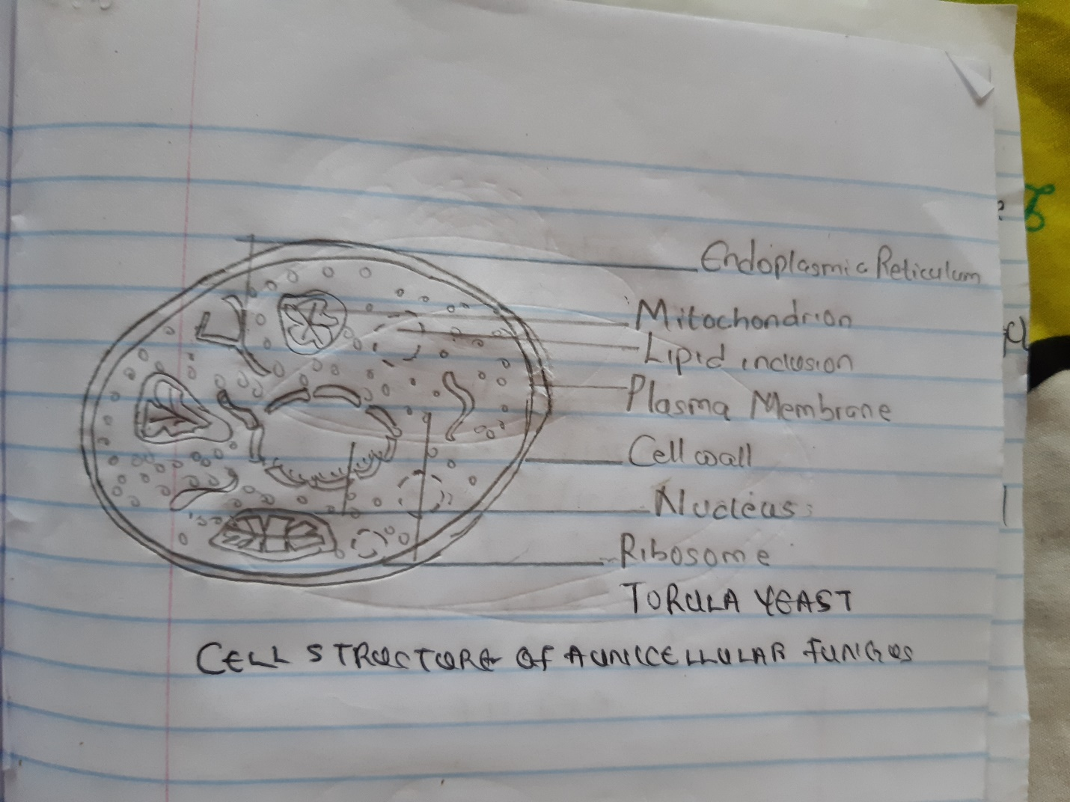

- Outline the sexual reproduction in a typical filamentous form of fungi
- Fungal life cycles are unique and complex.
- Fungi reproduce sexually either through cross- or self-fertilization. Haploid fungi form hyphae that have gametes at the tips.
- Two different mating types (represented as “+ type” and “– type”) are involved.
- The cytoplasms of the + and – type gametes fuse (in an event called plasmogamy), producing a cell with two distinct nuclei (a dikaryotic cell).
- Later, the nuclei fuse (in an event called karyogamy) to create a diploid zygote.
- The zygote undergoes meiosis to form spores that germinate to start the haploid stage, which eventually creates more haploid mycelia .
- Depending on the taxonomic group, these sexually produced spores are known as zygospores (in Zygomycota), ascospores (in Ascomycota), or basidiospores (in Basidiomycota).
- How do bryophytes adapt to their environment?
Two adaptations made the move from water to land possible for Bryophytes: a waxy cuticle and gametangia. The waxy cuticle helped to protect the plants tissue from drying out and the gametangia provided further protection against drying out specifically for the plants gametes. Bryophytes also show embryonic development which is a significant adaptation that links them to the vascular land plants.
- Describe with illustration the following terminologies
- Eusteles : a type of stele found in most seed plants, consisting of a central pith surrounded by the primary vascular tissue
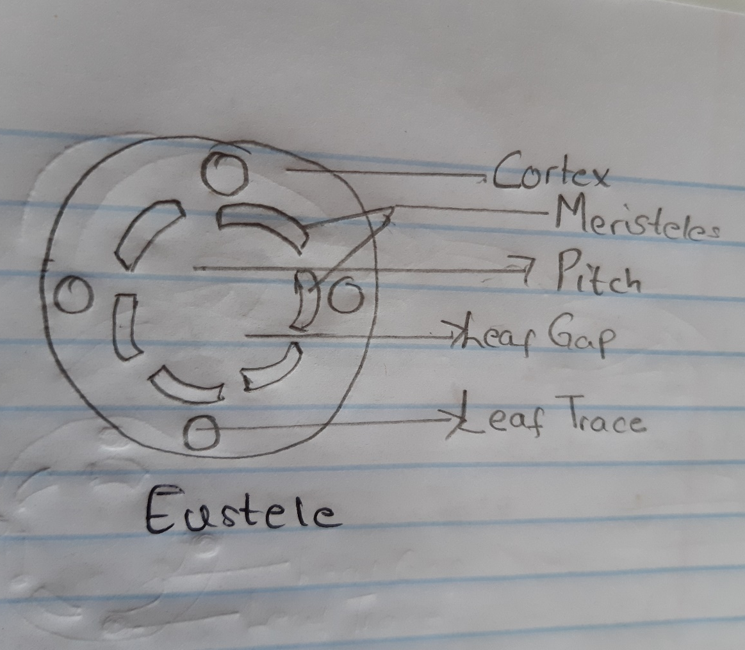
- Atactostele: A protostele in which xylem appears as stellate or star shaped with many radiating arms in transverse section and phloem is present in small patches in between the radiating arms of the xylem is known as actinostele e.g., Lycopodium serratum., Psilotum.
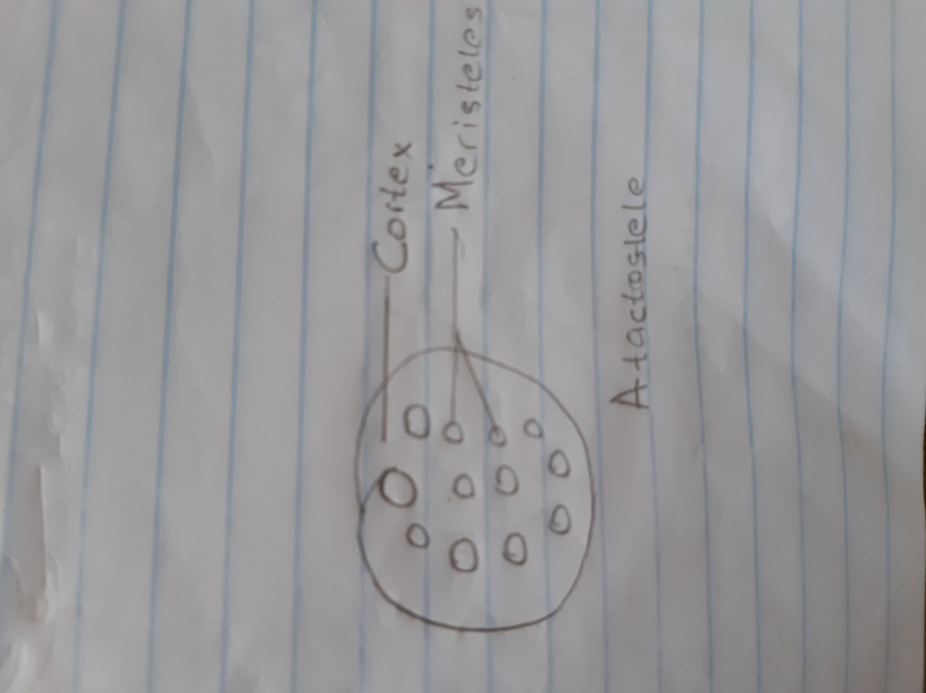
- Siphonostele : A stele with central pith surrounded by vascular tissue is called siphonostele or a medullated protostele is called siphonostele.
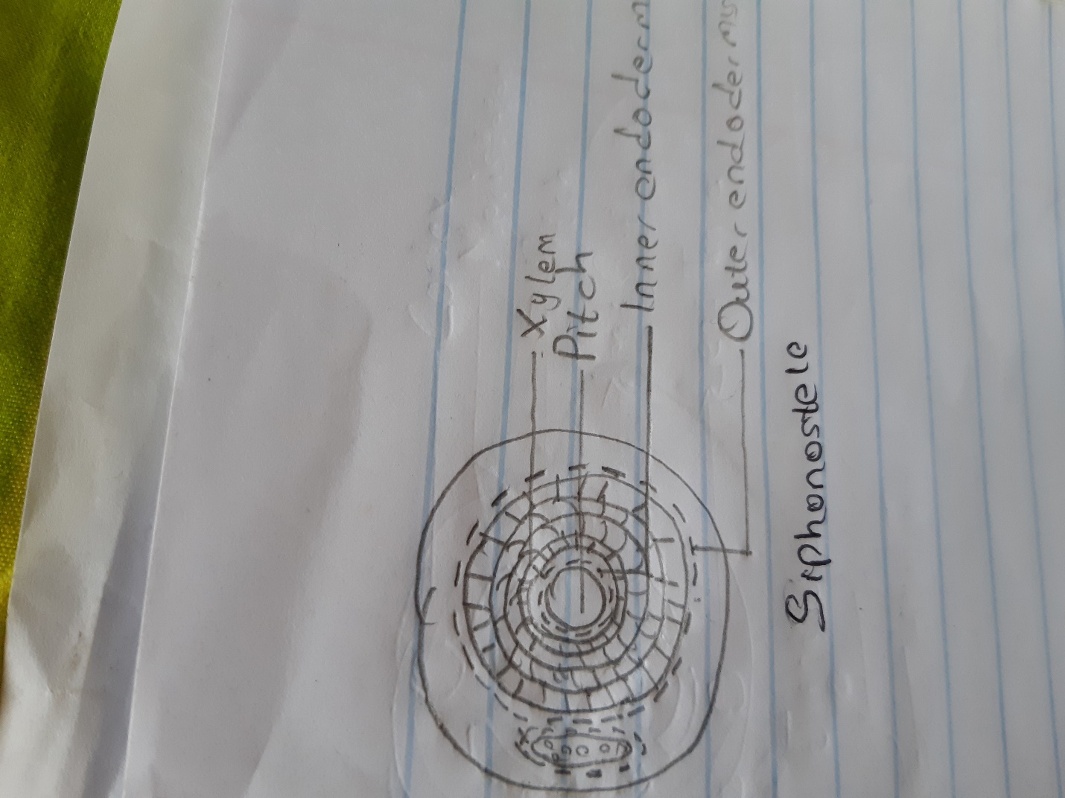

- Dictyostele : A siphonostele with more overlapping leaf gaps so as to show more than interruption in one transverse section is known as dissected siphonostele or dictyostele. The vascular parts of dictyostele between the neighbouring leaf gaps are known as meristeles.
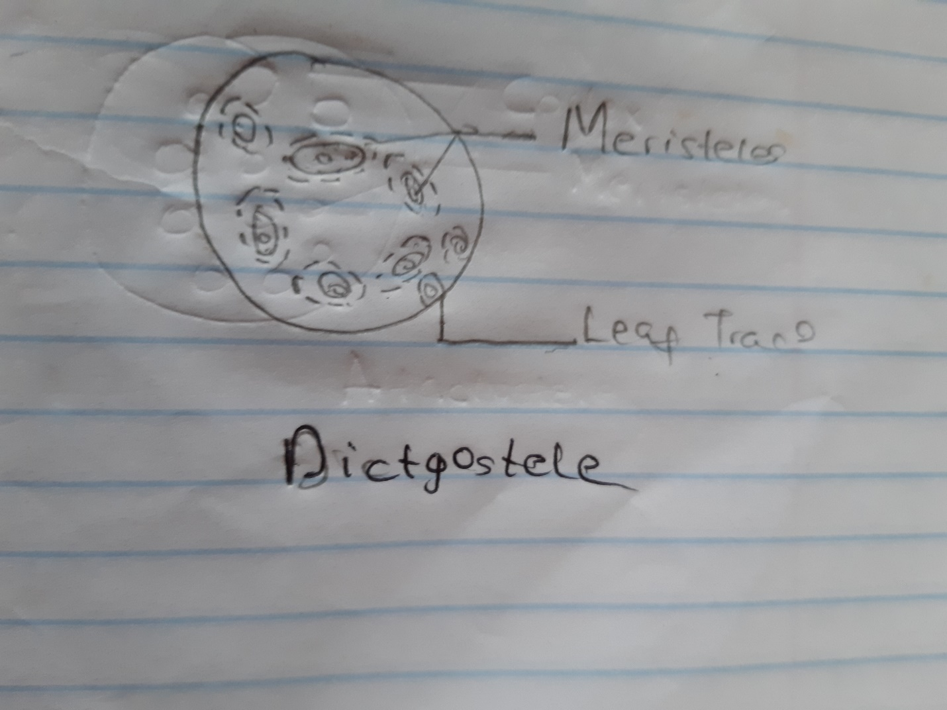

- Illustrate the life cycle of a primitive vascular plant
