- -Fungi is responsible for the mediationof decay with the study of fungi .
- Fungi e.g yeast (saccharomyces species) are important in food industry.
- Mushrooms are eaten by many human societies . species e.g penicillium notatum produce important antibiotics.
- Many fungi species meditate food spoilage , wood ,clothes and paper , many are also plants pathogens.
2.
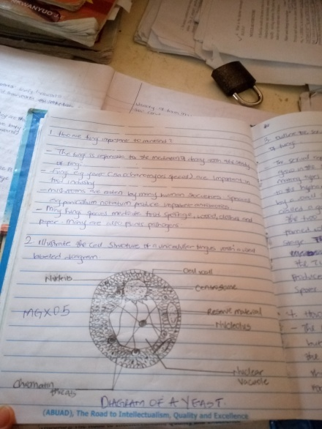
- The sexual reproduction occurs when two mating types of hyphae grow in the same medium chemical interaction in the two mating types of hyphae induces growths perpendicular to thehyphaee in opposite directions. These growths are delimited by a wall such that many nuclei are isolated in what is called a gametangium.
The two gametangia fuse (plasmogamy) and a zygote is formed which may undergo prolonged dormancy or resting stage. The nuclei in the zygote fuse in two’s and undergo meiosis independently. The zygote germinates under favourable conditions to produce fruiting which at maturity liberates the haploid spores.
- The bryophytes are considered amphibians , the live on land but require water for reproduction. The are monophyletic the have a cuticle for preventing excessive water loss, their rhizoids lack true root. The leaf like, stem like and root like structures. The have definite structures for water and nutrient absorption from the soil, therefore the plant body is divided into two can aerial position(above the soil) and a subterranean portion (below the soil)
5.

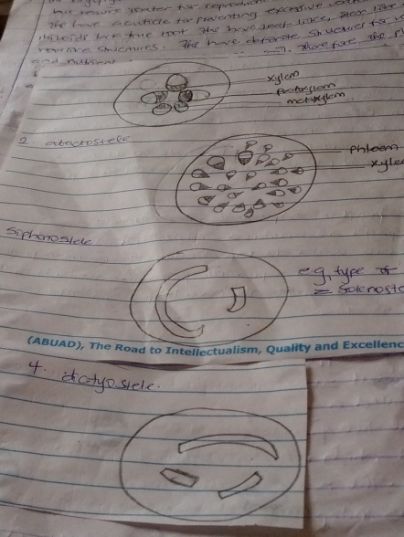

6.