NAME: OGUNNIKE IYANUOLUWA. O
MATRIC NO: 18/MHS05/011
COURSE: PHS 204
DEPARTMENT: PHYSIOLOGY
COLLEGE: MHS

QUESTION
Title: Discuss Contraception and different types with details of any five.
- Points to include: Write what you know about Contraception and the types you know.

Contraception (birth control) is a way to prevent pregnancy by interfering with the normal process of ovulation, fertilization and implantation.. It keeps the sperm and the egg apart and stops egg production.
There are many types of contraception, but not all types are appropriate for all situations. The most appropriate method of birth control depends on an individual’s overall health, frequency of sexual activity, desire to have children, age and other criteria.
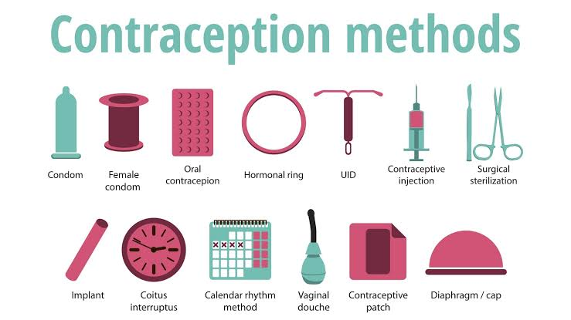

- Long- Acting Reversible Contraception (LARC)
- Intrauterine methods: the use of an intrauterine device can be inserted into the uterus to prevent pregnancy. It is a small T- shaped device which can remain in place and function effectively for many years at a time. They are of two types;
- The hormonal IUD; which releases a progestin hormone known as levonogestrel into the uterus.
- The copper IUD; which prevents sperm from reaching the egg and it may prevent the egg from attaching in the womb.
- Implants: they are implantable rods which are flexible and plastic. This rod releases progestin and can remain implanted for up to 5 years.
- Barrier methods
These methods work by preventing the sperm from getting to the egg. This method includes male condom, female condom, spermicides, cervical cap and diaphragm. The condom is the only form of birth control that protects STDs (Sexually Transmitted Diseases).
- Emergency contraception
This can be used after unprotected sex or if a condom breaks.
- Copper IUD: which can be inserted within 120 hours of unprotected intercourse.
- Emergency contraceptive pills: are hormonal pills that are intended for use in the event of unprotected intercourse.

- Hormonal methods
These use medications (hormones) to prevent ovulation. This include birth control pills (oral contraceptives), Depo Provera injections and Norplant.
- Sterilization
It is a permanent type of contraception that prevents a woman from getting pregnant or prevents a man from releasing sperm. These procedures are not usually reversible.
- Sterilization implant: a nonsurgical method for permanently blocking the fallopian tube.
- Tubal ligation: it is a surgical procedure in which the doctor cuts, ties or seals the fallopian tubes. The sperm cannot reach the eggs to fertilize them and the egg cannot reach the uterus.
- Vasectomy: a surgical procedure that cuts, closes or blocks the vas deferens. The sperm cannot leave the testes and cannot reach the egg.

