**NAME: BIAMBO, SOMIEIBI ANNE**

**MATRIC NO: 19/SCI18/002**

**DEPARTMENT: ARCHITECTURE**

**COURSE: PHY 102**

**SECTION A**

**QUESTION 1**

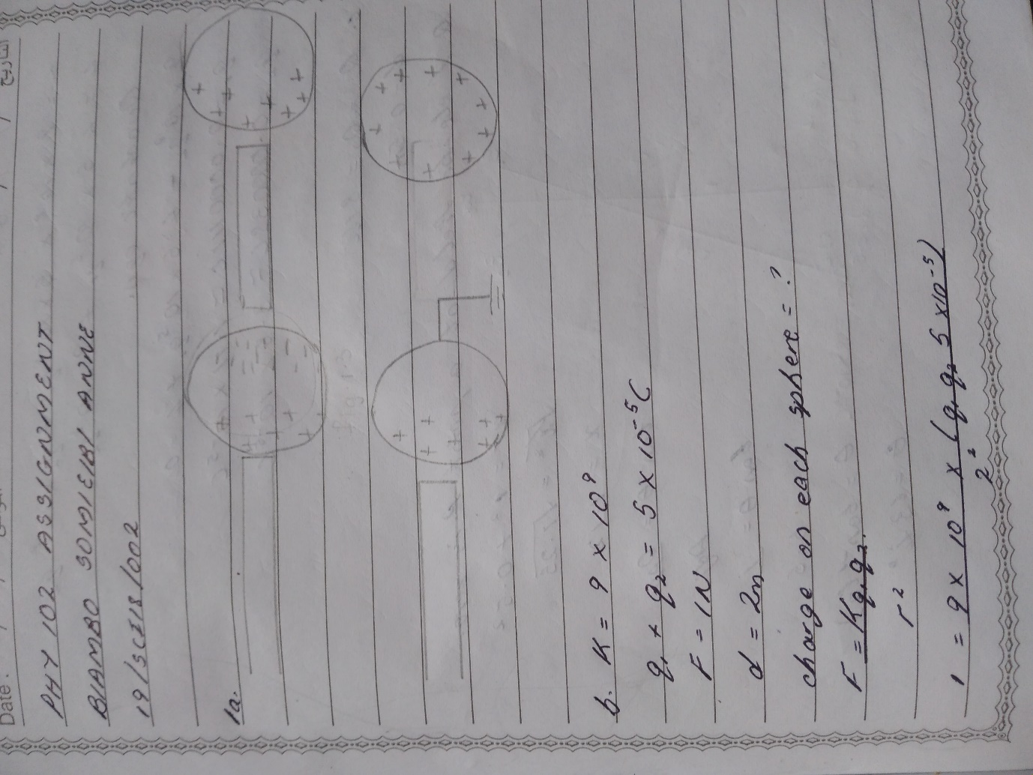

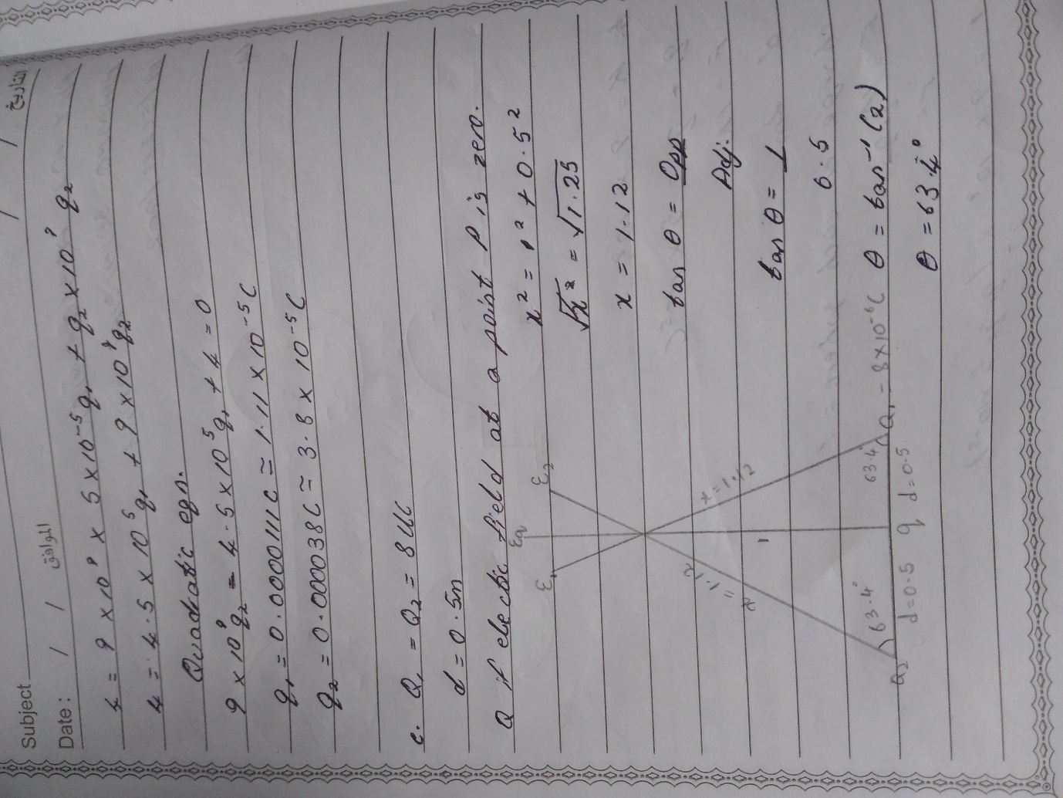

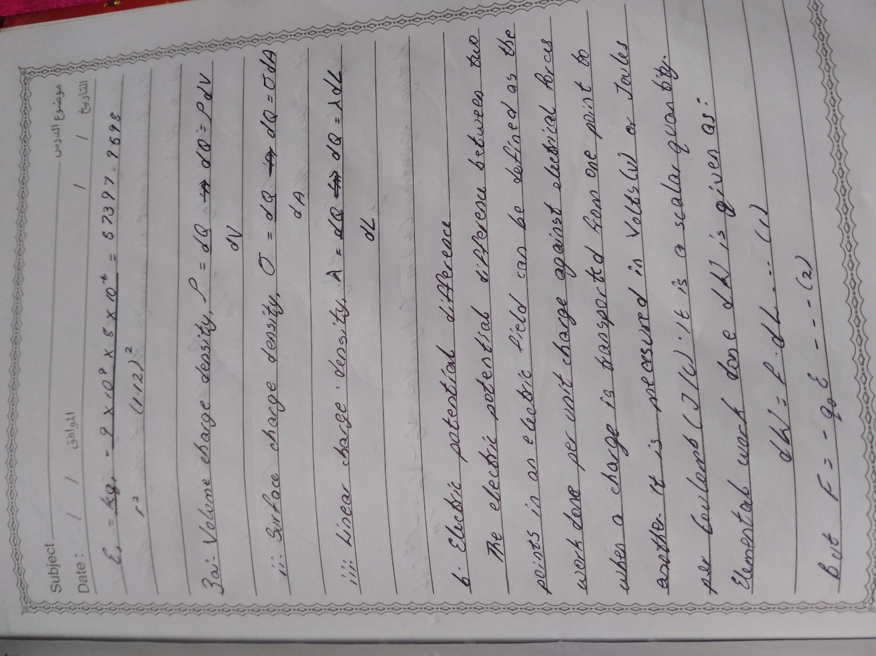

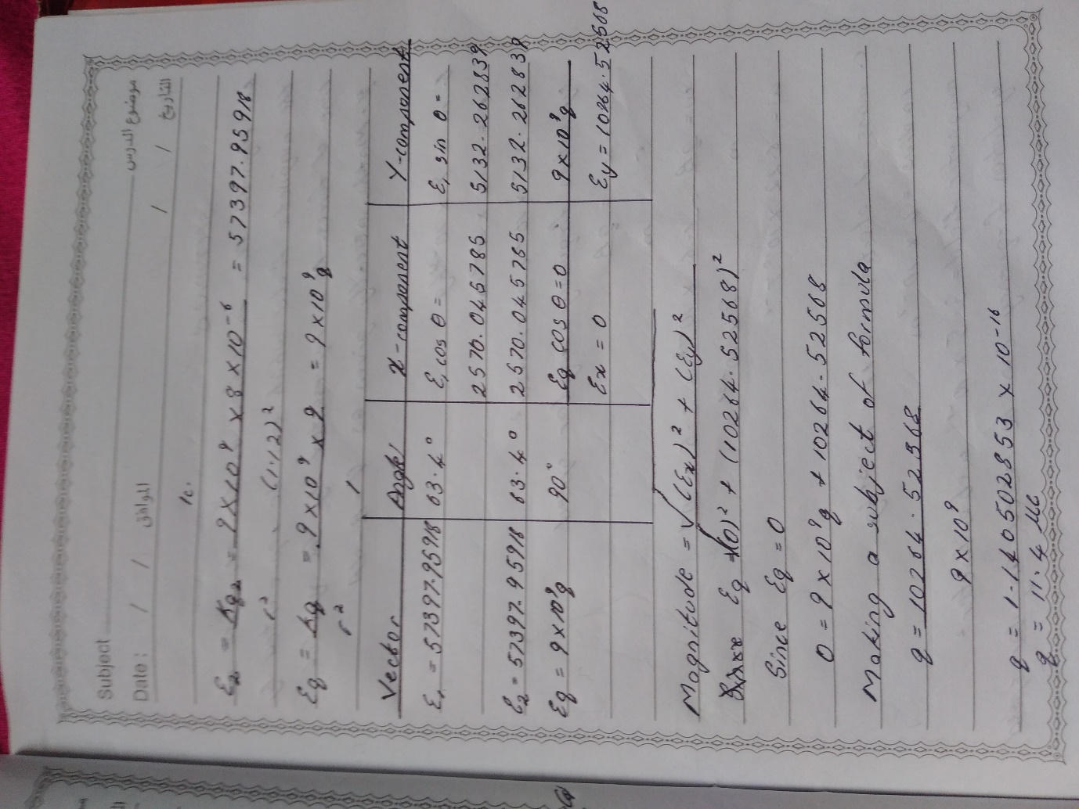

**QUESTION 3**

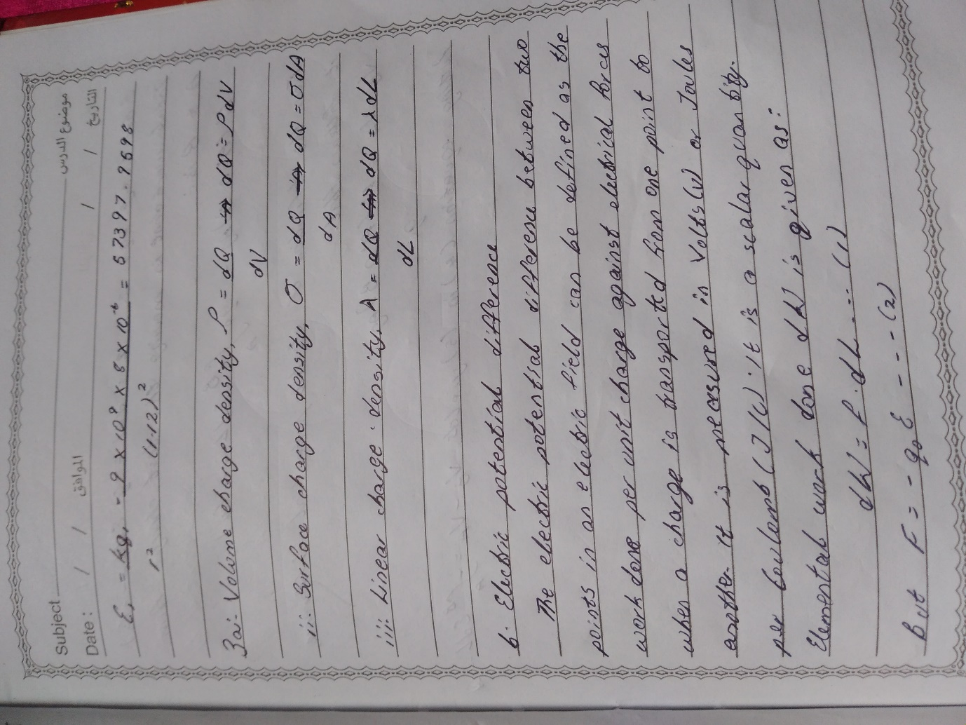

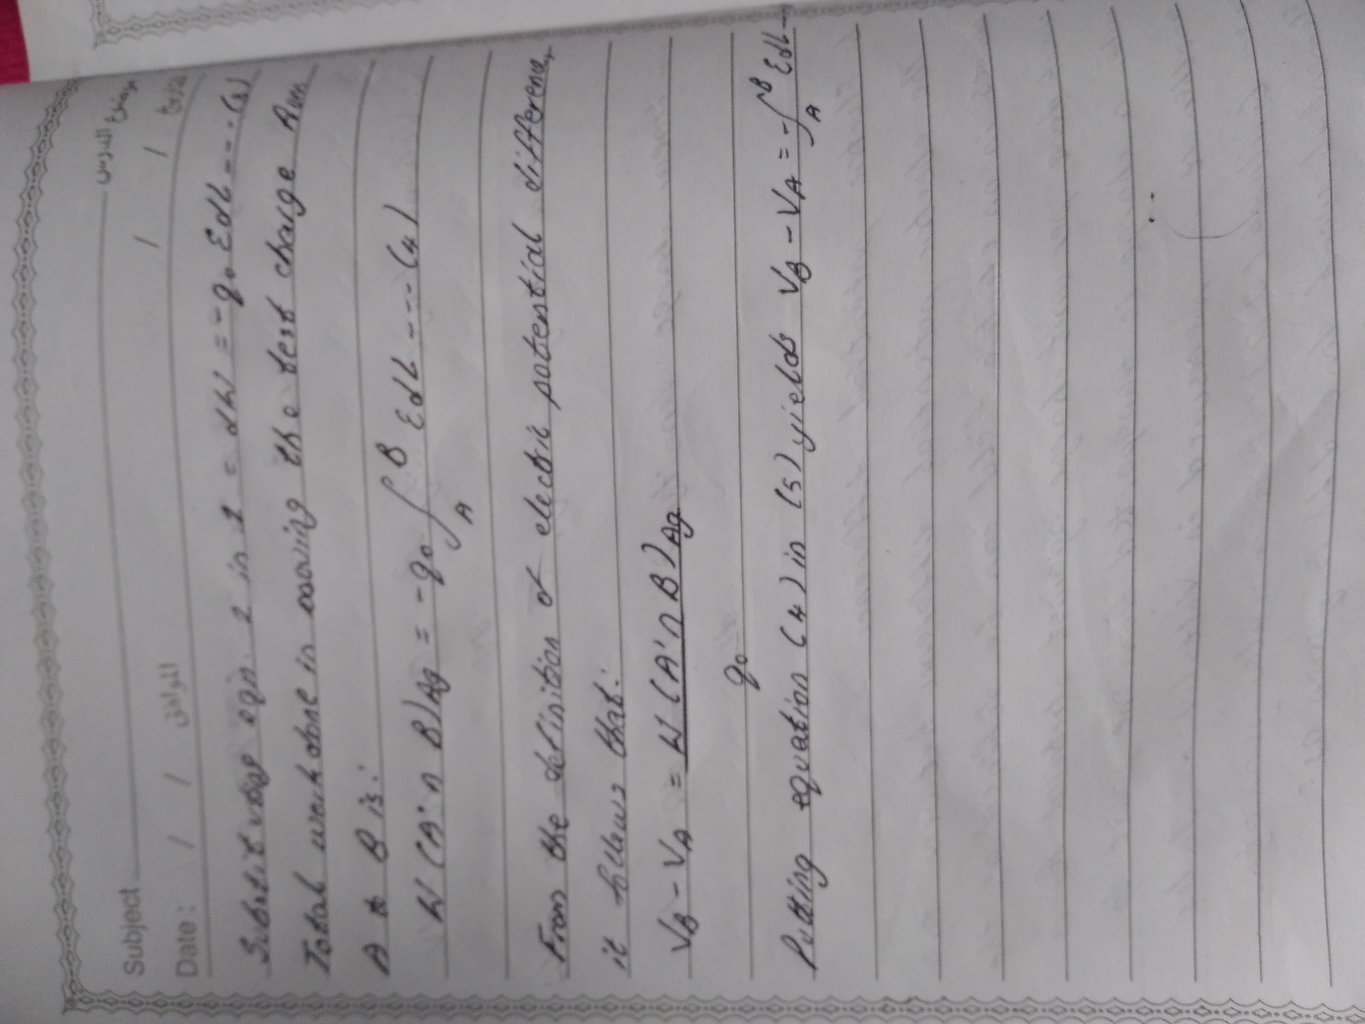

**SECTION B**

**QUESTION 4 & 5**

