NAME: SAMPSON JOSHUA CHIBUIKE
DEPARTMENT: MEDICINE AND SURGERY
MATRIC N.O: 19/MHS01/394
1.
- They are added in the production of insecticides
- They serve as food materials to man
- They serve as medicine
- They help in the recycling process
- They help curb crop diseases
- They help curb animal diseases
- They help to prevent food spoilage
2.
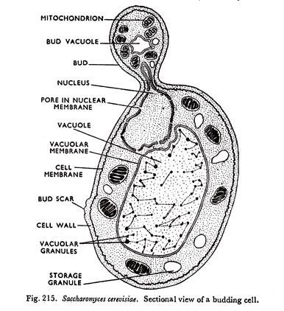

In contrast to molds, yeasts are unicellular fungi. The budding yeasts reproduce asexually by budding off a smaller daughter cell; the resulting cells may sometimes stick together as a short chain or pseudohypha Candida albicans is a common yeast that forms pseudohyphae; it is associated with various infections in humans, including vaginal yeast infections, oral thrush, and candidiasis of the skin.

Some fungi are dimorphic, having more than one appearance during their life cycle. These dimorphic fungi may be able to appear as yeasts or molds, which can be important for infectivity. They are capable of changing their appearance in response to environmental changes such as nutrient availability or fluctuations in temperature, growing as a mold, for example, at 25 °C (77 °F), and as yeast cells at 37 °C (98.6 °F).
3. Sexual reproduction in a typical filamentous fungi.
Sexual reproduction in the fungi consists of three sequential stages: plasmogamy, karyogamy, and meiosis. The diploid chromosomes are pulled apart into two daughter cells, each containing a single set of chromosomes (a haploid state). Plasmogamy, the fusion of two protoplasts (the contents of the two cells), brings together two compatible haploid nuclei. At this point, two nuclear types are present in the same cell, but the nuclei have not yet fused. Karyogamy results in the fusion of these haploid nuclei and the formation of a diploid nucleus (i.e., a nucleus containing two sets of chromosomes, one from each parent). The cell formed by karyogamy is called the zygote. In most fungi the zygote is the only cell in the entire life cycle that is diploid. The dikaryotic state that results from plasmogamy is often a prominent condition in fungi and may be prolonged over several generations. In the lower fungi, karyogamy usually follows plasmogamy almost immediately. In the more evolved fungi, however, karyogamy is separated from plasmogamy. Once karyogamy has occurred, meiosis (cell division that reduces the chromosome number to one set per cell) generally follows and restores the haploid phase. The haploid nuclei that result from meiosis are generally incorporated in spores called meiospores.

4. How do bryophytes adapt to their environment
•They have a waxy cuticle that prevents the body, the zygote, and the embryo from drying out.
•Spores are dispersed by the wind.
•Importance of Bryophytes
•They colonize rocks and convert them to soil.
•Sphagnummoss, or peat moss, is commercially important because of its water-holding capacity.
•Native Americans in New Jersey used Sphagnum for diapers & in their shoes.
•Soldiers put Sphagnum on wounds.
5. Illustrated terminologies
a. Eusteles: In this arrangement, the primary vascular tissue consists of vascular bundles, usually in one or two rings around the pith. In addition to being found in stems, the eustele appears in the roots of monocot flowering plants. The vascular bundles in a eustele can be collateral (with the phloem on only one side of the xylem) or bicollateral (with phloem on both sides of the xylem, as in some Solanaceae).
b. atactostele: There is also a variant of the eustele found in monocots like maize and rye. The variation has numerous scattered bundles in the stem and is called an atactostele (characterestic of monocot stem). However, it is really just a variant of the eustele.
c. Siphonostele: Siphonosteles have a region of ground tissue called the pith internal to xylem. The vascular strand comprises a cylinder surrounding the pith. Siphonosteles often have interruptions in the vascular strand where leaves (typically megaphylls) originate (called leaf gaps).
d. Dictyostele: if multiple gaps in the vascular cylinder exist in any one transverse section. The numerous leaf gaps and leaf traces give a dictyostele the appearance of many isolated islands of xylem surrounded by phloem. Each of the apparently isolated units of a dictyostele can be called a meristele. Among living plants, this type of stele is found only in the stems of ferns.

6. Life cycle of a primitive vascular system
The bryophyte lifecycle consists of alternating generations between the haploid gametophyte and the diploid sporophyte. During the gametophyte stage, haploid gametes (male and female) are formed in the specialized sex organs: the antheridia (male) and archegonia (female). The gametes consist of flagellated sperm, which swim via water or are transported by insect species. The two haploid gametes (sperm and egg) fuse, a diploid zygote is formed. As described above, the zygote of bryophytes grows inside the archegonia and will eventually become a diploid sporophyte. Mature sporophytes remain attached to the gametophyte and generate haploid spores via meiosis inside the sporangium. These spores are dispersed, and under favorable environmental conditions become new gametophytes.

