NAME: OHIOMOBA BRITELLE IJEOMA
DEPT: MEDICINE AND SURGERY
COLLEGE: MEDICINE AND HEALTH SCIENCES
MATRIC NO: 19/MHS01/303
COURSE CODE: BIO 102
1a. They are very important to the entire terrestrial ecosystem in material cycling and to man.
b. They are responsible for the mediation of decay of organic matter.
c. The surface of the earth would have been clogged up with dead matters with various elements locked up in them instead of returning to various cycles without fungi and other microbes
d. They are important in food industry. Mushrooms are eaten by human societies.
e. They are also used to produce important antibiotics

2. 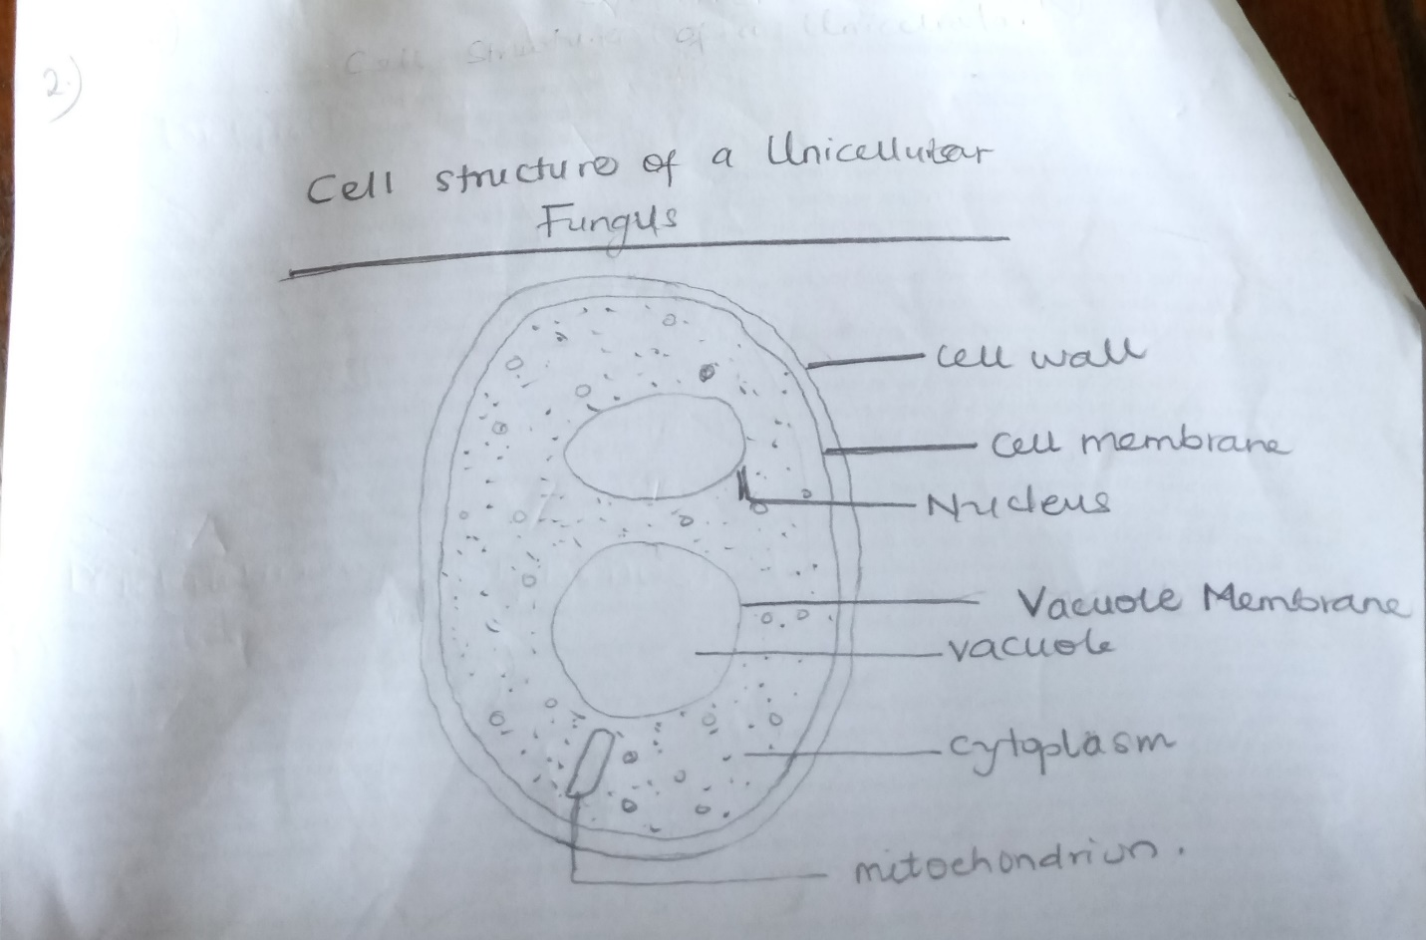

3. sexual reproduction in rhizopus stolonifer; occurs when two mating types of hyphae grow in the same medium. Chemical interaction in the two mating types of hyphae induces growths perpendicular to the hyphae in opposite directions. These growths are delimited by a wall such that many nuclei are isolated in what is called a gametangium. The two gametangia fuse(plasmogamy) and a zygote is formed which may undergo prolonged dormancy or resting stage. The nuclei in the zygote fuse in twos and undergoes meiosis independently. The zygote germinates under favourable conditions to produce a fruiting which at maturity liberates the haploid spores.
4. Bryophytes adapt to their environment in two ways;
a. They have definite structures for water and nutrients absorption from the soil; therefore the plant body is divided into two (an aerial portion and a subterranean portion(is the rhizoid and is not a true root).
b. The aerial portion being exposed to the atmosphere demands some modifications that prevents excessive water loss through the body and some other modifications that permits climination of excess water from the plant body and not only exchange of gases between the internal parts of the plant and the atmosphere therefore openings are available on the aerial parts of pant.
5.
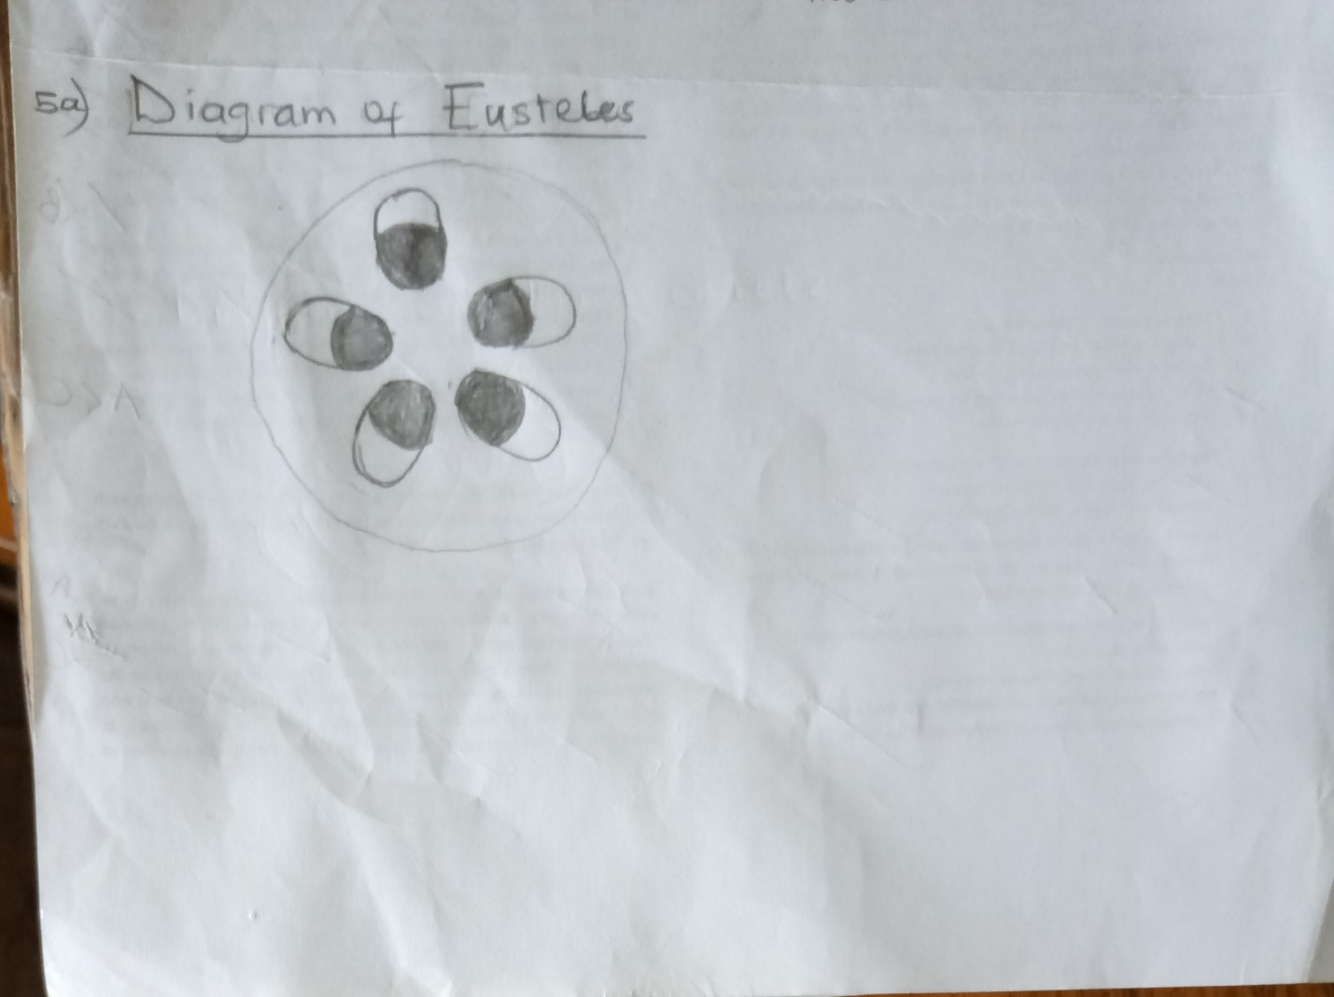
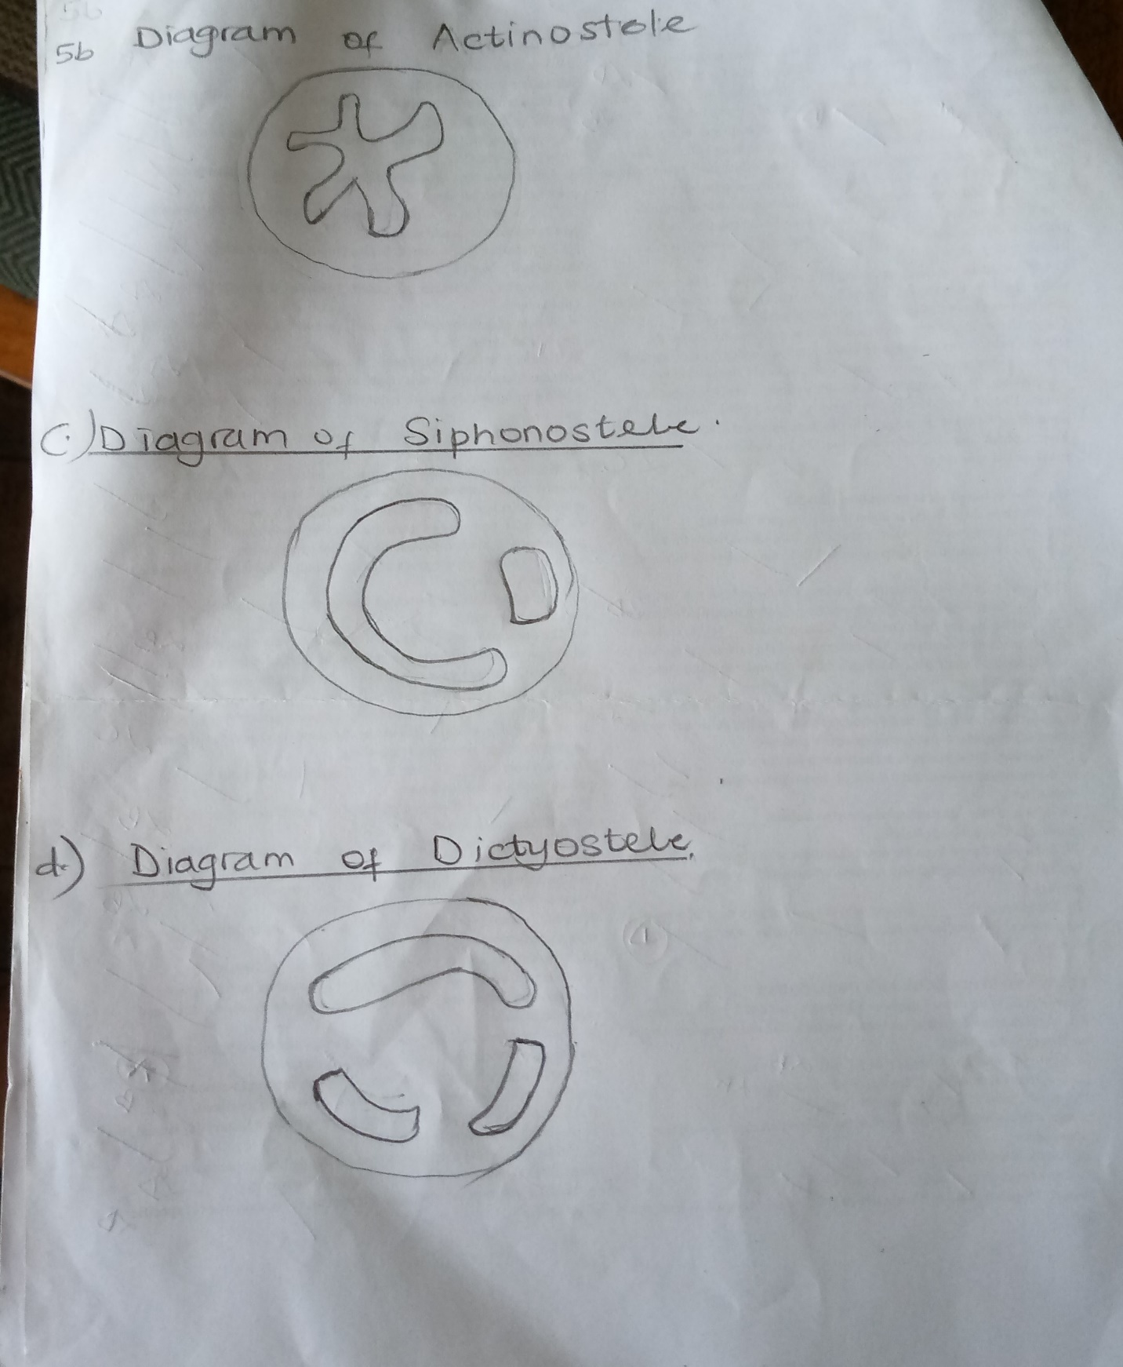
6. 