NAME: Osibanjo Ayoyimika Ezekiel
19/MHS01/363
MBBS
Biology (BIO 102)
100 LVL

QUESTION
- How are fungi important to mankind?
Ans : a. Fungi are responsible for the mediation of decay of organic matter.
b. yeast are important in the food industry.
c. mushrooms are a source of food to individuals in some societies.
d. without fungi and other microbes, the surface of the Earth would have been clogged up with dead matters with all the various elements locked up in them instead of returning into various cycles.
e. many fungi species mediate the spoilage of wood, food, clothes and paper.

- Illustrate the cell structure of a unicellular fungus with a well labeled diagram
Ans: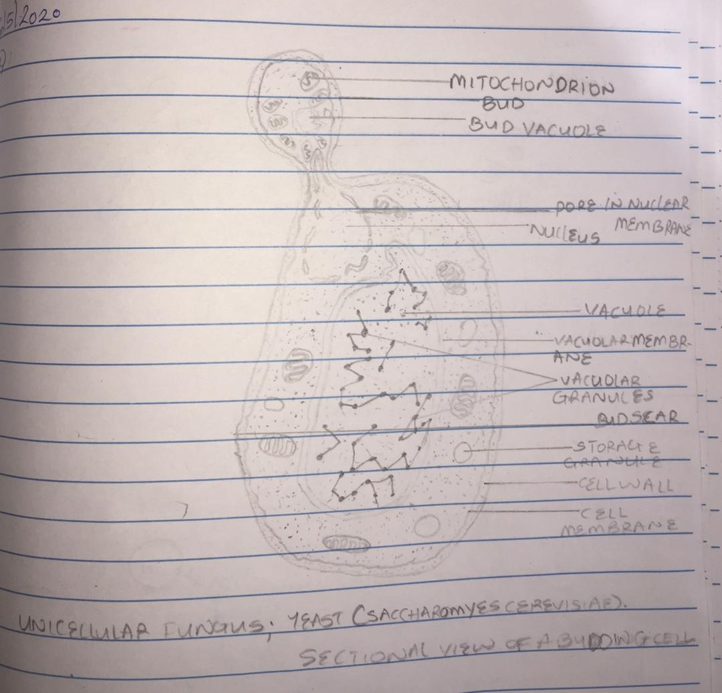

- Outline the sexual reproduction in a typical filamentous form of fungi.
Ans: 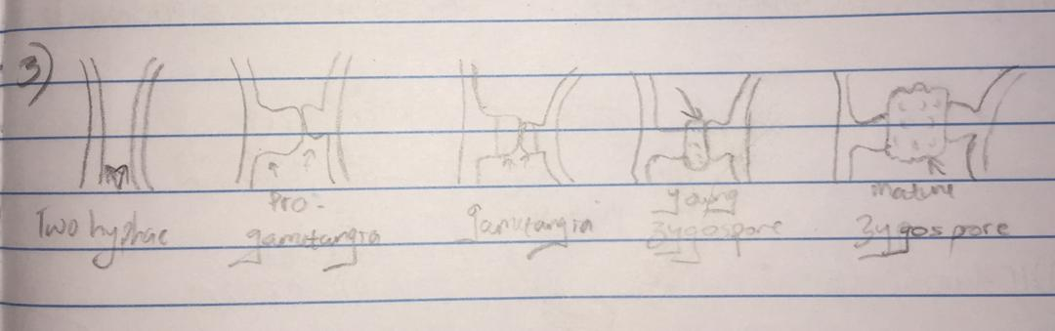
The two gametangia fuse (plasmogamy) and a zygote is formed which may undergo prolonged dormancy or resting stage. The nuclei in the zygote fuses in twos and undergo meiosis independently. The zygote germinates under favorable conditions to produce a fruiting which at maturity liberates maturity liberates the haploid spores.

- How do Bryophytes adapt to their environment
Ans: a. They have definite structures for water and nutrient absorption from the soil; therefore the plant body is divided into two (an aerial portion and a subterranean portion).
b. The aerial portion being exposed to the atmosphere demands some modifications that prevent excessive loss of water through the body(i.e. dessication)
c. some other modifiactions that permit elimination of excess water from the plant body and not only exchange of gases between the internal parts of the plant and the atmosphere therefore openings are available on the aerial parts of the plant.

- Describe with illustration the following terminologies; Eusteles, Atactostele , siphonostele and dictoystele
Ans :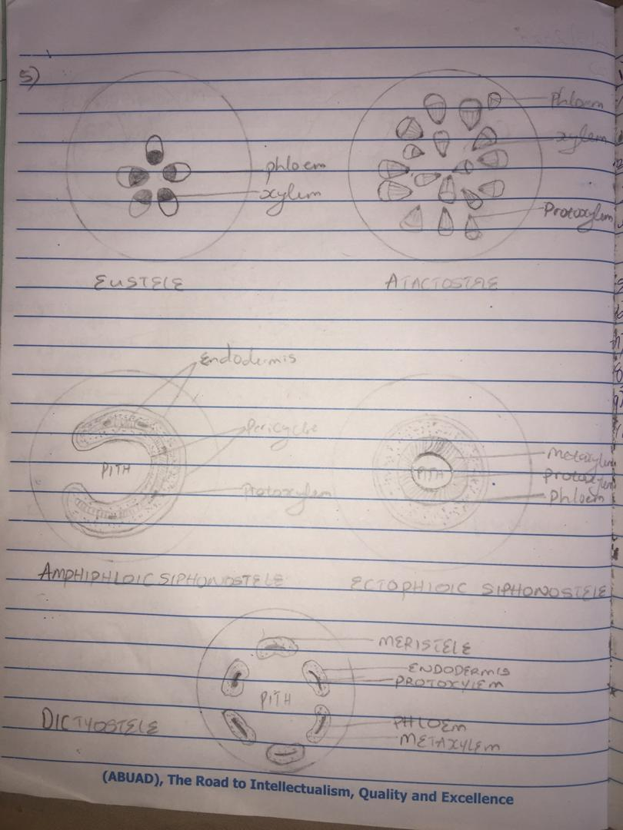

- Illustrate the life cycle of a primitive vascular plant.
