NAME: SALISU FAROUK
MATRIC NO.: 17/MHS01/293
COURSE: MEDICAL BIOCHEMISTRY
LECRURER: MR. AKAWA
- DEFINE THE FOLLOWING TERMS
A. KETOGENESIS
B. KETONAEMIA
C. KETONURIA
D. KETOSIS
- KETOGENESIS
Ketogenesis is the biochemical process through which organisms produce ketone bodies through breakdown of fatty acids and ketogenic amino acids. This process supplies energy under circumstances such as fasting or caloric restriction to certain organs, particularly the brain, heart and skeletal muscle. Insufficient gluconeogenesis can cause hypoglycemia and excessive production of ketone bodies, ultimately leading to a life-threatening condition known as ketoacidosis.
Ketone bodies are produced mainly in the mitochondria of liver cells, and synthesis can occur in response to an unavailability of blood glucose, such as during fasting. Other cells, e.g. human astrocytes, are capable of carrying out ketogenesis, but they are not as effective at doing so Ketogenesis occurs constantly in a healthy individual.
Ketogenesis takes place in the setting of low glucose levels in the blood, after exhaustion of other cellular carbohydrate stores, such as glycogen.^{[7]} It can also take place when there is insufficient insulin (e.g. in type 1 (but not 2) diabetes), particularly during periods of "ketogenic stress" such as intercurrent illness.

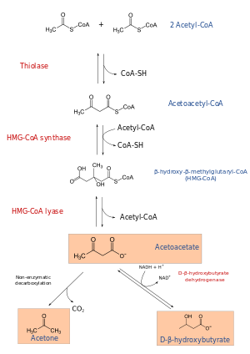
Ketogenesis pathway: The three ketone bodies (acetoacetate, acetone, and beta-hydroxy-butyrate) are marked within an orange box.

- KETONAEMIA
The presence of an abnormally high concentration of ketone bodies in the blood. Seriously ill patients are easy to detect clinically, but well-appearing diabetic patients who present with vague symptoms such as malaise, nausea and hyperglycemia with ketonemia are more difficult to identify.
A condition marked by an abnormal increase of ketone bodies in the circulating blood.
Normally, when blood glucose decreases for more than a couple of hours, ketonemia develops in response to decreased insulin and the brain will use ketones as an alternative endogenous fuel.

- KETONURIA
A condition in which abnormally high amounts of ketones and keytone bodies (a byproduct of the breakdown of cells) are present in the urine.
Ketonuria is a sign seen in diabetes mellitus that is out of control. Diabetics prone to ketonuria need to monitor their urine for signs of ketone buildup that could lead to life-threatening symptoms unless promptly treated. Ketonuria can also develop as a result of fasting, dieting, starvation and eating disorders. Alternate names for ketonuria include ketoaciduria and acetonuria.

- KETOSIS
Ketosis is a metabolic process characterized by elevated levels of ketone bodies in the blood or urine. Physiologic ketosis is a normal response to low glucose availability, such as low-carbohydrate diets or fasting, that provides an additional energy source for the brain in the form of ketones. Physiologic ketosis is a normal physiologic state characterized by elevated serum ketones and normal blood glucose and blood pH. In physiologic ketosis, ketones in the blood are elevated above baseline levels, but the body's acid-base homeostasis is maintained. Ketone levels can be measured in blood, urine or breath and are generally between 0.5 and 3.0 millimolar (mM) in physiologic ketosis.
When ketosis is induced by carbohydrate restriction, it is sometimes referred to as nutritional ketosis. A low-carbohydrate, moderate protein diet that can lead to ketosis is called a ketogenic diet. Ketosis is well-established as a treatment for epilepsy and is also effective in treating type 2 diabetes. The possible effect on a range of neurological diseases, metabolic syndrome, cancer, and other conditions is currently under investigation.
The precursors of ketone bodies include fatty acids from adipose tissue or the diet and ketogenic amino acids. The formation of ketone bodies occurs via ketogenesis in the mitochondrial matrix of liver cells.
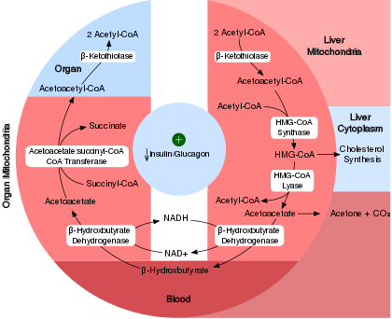
Biochemistry of Ketosis.

- WHAT ARE THE CONSEQUENCES OF KETOSIS
CONSEQUENCES OF KETOSIS
The most common side effects of ketosis include headache, fatigue, dizziness, insomnia, difficulty in exercise tolerance, constipation, and nausea, especially in the first days and weeks after starting a ketogenic diet. Breath may develop a sweet, fruity flavor via production of acetone that is exhaled because of its high volatility. Most adverse effects of long-term ketosis reported are in children because of its longstanding acceptance as a treatment for pediatric epilepsy. These include compromised bone health, stunted growth, hyperlipidemia, and kidney stones.
When considering the keto diet, you’ll probably want to know about the side effects before you decide if it’s right for you.
The keto diet requires adhering to an extremely low-carb, high-fat diet in order to put your body into a metabolic state called ketosis. This makes your body more efficient at burning fat. In recent weeks, the keto diet has been in the news because some experts say it can cause changes in libido. “The ketogenic diet can definitely result in a drop in libido when starting the diet, as the dieter will be experiencing symptoms of carb withdrawal and potentially the keto flu,” noted Dr. Nancy P. Rahnama, a bariatric and internal medicine doctor based in California. While the libido warning got a lot of notoriety in the media, actual research confirming this side effect was hard to come by.
However, there are some side effects, that are well known and that any aspiring keto dieter can get ready for.
- The keto flu; Symptoms of the keto flu can include everything from headache, weakness, and irritability, to constipation, nausea, and vomiting.
- Kidney and heart damage; Because the body can be low on electrolytes and fluid on top of the increased urination, that can lead to a loss of electrolytes such as sodium, magnesium, and potassium. This can make people prone to acute kidney injury.
- Yo-yo dieting patterns; The keto diet can also lead to yo-yo dieting, because people have difficulty staying on the restrictive diet permanently.

Nutritional Concerns: “There is a fear among health experts that such high intakes of unhealthful fats would have a long-term negative effect,” she explained. Weight loss can often confuse the data in the short term. This is because when overweight people lose weight, regardless of how they do it, they often end up with better blood lipids and blood glucose levels. The keto diet is also extremely low in certain fruits, vegetables, grains, and legumes that are generally thought of as healthy. Without these foods, people on the diet can miss out on fiber, certain vitamins, minerals, and phytochemicals that only come in these foods. That has significant human health impacts over the long term such as bone loss and increased risk of chronic diseases.
“Hundreds of studies suggest that diets rich in whole plant foods are linked with significantly lower levels of diseases like osteoporosis, Alzheimer’s disease, heart disease, cancer, and type 2 diabetes,” Palmer said. “So, do people want to risk their long-term health just to lose weight more quickly?”

- WRITE CONCISELY ON THE MANAGEMENT OF KETOACIDOSIS
Ketoacidosis is most commonly the result of complete insulin deficiency in type 1 diabetes or late-stage type 2 diabetes. Ketone levels can be measured in blood, urine or breath and are generally between 0.5 and 3.0 millimolar (mM) in physiologic ketosis, while ketoacidosis may cause blood concentrations greater than 10 mM.
If diagnosed with diabetic ketoacidosis, treatment usually occurs in the emergency room of the hospital. Treatment usually involves:
- Fluid replacement. You'll receive fluids — either by mouth or intravenously until you're rehydrated. The fluids will replace those you've lost through excessive urination, as well as help dilute the excess sugar in your blood.
- Electrolyte replacement. Electrolytes are minerals in your blood that carry an electric charge, such as sodium, potassium and chloride. The absence of insulin can lower the level of several electrolytes in your blood. You'll receive electrolytes through a vein to help keep your heart, muscles and nerve cells functioning normally.
- Insulin therapy. Insulin reverses the processes that cause diabetic ketoacidosis. In addition to fluids and electrolytes, you'll receive insulin therapy — usually through a vein. When your blood sugar level falls to about 200 mg/dL (11.1 mmol/L) and your blood is no longer acidic, you may be able to stop intravenous insulin therapy and resume your normal subcutaneous insulin therapy.
As the body chemistry returns to normal, the doctor will consider additional testing to check for possible triggers for the diabetic ketoacidosis. Depending on circumstances, the patient might need additional treatment.

