Name: Raji Mubarak Akanji
Department: Industrial Chemistry
Course: BIO 102.
Date: 5/8/2020
Matric No: 18/eng01/022
BIO 102 ASSIGNMENT.

1. Importance of Fungi in Human Life
Although we often think of fungi as organisms that cause disease and rot food, fungi are important to human life on many levels. They influence the well-being of human populations on a large scale because they are part of the nutrient cycle in ecosystems. They also have other ecosystem uses, such as pesticides.

Biological Insecticides
As animal pathogens, fungi help to control the population of damaging pests. These fungi are very specific to the insects they attack; they do not infect animals or plants. Fungi are currently under investigation as potential microbial insecticides, with several already on the market. For example, the fungus Beauveria bassiana is a pesticide being tested as a possible biological control agent for the recent spread of emerald ash borer.

Farming
The mycorrhizal relationship between fungi and plant roots is essential for the productivity of farm land. Without the fungal partner in root systems, 80–90 percent of trees and grasses would not survive. Mycorrhizal fungal inoculants are available as soil additives from gardening supply stores and are promoted by supporters of organic agriculture.

Food
Fungi figure prominently in the human diet. Morels, shiitake mushrooms, chanterelles, and truffles are considered delicacies. The meadow mushroom, Agaricus campestris, appears in many dishes. Molds of the genus Penicillium ripen many cheeses. They originate in the natural environment such as the caves of Roquefort, France, where wheels of sheep milk cheese are stacked to capture the molds responsible for the blue veins and pungent taste of the cheese.
2. 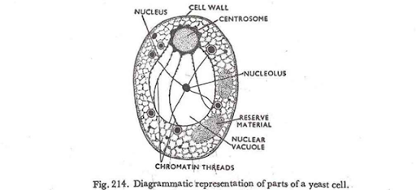
Yeast is a singular unicellular fungi.The diagram of yeast is placed above.

3. Reproductive Processes Of Fungi
Following a period of intensive growth, fungi enter a reproductive phase by forming and releasing vast quantities of spores. Spores are usually single cells produced by fragmentation of the mycelium or within specialized structures (sporangia, gametangia, sporophores, etc.). Spores may be produced either directly by asexual methods or indirectly by sexual reproduction. Sexual reproduction in fungi, as in other living organisms, involves the fusion of two nuclei that are brought together when two sex cells (gametes) unite. Asexual reproduction, which is simpler and more direct, may be accomplished by various methods.

Asexual reproduction
Typically in asexual reproduction, a single individual gives rise to a genetic duplicate of the progenitor without a genetic contribution from another individual. Perhaps the simplest method of reproduction of fungi is by fragmentation of the thallus, the body of a fungus. Some yeasts, which are single-celled fungi, reproduce by simple cell division, or fission, in which one cell undergoes nuclear division and splits into two daughter cells; after some growth, these cells divide, and eventually a population of cells forms. In filamentous fungi the mycelium may fragment into a number of segments, each of which is capable of growing into a new individual. In the laboratory, fungi are commonly propagated on a layer of solid nutrient agar inoculated either with spores or with fragments of mycelium.
Budding, which is another method of asexual reproduction, occurs in most yeasts and in some filamentous fungi. In this process, a bud develops on the surface of either the yeast cell or the hypha, with the cytoplasm of the bud being continuous with that of the parent cell. The nucleus of the parent cell then divides; one of the daughter nuclei migrates into the bud, and the other remains in the parent cell. The parent cell is capable of producing many buds over its surface by continuous synthesis of cytoplasm and repeated nuclear divisions. After a bud develops to a certain point and even before it is severed from the parent cell, it is itself capable of budding by the same process. In this way, a chain of cells may be produced. Eventually, the individual buds pinch off the parent cell and become individual yeast cells. Buds that are pinched off a hypha of a filamentous fungus behave as spores; that is, they germinate, each giving rise to a structure called a germ tube, which develops into a new hypha.
Although fragmentation, fission, and budding are methods of asexual reproduction in a number of fungi, the majority reproduce asexually by the formation of spores. Spores that are produced asexually are often termed mitospores, and such spores are produced in a variety of ways.
4. Two adaptations made the move from water to land possible for Bryophytes: a waxy cuticle and gametangia. The waxy cuticle helped to protect the plants tissue from drying out and the gametangia provided further protection against drying out specifically for the plants gametes.
5. Definition of eustele. : a stele typical of dicotyledonous plants that consists of vascular bundles of xylem and phloem strands with parenchymal cells between the bundles.
Diagram of eustele
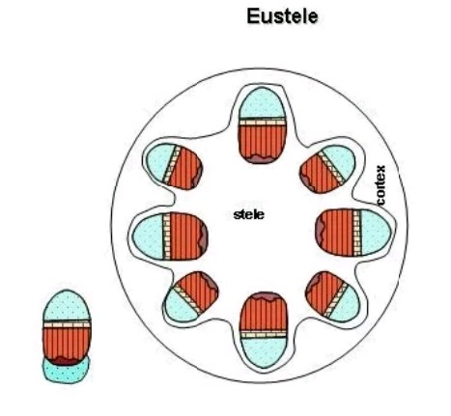
atactostele. Noun. (plural atactosteles) (botany) A type of eustele, found in monocots, in which the vascular tissue in the stem exists as scattered bundles.
Diagram: 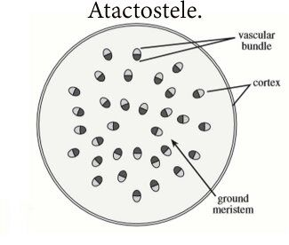
Siphonostele is in which ring of xylem is surrounded by a continuous layer of phloem, either on the ouside only or on the outside and inside (amphiphloic siphonostele) if latters much dissected, it is known as a dictyostele.
Diagram:
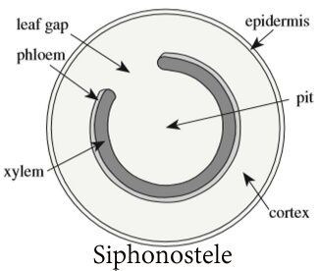

Dictyostele a dissected amphiphloic siphonostele.eg: Pteris rhizome
Diagram:
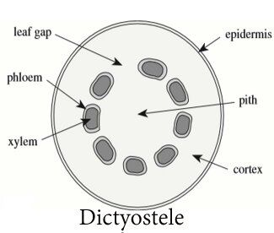
6.

LIFE CYCLE OF PRIMITE VASCULAR PLANT.(Pteridophytes).
