Name: Adeyemo Sinmiloluwa
Course: Biochemistry
Matric no: 17/MHS01/025
Department: Medicine and Surgery
ASSIGNMENT GROUP 2
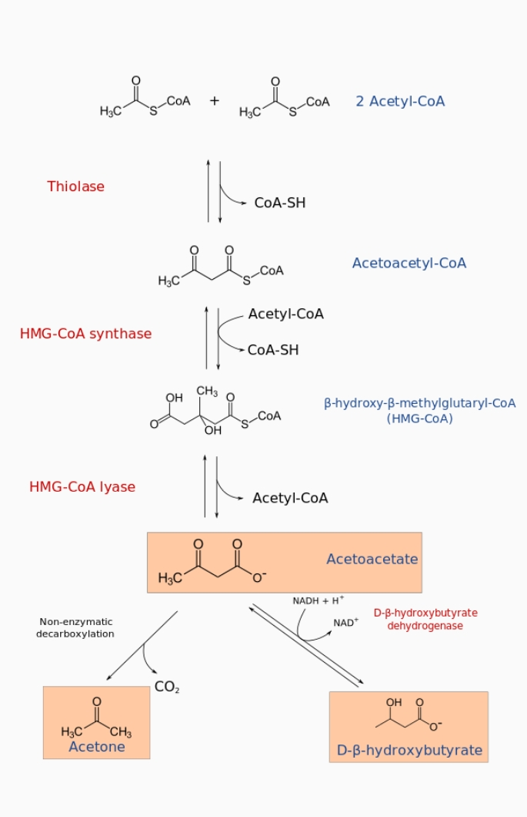
A. Ketogenesis pathway. The three ketone bodies (acetoacetate, acetone, and beta-hydroxy-butyrate) are marked within an orange box.
Ketogenesis is the biochemical process through which organisms produce ketone bodies through breakdown of fatty acids and ketogenic amino acids. This process supplies energy under circumstances such as fasting or caloric restriction to certain organs, particularly the brain, heart and skeletal muscle. Insufficient gluconeogenesis can cause hypoglycemia and excessive production of ketone bodies, ultimately leading to a life-threatening condition known as ketoacidosis.. Ketone bodies are produced mainly in the mitochondria of liver cells, and synthesis can occur in response to an unavailability of blood glucose, such as during fasting.[3] Other cells, e.g. human astrocytes, are capable of carrying out ketogenesis, but they are not as effective at doing so. Ketogenesis occurs constantly in a healthy individual. Ketogenesis in healthy individuals is ultimately under the control of the master regulatory protein AMPK, which is activated during times of metabolic stress, such as carbohydrate insufficiency. Activation in the liver inhibits lipogenesis, promotes fatty acid oxidation, switches off acetyl-CoA carboxylase, turns on malonyl-CoA decarboxylase, and consequently induces ketogenesis.
B. Ketonaemia, ketones in the bloodstream, is a physiological consequence of lipid metabolism. It is the presence of an abnormally high concentration of ketone bodies in the blood.
C. Ketonuria happens when you have high ketone levels in your urine. This condition is also called ketoaciduria and acetonuria. Ketonuria is most common in individuals who have diabetes, particularly type 1 diabetes mellitus. It can also occur in women who are pregnant or breastfeeding. Ketonuria is a sign that your body is primarily using fats and protein for fuel. This is called ketosis. It’s a normal process if you’re fasting or on a low-carbohydrate, ketogenic diet. A ketogenic diet does not typically pose a health risk if it’s done in a balanced way. If ketone levels rise too high for too long, your blood becomes acidic. Which can be harmful to one’s health.
Other cause of ketonuria include:
- drinking excess alcohol
- excessive vomiting
- pregnancy
- starvation
- illness or infection
- heart attack
- emotional or physical trauma
- medications, such as corticosteroids and diuretics
- drug use

Consequences of ketosis
Ketosis is a metabolic process. When the body does not have enough glucose for energy, it burns stored fats instead. This results in a buildup of acids called ketones within the body. During ketosis, many parts of your body are burning ketones for energy instead of carbs. This includes a large part of the brain.
However, this doesn't happen instantly. It takes your body and brain some time to "adapt" to burning fat and ketones instead of carbs.
During this adaptation phase, you may experience some temporary side effects. These are generally referred to as the "low-carb flu" or "keto flu."
These may include:
- Headache.
- Fatigue.
- Brain fog.
- Increased hunger.
- Poor sleep.
- Nausea.
- Decreased physical performance
Management of Diabetic ketoacidosis
A serious diabetes complication where the body produces excess blood acids (ketones).
This condition occurs when there isn't enough insulin in the body. It can be triggered by infection or other illness.
Management & treatment includes;
- Fluid replacement. You'll receive fluids — either by mouth or through a vein (intravenously) — until you're rehydrated. The fluids will replace those you've lost through excessive urination, as well as help dilute the excess sugar in your blood.
- Electrolyte replacement. Electrolytes are minerals in your blood that carry an electric charge, such as sodium, potassium and chloride. The absence of insulin can lower the level of several electrolytes in your blood. You'll receive electrolytes through a vein to help keep your heart, muscles and nerve cells functioning normally.
- Insulin therapy. Insulin reverses the processes that cause diabetic ketoacidosis. In addition to fluids and electrolytes, you'll receive insulin therapy — usually through a vein. When your blood sugar level falls to about 200 mg/dL (11.1 mmol/L) and your blood is no longer acidic, you may be able to stop intravenous insulin therapy and resume your normal subcutaneous insulin therapy.

