ADEBARA FAITH INUMIDUN
17/SCI05/001
MEDICINE AND SURGERY
300 LEVEL
2019/2020

MEDICAL BIOCHEMISTRY IV ASSIGNMENT FOR GROUP 2:
- Define the following terms:
- Ketogenesis
- Ketonaemia
- Ketonuria
- What are the consequences of ketosis?
- Write concisely on the management of ketoacidosis

Question 1
- KETOGENESIS:
Ketogenesis is a catabolic pathway of metabolism. It is the biochemical process through which organisms produce ketone bodies through breakdown of fatty acids and ketogenic amino acids.
This process supplies energy under circumstances such as fasting or caloric restriction to certain organs, particularly the brain, heart and skeletal muscle. Insufficient gluconeogenesis can cause hypoglycemia and excessive production of ketone bodies, ultimately leading to a life-threatening condition known as ketoacidosis.
The synthesis of ketone bodies is performed in liver mitochondria from acetyl-CoA.
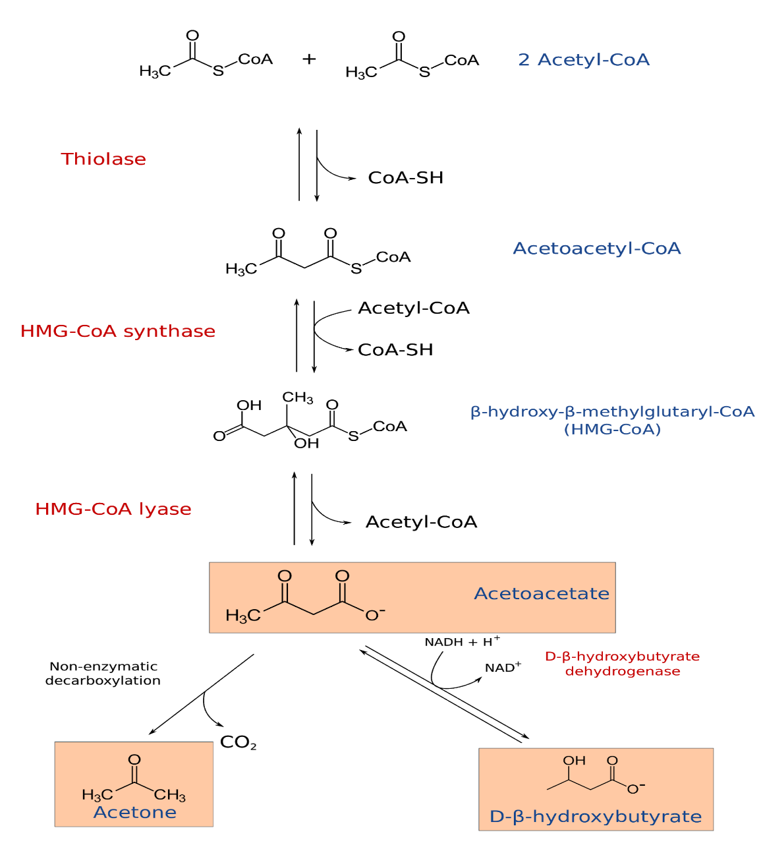
KETOGENESIS PATHWAY
- KETONAEMIA:
It is the presence of an abnormally high concentration of ketone bodies in the blood.

- KETONURIA:
Ketonuria is a medical condition in which ketone bodies are present in the urine.
Normally, the urine should not contain a noticeable concentration of ketones to give a positive reading. ketonuria is seen in conditions in which the body produces excess ketones as an indication the body is using fat as the major source of energy. It is seen during prolonged starvation or more commonly in type 1 diabetes mellitus.
Ketone bodies that commonly appear in the urine when fats are burned for energy are acetoacetate and beta-hydroxybutyric acid. Acetone is also produced and is expired by the lungs.
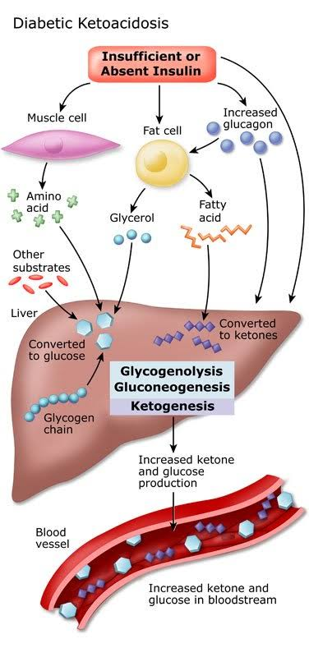

Question 2
CONSEQUENCES OF KETOSIS
Consequences of ketosis include:
- Metabolic acidosis: Acetoacetate and beta-hydroxy butyrate are acids. When they accumulate, it would result in metabolic acidosis. There will be increased anion gap.
- Reduced buffers: The plasma bicarbonate is used up for buffering of these acids.
- Kussmaul's respiration: Patients will have typical acidotic breathing due to compensatory hyperventilation.
- Smell of acetone (a sweet, fruit-like smell) in patient's breath.
- Osmotic diuresis induced by ketonuria may lead to dehydration.
- Sodium loss: The ketone bodies are excreted in urine as their sodium salt, leading to loss of cations from the body.
- High potassium: Due to lowered uptake of potassium by cells in the absence of insulin.
- Dehydration: The sodium loss further aggravates the dehydration.
- Coma: Hypokalemia, dehydration and acidosis contribute to the lethal effect of ketosis.
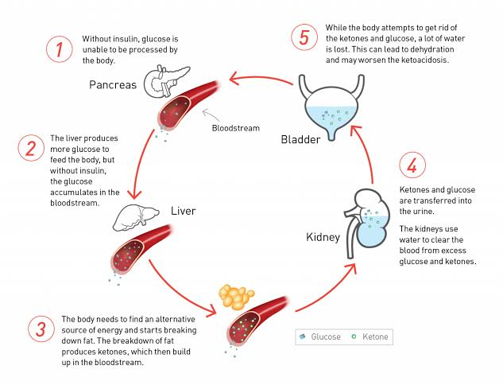
Question 3
MANAGEMENT OF KETOACIDOSIS
The following can be done to manage ketoacidosis effectively:
- Parenteral administration of insulin and glucose by intravenous route to control diabetes. Insulin reverses the processes that cause diabetic ketoacidosis. In addition to fluids and electrolytes, one will receive insulin therapy, usually intravenously. When the blood sugar level falls to about 200 mg/dL (11.1 mmol/L) and the blood is no longer acidic, intravenous insulin therapy may be stopped and then normal subcutaneous insulin therapy can be resumed.

- Fluid replacement: fluids are given either by mouth or intravenously until the person is rehydrated. This includes:
- Intravenous bicarbonate to correct the acidosis.
- Correction of water imbalance by normal saline.

- Correction of electrolyte imbalance: Electrolytes are minerals in your blood that carry an electric charge, such as sodium, potassium and chloride. The absence of insulin can lower the level of several electrolytes in the blood. Also, Insulin induces glycogen deposition, and along with that, extracellular potassium is distributed intracellularly. This leads to dangerous hypokalemia, which is to be immediately corrected. Electrolytes are given intravenously to help keep the heart, muscles and nerve cells functioning normally.

- Treatment of underlying precipitating causes, such as infection.

