ANA 402: Electron Microscopic Technique & Ultrastructure
DR. Ogedengbe O.O

By:
ANYANWU COLLINS-KEVIN
16/MHS01/046

1.1: Glass Knife Making
A glass knife is a microtome blade of choice for the ultra-thin sectioning required in transmission electron microscopy because they can be manufactured by hand and are sharper than softer metal blades because the crystalline structure of metals makes it impossible to obtain a continuous sharp edge. The knife is a fabricated sharp edge line of a glass made by fracturing a thick glass or a glass rod. The glass knife is used to make an exposed specimen surface flat prior to ultrathin sectioning using a diamond knife, or to perform trimming of the resin of a resin embedded specimen.
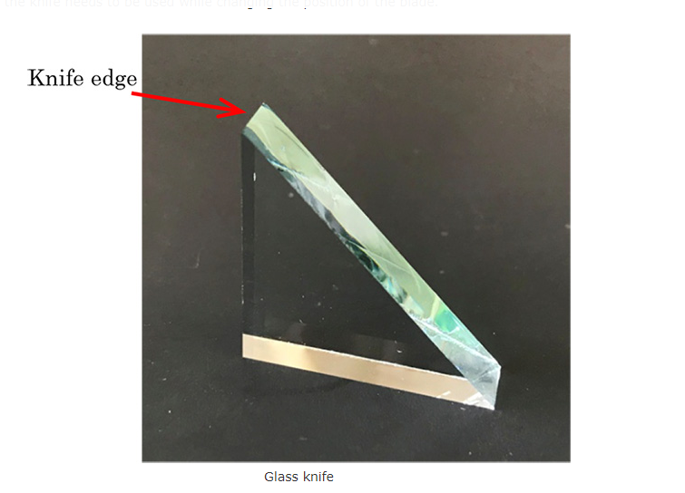
Figure 1 – Glass Knife

1.2: Balanced Break Concept
The technique of producing a straight, controlled break in a strip of scientific quality glass requires that the knife maker apply equal weight and pressure to each side of the score. In addition, the support elements that touch the glass from below must have minimum surface contact to avoid uncontrolled stress applied to the glass prior to the break. In this method, a glass strip, is scored and broken into two equal halves. With an equal mass of glass on each side of the score, the break is balanced and the freshly fractured surfaces are plane. By continuing to divide each piece produced into two equal halves a certain amount of squared can be produced. All squares have straight sides and precise right angled corners unlike squares produced from sequential breaking of a glass trip which have curved surfaces.
1.2.1: Scoring and Breaking principles
Producing good glass knives routinely depends on a supply of reproducible squares, an accurately positioned score and controlled pressure precisely applied to make the break. As a general rule, the knife edge is straighter and the counter piece (knife shoulder) is small when the fracture occurs close to the corner (long score). Using a short score was in the past suggested for cryo knives as the free break is longer resulting in the sharpest, longest useable knife edge. Each score is preset and equidistant from the corners of the square. During the break the glass sits on two steel hemispheres and is held from above by two pins. The break follows the score line as far as it goes and then a free break occurs. The direction of this free break is determined by the mass of the glass on either side of the break and the breaking forces. The free break curves to the edge of the square resulting in one knife and one flat edge counter piece (knife shoulder) opposite the knife edge. When the score runs centrally through a square a very small counterpace is obtained and the knife angle is very close to 45°. This is the optimal result for cryo knives. For resin sectioning, the user sets the knife shoulder adjustment a little larger (~ 0.5 mm), to produce a larger knife angle which is more stable for resin sectioning.
1.3: Preparing Glass knives
The leica knifemaker is a precision instrument for securing, scoring and breaking glass strips first into squares and then into diagonal knives. Steps for the production of these glass knives include:
- Washing the glass strips using standard detergents and a lint free cotton cloth. Care should be taken as the glass slip would be extremely slippery and in case of falling do not make any attempts to catch it.
- Rinse off the glass strip using tap water and wipe gently with paper towels or allow to dry in a dust free environment
- Handling the glass strip with cotton or nylon gloves, pass a length of the glass strip into the knifemaker with factory scoring. Score and break into glass squares
- Place squares in the machine with orientation for diagonal scoring, and engage rubber dampeners to absorb shock from the break
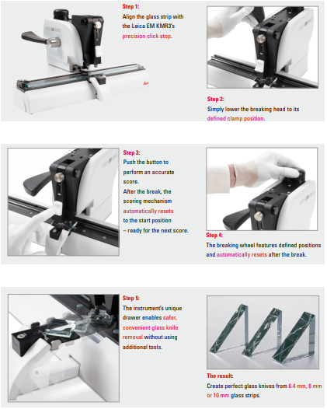
2.1: Knifemaker
