NAME: OKEDARE ADESEWA JULIET
MATRIC NUMBER: 19/MHS02/091
DEPARTMENT: NURSING
COURSE CODE: BIO102
COURSE TITLE: GENERAL BIOLOGY II
LEVEL: 100 LEVEL

- How are fungi important to mankind?
- Fungi is responsible for the decaying of organic matter to avoid the clogged up of the surface of the earth with organic matter.
- Fungi play a role in human nutrition e.g. mushroom serve as source of food.
- Species of fungi e.g. penicillium notatum produce important antibiotics.
- Fungi serves as an agents of fermentation in the production of bread, cheeses, alcoholic beverages and other food preparations.
- Illustrate the cell structure of a unicellular fungus with a well labeled diagram.
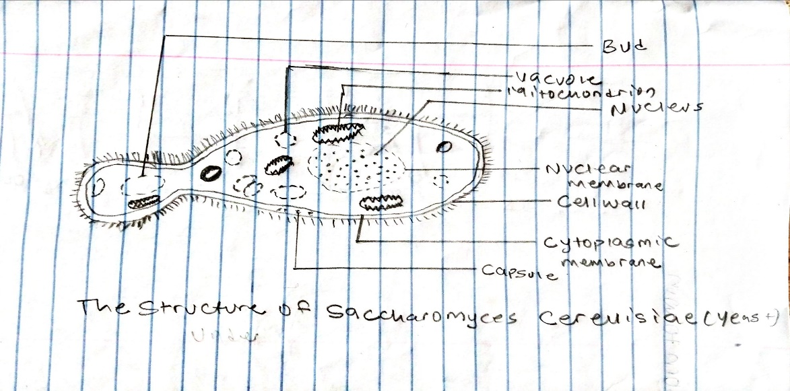

- Outline the sexual reproduction in a typical filamentous form of fungi.
The filamentous form of fungi is Rhizopus stolonifer.
Sexual reproduction in Rhizopus stolonifer: this occur when two mating types of hyphae grow in the same medium and there is induces growth by the chemical interaction that is perpendicular to the hyphae in opposite direction. These growths are delimited by a wall called a gametangium where many nuclei are isolated. The fusion of gametangia (plasmogamy) and a zygote is formed which undergo a resting stage or dormancy. The nuclei of the zygotes fuse in twos and undergo meiosis independently. The zygotes germinates under favorable conditions to produce a fruiting which at maturity liberates the haploid spores.
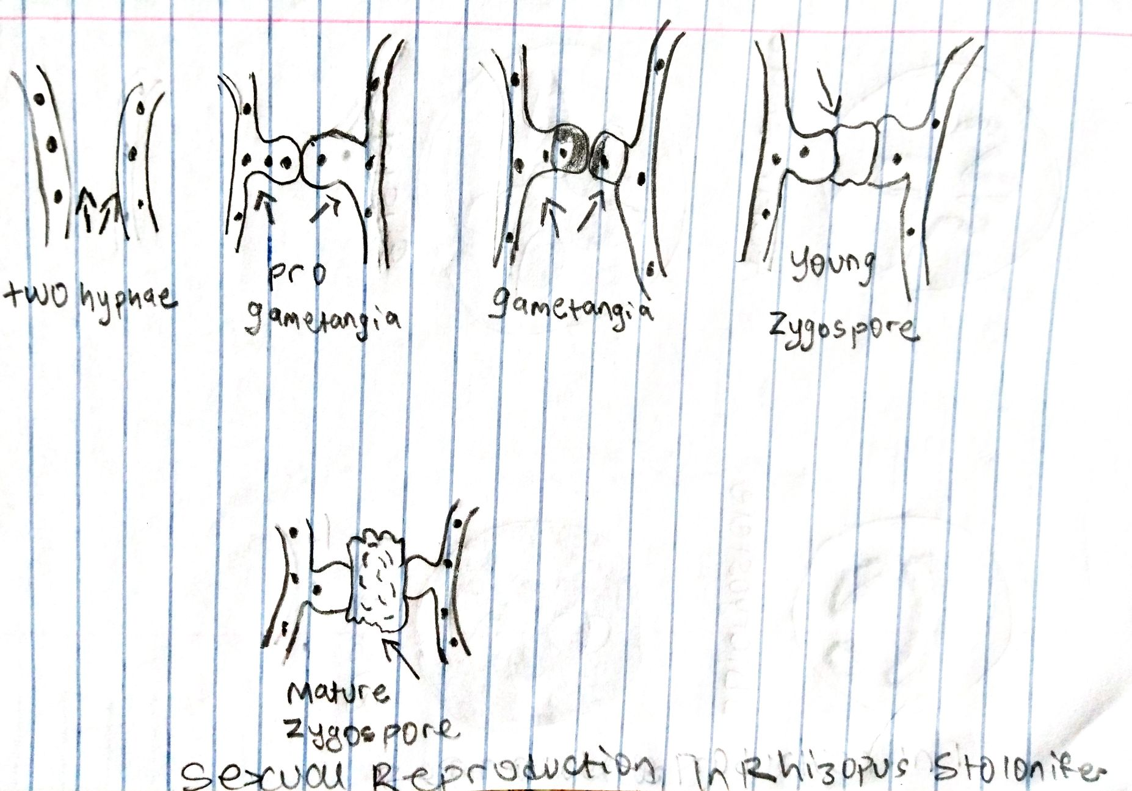

- How do Bryophytes adapt to their environment.
- The bryophytes have definite structures for water and nutrient absorption from soil; their plant body is divided into two (an aerial portion and a subterranean portion). The subterranean portion is the rhizoid and is not a true root as the case of land plants that are advanced.
- The aerial portion that is exposed to the atmosphere demands some modifications that prevent excessive loss of water through the body surface (desiccation).
- The bryophytes have other modification that permit elimination of excess water from the plant body and not only exchange of gasses between the internal parts of the plant and the atmosphere therefore openings are available on the aerial parts of the plant.

- Describe with illustration the following terminologies:
- Eusteles: the vascular bundle of eusteles are discrete, concentric collateral bundles of xylem and phloem.
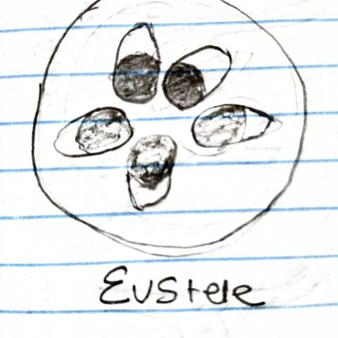

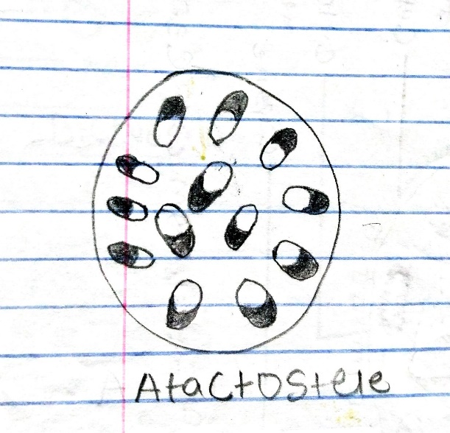
- Atactostele: is stele found in monocot in which the vascular tissue in the stem exists as scattered bundles.

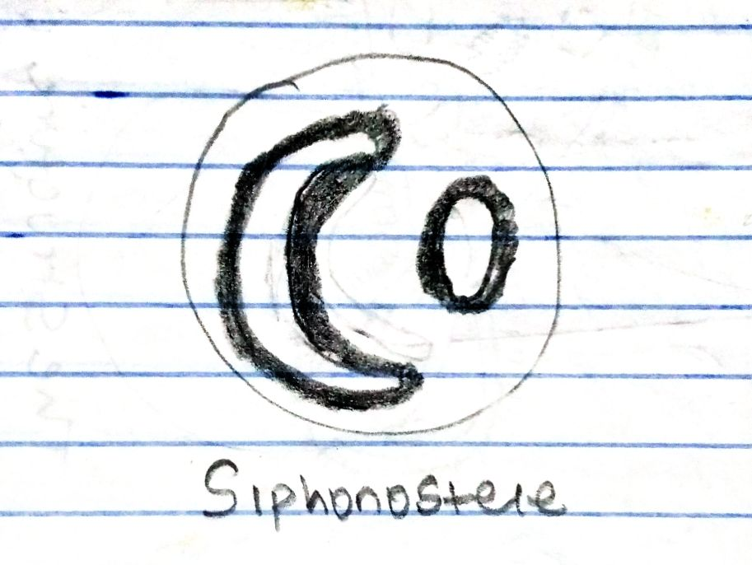
- Siphonostele: is a stele consisting of a core of pith surrounded by concentric layers of xylem and phloem.

- Dictyostele: is a stele in which vascular cylinder is broken up into a longitudinal network of vascular strands around a central pith.
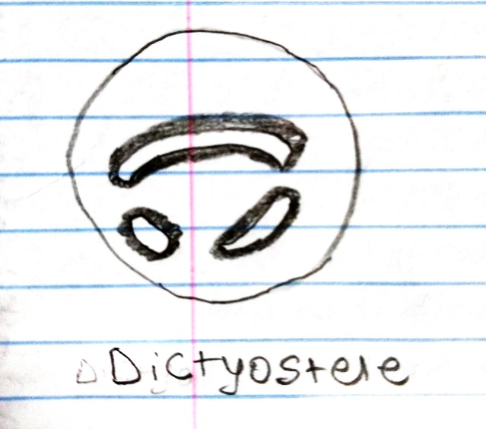

- Illustrate the life cycle of a primitive vascular plant.

