NAME: OLAWOYE OLASALEWA ENIOLA
DEPARTMENT: MEDICINE AND SURGERY
COLLEGE: MEDICINE AND HEALTH SCIENCES
MATRIC NUMBER: 18/MHS01/288
COURSE CODE: ANA 205
COURSE TITLE: GENERAL EMBRYOLOGY
DATE: 22/4/20

Discuss the second week of development.
The following events take place during the second week of development:-
1. Completion of implantation of the blastocyst
2. Formation of bilaminar embryonic disc(epiblast and hypoblast)
3. Formation of extraembryonic structures (amniotic cavity,amnion, umbilical vesicle[yolk sac], connecting stalk and chorionic sac).
Day 8
-At the eight day of development, the blastocyst is partially(slowly) embedded in the endometrium(endometrial stroma).
- The syncytiotrophoblast continues its invasion of the endometrium, thereby eroding endometrial blood vessels and endometrial glands.
- Mitotic figures are found in the cytotrophoblast but not in the syncytiotrophoblast. Thus, cells in the cytotrophoblast divide and migrate into the syncytiotrophoblast, where they fuse and lose their individual cell membranes.
- Cells of the inner cell mass or embryoblast also differentiate into two layers:
I) The "hypoblast" layer which is made up of small cuboidal cells and it is adjacent(nearer) to the blastocystic cavity.
II) The "epiblast" layer which is made up of high columnar cells and it is adjacent to the amniotic cavity.

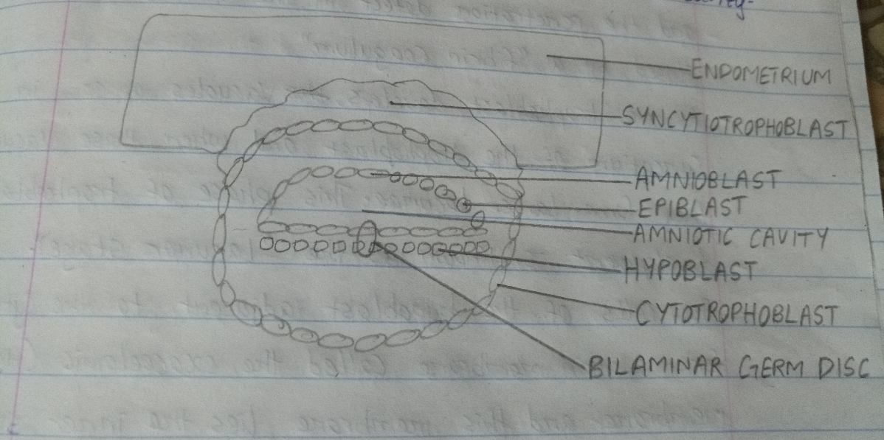

- The hypoblast and epiblast layers together form a flat ovoid shaped disc called the bilaminar embryonic disc. At the same time, a small cavity appears within the epiblast and this cavity enlarges to become the "amniotic cavity".
- Epiblast cells adjacent to the cytotrophoblast are called " amnioblasts" and the amnioblasts together with the rest of the epiblast, line the amniotic cavity.
- The endometrium adjacent to the implantation site is edematous and highly vascular. The large tortuous glands secrete abundant glycogen and mucus.
Day 9
- The blastocyst is more deeply embedded in the endometrium and the penetration defect in the surface epithelium is closed by a "fibrin coagulum".
- As the trophoblast develops, vacuoles appear in the syncytium of the trophoblast and when these vacuoles fuse, they form larger lacunae. This phase of trophoblast development is known as the " lacunae stage".
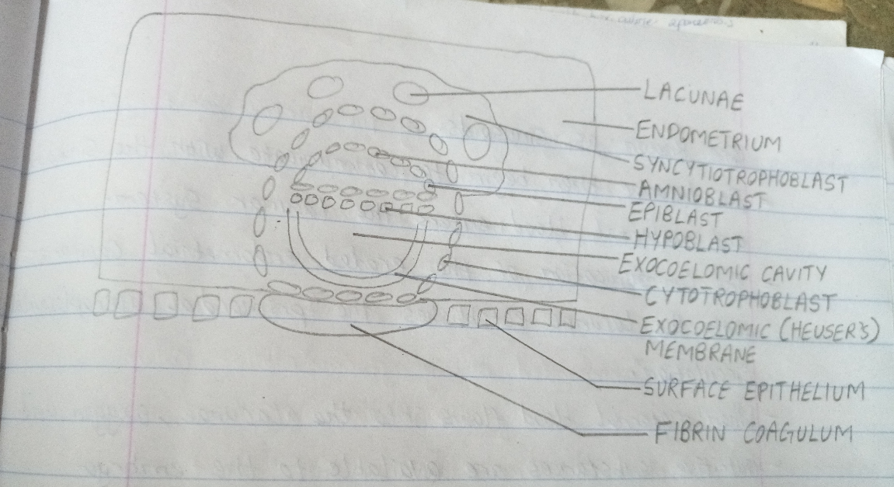

- The cells of the hypoblast adjacent to the cytotrophoblast form a thin membrane called the exocoelomic (Heuser's) membrane and this membrane lines the inner surface of the cytotrophoblast.
- The exocoelomic (Heuser's) membrane together with the hypoblast forms the lining of the exocoelomic cavity or primitive yolk sac or primary umbilical vesicle.
Days 11 and 12
- By the 11th to 12th day of development, the blastocyst is completely embedded in the endometrium (endometrial stroma), and the surface epithelium almost entirely covers the original defect in the uterine wall.
- The blastocyst now produces a slight profusion into the lumen of the uterus.
- The trophoblast is characterized by lacunar spaces in the syncytium that forms an intercommunicating network. This network is particularly evident at the embryonic pole while the trophoblast still consists mainly of cytotrophoblastic cells at the abembryonic pole.
- Cells of the syncytiotrophoblast penetrate deeper into the stroma(tissue) and erode the endothelial lining of the endometrial capillaries.
- These ruptured capillaries which are congested and dilated are known as sinusoids.
- The lacunae then begins to communicate with the sinusoids and maternal blood enters the lacunar system.
- The communication of the eroded endometrial capillaries with the lacunae establishes the "primordial uteroplacental circulation".
- When maternal blood flows into the lacunae, oxygen and nutritive substances are available to the embryo.
- A new population of cells appears between the inner surface of the cytotrophoblast and the outer surface of the exocoelomic cavity. These cells which are derived from yolk sac cells form a fine, loose connective tissue called the "extraembryonic mesoderm".
- Soon, large cavities develop in the extraembryonic mesoderm and when these become confluent, they form a new space known as the extraembryonic cavity or chorionic cavity or extraembryonic coelom. This space surrouns the primitive yolk sac and amniotic cavity, except where the germ disc is connected to the trophoblast by the connecting stalk (which develops into the umbilical cord).
- The extraembryonic mesoderm lining the cytotrophoblast and amnion is called the extraembryonic somatic mesoderm (also forms the connecting stalk) and the lining covering the yolk sac is known as the extraembryonic splanchnic mesoderm.
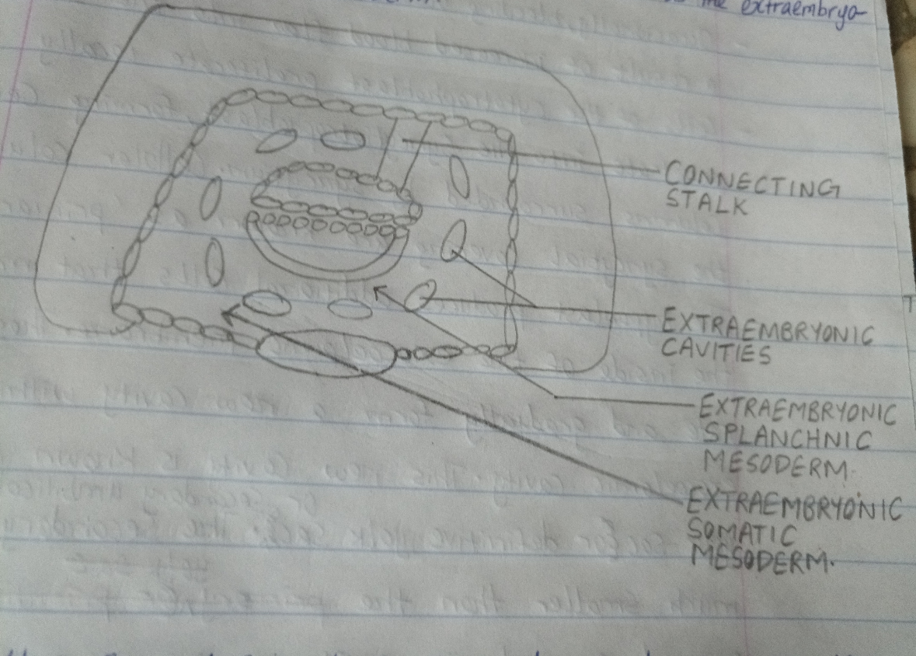

- As the conceptus implants, the endometrial connective tissue cells undergo a transformation called " decidual reaction". During this transformation, the cells of the endometrium swell because of the accumulation of glycogen and lipid in their cytoplasm and they are known as decidual cells.
- The primary function of the decidual reaction is to provide nutrition for the early embryo and an immunologically privileged site for the conceptus.
Day 13
- The surface defect in the endometrium has usually healed and has been completely covered by the surface epithelium.
- Occasionally, bleeding occurs at the implantation site as a result of increased blood flow into the lacunar spaces.
- Cells of the cytotrophoblast cytotrophoblast proliferate locally and penetrate into the syncytiotrophoblast, forming cellular columns surrounded by syncytium. Cellular columns with the syncytial covering are known as "primary villi".
- The hypoblast produces additional cells that migrate along the inside of the exocoelomic membrane. These cells proliferate and gradually form a new cavity within the exocoelomic cavity. This new cavity is known as the secondary yolk sac or definitive yolk sac or secondary umbilical vesicle. The secondary yolk sac is much smaller than the original exocoelomic cavity or primitive yolk sac.
- In humans, the yolk sac contains no yolk but is important for the transfer of nutrients between the fetus and mother.
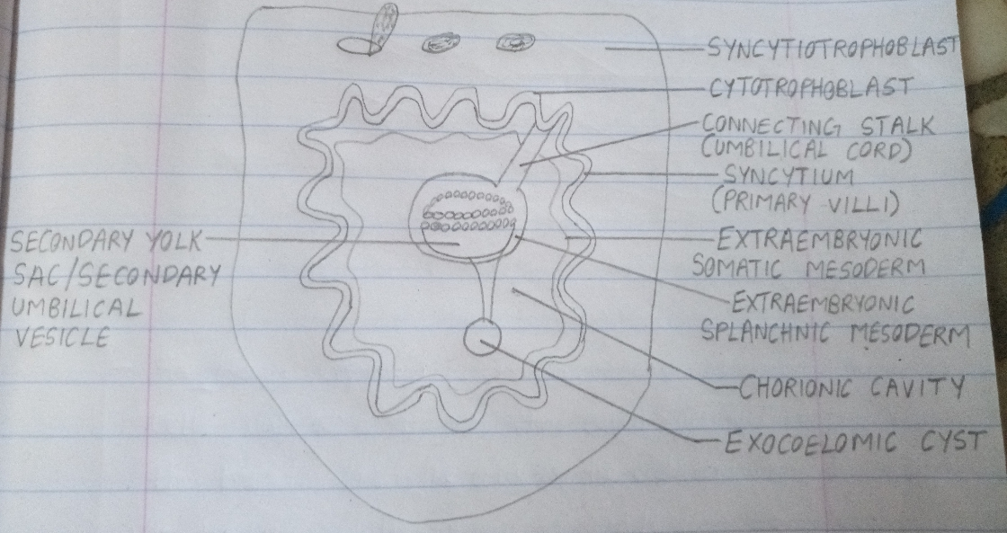

- During its formation, large portions of th exocoelomic cavity are pinched off to form "exocoelomic cysts" and the exocoelomic cysts are often found in the extraembryonic cavity or chorionic cavity or extraembryonic coelom.
- Meanwhile, the extraembryonic coelom expands and forms a large cavity called the chorionic cavity.
- The extraembryonic mesoderm lining the inside of the cytotrophoblast is then known as the chorionic plate.
Note:- The only place where the extra embryonic mesoderm transverses the chorionic cavity is the connecting stalk.
- With development of blood vessels, the connecting stalk becomes the umbilical cord.
Clinical correlates
- The syncytiotrophoblast produces a hormone called the human chorionic gonadotrophin(hCG) which enters the maternal blood through lacunae and keeps the corpus luteum secreting estrogens and progesterone.
- Human chorionic gonadotrophin maintains the hormonal activity of the corpus luteum in the ovary during pregnancy.
- Human chorionic gonadotrophin can be detected in maternal blood or urine as early as day ten of pregnancy and is the basis for pregnancy tests.
- Abnormal implantation sites sometimes occur even within the uterus. Normally, the human blastocyst implants along the anterior or posterior wall of the body of the uterus. Occasionally, the blastocyst implants close to the internal os (opening) of the cervix, so that later in development, the placenta bridges the opening (placenta previa) and causes severe, even life threatening bleeding in the second part of pregnancy and during delivery.
- Occasionally, implantation takes place outside the uterus, resulting in EXTRAUTERINE PREGNANCY or ECTOPIC PREGNANCY. Ectopic pregnancies may occur at any place in the abdominal cavity, ovary or uterine tube. 95% to 98% of ectopic implantations occur in the uterine tubes, most often in the AMPULLA and ISTHMUS.
- Sometimes, the blastocyst develops in the ovary proper, causing a "primary ovarian pregnancy".
- Ectopic pregnancies occur in 2% of all pregnancies and account for 9% of all pregnancy related deaths for the mother. In most ectopic pregnancies, the embryo dies about the second month is gestation and may result in severe hemorrhaging in the mother.

