ADAGUNODO JUMOKE GLORY
AGRICULTURAL SCIENCE
19/SCI07/001
BIO102 2ND ASSIGNMENT
1
How are fungi important to mankind?
Fungi are important decomposers in most ecosystems. Mycorrhizal fungi are essential for the growth of most plants. Fungi, as food, play a role in human nutrition in the form of mushrooms, and also as agents of fermentation in the production of bread, cheeses, alcoholic beverages, and numerous other food preparations.
Although we often think of fungi as organisms that cause disease and rot food, fungi are important to human life on many levels. They influence the well-being of human populations on a large scale because they are part of the nutrient cycle in ecosystems. They also have other ecosystem uses, such as pesticides.
Biological Insecticides
As animal pathogens, fungi help to control the population of damaging pests. These fungi are very specific to the insects they attack; they do not infect animals or plants. Fungi are currently under investigation as potential microbial insecticides, with several already on the market. For example, the fungus Beauveria bassiana is a pesticide being tested as a possible biological control agent for the recent spread of emerald ash borer.
Fungal Insecticides: The emerald ash borer is an insect that attacks ash trees. It is in turn parasitized by a pathogenic fungus that holds promise as a biological insecticide. The parasitic fungus appears as white fuzz on the body of the insect.
Farming
The mycorrhizal relationship between fungi and plant roots is essential for the productivity of farm land. Without the fungal partner in root systems, 80–90 percent of trees and grasses would not survive. Mycorrhizal fungal inoculants are available as soil additives from gardening supply stores and are promoted by supporters of organic agriculture.
Food
Fungi figure prominently in the human diet. Morels, shiitake mushrooms, chanterelles, and truffles are considered delicacies. The meadow mushroom, Agaricus campestris, appears in many dishes. Molds of the genus Penicillium ripen many cheeses. They originate in the natural environment such as the caves of Roquefort, France, where wheels of sheep milk cheese are stacked to capture the molds responsible for the blue veins and pungent taste of the cheese.

Morel mushroom: The morel mushroom is an ascomycete much appreciated for its delicate taste.
Fermentation of grains to produce beer and of fruits to produce wine is an ancient art that humans in most cultures have practiced for millennia. Ancient humans acquired wild yeasts from the environment and used them to ferment sugars into CO2 and ethanol under anaerobic conditions. It is now possible to purchase isolated strains of wild yeasts from different wine-making regions. Louis Pasteur was instrumental in developing a reliable strain of brewer’s yeast, Saccharomyces cerevisiae, for the French brewing industry in the late 1850s.
Saccharomyces cerevisiae, also know as baker’s yeast, is an important ingredient in bread, a food that has been considered a staple of human life for thousands of years. Before isolated yeast became available in modern times, humans simply let the dough collect yeast from the air and rise over a period of hours or days. A small piece of this leavened dough was saved and used as a starter (source of the same yeast) for the next batch, much in the same way sourdough bread is made today.
Saccharomyces cerevisiae: The yeast Saccharomyces cerevisiae is approximately 5 µm in diameter and is important for the production of wine, beer, and bread. The yeast also has many applications in medical research.
Medicine
Many secondary metabolites of fungi are of great commercial importance. Fungi naturally produce antibiotics to kill or inhibit the growth of bacteria, limiting their competition in the natural environment. Important antibiotics, such as penicillin and the cephalosporins, can be isolated from fungi. Valuable drugs isolated from fungi include the immunosuppressant drug cyclosporine (which reduces the risk of rejection after organ transplant), the precursors of steroid hormones, and ergot alkaloids used to stop bleeding. Psilocybin is a compound found in fungi such as Psilocybe semilanceata and Gymnopilus junonius, which have been used for their hallucinogenic properties by various cultures for thousands of years.

2.
Illustrate the cell structure of a unicellular fungus with a well labeled diagram.

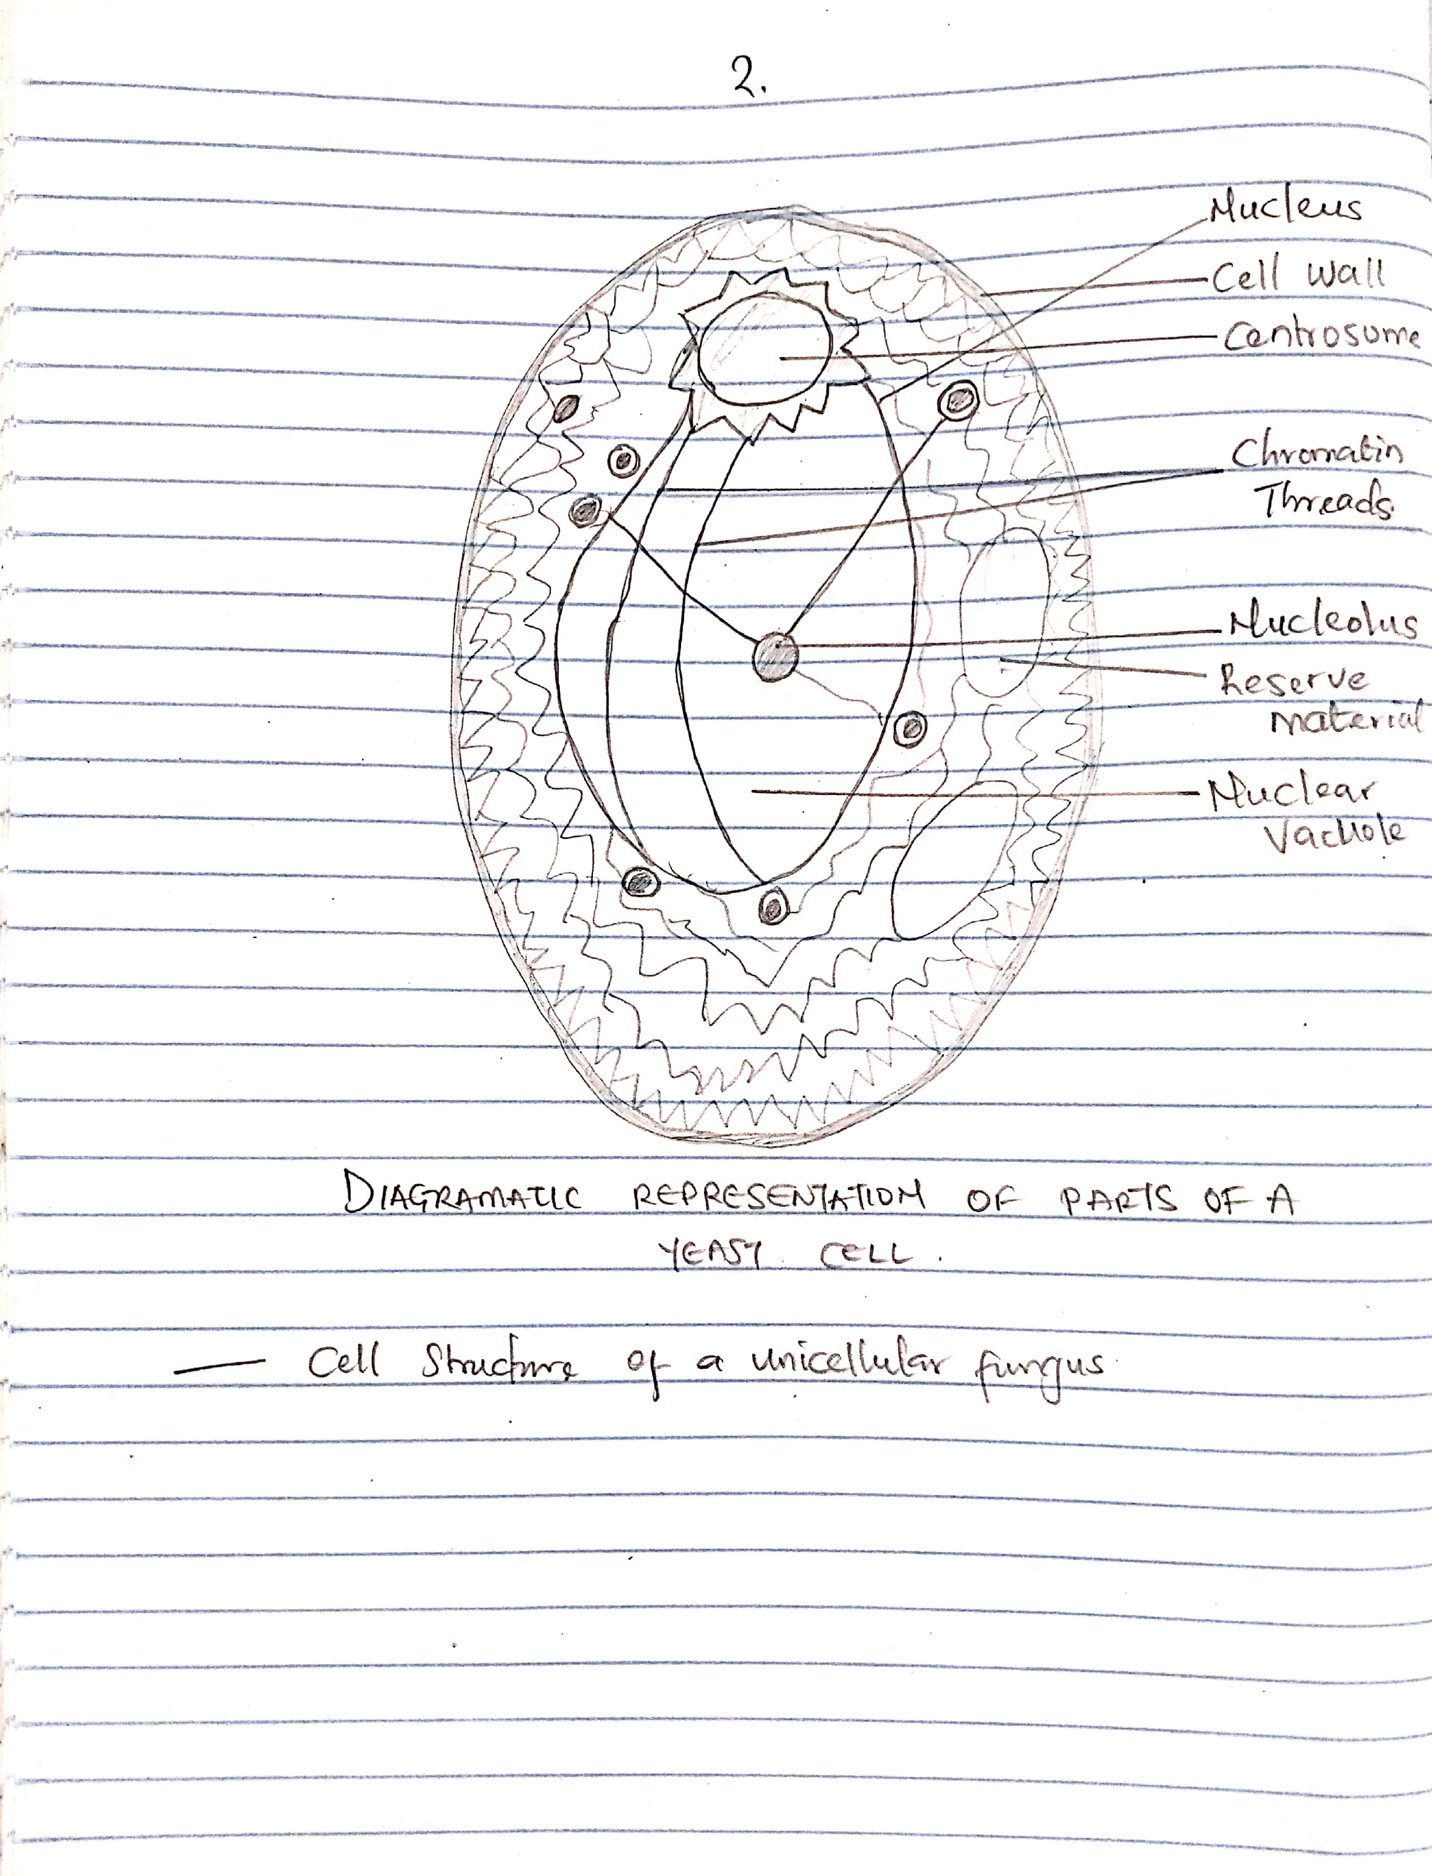
DIAGRAMATIC REPRESENTATION OF PARTS OF A YEAST CELL

3
Outline the sexual reproduction in a typical filamentous form of fungi.

4
How do Bryophytes adapt to their environment?
Two adaptations made the move from water to land possible for Bryophytes: a waxy cuticle and gametangia. The waxy cuticle helped to protect the plants tissue from drying out and the gametangia provided further protection against drying out specifically for the plants gametes. Bryophytes also show embryonic development which is a significant adaptation that links them to the vascular land plants.
5
Describe with illustration the following terminologies: (a) eusteles (b) atactostele (c) siphonostele (d) dictyostele.
A
EUSTELE
a stele typical of dicotyledonous plants that consists of vascular bundles of xylem and phloem strands with parenchymal cells between the bundles
If the stele is split into distinct collateral vascular bundles,then it is called eustele.
It is modified ectophloic siphonostele. Spitting of the original stelar core takes place due to the overlapping of large number of leaf gaps. Individual vascular bundles in the eustele are arranged as broken ring in the ground tissue.
Example: dicot stern primary structure
B
Atactostele
It is similar to eustele. Both the individual vascular bundles are scatteredly distributed in the ground tissue.
Example: Monocot stem
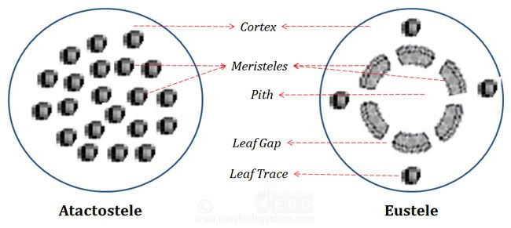
C

Siphonostele:

A stele with central pith surrounded by vascular tissue is called siphonostele or a medullated protostele is called siphonostele.
Evolution of Siphonostele from Protostele:
There are two main theories regarding the evolution of siphonostele from protostele:
(a) Intraxylary or Intrastelar origin:
According to this theory the siphonostele is evolved by the conversion of the central mass of the xylem into parenchymatous pith. This theory is also known as expansion theory and it is supported by Boodle (1901), Bower (1911), Gwynne-Vaughan (1903, 1914). Petry (1914), Thompson and Gewirtz and Fahn (1960) etc.
(b) Extrastelar Origin:
This theory is supported by Jaffery (1897, 1899, 1902, 1917). According to him the pith is originated as a result of invasion of the parenchymatous cells of the cortex into the stele. It takes place through the leaf gaps and branch gaps. This theory is also known as invasion theory.
Siphonostele is of two types:
(a) Ectophloic siphonostele, and
(b) Amphiphloic sipnonostele
(a) Ectophloic siphonostele:
Phloem is present only external to the xylem (Fig. 3A) e.g., Osmunda, Schizaea.
(b) Amphiphloic siphonostele:
Phloem is present on both external and internal to the xylem e.g., Marsilea rhizome. In it the pith is surrounded by inner endodermis, inner pericycle, inner phloem, xylem, outer phloem, outer pericycle and outer endodermis (Fig. 3B).
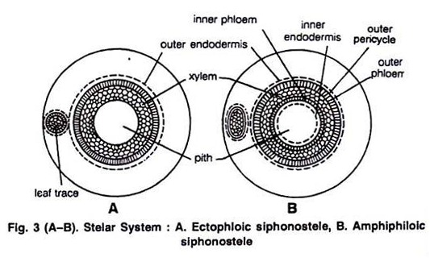
Other Modifications of Siphonostele:
(a) Cladosiphonic siphonostele:
The siphonostele without leaf gap is known as cladosiphonic siphonstele (Jeffery, 1910) e.g., Selaginella.
(b) Phyllosiphonic siphonostele:
A siphonostele with smaller or larger leaf gaps is called phyllosiphonic siphonostele e.g., Filicophyta.
(c) Solenostele:
The siphonostele which is perforated by scattered leaf traces is known as slenostele (Gwynne-Vaughan, 1907; Schoulte, 1938).
It may of two types:
(a) Ectophloic, and
(b) Amphiphloic.
(i) Ectophlopic siphonostele:
Phloem is present only on outer side (Fig. 4A).
(ii) Amphiphloic siphonostele:
Phloem is present on both the sides of the xylem (Fig. 4B).
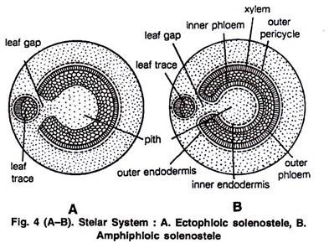
D
Dictyostele
A siphonostele with more overlapping leaf gaps so as to show more than interruption in one transverse section is known as dissected siphonostele or dictyostele. The vascular parts of dictyostele between the neighbouring leaf gaps are known as meristeles.
The meristeles are typically protosteles e.g., Pteris, Ophioglossum lusitanicum, Adiantum capillaris-veneris, Dryopteris chrysocoma etc. (Fig. 5 A,B).
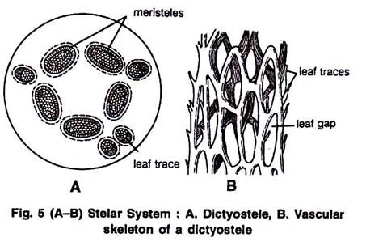
6
Illustrate the life cycle of a primitive vascular plant.
