NAME: Oony-Iye Eepho
MATRIC NO: 19/MHS01/357
DEPARTMENT: MEDICINE AND SURGERY
COURSE CODE: BIO 102

1. How are fungi important to mankind?
Answer: Importance of fungi to mankind are:
i) Fungi are responsible for the mediation of decay of organic matter.
ii) Fungi (e.g. yeast) are used in food and breweries industries as catalyst.
iii) Fungi (e.g. mushroom) can also be eaten as food.
iv) Fungi can be used as drugs or used to produce antibiotics, e.g. penicillin.
v) Some fungi are parasites to some household pests, hence they can be used as biological control agents in regard to such pests.

2. Illustrate the cell structure of a unicellular fungus with a well-labelled diagram.
Answer: The cell structure of a unicellular fungus:

3. Outline the sexual reproduction in a typical filamentous form of fungi.
Answer: In a typical filamentous fungus, e.g. Rhizopus Stolonifer, sexual reproduction occurs when two mating types of hyphae grow in the same medium. Chemical interactions in the two hyphae induces growth in the opposite direction. The growth is delimited by a wall, hence many nuclei are isolated in a gametangium. The gametangia fuses, a zygote is formed which undergoes the dormant stage. The nuclei in the zygote fuses in twos and undergoes meiosis. The zygote germinates under favourable condition to produce fruiting which brings haploid spores.

4. How do bryophytes adapt to their environment?
Answer: Bryophytes adapt to their environment in the following ways:
i) They have definite structures for the absorption of nutrients from the soil, hence the plant is divided into aerial and subterranean portion.
ii) The aerial portion is modified so that it is able to prevent excessive loss of water through the body surface to the atmosphere
iii) Openings are present in the aerial part of the plant and they help eliminate excess water from the plant’s body.

5. Describe with illustrations the following terminologies: a) Eusteles, b) Atactostele, c) Siphonostele, d) Dictyosteles
Answer:
a) Eusteles: A stele typical of dicotyledonous plants that consist of vascular bundles of xylem and phloem strands with parenchymal cells between the bundles.

Diagram of an Eusteles
b) Atactostele: A type of eustele found in monocots in which the vascular tissues in the stem exits as scattered bundles.

Diagram of an Atactostele
c) Siphonostele: A stele consisting of a core of pith surrounded by concentric layers of xylem and phloem.

Diagram of a Siphonostele
d) Dictylostele: A stele which the vascular cylinder is broken up into longitudinal series of vascular strands and a central pith.
Diagram of a Dictylostele
6. Illustrate the life cycle of a primitive vascular plant.
Answer:
The sporangium develops from diploid cells on the stem. Sporogenous cells undergo meiosis to produce haploid spores. Spores when liberated germinate into gametophytes. At maturity the terminal ends of the gametophyes bear archegonia while the antheridia are borne as protuberances on the lower branches. Sperms with flagella are released when the antheridia ripen, the sperms swim into the archegonia and a zygote is produced, the zygote gradually develops into a sporophyte.
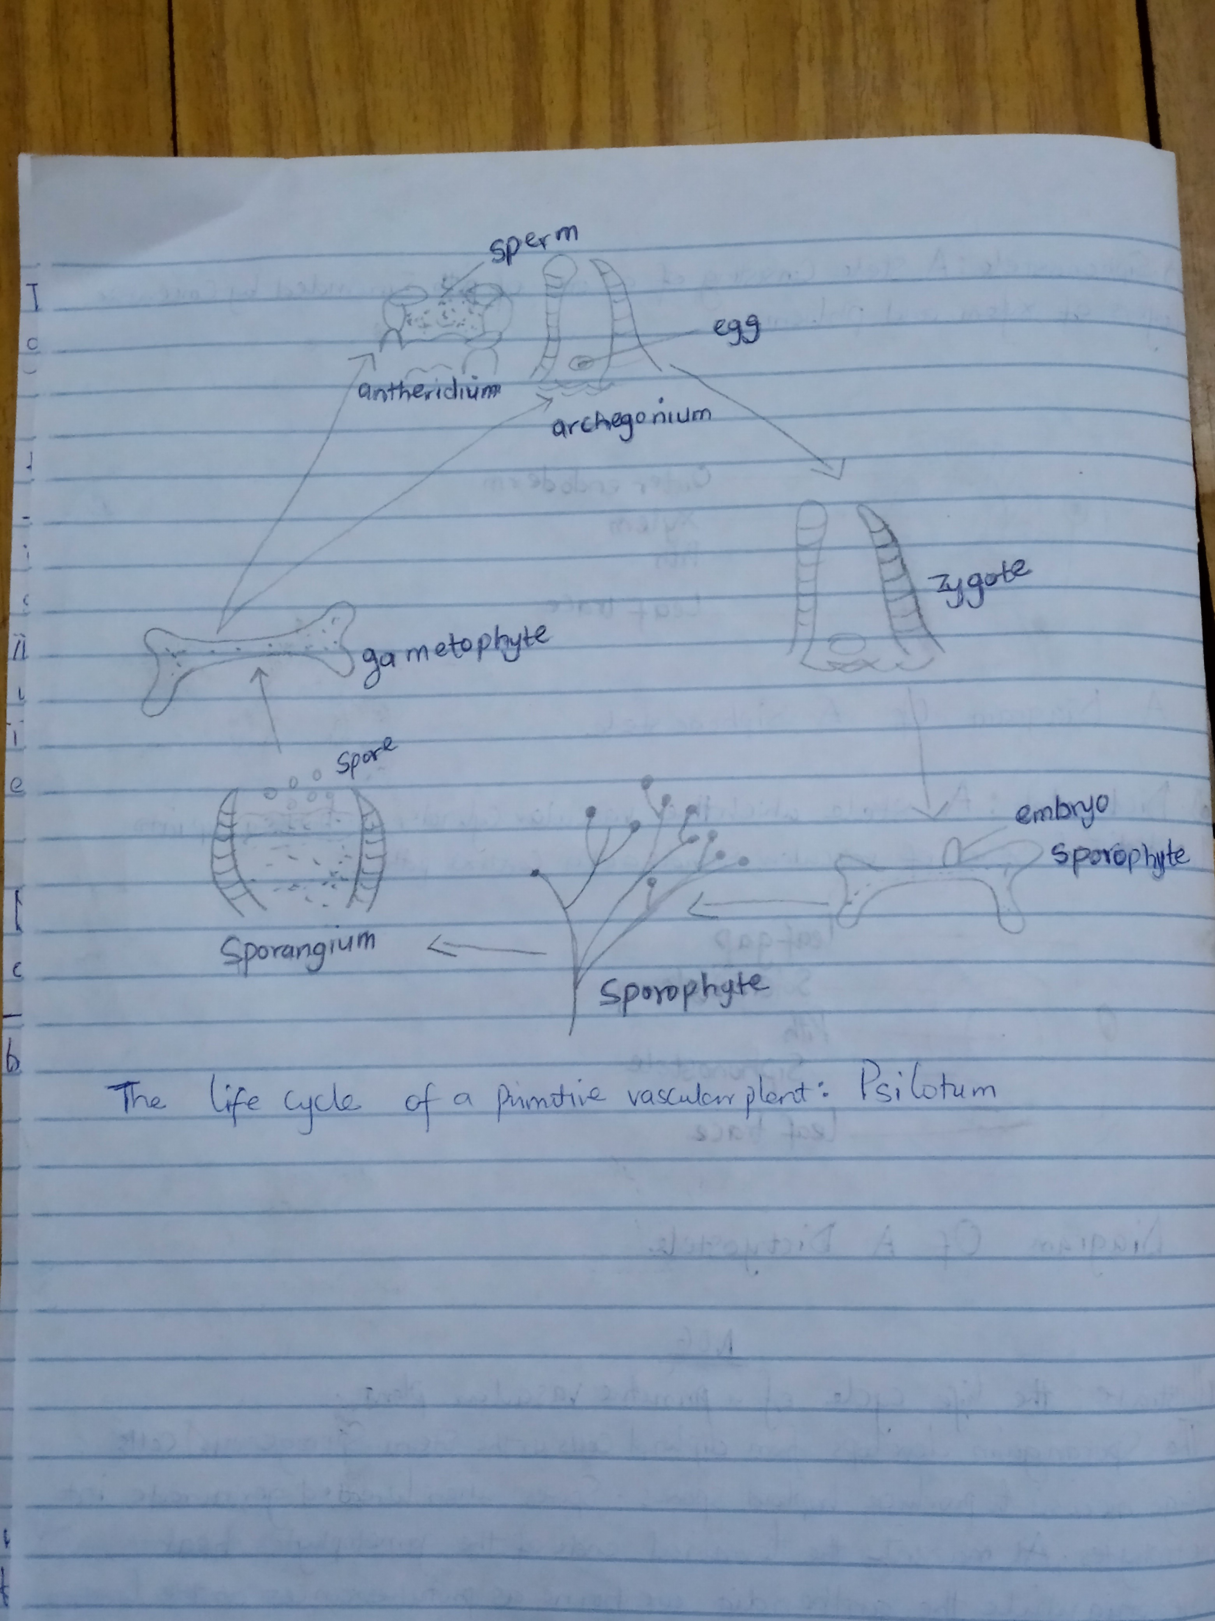
The Life Cycle Of A Primitive Vascular Plant: Psilotum

