NAME: Mbama Crystabel Zinachidi.
DEPARTMENT: Nursing.
MATRIC NUMBER: 19/MHS02/075
COURSE: BIOLOGY 102
- How are fungi important to mankind
- They are responsible for the mediation of decay of organic matter.
- They are important in food industry.
- They mediate the spoilage of food, wood, clothes and papers.
- They serve as parasites to some obnoxious pests
- Illustrate the cell structure of a unicellular fungus with a well labeled diagram.
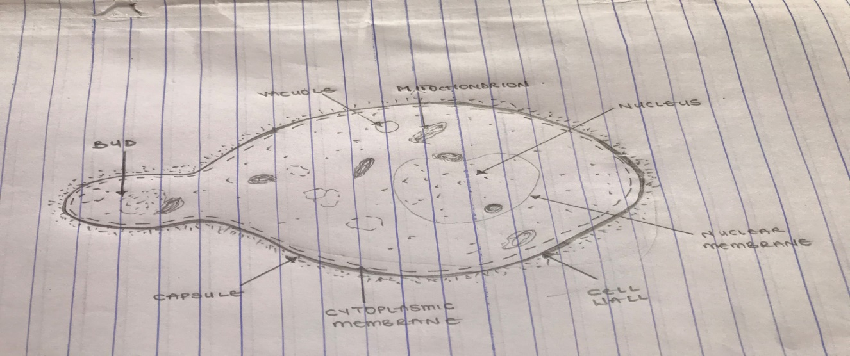
A WELL LABELLED DIAGRAM OF A UNICELLULAR FUNGUS(Saccharomyces Cerevisiae) YEAST

- Outline the sexual reproduction in a typical filamentous form of fungi
The sexual reproduction occurs when two mating types of hyphae grow in the same medium.
- The two gamentigia fuse and a zygote is formed.
- The zygote undergoes prolonged dormancy or resting stage
- The nucleus in the zygote fuses in twos and undergo meiosis independently.
- The zygote germinates under favorable conditions to produce a fruiting which at maturity liberates the haploid spores.

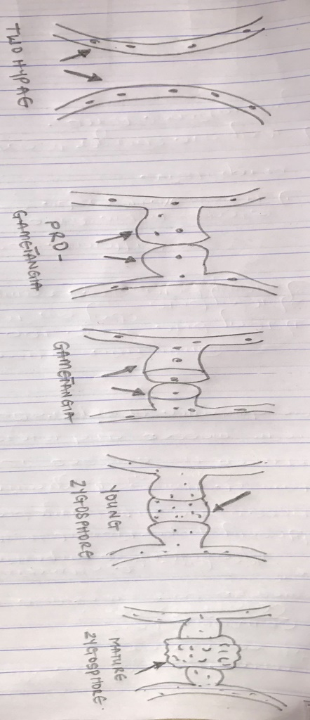
- How do bryophytes adapt to their environment?
- They have definite structures for water and nutrient absorption from the soil to help them adapt to their environment.
- The aerial portion of the plant body exposed to the atmosphere demands some modifications that excessive loss of water through the body surface.
- Some other modifications that permit elimination of excess water from plant body and not only exchange of gases between the internal parts of the plant and the atmosphere therefore openings are available on the aerial parts of the plant.
- Describe with illustration the following terminologies: a) euteles b) atactosele c) siphonostele d) dictyostele
- EUTELES
The vascular bundles are discrete, concentric collateral bundles of xylem and phloem.
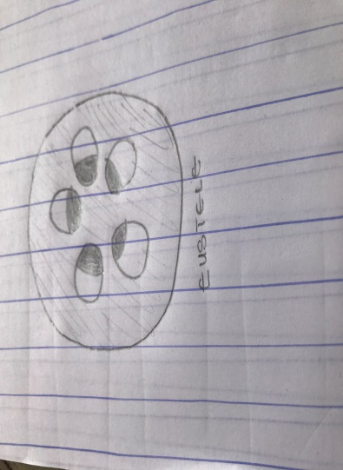

- ATACTOSELE
The vascular bundles are scattered. The nature of the vascular supply to leaves is also noted worthy element of the vascular system.
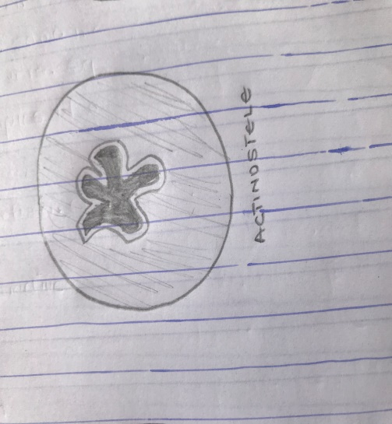
- SIPHONOSTELR
In more advanced vascular system, the stele is a cylinder enclosing a parenchymatous pitch
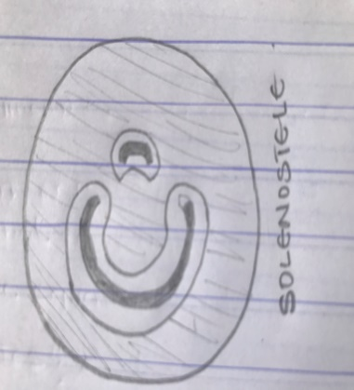
- DICTYOSTELE
Vascular supply is more associate with leaf gaps and the conducting cylinder is a dissected one which is the dictyostele.
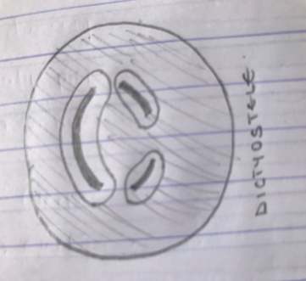
- Illustrate the life cycle of a primitive vascular plant.
