NAME: ESAN FAITH
DEPARTMENT: PHARMACOLOGY
MATRIC NUMBER: 18/MHS07/017
COURSE: PHS 204- PHYSIOLOGY OF REPRODUCTION AND ENDOCRINE ORGANS
ASSIGNMENT: DISCUSS CONTRACEPTION AND DIFFERENT TYPES WITH DETAILS ON ANY 5
Birth control, also known as contraception and fertility control, is a method or device used to prevent pregnancy Birth control has been used since ancient times, but effective and safe methods of birth control only became available in the 20th century Planning, making available, and using birth control is called family planning Some cultures limit or discourage access to birth control because they consider it to be morally, religiously, or politically undesirable. The most effective methods of birth control are sterilization by means of vasectomy in males and tubal ligation in females, intrauterine devices (IUDs), and implantable birth control This is followed by a number of hormone-based methods including oral pills, patches, vaginal rings, and injections.] Less effective methods include physical barriers such as condoms, diaphragms and birth control sponges and fertility awareness methods The least effective methods are spermicides and withdrawal by the male before ejaculation Sterilization, while highly effective, is not usually reversible; all other methods are reversible, most immediately upon stopping them.^{[5]} Safe sex practices, such as with the use of male or female condoms, can also help prevent sexually transmitted infections Other methods of birth control do not protect against sexually transmitted diseases.] Emergency birth control can prevent pregnancy if taken within 72 to 120 hours after unprotected sex Some argue not having sex is also a form of birth control, but abstinence-only sex education may increase teenage pregnancies if offered without birth control education, due to non-compliance In teenagers, pregnancies are at greater risk of poor outcomes Comprehensive sex education and access to birth control decreases the rate of unwanted pregnancies in this age group While all forms of birth control can generally be used by young people, long-acting reversible birth control such as implants, IUDs, or vaginal rings are more successful in reducing rates of teenage pregnancy. After the delivery of a child, a woman who is not exclusively breastfeeding may become pregnant again after as few as four to six weeks. Some methods of birth control can be started immediately following the birth, while others require a delay of up to six months.[ In women who are breastfeeding, progestin-only methods are preferred over combined oral birth control pills. In women who have reached menopause, it is recommended that birth control be continued for one year after the last period. About 222 million women who want to avoid pregnancy in developing countries are not using a modern birth control method. Birth control use in developing countries has decreased the number of deaths during or around the time of pregnancy by 40% (about 270,000 deaths prevented in 2008) and could prevent 70% if the full demand for birth control were met. By lengthening the time between pregnancies, birth control can improve adult women's delivery outcomes and the survival of their children. In the developing world, women's earnings, assets, and weight, as well as their children's schooling and health, all improve with greater access to birth control. Birth control increases economic growth because of fewer dependent children, more women participating in the workforce, and less use of scarce resources

EFFECT
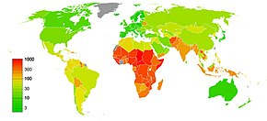
Maternal mortality rate as of 2010.^{[119]}
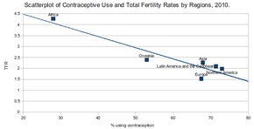
Birth control use and total fertility rate by region.
Contraceptive use in developing countries is estimated to have decreased the number of maternal deaths by 40% (about 270,000 deaths prevented in 2008) and could prevent 70% of deaths if the full demand for birth control were met. These benefits are achieved by reducing the number of unplanned pregnancies that subsequently result in unsafe abortions and by preventing pregnancies in those at high risk.
Birth control also improves child survival in the developing world by lengthening the time between pregnancies. In this population, outcomes are worse when a mother gets pregnant within eighteen months of a previous delivery. Delaying another pregnancy after a miscarriage however does not appear to alter risk and women are advised to attempt pregnancy in this situation whenever they are ready.
Teenage pregnancies, especially among younger teens, are at greater risk of adverse outcomes including early birth, low birth weight, and death of the infant. 82% of pregnancies in those between 15 and 19 are unplanned. Comprehensive sex education and access to birth control are effective in decreasing pregnancy rates in this age group.

GIVE EXAMPLES OF THE TYPES OF CONTRACEPTIVES AND MAJOR ON ANY 5
CONDOM
ORAL CONTRACEPTIVE PILLS
STERILIZTION
INTAUTERINE DEVICE
CONTRACEPTIVE IMPLANT
CONTRACEPTIVE INJECTION
CONTRACEPTIVE RING
EMERGENCY CONTRACEPTIVE PILL
DIAPHRAGM
The Condom
The condom is the only form of contraception that protects against most STIs as well as preventing pregnancy. This method of contraception can be used on demand, is hormone free and can easily be carried with you. And it comes in male and female varieties.
Male condoms are rolled onto an erect penis and act as a physical barrier, preventing sexual fluids from passing between people during sex. The female condom is placed into the vagina right before sex. Based on typical use, the female condom is not quite as effective as the male latex condom and it may take a little practice to get used to.
Pros include: It’s the best protection against STIs; can be used on demand; hormone free.
Cons include: It can tear or come off during sex if not used properly; some people are allergic to latex condoms.
Condoms are the only form of contraception that also protect against STIs.

The Oral Contraceptive Pill
It’s the little tablet taken once a day. The oral contraceptive pill is the most commonly reported method of contraception used by Australian women. There are a few different types of pill to choose from, so it’s about finding the one that’s right for you. The combined pill contains estrogen and progestin and mini pill contains only one hormone, a progestin. The pill can have many benefits, however remembering to take it on time is a must. Pros of taking the pill include: Highly effective when used correctly; permits sexual spontaneity and doesn’t interrupt sex; some pills may even reduce heavy and painful periods and/or may have a positive effect on acne.
Cons include: Forgetting to take your pill means it won’t be as effective; it can only be used by women; is not suitable for women who can't take oestrogen-containing contraception; it does not protect against STIs. The pill is only available by getting a prescription from a medical professional so visit your local doctor or sexual health clinic.
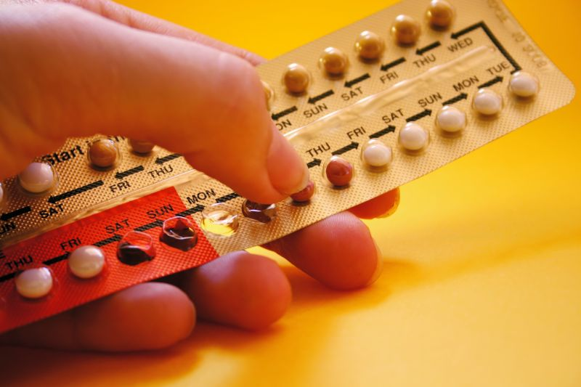
The oral contraceptive pill is taken once a day and is currently the most common contraception used by Australian women.

The Contraceptive Injection
The injection contains a synthetic version of the hormone progestogen. It is given into a woman’s buttock or the upper arm, and over the next 12 weeks the hormone is slowly released into your bloodstream.
Pros: The injection lasts for up to three months; is very effective; permits sexual spontaneity and doesn’t interrupt sex.
Cons: The injection may cause disrupted periods or irregular bleeding; it requires keeping track of the number of months used; itdoes not protect against STIs.
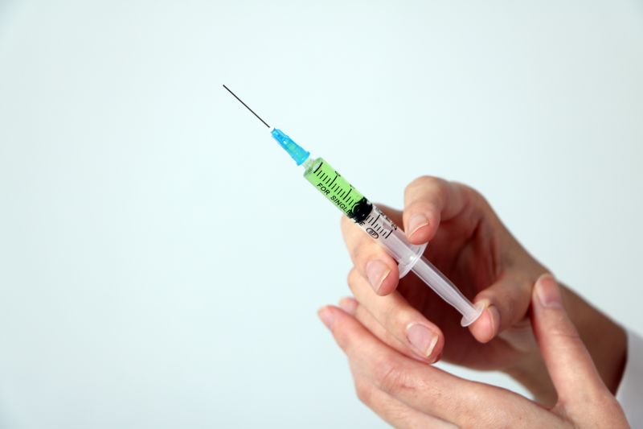
The contraceptive injection uses progestogen to prevent pregnancy.

Emergency Contraception Pill (The ‘Morning After’ Pill)
The Emergency Contraception Pill can be used to prevent pregnancy after sex if contraception wasn’t used, a condom has broken during sex, or a woman has been sexually assaulted. While it is sometimes call the ‘Morning After’ pill, it can actually be effective for up to five days after having unprotected sex. The sooner it is taken, the more effective it is; when taken in the first three days after sex, it prevents about 85% of expected pregnancies.
This pill contains special doses of female hormones. Any woman can take the emergency contraception pill, even those who cannot take other oral contraceptive pills. It can be bought over the counter at a pharmacy or chemist without a prescription.
The common side effects of the emergency contraceptive include nausea, vomiting and the next period may be early or delayed. Emergency contraception does not protect against STIs.
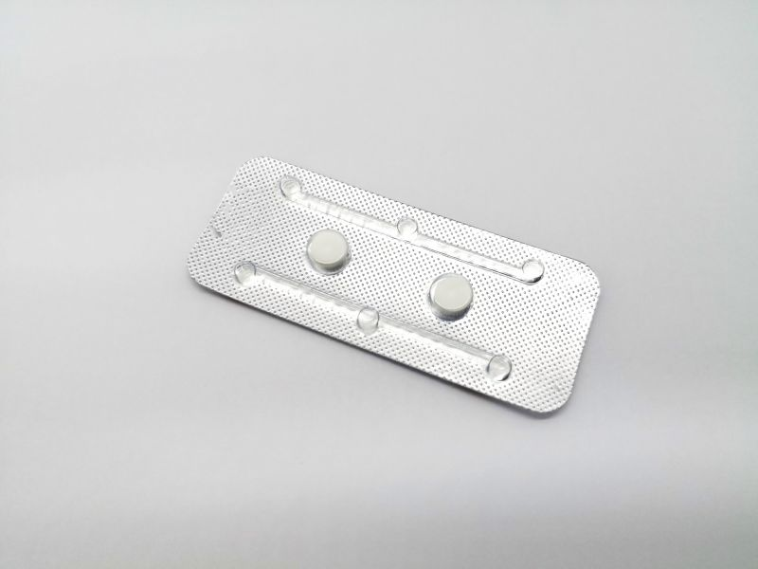
Emergency contraception can be used after having sex to prevent pregnancy.

Contraceptive Ring
This method consists of a flexible plastic ring constantly releasing hormones that is placed in the vagina by the woman. It stays in place for three weeks, and then you remove it, take a week off then pop another one in. The ring releases the hormones oestrogen and progestogen. These are the same hormones used in the combined oral contraceptive pill, but at a lower dose.
Pros include: You can insert and remove a vaginal ring yourself; this contraceptive method has few side effects, allows control of your periods and allows your fertility to return quickly when the ring is removed.
Cons include: It is not suitable for women who can't take oestrogen-containing contraception; you need to remember to replace it at the right time; does not protect against STIs.
The contraceptive ring releases a lower dose of hormones to control a woman's ability to conceive than other contraceptive methods like the pill.

