YAYOCK IRENE YANAT.
19/MHS01/440
MEDICINE AND SURGERY.

- Fungi are important to mankind for the following reasons:
- Fungi are responsible for the mediation of decay of organic matter
- Fungi are important in the food industry.
- Without fungi and other microbes, the surface of the earth would have been clogged up with dead matters with all the various elements locked up in them instead of returning into various cycles
- Mushrooms are eaten by many human societies e.g Penicillium notatium produce important antibodies
- Some fungi are parasites to some certain horrible obnoxious pests e.g. houseflies, grasshoppers and therefore constitute important biological control agents in regard to such pests.

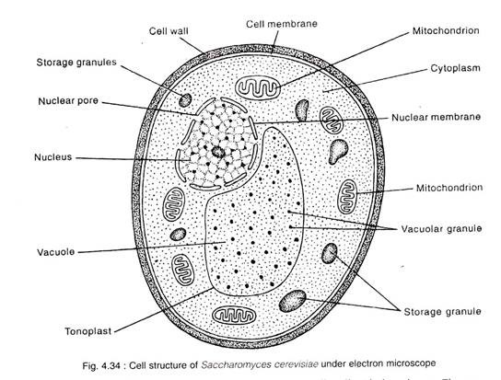

- Filamentous form of algae is hyphae. Sexual reproduction occurs when two mating types of hyphae grow in the same medium. Chemical interaction in the two mating types of hyphae induces growths perpendicular to the hyphae in opposite directions. These growth are delimited by a wall such that many nuclei are isolated in what is called a gametangium.
The two gametangia fuse (plasogamy) and a zygote is formed which may undergo prolonged dormancy or resting stage. The nuclei in the zygote fuse in two and undergoes meiosis independently. The zygote germinates under favourable condition to a produce a fruiting which at maturity liberates the haploid spores.

- Bryophytes adapt to their environment by the following;
- They definite structures for water and nutrient absorption from the soil; therefore the plant body is divided into two (an aerial portion and a subterranean portion). The subterranean portion is the rhizoid and is not a true root as a case of land plants that are advanced.
- The aerial portion being exposed to the atmosphere demands same modifications that prevents excessive loss of water through the body surface (i.e. dessication).
- Some other modifications that permit elimination of excess water from the plant body and not only exchange of gases between the internal parts of the plant and the atmosphere therefore openings are available on aerial parts of the plant

- Description of some terminologies
- Eusteles: the vascular bundles are discrete, concentric bundles of xylem and phloem.

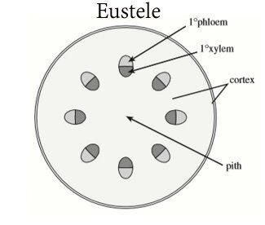

- Atactostele: the vascular bundles are scattered, formed in monocots a type of eustele

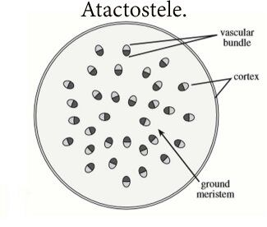

- Siphonostele: a stele consisting of a core of pith surrounded by concentric layers of xylem and phloem.
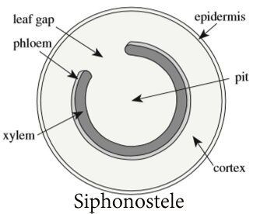

- Dictyostele: a stele in which the vascular cylinder is broken up into a longitudinal series or network of vascular strands around a central pith.

 