NAME: ESAN FAITH
MATRIC NUMBER: 18/MHS07/017
DEPARTMENT: PHARMACOLOGY
COURSE- PHS 204- PHYSIOLOGY OF REPRODUCTION AND ENDROCRINE ORGANS
ASSIGNMENT: DISSCUSS LACTATION AND GESTATION PERIOD IN A NORMAL FEMALE

LACTATION
Lactation describes the secretion of milk from the mammary glands and the period of time that a mother lactates to feed her young. The process occurs in all female mammals, although it predates the origin of mammals. A positive feedback loop ensures continued milk production as long as the infant continues to breastfeed..
In humans the process of feeding milk is called breastfeeding or nursing.
The chief function of lactation is to provide nutrition and immune protection to the young after birth. In almost all mammals, lactation induces a period of infertility, which serves to provide the optimal birth spacing for survival of the offspring.
In most species, milk comes out of the mother’s nipples; however, the platypus (a non-placental mammal) releases milk through ducts in its abdomen. In only one species of mammal, the dayak fruit bat, is milk production a normal male function.
In some other mammals, the male may produce milk as the result of a hormone imbalance. This phenomenon may also be observed in newborn infants as well (for instance, witch’s milk).
Galactopoiesis is the maintenance of milk production. This stage requires prolactin and oxytocin.

Preparation for Lactation
By the fifth or sixth month of pregnancy, the breasts are ready to produce milk. During the latter part of pregnancy, the woman’s breasts enter into the lactogenesis I stage. This is when the breasts make colostrum, a thick, sometimes yellowish fluid.
At this stage, high levels of progesterone inhibit most milk production. It is not a medical concern if a pregnant woman leaks any colostrum before her baby’s birth, nor is it an indication of future milk production.
At birth, prolactin levels remain high, while the delivery of the placenta results in a sudden drop in progesterone, estrogen, and human placental lactogen levels. This abrupt withdrawal of progesterone in the presence of high prolactin levels stimulates the copious milk production of the lactogenesis II stage.
When the breast is stimulated, prolactin levels in the blood rise and peak in about 45 minutes, then return to the pre-breastfeeding state about three hours later. The release of prolactin triggers the cells in the alveoli to make milk.

Colostrum
Colostrum is the first milk a breastfed baby receives. It contains higher amounts of white blood cells and antibodies than mature milk, and is especially high in immunoglobulin A (IgA), which coats the lining of the baby’s immature intestines, and helps to prevent pathogens from invading the baby’s system. Secretory IgA also helps prevent food allergies. Over the first two weeks after the birth, colostrum production slowly gives way to mature breast milk.
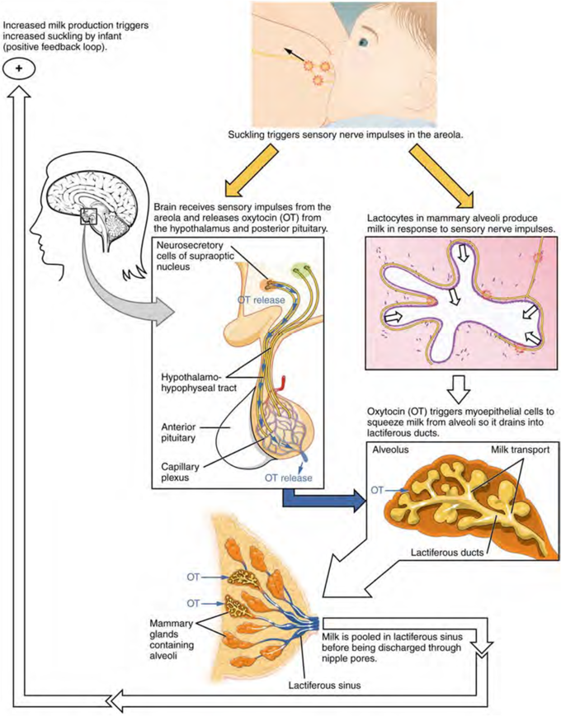

CHANGES IN THE COMPOSITION OF BREAST MILK
In the final weeks of pregnancy, the alveoli swell with colostrum, a thick, yellowish substance that is high in protein but contains less fat and glucose than mature breast milk. Before childbirth, some women experience leakage of colostrum from the nipples. In contrast, mature breast milk does not leak during pregnancy and is not secreted until several days after childbirth.
*Cow’s milk should never be given to an infant. Its composition is not suitable and its proteins are difficult for the infant to digest.
Compositions of Human Colostrum, Mature Breast Milk, and Cow’s Milk (g/L) (Table 3)
 | Human colostrum | Human breast milk | Cow’s milk*
Total protein | 23 | 11 | 31
Immunoglobulins | 19 | 0.1 | 1
Fat | 30 | 45 | 38
Lactose | 57 | 71 | 47
Calcium | 0.5 | 0.3 | 1.4
Phosphorus | 0.16 | 0.14 | 0.90
Sodium | 0.50 | 0.15 | 0.41
Colostrum is secreted during the first 48–72 hours postpartum. Only a small volume of colostrum is produced—approximately 3 ounces in a 24-hour period—but it is sufficient for the newborn in the first few days of life. Colostrum is rich with immunoglobulins, which confer gastrointestinal, and also likely systemic, immunity as the newborn adjusts to a nonsterile environment.
After about the third postpartum day, the mother secretes transitional milk that represents an intermediate between mature milk and colostrum. This is followed by mature milk from approximately postpartum day 10. As you can see in the accompanying table, cow’s milk is not a substitute for breast milk. It contains less lactose, less fat, and more protein and minerals. Moreover, the proteins in cow’s milk are difficult for an infant’s immature digestive system to metabolize and absorb.
The first few weeks of breastfeeding may involve leakage, soreness, and periods of milk engorgement as the relationship between milk supply and infant demand becomes established. Once this period is complete, the mother will produce approximately 1.5 liters of milk per day for a single infant, and more if she has twins or triplets. As the infant goes through growth spurts, the milk supply constantly adjusts to accommodate changes in demand. A woman can continue to lactate for years, but once breastfeeding is stopped for approximately 1 week, any remaining milk will be reabsorbed; in most cases, no more will be produced, even if suckling or pumping is resumed.
Mature milk changes from the beginning to the end of a feeding. The early milk, called foremilk, is watery, translucent, and rich in lactose and protein. Its purpose is to quench the infant’s thirst. Hindmilk is delivered toward the end of a feeding. It is opaque, creamy, and rich in fat, and serves to satisfy the infant’s appetite.
During the first days of a newborn’s life, it is important for meconium to be cleared from the intestines and for bilirubin to be kept low in the circulation. Recall that bilirubin, a product of erythrocyte breakdown, is processed by the liver and secreted in bile. It enters the gastrointestinal tract and exits the body in the stool. Breast milk has laxative properties that help expel meconium from the intestines and clear bilirubin through the excretion of bile. A high concentration of bilirubin in the blood causes jaundice. Some degree of jaundice is normal in newborns, but a high level of bilirubin—which is neurotoxic—can cause brain damage. Newborns, who do not yet have a fully functional blood–brain barrier, are highly vulnerable to the bilirubin circulating in the blood. Indeed, hyperbilirubinemia, a high level of circulating bilirubin, is the most common condition requiring medical attention in newborns. Newborns with hyperbilirubinemia are treated with phototherapy because UV light helps to break down the bilirubin quickly.
GESTATION

Gestation is the period of development during the carrying of an embryo or fetus inside viviparous animals. It is typical for mammals, but also occurs for some non-mammals. Mammals during pregnancy can have one or more gestations at the same time, for example in a multiple birth.
The time interval of a gestation is called the gestation period. In human obstetrics, gestational age refers to the fertilization age plus two weeks. This is approximately the duration since the woman's last menstrual period (LMP) began.
Human pregnancy can be divided roughly into three trimesters, each approximately three months long. The first trimester is from the last period through the 13th week, the second trimester is 14th–27th week, and the third trimester is 28th–42nd week. Birth normally occurs at a gestational age of about 40 weeks, though it is common for births to occur from 37 to 42 weeks. From the 9th week of pregnancy (11th week of gestational age), the embryo is called a fetus.
Various factors can come into play in determining the duration of gestation. For humans, male fetuses normally gestate several days longer than females and multiple pregnancies gestate for a shorter period
The pregnant state is characterized by a myriad of alterations in the normal physiology of the gravid woman. An understanding of some of the major mechanisms that produce these changes is helpful in the analysis of symptoms and problems that arise during the course of a normal gestation. When associated disease is present, understanding of these alterations becomes more important in that they must be distinguished from pathophysiologic changes wrought by the disease process. The interaction between disease and gestational physiology may make the appropriate diagnosis and management of the pregnant woman difficult. When a pregnant woman requires medical or surgical therapy, the consultative services of an obstetrician or clinician trained in the complexities of maternal physiology is absolutely critical to the proper management of clinical problems.
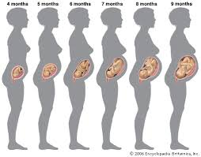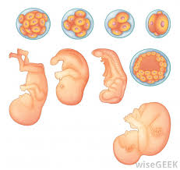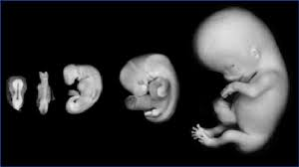

MODELS OF PREGNANCY AS A PHYSIOLOGICALLY ADAPTED STATE
Model I: Pregnancy as an Arteriovenous Fistula
In 1938, Burwell and associates suggested that there are strong similarities between the physiologic alterations seen in normal pregnancy and those seen in patients with large arteriovenous fistulas. Patients on chronic renal dialysis who have peripheral shunts constructed for purposes of dialysis typically have flow rates in their shunts of approximately 600 ml/minute. Because uteroplacental flow rates at term (nearly 600 ml/minute) are essentially the same as those in the artificially produced shunts, it is not surprising that there are similarities between the cardiovascular changes in the shunted patients and cardiovascular alterations in the pregnant woman, particularly as she approaches term.
In both of these circumstances there is evidence of increased peripheral circulation, decreased peripheral resistance, increased heart rate, increased cardiac output, and increased plasma volume. This particular model can be used to explain a number of other changes related not directly to the shunting mechanism but to secondary changes produced by increased peripheral circulation, such as increased renal plasma flow and the physiologic alterations associated with increased renal perfusion.
Model II: Pregnancy as a State of Heat Adaptation
Abrams and associates and others have shown that there is a considerable temperature gradient between the mother and fetus. Aortic temperature measurements made in the pregnant ewe indicate that the fetal core temperature exceeds that of the mother by 0.5°C, which is a significant amount. Thermodynamics and the physics of heat transfer suggest that because of this temperature difference, the flow of heat from the fetus to the mother is relatively constant. As a result, the maternal organism must adjust her thermoregulatory system to permit increased heat loss to the environment. Aside from physical considerations, the need for maternal thermoregulatory adjustments is suggested by the observation that homeothermic mammals function within a very narrow range of internal temperatures. Extremes in either direction produce significant alterations in the function of fundamental systems responsible for the maintenance of life.
Responses of the homeothermic mammal to internal and environmental heating produce similar physiologic alterations. These include increased respiratory rate, increased cardiac output, increased heart rate, expansion of plasma volume, increased peripheral circulation, and a number of other changes similar to those seen in normal human gestation.
Model III: Pregnancy as a Hyperprogestational State
With the onset of normal gestation, all maternal systems are subjected to increasing levels of circulating progesterone. At first the corpus luteum of pregnancy, and later the placenta, produce large amounts of this hormone. At term, serum levels may be as high as 2.5 times those considered normal in the menstruating woman.
Increased basal body temperature and changes in the smooth muscle dynamics of the uterus, the vascular system, the urinary system, the gastrointestinal system, and the respiratory system in pregnancy have often been explained on the basis of increasing levels of serum progesterone. The mechanism proposed to explain many of these changes relates to the effect of progesterone on the electrochemical gradient at the cell membrane of individual smooth muscle fibers.⁷ According to this hypothesis, progesterone acts to hyperpolarize the cell membrane, depressing the resting electrical potential at the membrane to a level below that of the normal activation threshold. This effectively puts the muscle at rest, because much greater levels of stimulation are required to produce depolarization and subsequent muscle contraction. Decreased tone and overall decrease in contractile activity is seen in most of the structures that depend on smooth muscle for their action. This includes the uterus, gut, respiratory system, ureters, and peripheral vascular system.
Volume expansion of the intravascular space, decreased peripheral resistance, increased heart rate, and a number of other alterations associated with the pregnant state could theoretically be explained on the basis of progesterone's effect on smooth muscle.
Overall, it seems unlikely that a single model can be invoked to explain the varied changes that take place in the human female during the course of gestation. It is more likely that all of these mechanisms contribute, along with other factors still unidentified, to the myriad changes that constitute the physiologic alterations associated with the normal human gestation. Each model, nonetheless, helps the clinician to anticipate and integrate the changes in many of the altered systems. The constructs described permit the alterations in individual systems to be fused into a more coherent overview.

