THE DESIGN AND ANALYSIS OF A REINFORCED CONCRETE CONTINUOUS BEAM USING THE BS CODE

BY
GROUP 1
ADENIRAN MORENIKEJI 15/ENG03/002
AGBEDE GOODNESS 15/ENG03/003
OKORE KALU NNAMDI 15/ENG03/020
USMAN AMEENAT SAMIRAH 15/ENG03/034
OGBOGU OFILI 15/ENG03/025
ADENIYI OLUWATOBI 16/ENG03/055
OLAOYE OLAWALE 16/ENG03/062
ITEPU DANIEL 15/ENG03/017

SUBMITTED IN PARTIAL FULFILMENT
OF THE REQUIREMENT FOR THE AWARD OF THE
BACHELOR OF ENGINEEERING (B.ENG) DEGREE IN CIVIL ENGINEERING
TO
DR. JOHN WASIU
DEPARTMENT OF CIVIL ENGINEERING, COLLEGE OF ENGINEERING, AFE BABALOLA UNIVERSITY, ADO-EKITI,
NIGERIA
MAY, 2020

SOLUTION
Assumptions
- Dead load, $G_{k}=25{kN}/m$
- Live load, $Q_{k}=5{kN}/m$
Design load, DL $=1.4G_{k}+{1.6Q}_{k}$
$=1.4\left(25\right)+1.6\left(5\right)=43{kN}/m$

S/N | CALCULATIONS | REMARKS
1 | 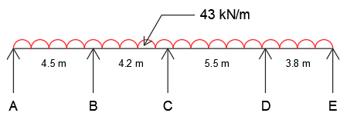  USING HARDY CROSS METHOD OF MOMENT DISTRIBUTION  Stiffness, k = $1/l$ (k = $3/4×1/l$ for the end spans)  Distribution factor, DF = $\frac{k}{\sum{k}}$  Fixed end moment, FEM = $±\frac{wl^{2}}{12}$  Out of balance moment, OBM = $∑$ moments at a joint  Balance moment, BM = $-1×$ OBM  Distributed moment, DM = BM $×$ DF  Transferred moment, TM = $1/2×$ DM  Final moment, M = FEM $+$ DM $+$ TM
MEMBERS | AB BA | BC CB | CD DC | DE ED
k | 0.1667 | 0.2381 | 0.1818 | 0.1974
DF 0 | 1 0.4118 | 0.5882 0.567 | 0.433 0.4794 | 0.5206 1 | 0
FEM | -72.56 72.56 | -63.21 63.21 | -108.4 108.4 | -51.74 51.74
OBM -72.56 9.35 -45.19 56.66 51.74
BM 72.56 -9.35 45.19 -56.66 -51.74
DM 0 | 72.56 -3.85 | -5.5 25.62 | 19.57 -27.16 | -29.5 -51.74 | 0
TM | -1.93 36.28 | 12.81 -2.75 | -13.58 9.79 | -25.87 -14.75
OBM -1.93 49.09 -16.33 -16.08 -14.75
BM 1.93 -49.09 16.33 16.08 14.75
DM 0 | 1.93 -20.22 | -28.87 9.26 | 7.07 7.71 | 8.37 14.75 | 0
TM | -10.11 0.97 | 4.63 -14.44 | 3.86 3.54 | 7.38 4.19
OBM -10.11 5.6 -10.58 10.92 4.19
BM 10.11 -5.6 10.58 -10.92 -4.19
DM 0 | 10.11 -2.31 | -3.29 6.00 | 4.58 -5.24 | -5.68 -4.19 | 0
TM | -1.16 5.06 | 3.00 -1.65 | -2.62 2.29 | -2.10 -2.84
OBM -1.16 8.06 -4.27 0.19 -2.84
BM 1.16 -8.06 4.27 -0.19 2.84
DM 0 | 1.16 -3.32 | -4.74 2.42 | 1.85 -0.09 | -0.10 2.84 | 0
M 0 | 0 85.17 | -85.17 87.67 | -87.67 99.24 | -99.24 0 | 0

 | Support Moments  $M_{A}=0$  $M_{B}=85.17 kNM$  $M_{C}=87.67 kNM$  $M_{D}=99.24 kNM$  $M_{E}=0$  Free Moments $\left(M^{f}=\frac{wl^{2}}{8}\right)$  ${M^{f}}_{AB}=\frac{43×{4.5}^{2}}{8}=108.84 kNm$  ${M^{f}}_{BC}=\frac{43×{4.2}^{2}}{8}=94.82 kNm$  ${M^{f}}_{CD}=\frac{43×{5.5}^{2}}{8}=162.59 kNm$  ${M^{f}}_{DE}=\frac{43×{3.8}^{2}}{8}=77.62 kNm$  Span Moments $\left({M^{s}}_{AB}={M^{f}}_{AB}-\left(\frac{M_{A}+M_{B}}{2}\right)\right)$  ${M^{s}}_{AB}=108.84-\left(\frac{0+85.17}{2}\right)=66.26 kNm$  ${M^{s}}_{BC}=94.82-\left(\frac{85.17+87.67}{2}\right)=8.4 kNm$  ${M^{s}}_{CD}=162.59-\left(\frac{87.67+99.24}{2}\right)=69.14 kNm$  ${M^{s}}_{DE}=77.62-\left(\frac{99.24+0}{2}\right)=28 kNm$  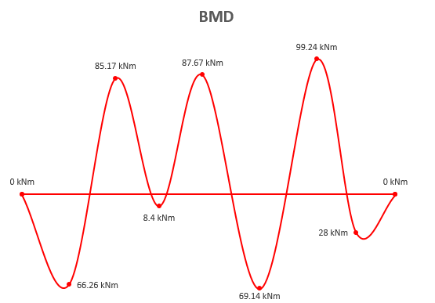  Shear Force $\left(V_{AB}=\left(\frac{wl}{2}\right)+\left(\frac{M_{A}-M_{B}}{L_{AB}}\right)\right)$  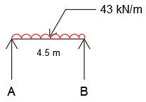  $V_{AB}=\left(\frac{43×4.5}{2}\right)+\left(\frac{0-85.17}{4.5}\right)=77.82 kN$  $V_{BA}=\left(\frac{43×4.5}{2}\right)+\left(\frac{85.17-0}{4.5}\right)=115.68 kN$  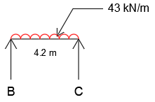  $V_{BC}=\left(\frac{43×4.2}{2}\right)+\left(\frac{85.17-87.67}{4.2}\right)=89.7 kN$  $V_{CB}=\left(\frac{43×4.2}{2}\right)+\left(\frac{87.67-85.17}{4.2}\right)=90.9 kN$  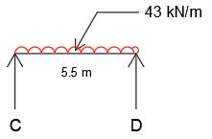  $V_{CD}=\left(\frac{43×5.5}{2}\right)+\left(\frac{87.67-99.24}{5.5}\right)=116.15 kN$  $V_{DC}=\left(\frac{43×5.5}{2}\right)+\left(\frac{99.24-87.67}{5.5}\right)=120.35 kN$  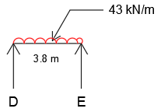  $V_{DE}=\left(\frac{43×3.8}{2}\right)+\left(\frac{99.24-0}{3.8}\right)=107.82 kN$  $V_{ED}=\left(\frac{43×3.8}{2}\right)+\left(\frac{0-99.24}{3.8}\right)=55.58 kN$  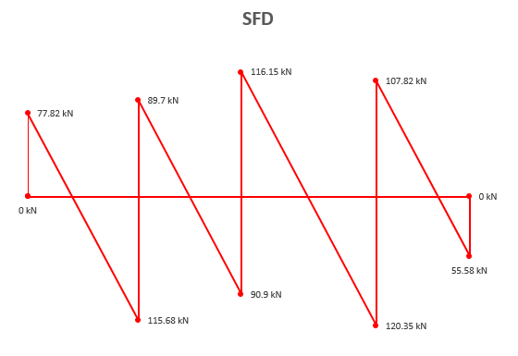  DESIGN  Beam size = 230 * 600 mm  Beam span = 18 m  Characteristic strength of concrete, $f_{cu}=25N/{{mm}^{2}}$  Characteristic strength of steel, $f_{y}=410N/{{mm}^{2}}$  Diameter of bar, $θ_{bar}=16 mm$  Diameter of stirrup, $θ_{stirrup}=10 mm$  Cover = 20 mm  Effective depth, $d=h-cover-1/2θ_{bar}-θ_{stirrup}$  $d=600-20-8-10=562 mm$  Supports  $M_{max}=99.24 kNm$  Ultimate moment of resistance, $M_{u}=0.156f_{cu}bd^{2}$  $M_{u}=\frac{0.156×25×230×{562}^{2}}{1000×1000}=283.31 kNm$  $k=\frac{M_{max}}{bd^{2}f_{cu}}=\frac{99.24×{10}^{6}}{230×{562}^{2}×25}=0.0546$  Lever arm factor, $la=0.5+\sqrt{0.25-\frac{k}{0.9}}$  $la=0.5+\sqrt{0.25-\frac{0.0546}{0.9}}$  $la=0.935<0.95$  Lever arm, $z=lad=0.935×562=525.47 mm$  Area of steel in tension, $As=\frac{M_{max}}{0.95f_{y}z}$  $As=\frac{99.24×{10}^{6}}{0.95×410×525.47}=484.88 {mm}^{2}$  Provide 3Y16 bars TOP $\left(As=603 {mm}^{2}\right)$  Check;  $0.15≤\frac{100As}{bd}≤4$  $0.15≤\frac{100×603}{230×562}≤4$  $0.15<0.47<4$  Spans  ${M^{s}}_{max}=69.14 kNm$  $k=\frac{{M^{s}}_{max}}{bd^{2}f_{cu}}=\frac{69.14×{10}^{6}}{230×{562}^{2}×25}=0.0381$  Lever arm factor, $la=0.5+\sqrt{0.25-\frac{k}{0.9}}$  $la=0.5+\sqrt{0.25-\frac{0.0381}{0.9}}$  $la=0.955>0.95$  Lever arm, $z=lad=0.95×562=533.9 mm$  Area of steel, $As=\frac{{M^{s}}_{max}}{0.95f_{y}z}$  $As=\frac{69.14×{10}^{6}}{0.95×410×533.9}=332.48 {mm}^{2}$  Provide 2Y16 bars BOTTOM $\left(As=402 {mm}^{2}\right)$  Deflection  Design service stress, $f_{s}=\frac{2}{3}×f_{y}×\frac{{As}_{req}}{{As}_{prov}}$  $f_{s}=\frac{2}{3}×410×\frac{332.48}{402}=226.0643$  Modification factor, $Mf=0.55+\frac{\left(477-f_{s}\right)}{120\left(0.9+\frac{{M^{s}}_{max}}{bd^{2}}\right)}≤2$  $Mf=0.55+\frac{\left(477-226.0643\right)}{120\left(0.9+\frac{69.14×{10}^{6}}{230×{562}^{2}}\right)}≤2$  $Mf=1.68<2$  Deflection, $df=\frac{beam span}{26×Mf}$  $df=\frac{18×{10}^{3}}{26×1.68}$  $df=412.09 mm$  Shear  Shear force, $V_{max}=120.35 kN$  Shear stress, $v=\frac{V_{max}}{bd}$  $v=\frac{120.35×{10}^{3}}{230×562}=0.93N/{{mm}^{2}}$  Permissible shear stress, $v_{c}=0.79×\frac{{\left(\frac{100As}{bd}\right)}^{\frac{1}{3}}×{\left(\frac{400}{d}\right)}^{\frac{1}{4}}}{λ_{m}}$  $λ_{m}=1.25$  $v_{c}=0.79×\frac{{\left(\frac{100×402}{230×562}\right)}^{\frac{1}{3}}×{\left(\frac{400}{562}\right)}^{\frac{1}{4}}}{1.25}=0.39N/{{mm}^{2}}$  The shear condition is (iii), that is, $\left(v_{c}+0.4\right)<v<0.8\sqrt{f_{cu}} OR 5$  Hence, minimum stirrups are required throughout the beam span  Spacing, $s_{v}=\frac{0.95{As}_{v}f_{y}}{b\left(v-v_{c}\right)}$  ${As}_{v}=2×\frac{π×{10}^{2}}{4}=157{ mm}^{2}$  $s_{v}=\frac{0.95×157×410}{230\left(0.93-0.39\right)}=492.36 mm$  But spacing is limited to 300 mm  Provide 2 legs Y10 @ 300 mm c/c stirrups throughout  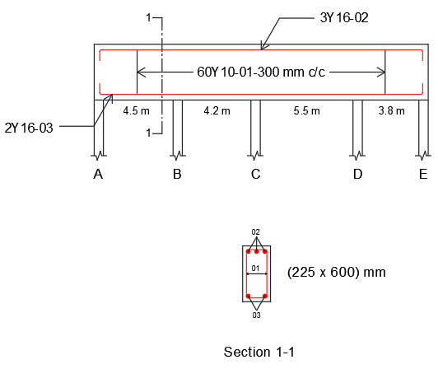  (230 x 600) mm | $$M<M_{u}$$  Only tension reinforcement is required  Use 0.935 as lever arm factor  All supports:  3Y16 TOP  Area of steel provided lies within the limit  Use 0.95 as lever arm factor  All spans:  2Y16 BOTTOM  Use 1.68 as modification factor  $$df<d$$  Deflection is satisfied  Stirrups:  2 legs Y10 @ 300 mm c/c

