Name: Fagbemi Victoria Ifeoluwa
Department: Nursing Science
Matric No: 19/MHS02/053
Bio 102

Importance of Fungi to man include:
- Fungi are important to man for the following reasons;
- They are responsible for the mediation of the decay of dead organic matter.
- Yeast is important in food industries like bakeries and yogurt making factories.
- Mushrooms are eaten by man.
- Some fungi are parasites to obnoxious pests of man
Cell structure of a fungi
Fungi are eukaryotes and have a complex organization. As eukaryotes, fungal contains a membrane-bound nucleus where the DNA is wrapped around the histone proteins. A few types of fungi have structures comparable to bacterial plasmids (coops of DNA). Fungal cells also contain mitochondria and a complex system of internal membranes. Including Endoplasmic reticulum and Golgi apparatus. There is no chlorophyll or chloroplast. Fungi also possess cellular pigments.
The rigid layers of Fungal Cell Walls contain complex polysachariddes called chitin(found in the exoskeleton which gives structural strength to the cell walls of fungi) and glucans.
Fungi have plasma membrane similar to eukaroyes except that the structure is stabilized by eryosterol which replaces cholestrol
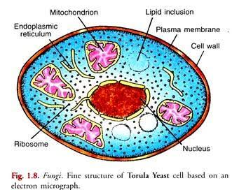

3. Sexual reproduction in a filamentous fungi like Rhizopus stolonifer undergoes the following steps;
- First, two mating types of hyphae grow in the same medium.
- A chemical interaction between them causes growth perpendicular to the hyphae in opposite directions, so they can meet with one another.
- The growths are the delimited by a wall just so the nuclei are isolated in differentiated sex organs called gametangia (plural).
- The gametangia fuse in a process called plasmogamy and together they form a zygote which may undergo dormancy for a period.
- The nuclei in the zygote fuse in twos and undergo meiosis independently, it then moves on to germinating under favorable conditions so as to liberate haploid spores at maturity through the production of a fruiting.
vi. In summary, sexual reproduction in fungi consists of three stages; plasmogamy, karogamy and meiosis
4.
Bryophte survive with the waxy cuticle which help protect the plants tissue from dying out and the mentangia which provide further protection against drying in certain plants gametes.
5.
Eusteles: A type of siphonostele in which the vascular tissue in the stem formsa central ring of bundles around a pith. The vascular bundles are discrete, concentric collateral bundles of xylem and phloem .

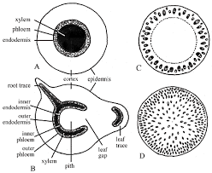
Atactostele:A type of eustele,found in monocots,in which the vascular tissue in the stem exist as scattered bundles.
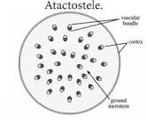
Siphonostele: A stele in which the vascular tissue is in the form of a cylinder surrounding the pith, as in the stems of most ferns and other seedless vascular plant.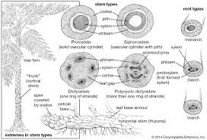
6.
Life cycle of a Fern: the life cycle has two different stages; sporophyte, which releases spores, and gametophyte, which releases gametes. Gametophyte plants are haploid, sporophyte plants diploid. This type of life cycle is called alternation of generations.
The diagram below explains the life cycle