NAME: Agbogu David Tobechukwu
MATRIC NO: 19/MHS01/052
DEPT: MBBS COLLEGE MHS

1 How are fungi important to mankind?
- Fungi serve as yeast for food industries
- Fungi are responsible for breaking down organic matter and releasing carbon, oxygen, nitrogen and phosphorus into the soil.
- They also help in the production of medicines.
2 illustrate the cell structure of a unicellular fungus with a well labeled diagram.
Brewer’s yeast is one of the best known examples of unicellular forms in fungi. The cell structure is very simple, though the organism is one of the more advanced fungal forms from the point of view of its spore-producing structures. Cell exists in diploid/ haploid states. Under favourable environmental condition, in both states, they multiply rapidly by simple mitotic cell divisions- budding involving nuclear division and division of the cytoplasm in such a way that one segment of the constricted cytoplasm is smaller than the others.
Diploid cell arise from haploid cells by processes of plasmogamy and karyogamy (some kind of fertilization). A diploid cell may undergo meiosis under certain conditions to produce four(4) haploid spores---ascospores (contained in simple structure- an ascus).
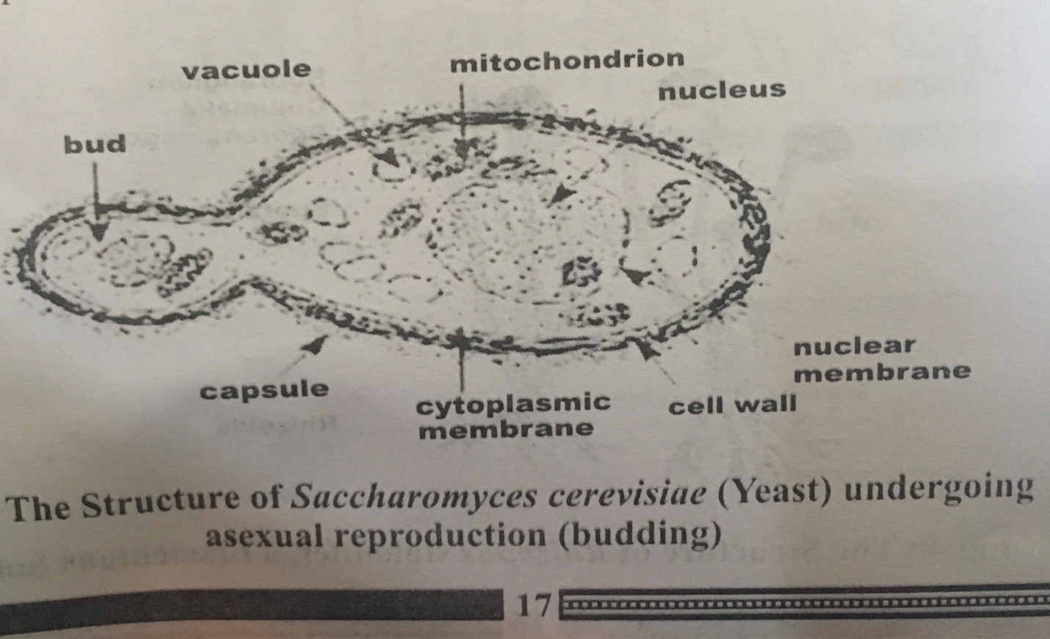
3 Outline the sexual reproduction in a typical filamentous form of fungi.
Sexual reproduction occurs when two mating types of hyphae grow in the same medium. Chemical interaction in the two mating types of hyphae induces growths perpendicular to the hyphae in opposite directions. These growths are delimited by a wall such that many nuclei are isolated in what is called a gametangium. The two gametangia fuse (plasmogamy) and a zygote is formed which may undergo dormancy or resting stage. The nuclei in the zygotes fuse in twos and undergo meiosis independently. The zygote germinates under favourable conditions to produce a fruiting which at maturity liberates the haploid spores.
4 How do bryophytes adapt to their environment?
- They have definite structures for water and nutrient absorption from the soil; therefore the plant body is divided into two (an aerial portion and a subterranean portion). The subterranean portion is the rhizoid and is not a true root as the case of land plants that are advanced.
- The aerial portion being exposed to the atmosphere demands some modifications that prevent excessive loss of water through the body surface.

5 Describe with illustration the following terminologies
- Eusteles: in herbaceous dicotyledonous plants----Eusteles in which the vascular bundles are discrete, concentric collateral bundles of xylem and phloem.
- Atactostele: in grasses and many monocotyledonous plants---Atactostele i.e. the vascular bundles are scattered. The nature of the vascular supply to leaves is also note worthy element of the vascular system.
- Siphonostele: they are more advanced vascular systems e.g. stem of ferns and higher vascular plants, the stele is a cylinder enclosing parenchymatous pith.
- Dictyostele: in siphonosteles, vascular supply to leaves is associated with leaf gaps and the conducting cylinder is a dissected one—dictyostele.
6 illustrate the lifecycle of a primitive vascular plant.
The life cycle of pteridophytes shows apparent alternation of generations but is dominated by the sporophyte phase. They have been evolving towards having a more reduced gametophyte and a more developed sporophyte. The asexual generation of pteridophytes is the diploid(2n) sporophyte. Sporophytes are conspicuous and long-lived. They produce many sporangia, which contain a sporocyte. Sporocytes form haploid spores via meiosis and this is when the sexual generation starts. Ferns are either homosporous or heterosporous. As spores mature, they leave the ferns, germinate in appropriate environments and develop into a gametophyte. Gametophytes are small-sized, simple in structure and short-lived. Gametophytes of homosporous ferns are bisexual and enclose both archegonium and antheridium. Gametophytes of heterosporous ferns are unisexual and enclose archegonium and antheridium respectively. Archegonia contain eggs, while antheridia contain sperms. Sperms use their flagella to swim to the egg in the archegonia via watery media and under attraction of chemicals (mainly malic acid and salts). The fertilized diploid(2n) zygote will grow into an embryo and continue to develop in the gametophyte. Then the gametophyte will perish very quickly while the embryo will develop into a free-living sporophyte, which is the green fern we usually see.

