NAME: Anita C. Ekweozor
MATRIC NO: 18/sms13/005
COURSE: SOC 204 (sociology of the family)
LEVEL: 200

QUESTIONS
- WRITE ON THE HISTORY OF YOUR FAMILY UP TO THE THIRD GENERATION
- DISCUSS THE FUNCTIONS PERFORMED BY YOUR FAMILY
- WORK ON YOUR FAMILY TREE AND EXPLAIN THE KIN CONNECTIONS.

ANSWERS
- My matrilineal grand dad married only one wife whom is my dad’s mother and my grandmother, while my matrilineal grand dad also married one wife is my mum’s mother and my grandmother, my mother’s parents gave birth to 9 children which consists of 4 male and 5 female then my paternal grandparents gave birth to 7 children which consists of 3 male and 4 female.
My maternal grandparents were traders and weren’t educated but they were very successful in their businesses and earned a lot, while my paternal grandparents we’re farmers and weren’t really educated neither did they have a flourishing business as well but they managed to send some of their children to school who later became successful and sent the younger ones to school to get quality education.
My parents gave birth to 5 children which consist of 2 male and 3 female, in which I am the first. I have 22 cousins from my maternal side and 13 from my ppaternal side.

- There are some functions performed by my family, the family is the primary unit for socializing children. As previous chapters indicated, no society is possible without adequate socialization of its young. In most societies, the family is the major unit in which socialization happens. Parents, siblings, and, if the family is extended rather than nuclear, other relatives all help to socialize children from the time they are born, the family is ideally a major source of practical and emotional support for its members. It provides them food, clothing, shelter, and other essentials, and it also provides them love, comfort, help in times of emotional distress, and other types of intangible support that we all need. The family helps regulate sexual activity and sexual reproduction. All societies have norms governing with whom and how often a person should have sex. The family is the major unit for teaching these norms and the major unit through which sexual reproduction occurs. One reason for this is to ensure that infants have adequate emotional and practical care when they are born. The incest taboo that most societies have, which prohibits sex between certain relatives, helps to minimize conflict within the family if sex occurred among its members and to establish social ties among different families and thus among society as a whole, the family provides its members with a social identity. Children are born into their parents’ social class, race and ethnicity, religion, and so forth. social identity is important for our life chances. Some children have advantages throughout life because of the social identity they acquire from their parents, while others face many obstacles because the social class or race and ethnicity into which they are born are at the bottom of the social hierarchy. Beyond discussing the family’s functions, the functional perspective on the family maintains that sudden or far-reaching changes in conventional family structure and processes threaten the family’s stability and thus that of society. For example, most sociology and marriage-and-family textbooks during the 1950s maintained that the male breadwinner–female homemaker nuclear family was the best arrangement for children, as it provided for a family’s economic and child-rearing needs. Any shift in this arrangement, they warned, would harm children and by extension the family as a social institution and even society itself. Textbooks no longer contain this warning, but many conservative observers continue to worry about the impact on children of working mothers and one-parent families.

3) 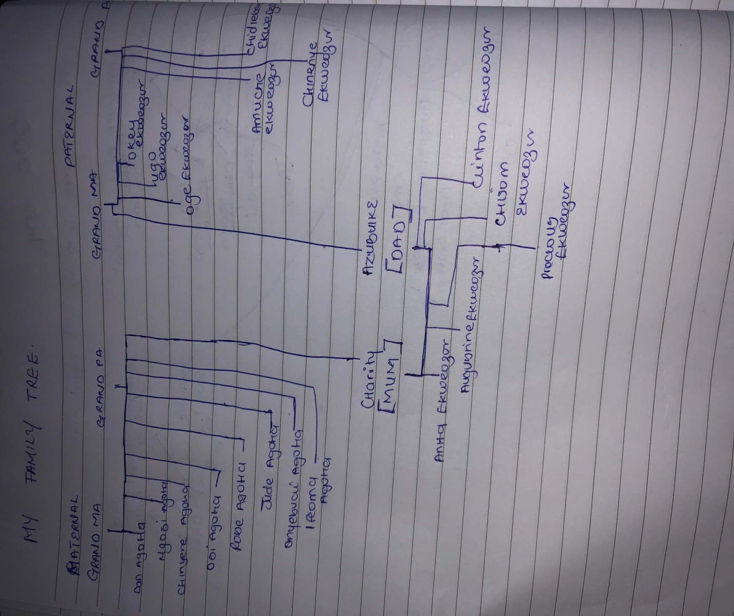

Kin Relationships
Kin relationships are traditionally defined as ties based on blood and marriage. They include lineal generational bonds (children, parents, grandparents, and greatgrandparents), collateral bonds (siblings, cousins, nieces and nephews, and aunts and uncles), and ties with in-laws. An often-made distinction is that between primary kin (members of the families of origin and procreation) and secondary kin (other family members). The former are what people generally refer to as “immediate family,” and the latter are generally labeled “extended family.” Marriage, as a principle of kinship, differs from blood in that it can be terminated.

