Name: OKONKWO ELOCHUKWU EMMANUEL
Department: PHARMACY
Matric No: 18/MHS07/037
BIO 102
- Importance of Fungi to man include:
- fungi maintain soil fertility
- fungi are used ass decomposers
- Fungi can also be consumed as food by man
- Fungi can be used as test organism in labs
- Fungi react with plants mycorrhiza which is found on the root of plants

- Cell structure of a fungi
Fungi are eukaryotes and have a complex organization. As eukaryotes, fungal contains a membrane-bound nucleus where the DNA is wrapped around the histone proteins. A few types of fungi have structures comparable to bacterial plasmids (coops of DNA). Fungal cells also contain mitochondria and a complex system of internal membranes. Including Endoplasmic reticulum and Golgi apparatus. There is no chlorophyll or chloroplast. Fungi also possess cellular pigments.
The rigid layers of Fungal Cell Walls contain complex polysachariddes called chitin(found in the exoskeleton which gives structural strength to the cell walls of fungi) and glucans.
Fungi have plasma membrane similar to eukaroyes except that the structure is stabilized by eryosterol which replaces cholestrol
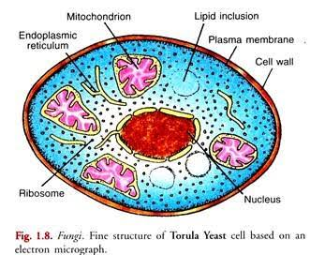

3. Reproductioon in filamentous form of fungi
Hyphae which is filamentous form of fungi reproduces by realizing quantities of spores , Spores maybe produced eitheer directlyby asexual methods or sexually
Sexual Reproduction consists of three sequential stages; Plasmogamy,karyogamy and meisois. While asexuall it can be done through budding and fragmentation.
4. Bryophte survive with the waxy cuticle which help protect the plants tissue from dying out and the mentangia which provide further protection against drying in certain plants gametes.
5. Eusteles: A type of siphonostele in which the vascular tissue in the stem formsa central ring of bundles around a pith. Monoctlydons exhibit this.

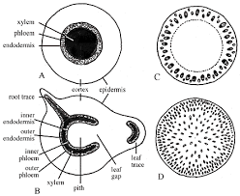
Atactostele: A type of eustele,found in monocots,in which the vascular tissue in the stem exist as scattered bundles.
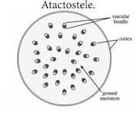
Siphonostele: A stele in which the vascular tissue is in the form of a cylinder surrounding the pith, as in the stems of most ferns and other seedless vascular plant.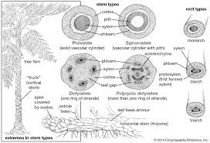
6. Life cycle of a Fern: the life cycle has two different stages; sporophyte, which releases spores, and gametophyte, which releases gametes. Gametophyte plants are haploid, sporophyte plants diploid. This type of life cycle is called alternation of generations.
The diagram below explains the life cycle