ADELOTAN HAIRAT OLASUBOMI
19/MHS01/032
MEDICINE AND SURGERY
BIO 102
ASSIGNMENT
- How are fungi important to mankind?
Fungi are important to mankind in the following ways:
- Fungi e.g. yeasts are important in the food industry like in the production of beer, wine and bread.
- They also serve as food for man e.g. mushrooms.
- Fungi not only directly produce substances that humans use as medicine, but they are also versatile tools in the vast filed of medical research.
- They serve as natural pesticides by attacking insects.

- Illustrate the cell structure of a unicellular fungus with a well labelled diagram.

- Outline the sexual reproduction in a typical filamentous form of fungi.
Sexual reproduction in a filamentous fungus: Rhizopus stolonifer;
- This occurs when two mating types of hyphae grow in the same medium.
- Chemical interaction in the two mating types of hyphae induces growths perpendicular to the hyphae in opposite directions. These growths are delimited by a wall such that many nuclei are isolated in what is called a gametangium.
- The two gamentangia fuse(plasmogamy) and a zygote is formed which may undergo prolonged dormancy or resting stage.
- The nuclei in the zygotes fuse in two’s and undergo meiosis independently.
- The zygote germinates under favourable conditions to produce a fruiting which at maturity liberates the haploid spores.
- How do bryophytes adapt to the environment?
- The aerial portion being exposed to the atmosphere demands some modifications that prevents excessive loss of water through the body surface (i.e. desiccation)
- They have definite structures for water and nutrient absorption from the soil; therefore, the plant body is divided into two an aerial and subterranean portion.
- Some other modifications that permit elimination of excess water from the plant body and not only exchange of gases between the internal parts of the plant and the atmosphere therefore, openings are available on the aerial parts of the plant.
- Describe with illustration the following terminologies:
- Eusteles; A stele typical of dicotyledonous plants that consist of vascular bundles of xylem and phloem strands with parenchymal cells between the bundles.
- Atactostele; A stele found in monocots in which the vascular tissue in the stem exists as scattered bundles.
- Siphonostele; A stele consisting of a core of pith surrounded by concentric layers of xylem and phloem.
- Dictyostele; A stele in which the vascular cylinder is broken up into a longitudinal series or network of vascular strands around a central pith.

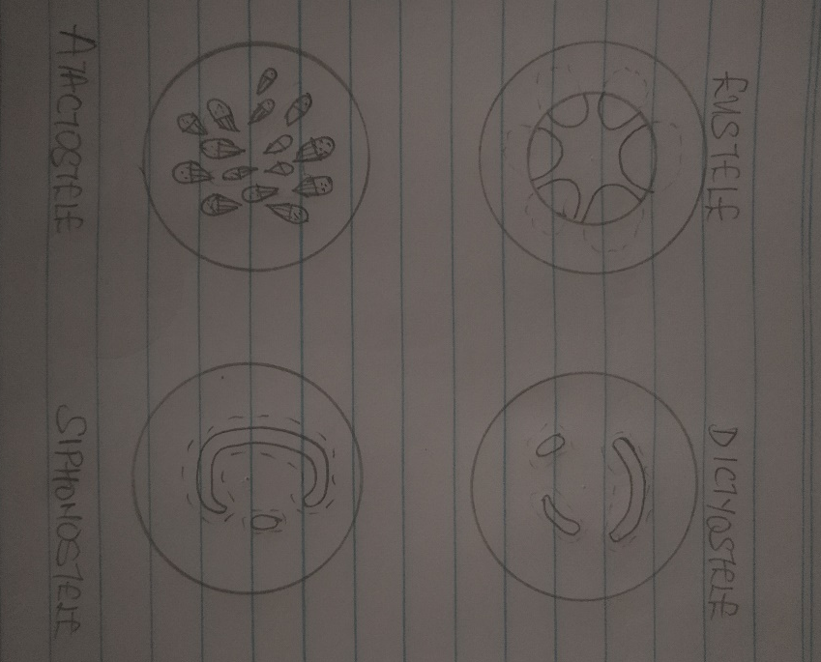

- Illustrate the life cycle of a primitive vascular plant
A primitive vascular plant example is Psilotum.

