NAME: ADEBAYO ADEDAMOLA AYODEJI
COURSE TITLE: GENERAL BIOLOGY II
COURSE CODE: BIO 102
MATRIC NUMBER: 19/MHS01/020

QUESTIONS
- How are fungi important to mankind
- Illustrate the cell structure of a unicellular fungus with a well labelled diagram
- Outline the sexual reproduction in a typical filamentous form of fungi
- How do bryophytes adapt to their environment?
- Describe with the illustration the following terminologies:(a) eusteles (b) atactostele (c)siphonostele (d) dictyosytele
- Illustrate the live cycle of a primitive vascular plant

1 IMPORTANCE OF FUNGI TO MANKIND
They serve as Animal pathogen by controlling the population of damaging pests
They are essential for the productivity of a farmland
They help in fermentation of grains to produce beer and fermentation of fruit to produce wine
They naturally produce Antibiotics to kill or inhibit the growth of bacteria
They serve as food to man E.g Mushroom
Many fungi species mediate the spoilage of wood, food, clothes and paper
Fungi are responsible for the meditation of decay of organic material

2 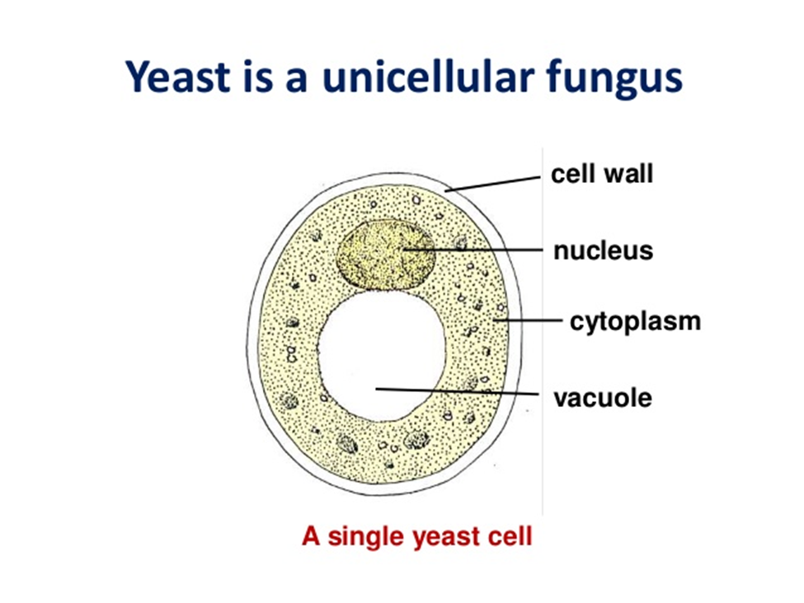

3 SEXUAL REPRODUCTION IN A TYPICAL FILAMENTOUS FORM OF FUNGI
Sexual reproduction occurs when two mating types of hyphae grow in the same medium. Chemical interactions in the two mating types of hyphae indicates growths perpendicular to the hyphae induces growth perpendicular to the hyphae in opposite directions. These growths are delimited by a wall such that many nuclei are isolated in what is called a gametangium.
The two gametangia fuse(Plasmogamy) and a zygote is formed which may undergo prolong dormancy or resting stage. The nuclei in the zygotes fuse in twos and undergo meiosis independently
The zygote germinates under favorable conditions to produce a fruiting which at maturity liberates the haploid spores.
Relatives of rhizopus in similar circumstance are many. Mucor spp are a group which lack rhizoids.
The genes pilobolus is usually found growing on cow/Horse dung

4 Adaptation of bryophytes to their Environment
- They have definite structures for water and nutrient absorption from the soil; therefore the plant body is divided into two (an aerial portion and a subterranean portion). The subterranean portion is the rhizod and is not a true root as the case of the land plants that are advanced
- The aerial portion being exposed to the atmosphere demands some modifications that prevents excessive loss of water through the body surface (i.e desiccation)
- Some other modifications that permit elimination of excess water from the plant body and not only exchange of gases between the internal parts of the plant and the atmosphere therefore opening are available on the aerial parts of the plants

5(a) Eusteles: A type of siphonstele, in which the vascular tissue in the stem forms a central ring of bundles around a pith

5(b) Atactosele: A type of eustele, found in monocots, in which the vascular tissue in the stem exists as scattered bundles

5(c) Siphonstele: A type of stele in which the vascular tissue the pstem forms a cylinder surrounding a central pith and possessing leaf gaps

5(d) Dictyostele : A type of siphonstele, in which the vascular tissue in the stem forms a central cylinder around a pith, but with closely spaced leaf gaps

