NAME: OBOLO FAITH IFEOLUWA
MAT NO: 19/MHS01/274
DEPT: MEDICINE AND SURGERY
BIO 102 ASSIGNMENT
- How are fungi important to mankind?
- Illustrate the cell structure of a unicellular fungus with a well labelled diagram
- Outline the sexual reproduction in a typical filamentous form of fungi
- How do bryophytes adapt to their environment?
- Describe with illustration the following terminologies (a) eusteles (b) atactostele (c) siphonostele (d) dictyostele
- Illustrate the life cycle of a primitive vascular plant

ANSWER
- Fungi are important to mankind in the following ways;
- They are responsible for the mediation of decay of organic matter.
- Without them the surface of the earth would have been clogged up with dead matters with all the various elements locked up in them instead of returning into their various cycles.
- Fungi e.g yeast is important in the food industry.
- Some fungi species are used to produce important antibiotics.
- Many fungi species mediate the spoilage of wood, food, clothes and paper.
- Many are plant pathogens causing blights and smuts in cereals.
- Some fungi are parasites to certain horrible obnoxious pests.

- Diagram of a unicellular fungus.
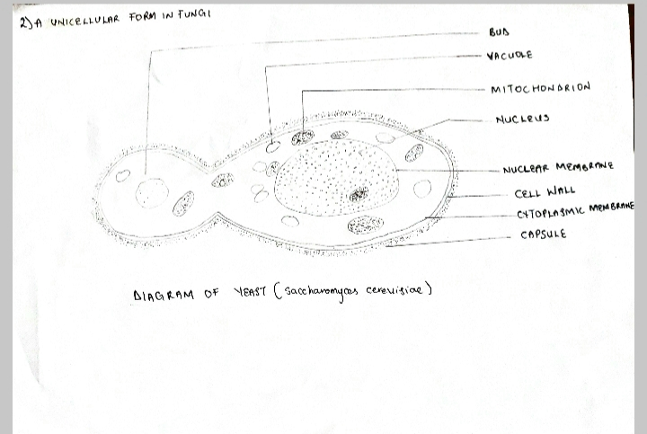

- Sexual reproduction occurs when two mating types of hyphae grow in the same medium. Chemical interaction in the two mating types of hyphae induces growths perpendicular to the hyphae in opposite directions. These growths are delimited by a wall such that many nuclei are isolated in what is called a gametangium. The two gametangia fuse and a zygote is formed which may undergo prolonged dormancy or resting stage. The nuclei in the zygote fuse in twos and undergo meiosis independently. The zygote germinates under favourable conditions to produce a fruiting which at maturity liberates the haploid spores.
- Bryophytes adapt to their habitat because;
- They have definite structures for water and nutrient absorption from the soil; therefore, the plant body is divided two (an aerial portion and a subterranean portion). The subterranean portion is the rhizoid and is not a true root as the case of land plants that are advanced.
- The aerial portion being exposed to the atmosphere demands some modifications that prevents excessive loss of water through the body surface (i.e. desiccation).
- Some other modifications that permit elimination of excess water from the plant body and not only exchange of gases between the internal parts of the plant and the atmosphere therefore openings are available on the aerial parts of the plant.

- The terminologies;
- Eusteles: This is a vascular organization in herbaceous dicotyledonous plants in which the vascular bundles are discrete, concentric collateral bundles of xylem and phloem.
- Atactostele: This is a vascular organization in grasses and many monocotyledonous plants in which the vascular bundles are scattered.
- Siphonostele: This is a vascular organization in more advanced vascular systems e.g. stems of ferns and higher vascular plants in which the stele is a cylinder enclosing a parenchymatous pith.
- Dictyostele: This is a vascular organization in siphonosteles in which vascular supply to leaves is associated with leaf gaps and the conducting cylinder is a dissected one.
ILLUSTRATION
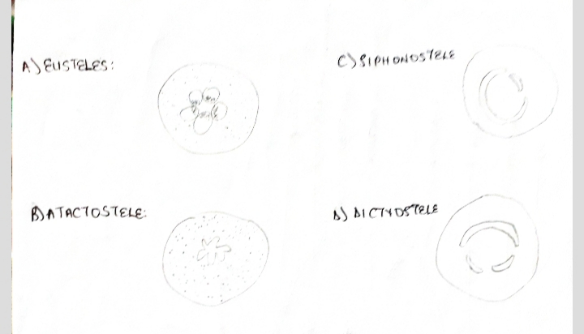

- Life cycle of a primitive vascular plant
