NAME: OGUNNIKE IYANUOLUWA. O
MATRIC NO: 18/MHS05/011
COURSE: PHS 204
DEPARTMENT: PHYSIOLOGY
COLLEGE: MHS

QUESTION
Title: Discuss lactation and gestation period in a normal female
Question: I expect more on the physiology of lactation and details on the physiology of pregnancy in a normal woman.

PHYSIOLOGY OF LACTATION
Lactation is the hallmark feature of female mammals. It is the secretion of milk from the mammary glands to provide nourishment to offspring. It begins at the midpoint of pregnancy.
Lactation is under endocrine control. The two hormones involved are prolactin and oxytocin. Prolactin is responsible for production of milk while oxytocin is responsible for ejection of milk caused by contraction of myoepithelial cells in the breast.
Lactogenesis, or the process of changes to the mammary glands to begin producing milk, begins during the late stage of pregnancy.
The physiology of lactation is a process that begins to take effect well before the initial latch of the newborn infant. It requires the mammary glands to change size, shape and composition during each stage of female development. (puberty, pregnancy and lactation).
Galactopoiesis is the maintenance of milk production. This stage requires prolactin and oxytocin.

Here are the stages of lactation:
- Mammogenesis: development of breasts to a functional state.
- Lactogenesis: synthesis and secretion of milk from the breast alveoli.
- Galactokinesis: ejection of milk outside the breast.
- Galactopoiesis: maintenance of lactation.
- Involution: regression and atrophy post lactation.

- By the fifth or sixth month of pregnancy, the breasts are ready to produce milk.
- Then at the latter part of pregnancy, the mammary glands enter into the lactogenesis I stage; this is when the breasts make colostrum, a thick, sometimes yellowish fluid.
Note: Colostrum is the first milk a breastfed baby receives. It has higher amount of white blood cells and antibodies than mature milk and is especially high in immunoglobin A, which coats the lining of the baby’s immature intestines and prevents pathogens from invading the baby’s system.

- At birth, prolactin levels remain high, while the delivery of the placenta results in a sudden drop of progesterone, estrogen and human placental lactogen levels. This stimulates the copius milk production of lactogenesis II stage.
- When the breast is stimulated, prolactin levels in the blood rise and peak in about forty-five minutes, then return to the pre-breastfeeding state about three hours later.
- The release of prolactin triggers the cells in the alveoli to make milk.
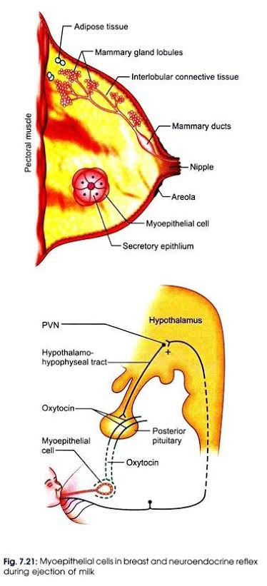
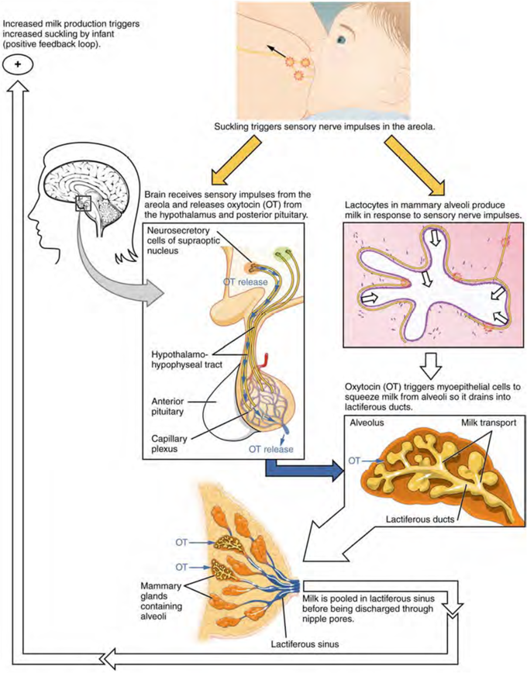

PHYSIOLOGY OF PREGNANCY
Pregnancy is the time from fertilization of an egg till birth. Pregnancy is a very complicated process that takes a lot of resources and as a result can have a wide range of effects on the mother, both physically and emotionally.
Unlike unfertilized eggs that proceed unaltered and disintegrate, a fertilized egg develops into a tiny embryo and travels to the uterus, where it implants itself in the uterine wall, develops into a fetus and grows steadily until it becomes a baby.
Pregnancy is divided into four stages:
- Initiation;
- Fertilization
- Implantation
- Secretion of HCG to “rescue” the corpus luteum.
- Gestation: it is the period of time between conception and childbirth. During this time, the baby grows and develops inside the mother’s womb.
- Parturition: the process of giving birth. It results from a complex interplay of maternal and fetal factors due to the sequential maturation of an endocrine organ communication system.
- Lactation.

