NAME: OGUNTUNDE RACHAEL OPEYEMI
MATRIC NO: 19/MHS10/003
DEPT: OPTOMETRY
COLLEGE: MHS
COURSE: BIO 102
- Importance of Fungi to mankind
- Fungi are responsible for the mediation of decay of organic matter.
- Fungi e.g. yeast are important in food industry.
- Mushrooms are eaten by many human societies
- Species such as Penicillium notatum produce important antibodies.
- Some fungi are parasites to some certain horrible obnoxious pests e.g. houseflies, grasshoppers and therefore serve as important biological control agents in regard to such pests.
- Fungi are very important to the entire terrestrial ecosystem in material cycling.
- The cell structure of a unicellular fungus with a well labeled diagram
The cell structure is very simple, though the organism is one of the more advanced fungal forms from the point of view of its spore-producing structures. Cell exists in diploid/ haploid states.
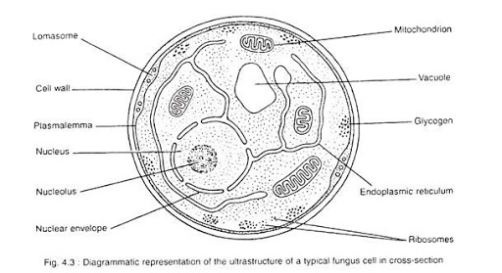

- The sexual reproduction in a typical filamentous form of fungi
Rhizopus stolonifer
This occurs when two mating types of hyphae grow in the same medium. Chemical interaction in the two mating types of hyphae induces growths perpendicular to the hyphae in opposite directions. These growths are delimited by a wall such that many nuclei are isolated in what is called a gametangium.
The two gametangia fuse (plasmogamy) and a zygote is formed which may undergo prolonged dormancy or resting stage. The nuclei in the zygotes fuse in twos and undergo meiosis independently.
The zygote germinates under favourable conditions to produce fruiting which at maturity liberates the haploid spores.
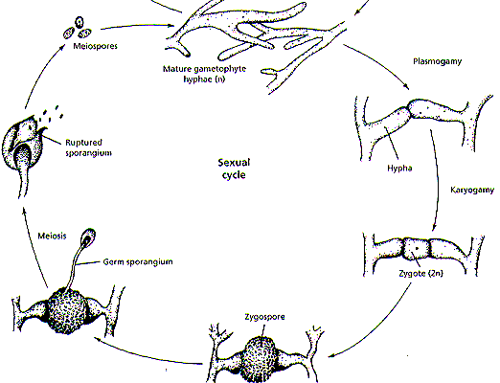

- How Bryophytes adapt to their environment
- They have definite structures for water and nutrient absorption from the soil; therefore the plant body is divide into two (an aerial portion and a subterranean portion). The subterranean portion is the rhizoid and is not a true root as the case of land plants that are advanced.
- The aerial portion being exposed to the atmosphere demands some modifications that prevents excessive loss of water through the body surface (i.e. dessication) and
- Some other modifications that permit elimination of excess water from the plant body and not only exchange of gases between the internal pats of the plant and the atmosphere therefore openings are available on the aerial parts of the plant.

- Describe
- Eusteles:
These are herbaceous dicotyledonous plants in which the vascular bundles are discrete, concentric collateral bundles of xylem and phloem.
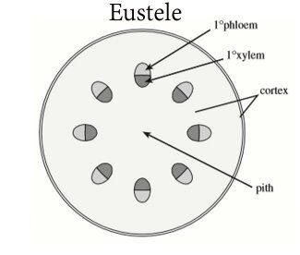

- Atactostele:
This is when the vascular bundle in grasses and monocotyledonous plants are scattered. 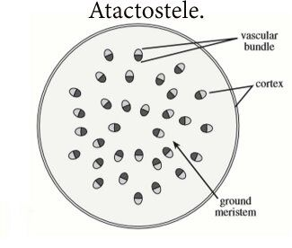

- Siphonostele:
This is found in a more advanced vascular systems e.g. stems of ferns and higher vascular plants, the stele is a cylinder enclosing a parenchymatous pith.
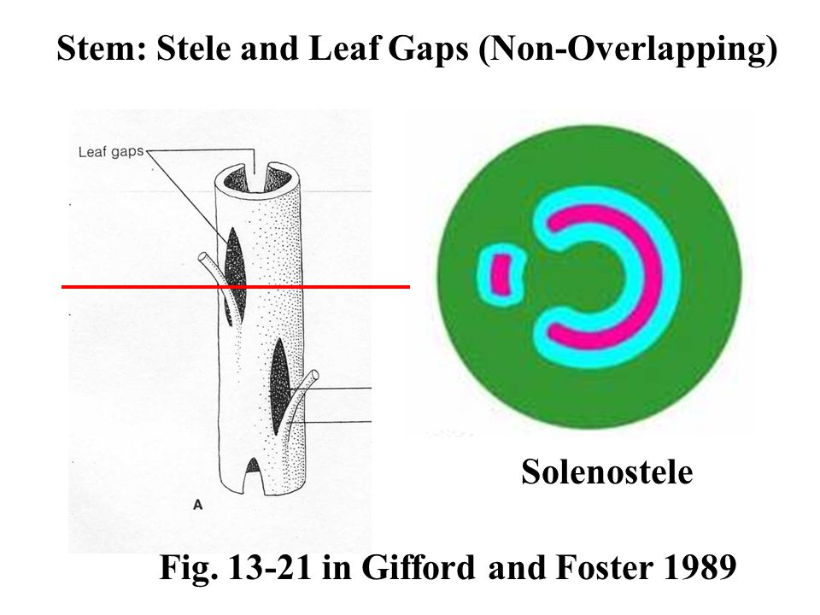
- Dictyostele:
This is when the conducting cylinder is a dissected one.

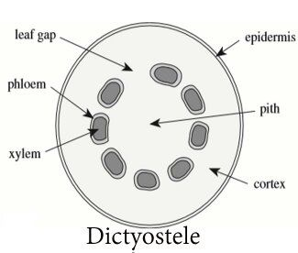

- The lifecycle of a primitive vascular plant.
