IBE CASSANDRA EZINNE
MBBS
19/MHS01/185
BIO 102

Importance of Fungi to Mankind
  - Fungi are responsible for the mediation of decay of organic matter
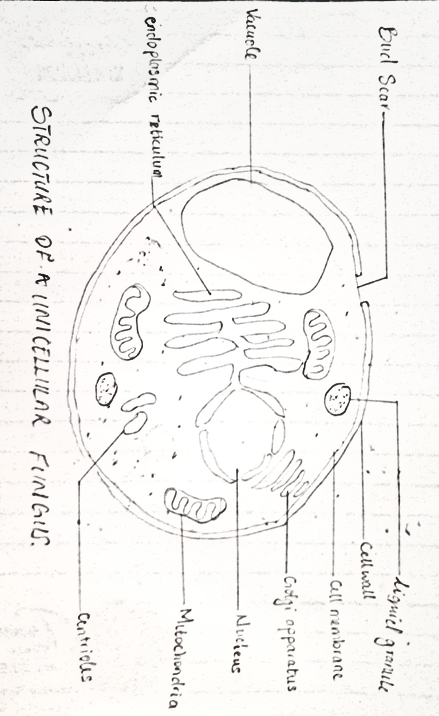
  - Some fungi are parasites to some certain horrible obnoxious pests therefore constituting important biological control agents in regard to such pests
  - Fungi are important in food industry
    - Yeast is used in bakeries
    - Mushrooms are eaten by man

Outline of The Sexual Reproduction in a Typical Filamentous Form of Fungi

  - First, two mating types of hyphae grow in the same medium.
  - A chemical interaction between them causes growth perpendicular to the hyphae in opposite directions.
  - The growths are the delimited by a wall just so the nuclei are isolated in what is called a gametangium.
  - The two gametangia fuse in a process called plasmogamy and a zygote is formed which may undergo dormancy for a period.
  - The nuclei in the zygote fuse in twos and undergo meiosis independently, it then moves on to germinating under favorable conditions so as to liberate haploid spores at maturity through the production of a fruiting.

Adaptation of Bryophytes
  - They possess definite structures for water and nutrient absorption from the soil.
  - They also possess a waxy cuticle that keeps them from drying out through the process of desiccation
  - They possess gametangia that keep the plants gametes from drying out.

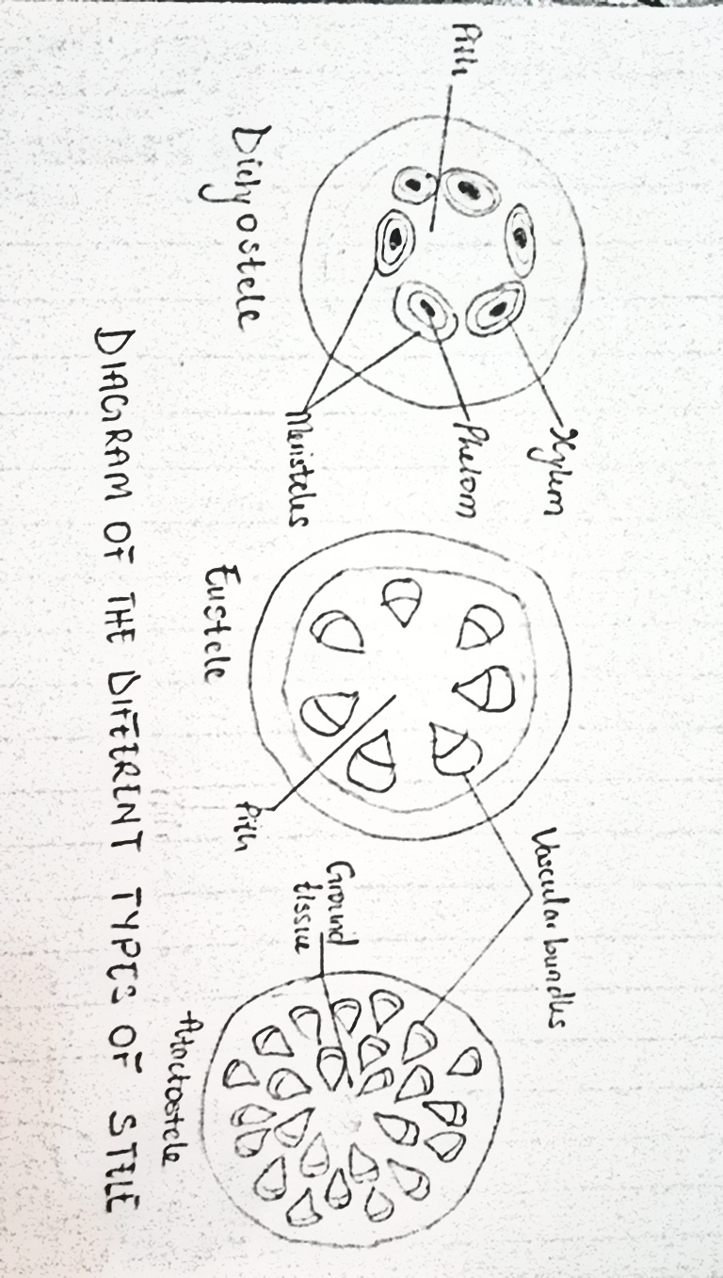
  - Eusteles; a type of stele in which the vascular tissue in the stem forms a central ring of bundles around a pith. The vascular bundles are discrete, concentric collateral bundles of xylem and phloem.
  - Atactostele; a type of stele found in monocots, in which the vascular tissue in the stem exists as scattered bundles.
  - Dictyostele; a type of stele in which the vascular cylinder is broken up into a longitudinal series or network of vascular strands around a pith.

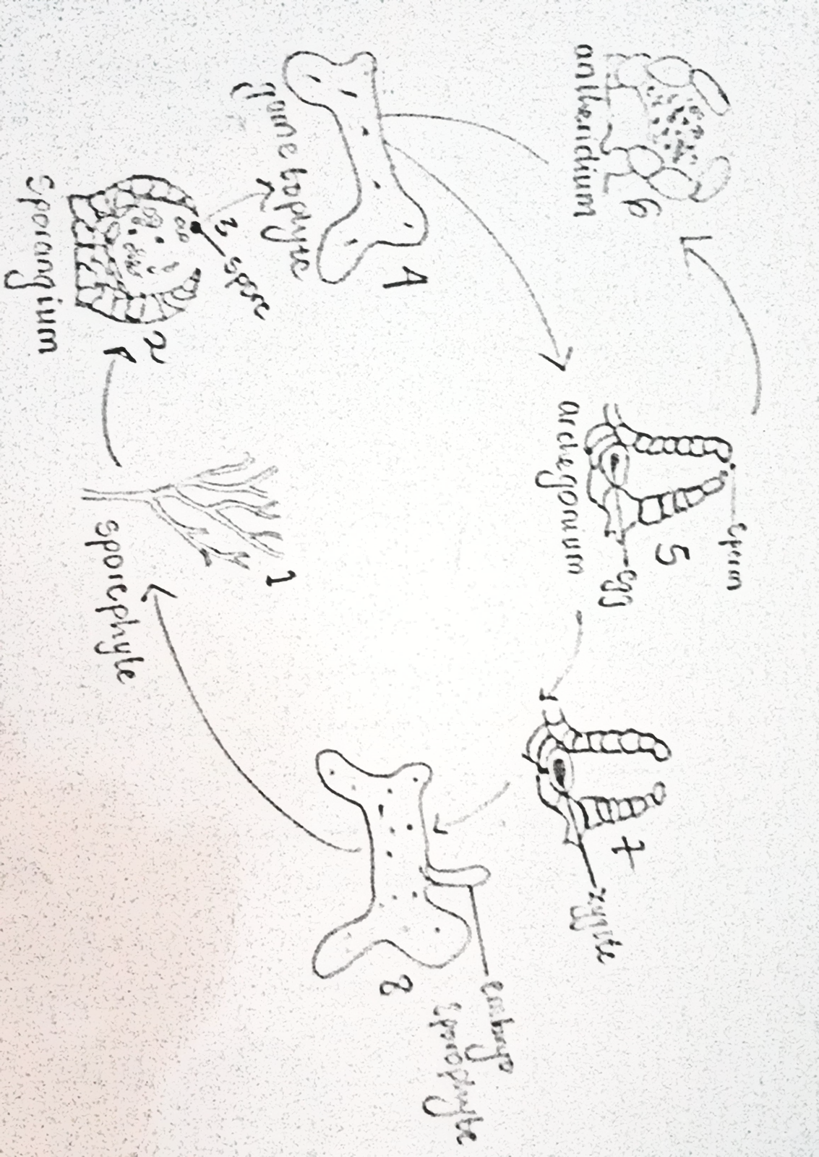
THE LIFE CYCLE OF A PRIMITIVE VASCULAR PLANT

