NAME; UZOSIKE FAITH AMARACHI
DEPARTMENT; ANATOMY
MATRIC NUMBER; 18/MHS03/019
COURSE; CELLULAR BIOCHEMISTRY
COURSE CODE; BCH 308
ASSIGNMENT TITTLE; DIABETES, OBESITY AND CANCER

QUESTION
- What do you understand by primary obesity?
- How does drug therapy and congenital syndrome affect secondary obesity
- Discuss the etiology of cancer and it’s molecular basis.

ANSWERS;

Obesity is a medical condition in which excess body fat has accumulated to an extent that it may have a negative effect on health. People are generally considered obese when their body mass index (BMI), a measurement obtained by dividing a person's weight by the square of the person's height, is over 30 kg/m2; the range 25–30 kg/m2 is defined as overweight. Some East Asian countries use lower values. Obesity increases the likelihood of various diseases and conditions, particularly cardiovascular diseases, type 2 diabetes, obstructive sleep apnea, certain types of cancer, osteoarthritis, and depression.

DRUG THERAPY;

APPETITE SUPPRESSANTS
Various pharmacologic agents, referred to as anorectic drugs, are used as adjuncts to behavioral therapy in weight reduction programs. The two classes of anorectic drugs currently available are the noradrenergic and the serotonergic agents.

Noradrenergic Agents. Noradrenergic drugs affect weight loss through action in the appetite center. Phenylpropanolamine (Dexatrim), a sympathomimetic drug and a synthetic derivative of ephedrine, is available as an over-the-counter appetite suppressant and decongestant. In studies lasting 14 weeks, the subjects who took phenylpropanolamine had a greater weight loss than those who took placebo, although the difference was minimal (In the table below). When taken in daily dosages of 20 to 75 mg, common adverse effects included nervousness, insomnia, dizziness, palpitations and headaches. Phenylpropanolamine in a dosage of 75 mg taken once daily was not associated with a clinically significant increase in blood pressure. When phenylpropanolamine is used in the treatment of obesity, the manufacturers recommend physician supervision if patients are also being treated for high blood pressure, depression or anxiety disorder, or if they have diabetes, heart disease or thyroid disease.

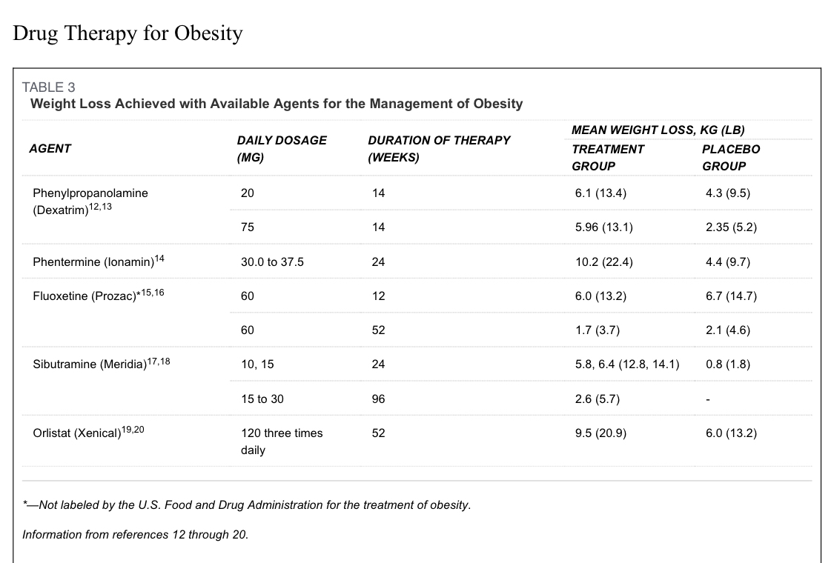
Phentermine (Ionamin) is structurally similar to amphetamine and modulates noradrenergic neurotransmission to decrease appetite; however, it has little or no effect on dopaminergic neurotransmission, which decreases its potential for abuse. The use of phentermine as a single agent is usually limited by an intolerance to its stimulatory activity. Phentermine was previously used in combination with fenfluramine (Pondimin) to improve weight loss and counteract the adverse effects of use of phentermine. Because of the withdrawal of fenfluramine from the U.S. market, phentermine is now used as a single weight-loss agent.

In older clinical trials, the use of phentermine alone resulted in significant weight loss when compared with placebo. In dosages ranging from 30.0 to 37.5 mg per day, phentermine is labeled for the management of exogenous obesity as a short-term (i.e., a few weeks) adjunct in a regimen of weight reduction based on caloric restriction. The most common adverse effects of phentermine include headache, insomnia, nervousness and irritability. Palpitations, tachycardia and elevations in blood pressure may also occur. Phentermine should not be taken by persons with hyperthyroidism, glaucoma, agitated states, advanced arteriosclerosis, symptomatic cardiovascular disease, moderate to severe hypertension or a history of drug abuse.

Serotonergic Agents. The serotonergic drugs partially inhibit the reuptake of serotonin and release serotonin into the synaptic cleft, thus acting on the hypothalamus to decrease satiety.Fenfluramine and dexfenfluramine (Redux), the first serotonergic agents labeled for the treatment of obesity, were withdrawn from the U.S. market in September 1997 because of case reports of valvular heart disease and primary pulmonary hypertension.

Fluoxetine (Prozac) is a highly selective serotonin reuptake inhibitor (SSRI) that has been studied in the treatment of obesity. Fluoxetine may increase energy expenditure by raising basal body temperature; however, weight loss has not been consistent among subjects in clinical trials. In a three-month study, fluoxetine did not significantly reduce weight when compared with placebo. In a longer clinical trial, significantly greater weight loss was achieved in the subjects taking fluoxetine at 20 weeks, compared with the subjects taking placebo. However, after one year, weight loss was not different in the two groups.

Although fluoxetine has been labeled by the U.S. Food and Drug Administration (FDA) for the treatment of depression, bulimia and obsessive-compulsive disorder, the FDA has not labeled fluoxetine for weight loss therapy.

Adrenergic/Serotonergic Agents. Sibutramine (Meridia) is an adrenergic/serotonergic agent recently labeled by the FDA for use in the management of obesity. Sibutramine and its metabolite inhibit monoamine uptake, suppressing appetite in a fashion similar to SSRIs. Sibutramine may also stimulate thermogenesis by activating the beta3-system in brown adipose tissue. Initially tested for its antidepressant activity, sibutramine was found to cause weight loss 1 to 2 kg (2.2 to 4.4 lb) in healthy and depressed patients. In six-month studies, weight loss in subjects taking sibutramine, although modest, was found to be significantly greater than the loss in subjects taking placebo, and weight loss increased with increasing dosages (In the table above). In a continued, open-label, 96-week extension study, weight was regained even in subjects taking high-dose sibutramine.

Sibutramine is indicated for the management of obesity, including weight loss and maintenance of weight loss, and should be used in conjunction with a reduced calorie diet. It is recommended for obese patients with an initial BMI of greater than 30 kg per m2, or greater than 27 kg per m2 in the presence of other risk factors (e.g., hypertension, diabetes, hyperlipidemia).

The recommended starting dosage of sibutramine is 10 mg administered once daily with or without food. If there is inadequate weight loss after four weeks, the dosage may be titrated to 15 mg administered once daily. The 5-mg dosage should be reserved for use in patients who do not tolerate the 10-mg dosage. The most common adverse effects associated with the use of sibutramine are dry mouth, anorexia, constipation and insomnia. A mild increase in blood pressure and heart rate have been noted in some nonhypertensive study participants.

THERMOGENIC AGENTS
The combination of ephedrine and caffeine possesses anorectic and thermogenic properties with only mild, transient side effects. Ephedrine increases the release of norepinephrine, which modulates food intake and acts as a sympathomimetic agent to stimulate heart rate and blood pressure, and enhance thermogenesis. Caffeine, an adenosine antagonist, reduces the breakdown of norepinephrine within the synaptic junction. Ephedrine (20 mg) with caffeine (200 mg [combination product] or two to three cups of caffeinated coffee) taken three times daily was found to be more effective than placebo or either agent alone. Side effects from the use of an ephedrine/caffeine combination (tremor, insomnia and dizziness) were transient after eight weeks of treatment and comparable with placebo effects. This combination is not currently available on the U.S. market.

Selective beta3-adrenergic agonists are currently under investigation. They are believed to increase the rate of metabolism and cause a reduction in weight by decreasing the body lipid content. Interest in this class of drugs began with the recent discovery that a mutation in the gene coding for the beta3-adrenergic receptor was associated with weight gain, abdominal obesity and insulin resistance.

DIGESTIVE INHIBITORS
Another strategy in the treatment of obesity is to use digestive inhibitors that interfere with the breakdown, digestion and absorption of dietary fat in the gastrointestinal tract. A reduction in fat is recommended in most weight loss diets; however, patient compliance with these diets is generally poor. Therefore, digestive inhibitors may have a role in creating the negative energy balance necessary for subsequent weight loss.

Gastric and pancreatic lipases aid in the digestion of dietary triglycerides by forming them into free fatty acids that are then absorbed at the brush border of the small intestine. Inhibition of these enzymes leads to inhibition of the digestion of dietary triglycerides and decreased cholesterol absorption, and may decrease absorption of lipid-soluble vitamins (A, D, E and K). Orlistat (Xenical), the first lipase inhibitor labeled by the FDA for treatment of obesity, is a potent and irreversible inhibitor of gastric and pancreatic lipases, preventing the absorption of about 30 percent of dietary fat.

Orlistat is indicated for use in patients with a BMI of at least 30 kg per m2 or in patients with hypertension, diabetes or dyslipidemia who have a BMI of greater than 27 kg per m2.Some reports of the occurrence of breast neoplasm among users of orlistat delayed its initial release. Because orlistat has minimal systemic absorption, these findings were poorly understood and were investigated in randomized controlled trials. During these placebo-controlled studies, there was no difference in the incidence of breast cancer in patients taking orlistat versus patients taking a placebo.

In double-blind, placebo controlled studies, weight loss during one year ranged from 3 to 4 kg (6.6 to 8.8 lb) with orlistat in a dosage of 120 mg three times daily versus placebo. Patients regained about one half as much weight (about 2 kg [4.4 lb]) during the second year of treatment with orlistat versus placebo. Statistically significant improvements in blood pressure, cholesterol levels, glucose and insulin measurements were noted in patients taking orlistat, but the difference was not clinically relevant.

Gastrointestinal side effects occurred in as many as 40 percent of patients and resulted in discontinuation of use in about 10 percent of patients. Based on orlistat's mechanism of action, side effects would be more significant in patients eating a high-fat diet. Gastrointestinal side effects included flatus with discharge, oily spotting and oily stool, fecal urgency, fecal incontinence and abdominal pain. Lipid-soluble vitamin concentrations may change during therapy but rarely need supplementation. Orlistat does not appear to interfere with the efficacy of other chronically administered medications (i.e., antihypertensive agents, warfarin [Coumadin] and oral contraceptives).

FAT SUBSTITUTES
In an effort to maintain the taste of foods while decreasing the fat content, American manufacturers have welcomed the development of fat substitutes. The goal of fat substitutes is to decrease caloric value from fat while maintaining the creaminess and richness derived from fat. The most recent fat-based substitute, olestra (Olean), contains zero kcal per g. Olestra is a sucrose polyester, labeled by the FDA for use as a food additive in prepackaged snacks (potato, corn and tortilla chips, and crackers) to replace 100 percent of the fat. As a sucrose polyester with six to eight fatty-acid side chains, it is too large to be hydrolyzed by digestive enzymes and, therefore, is not absorbed and has no caloric value. A 28-g serving of potato chips fried in fat contains 10 g of fat and 150 calories, while a similar serving of olestra potato chips contains no fat and only 70 calories.

The tolerability and safety of olestra have been studied extensively, but the effects on weight loss from long-term substitution of dietary fat with olestra have not been evaluated. A four-week study resulted in a 4-kg (8.8 lb) weight loss when olestra (in a dosage of 30 g per day) was substituted for dietary fat in a hypocaloric diet. Therefore, olestra may be effective in enhancing weight loss when used in a calorie-restricted diet.

The consumption of olestra-containing products has been shown to cause gastrointestinal side effects, such as bloating, flatulence, diarrhea, loose stools and anal leakage. In one study, participants were asked to consume a beverage and an unlabeled 369-g bag of potato chips made with olestra or potato chips made with triglycerides during a free movie screening. At two and 10 days after ingestion, there was no significant difference in the presence or frequency of gastrointestinal symptoms between the group ingesting olestra and the group ingesting triglycerides. However, significantly fewer chips containing olestra were consumed during the movie.

There is a concern that olestra may inhibit the absorption of fat-soluble vitamins (A, D, E and K) and carotenoids. It is important to remember that the absorption of fat-soluble vitamins from the digestive tract can only be affected by the presence of olestra if both foods are eaten at the same time. The FDA has required that all olestra-containing foods be supplemented (and so labeled) with vitamins A, D, E and K.

The systemic bioavailability of lipophilic oral medications could potentially be altered by coadministration with olestra, but this has not been demonstrated in combination with propranolol (Inderal), diazepam (Valium), norethindrone (Aygestin), ethinyl estradiol (Estinyl) or norgestrel (Lo Ovral). Because of olestra's possible effect on vitamin K absorption, it should be used with caution in patients taking warfarin, although this effect has not been adequately studied.

HORMONAL MANIPULATION
The gastrointestinal tract and central nervous system contain several peptides and hormones that regulate feeding behavior. For example, cholecystokinin and serotonin act to decrease appetite and food intake. Conversely, neuropeptide Y increases food intake and decreases energy expenditure. Leptin may limit food intake, decrease plasma insulin and increase energy expenditure.Therefore, agonists and antagonists of these hormones and peptides are currently under investigation for the treatment of obesity.

If drug therapy is recommended in the management of obesity, it should be used in combination with a structured diet and an exercise program to achieve the greatest and longest lasting results. Because weight loss is difficult to maintain after discontinuation of drug therapy, the long-term impact of anti-obesity agents should be considered before initiation of pharmacotherapy. In addition, the safety of many of these agents has only been studied over a short period of time. Finally, the effect of weight loss obtained through the use of drug therapy on overall morbidity and mortality has not been established.

CONGENITAL SYNDROME;

Babies born to mothers who are obese prior to and during pregnancy are at increased risk for a range of major birth defects, new research shows.

Pre-pregnancy obesity has previously been linked to an increase in birth defects involving the brain and spinal cord. This association was seen in the new study, and researchers also reported an increase in heart, limb, and gastrointestinal birth defects among babies born to obese moms.

Obese women were at increased risk for delivering babies with seven of 16 major birth defects evaluated by the researchers.
But researcher D. Kim Waller, PhD, of the University of Texas School of Public Health, tells WebMD that the chance of delivering a child with a major birth defect is still low for obese moms.

According to Waller, based on the study’s findings, major birth defects could be expected in four out of 100 babies born to obese mothers. The average birth defect risk is closer to three in 100 births among babies born to normal-weight mothers, he notes.
“Obese women should not be overly alarmed by these findings, but it is important to understand the risk," she says. "While the absolute risk that an obese woman will have an infant with a birth defect is low, the contribution to the public health, given high rates of obesity in the U.S., is significant."

Twofold Rise in Spina Bifida
Interviews were conducted with 10,249 women in eight states who gave birth to babies with birth defects between 1997 and 2002 and with 4,065 women who delivered babies without birth defects during the same period.

The birth defect found to be most strongly linked to obesity in the study was the neural tube defect spina bifida.

Compared with babies born to normal-weight women, babies born to obese women in the study were twice as likely to have the neural tube defect even though obese moms were just as likely to take folic acid supplements prior to conceiving.

Taking folic acid before pregnancy dramatically reduces the risk of spina bifida and related neural tube birth defects.

ETIOLOGY OF CANCER;
What causes cancer?

Cancer is caused by accumulated damage to genes. Such changes may be due to chance or to exposure to a cancer causing substance.
The substances that cause cancer are called carcinogens. A carcinogen may be a chemical substance, such as certain molecules in tobacco smoke. The cause of cancer may be environmental agents, viral or genetic factors. We should bear in mind, though, that in the majority of cancer cases we cannot attribute the disease to a single cause.
We can roughly divide cancer risk factors into the following groups:
biological or internal factors, such as age, gender, inherited genetic defects and skin type
environmental exposure, for instance to radon and UV radiation, and fine particulate matter
occupational risk factors, including carcinogens such as many chemicals, radioactive materials and asbestos
lifestyle-related factors.
Lifestyle-related factors that cause cancer include:
- Tobacco
- alcohol
- UV radiation in sunlight
- some food-related factors, such as nitrites and poly aromatic hydrocarbons generated by barbecuing food).
Lifestyles can prevent cancer

Cancer causing factors related to work and living environments include:
- asbestos fibers
- tar and pitch
- polynuclear hydrocarbons (e.g. benzopyrene)
- Some metal compounds
- Some plastic chemicals (e.g. Vinyl chloride)
Bacteria and viruses can cause cancer:
- Helicobacter pylori (H. pylori, which causes gastritis)
- HBV, HCV (hepatitis viruses that cause hepatitis)
- HPV (human papilloma virus, papilloma virus, which causes changes eg. Cervical cells)
- EBV (Epstein-Barr virus, the herpes virus that causes inflammation of the throat lymphoid)

Radiation can cause cancer:
- Ionising radiation (e.g. X-ray radiation, soil radon)
- Non-ionised radiation (the sun’s ultraviolet radiation)

Some drugs may increase the risk of cancer:
- certain antineoplastic agents
- certain hormones
- medicines that cause immune deficiency
In 5 – 10 per cent of breast cancer genetic predisposition plays an important role in the emergence of the disease.

MOLECULAR BASIS OF CANCER;

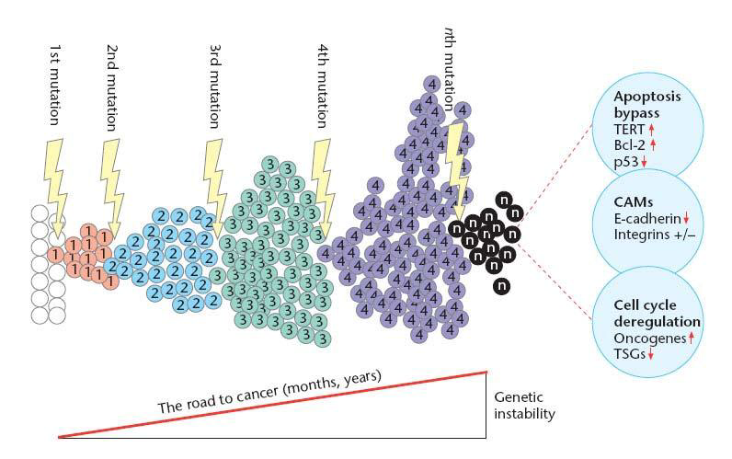
Cancer is a disease of uncontrolled growth and proliferation whereby cells have escaped the body’s normal growth control mechanisms and have gained the ability to divide indefinitely. It is a multi-step process that requires the accumulation of many genetic changes over time. These genetic alterations involve activation of proton-oncogenes to oncogenes, deregulation of tumour suppressor genes and DNA repair genes and ‘immortalisation’.
Figure1.

From figure1; Overview of the road to cancer. Cells may acquire mutations in genes that control proliferation, such as porto-oncogenes and/or tumour suppressor genes. Each new mutation may provide a selective advantage for this cell, leading to ‘clonal expansion’. Cellular properties changed in this process include cell cycle deregulation, apoptosis prevention and cell adhesion properties (CAMs – Cellular adhesion molecules).

Cell cycle regulation and the importance of apoptosis
In normal cells, proliferation and progression through the cell cycle is strictly regulated by groups of proteins that interact with each other in a specific sequence of events . Checkpoints ascertain that individual stages of the cell cycle are completed correctly and ensure that incompletely replicated DNA is not passed onto daughter cells. Core to this control system are cyclin-dependent kinases (CDKs). CDKs are ‘master protein kinases’ that drive progression through the different phases of the cell cycle by phosphorylating and activating other downstream kinases. CDK activity is dependent on the presence of activating subunits called cyclins which are synthesized and degraded in a cell cycle-dependent manner. Cyclin-CDK complexes are further tightly regulated by CDK inhibitors.

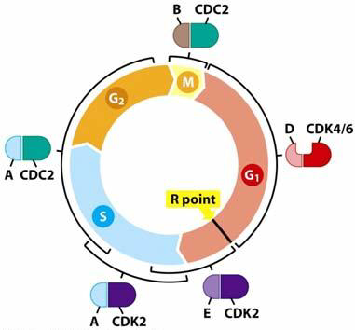
Figure2.

From figure 2: Cyclins and cyclin-dependent kinases (CDKs) regulate the cell cycle. CDK’s and their regulatory subunits, cyclins (A, B, D & E) tightly control transition through the cell cycle. The brackets indicate the periods in which the cyclin-CDK complexes are active and orchestrate all events necessary in this period. The restriction point (R point) is a point in G1 at which the cell becomes ‘committed’ to the cell cycle and after which extracellular proliferation signals are no longer required.

The re-entry of cells into the cell cycle is decided at the restriction point (R point). This decision is influenced by extracellular mitogenic signals which are transmitted via signaling pathways to key regulatory proteins, such as transcription factors (e.g. E2F) in the nucleus. These regulatory proteins ultimately activate the S-phase CDKs, which trigger the start of DNA synthesis.
In normal cells, activation of another transcription factor, p53, often referred to as the ‘guardian of the genome’, can impose cell cycle arrest and induce apoptosis (programmed cell death) through its ability to:
induce the expression of cell cycle inhibitors to prevent proliferation of a cell until any damage has been repaired or
initiate apoptosis, if the genomic damage is too great and cannot be repaired.
In >50% of all human tumours the p53 pathway is aberrant. Inactivation of the p53 protein renders it unable to signal and activate the cell’s apoptotic machinery resulting in increased survival of cancer cells.

Cell immortalisation and tumourigenesis
Immortalisation is defined as the acquisition of an infinite lifespan. Normal mammalian somatic cells proliferate a limited number of times before undergoing senescence. Senescent cells may remain metabolically active even though they have permanently ceased proliferation. Immortalisation is an essential step in the malignant transformation of normal cells and can be attributed, in part, to the presence of telomerase, the enzyme responsible for maintaining telomeres at the ends of chromosomes. By extending telomeric DNA, telomerase is able to counter the progressive telomere shortening that would otherwise lead to cell death. Unlike normal cells that lack detectable levels of telomerase activity, approximately 90% of human tumours consist of cells that contain an active telomerase enzyme.

Cell signalling in carcinogenesis

Growth factors and their receptors
Growth factors (GFs) play an important physiological role in the normal process of growth control aimed at maintaining tissue homeostasis. They transmit growth signals from one cell to another. These signals are sensed on the cell surface by specific growth factor receptors (GFRs). GFRs transfer the growth signal via signalling pathways to activate target molecules that promote proliferation

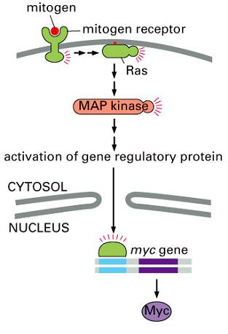
Figure 3 MAP kinase pathway.
From figure 3: The MAP kinase pathway as an example of a growth signalling pathway. The mitogen (or growth factor) binds to its receptor, a receptor tyrosine kinase. Tyrosine phosphorylation of the receptor leads to activation of several docking proteins, and eventually to the activation Ras, bound to the inside of the cell membrane. Active Ras in turn activates the MAP kinase signalling cascade, beginning with Raf (not shown here). The final MAP kinase in this sequence activates several target proteins, for example a transcription factor that activates expression of the Myc gene. Myc itself is a transcription factor that activates the expression of cell cycle regulatory genes.

Steps that characterise normal cell proliferation include:
- The binding of a GF to its specific receptor on the cell membrane
- Transient and limited activation of the GFR, which, activates several
Signal -transducing proteins (e.g. Ras) on the inner leaflet of the plasma membrane
- Transmission of the signal by signal transduction molecules, either to cytosolic targets or to the nucleus where they activate transcription of specific genes
- Entry of the cell into the cell cycle, ultimately resulting in cell division.
This pathway is often derailed in cancer and allows wayward cells to generate their own internal signals that stimulate proliferation and become independent of their environments. Cancer cells are able to induce their own growth stimulatory signals when mutations in the GFR gene occur, which facilitates activation in the absence of GFs or when overproduction of GFs results in an autocrine signalling loop.

Other elements of cell signalling
An alternative strategy by which cancer cells can become GF independent involves constitutive activation of internal signalling components. For example, the Ras protein in normal cells is switched off and does not signal unless a GFR becomes activated, which through a series of intermediaries, is able to activate the Ras protein, converting it from its quiescent state to an active, signal-emitting state. Thereafter, the Ras protein is able to release further downstream signals that are capable of inducing proliferation. In cancer cells, this signalling pathway is deregulated because structurally altered Ras proteins are able to continuously send growth stimulatory signals into the interior of the cell in the absence of GFs.

