NAME; OMAJUGHO TEMINERE JENNIFER
MATRIC NO; 18/mhs02/147
COURSE; PHYSIOLOGY
ASSIGNMENT
- Discuss the cyclic changes of vagina.

Vagina.
The muscular tube leading from the external genitals to the cervix of the uterus in women and most female mammals.

Studies in nonhuman primates indicate that changes in the thickness and integrity of the vaginal epithelium affect the transmission rates of HIV-1, but few studies have examined the normal variations that may occur in the vagina of normal macaques as a result of aging or changes in the menstrual cycle. This study was conducted to determine if differences occur in the thickness of the vaginal mucosa with age or menses. Vaginal mucosal thickness was compared in 46 rhesus macaques grouped as juvenile (1-3 years old), mature cycling (3-21 years old), and geriatric (> 21 years old). Epithelia of mature cycling macaques were also compared at different stages of the menstrual cycle. Older females (> 21 years) had the thinnest and least keratinized epithelium of all groups, followed by the youngest females (< 3 years). The vaginal epithelium was also thinner in cycling macaques during menses compared to the follicular stage. In addition, young, geriatric, or cycling macaques during menses had minimal keratinization. We hypothesize that normal physiologic changes in the vaginal epithelium of women occur with age and menses, which may affect a woman's susceptibility to HIV-1 transmission and other sexually transmitted diseases. Also, age and menstrual cycle should be considered when designing vaginal transmission experiments in rhesus macaques.
The vagina and vulva of the ferret undergo well‐marked cyclical changes in correlation with those of the ovaries and uterus.
During the anœstrum the vulva is small and the connective tissue of which it is mainly composed is compact. The vagina during this period is lined by a low columnar epithelium consisting of only two or three rows of cells and without a cornified layer.
During the pro‐œstrum and œstrus the vulva swells up to about fifty times its anœstrous size, the submucous connective tissue becoming spongy and the nuclei of the cells widely separated. The vaginal epithelium is several layers in thickness, and in the deeper part the cells become high and squamous. There is a pronounced cornified layer. Later, during cestrus, the cornified layer begins to slough, the process being continued over some time. The entire period represents the “follicular stage” of LOEB and other authors, and is presumably brought about by the action of œstrin. The vulval swelling serves the purpose of facilitating effective copulation which in the ferret is very prolonged.
During pregnancy and pseudo‐pregnancy (the latter condition in the ferret only occurring under experimental conditions as after copulation with a vasectomised male) the vulva is reduced to its ancestrous size. The reduction is accompanied by lymphoid degeneration and an invasion of leucocytes. The vaginal epithelium becomes reduced to a low columnar or cubical structure. There is no cornified layer, this being completely shed during œstrus. This period clearly represents the “luteal phase” in the ovarian cycle.
It is to be noted that the vulval swelling and other characteristics of the follicular stage terminate with ovulation just as does the swelling of the sexual skin in the Primate, as described by ZUCKERMAN and PARKES.
The description of the changes here recorded are in general agreeument with the observations by PARKES (1930) on the vaginal smear at different stages of the cycle in the ferret.
The vaginal cycle in the ferret is in a general way similar to that of the dog, as described by EVANS and COLE. It may be again remarked, however, that pseudo‐pregnancy only occurs under experimental conditions in the ferret, yet under the influence of pro‐gestin secreted by the corpus luteum the vagina and vulva undergo similar changes during both pregnancy and pseudo‐pregnancy.
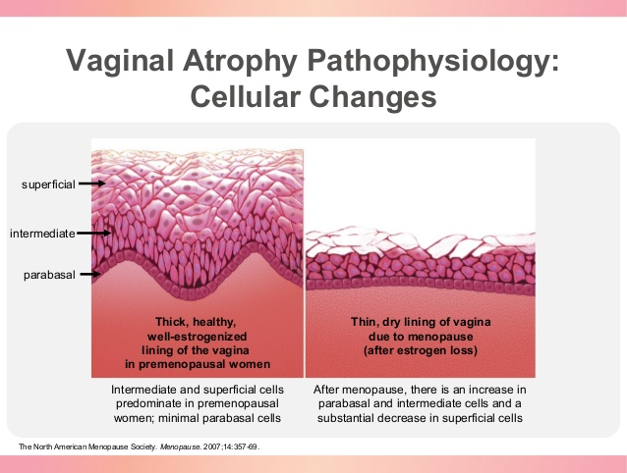

- Discuss the cyclic changes in breasts.
Every woman is different. But it’s common to have one or more of the following:
- Swelling
- Tenderness
- Aches
- Soreness
- Changes in texture
There are a few steps you can take to curb changes in your breasts during your monthly cycle:
- Eat a diet lower in fat, avoiding high-fat foods.
- Skip caffeine, which means no coffee, tea, cola, and chocolate.
- Avoid salt 1 to 2 week before your period starts.
- Wear a bra that fits you properly and provides good breast support.
- Aim for a daily cardio workout.
While most changes in your breasts shouldn’t cause alarm, you should make the call if you notice:
Waldenstrom's macroglobulinemia is a rare type of blood cancer. Learn more about the disease, and its symptoms, causes, and treatments.

Chronic Lymphocytic Leukemia Symptoms
Chronic lymphocytic leukemia (CLL) is a cancer that affects a type of white blood cell called a "lymphocyte." Learn more about the symptoms, causes, diagnosis, risk factors, and
- Unusual, new, or changing lumps in your breast or under your arm
- Nipple discharge (aside from breast milk), particularly if it’s bloody or brown
- Severe symptoms that make it hard to sleep, even after you make changes to your diet and exercise routine
You should also reach out if you have changes in:
- The size or shape of your breast that doesn’t go away after you get your period
- Your nipple, such as if it becomes more pointed or turns inward
- Your breast’s skin, including itching, redness, scaling, dimples, or puckering

What Will My Doctor Do?
She'll give you a physical exam and ask you questions about your symptoms and your family’s medical history.
Most likely, your doctor will ask you questions about your premenstrual breast tenderness, such as whether it happens every time you get your period, whether you've noticed any lumps or discharge, and other symptoms you’ve noticed.
You’ll get a breast exam to check for lumps, and you may also need a mammogram or breast ultrasound.
Remember, most breast lumps aren’t cancer. But you have to see your doctor to be sure. If needed, you may get a biopsy, in which the doctor takes a tiny bit of the lump to test.
Your doctor may also suggest a few options to ease symptoms. For instance, taking diuretics, or "water pills," before your period starts may reduce breast swelling and soreness. Hormonal birth control methods can also help. In severe cases, your doctor may refer you to a breast specialist for another exam.
The volumes and spin-lattice (T1) relaxation times of breast tissues and parenchymal water content were measured non-invasively by magnetic resonance imaging (MRI) in eight healthy women during four to eight consecutive menstrual cycles. Total breast volume, and parenchymal volume, T1 relaxation time and water content were lowest between days 6 and 15. Between days 16 and 28, parenchymal volume, T1 relaxation time and water content rose sharply by 38.9%, 15.1% and 24.5%, respectively, and peaked after day 25. Within 5 days of the onset of menses, parenchymal volume fell sharply by 30.3%, while water content declined by 17.5%. Rising parenchymal volume in the second half of the menstrual cycle is not solely due to increased tissue water content and provides in vivo evidence for both growth and increased tissue fluid at this time.
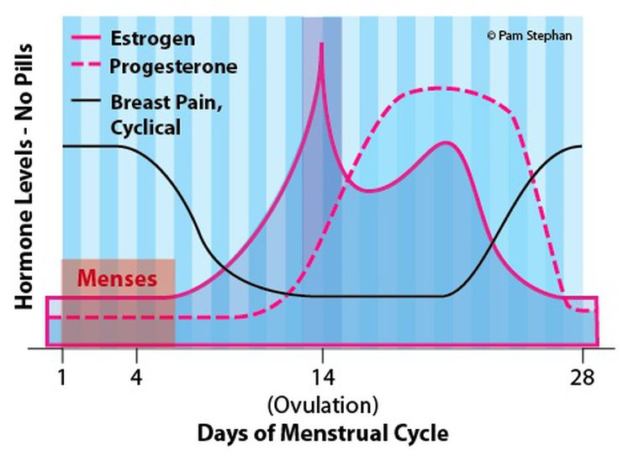
- Explain menstrual cycle.
The menstrual cycle is the regular natural change that occurs in the female reproductive system (specifically the uterus and ovaries) that makes pregnancy possible. The cycle is required for the production of oocytes, and for the preparation of the uterus for pregnancy.
Each month during the years between puberty and menopause, a woman’s body goes through a number of changes to get it ready for a possible pregnancy. This series of hormone-driven events is called the menstrual cycle.
During each menstrual cycle, an egg develops and is released from the ovaries. The lining of the uterus builds up. If a pregnancy doesn’t happen, the uterine lining sheds during a menstrual period. Then the cycle starts again.
A woman’s menstrual cycle is divided into four phases:
- menstrual phase
- follicular phase
- ovulation phase
- luteal phase
The length of each phase can differ from woman to woman, and it can change over time.

Menstrual phase
The menstrual phase is the first stage of the menstrual cycle. It’s also when you get your period.
This phase starts when an egg from the previous cycle isn’t fertilized. Because pregnancy hasn’t taken place, levels of the hormones estrogen and progesterone drop.
The thickened lining of your uterus, which would support a pregnancy, is no longer needed, so it sheds through your vagina. During your period, you release a combination of blood, mucus, and tissue from your uterus.
You may have period symptoms like these:
- cramps
- tender breasts
- bloating
- mood swings
- irritability
- headaches
- tiredness
- low back pain
On average, women are in the menstrual phase of their cycle for 3 to 7 days. Some women have longer periods than others.

Follicular phase
The follicular phase starts on the first day of your period (so there is some overlap with the menstrual phase) and ends when you ovulate.
It starts when the hypothalamus sends a signal to your pituitary gland to release follicle-stimulating hormone (FSH). This hormone stimulates your ovaries to produce around 5 to 20 small sacs called follicles. Each follicle contains an immature egg.
Only the healthiest egg will eventually mature. (On rare occasions, a woman may have two eggs mature.) The rest of the follicles will be reabsorbed into your body.
The maturing follicle sets off a surge in estrogen that thickens the lining of your uterus. This creates a nutrient-rich environment for an embryo to grow.
The average follicular phaseTrusted Source lasts for about 16 days. It can range from 11 to 27 days, depending on your cycle.
Top of Form

Bottom of Form

Ovulation phase
Rising estrogen levels during the follicular phase trigger your pituitary gland to release luteinizing hormone (LH). This is what starts the process of ovulation.
Ovulation is when your ovary releases a mature egg. The egg travels down the fallopian tube toward the uterus to be fertilized by sperm.
The ovulation phase is the only time during your menstrual cycle when you can get pregnant. You can tell that you’re ovulating by symptoms like these:
- a slight rise in basal body temperature
- thicker discharge that has the texture of egg whites
Ovulation happens at around day 14 if you have a 28-day cycle — right in the middle of your menstrual cycle. It lasts about 24 hours. After a day, the egg will die or dissolve if it isn’t fertilized.
sperm can live up to five days, pregnancy can occur if a woman has sex as much as five days prior to ovulation.

Luteal phase
After the follicle releases its egg, it changes into the corpus luteum. This structure releases hormones, mainly progesterone and some estrogen. The rise in hormones keeps your uterine lining thick and ready for a fertilized egg to implant.
If you do get pregnant, your body will produce human chorionic gonadotropin (hCG). This is the hormone pregnancy tests detect. It helps maintain the corpus luteum and keeps the uterine lining thick.
If you don’t get pregnant, the corpus luteum will shrink away and be resorbed. This leads to decreased levels of estrogen and progesterone, which causes the onset of your period. The uterine lining will shed during your period.
During this phase, if you don’t get pregnant, you may experience symptoms of premenstrual syndrome (PMS). These include:
- bloating
- breast swelling, pain, or tenderness
- mood changes
- headache
- weight gain
- changes in sexual desire
- food cravings
- trouble sleeping
The luteal phase lasts for 11 to 17 days. The average lengthTrusted Source is 14 days.

Identifying common issues
Every woman’s menstrual cycle is different. Some women get their period at the same time each month. Others are more irregular. Some women bleed more heavily or for a longer number of days than others.
Your menstrual cycle can also change during certain times of your life. For example, it can get more irregular as you get close to menopause.
One way to find out if you’re having any issues with your menstrual cycle is to track your periods. Write down when they start and end. Also record any changes to the amount or number of days you bleed, and whether you have spotting between periods.
Any of these things can alter your menstrual cycle:
- Birth control. The birth control pill may make your periods shorter and lighter. While on some pills, you won’t get a period at all.
- Pregnancy. Your periods should stop during pregnancy. Missed periods are one of the most obvious first signs that you’re pregnant.
- Polycystic ovary syndrome (PCOS). This hormonal imbalance prevents an egg from developing normally in the ovaries. PCOS causes irregular menstrual cycles and missed periods.
- Uterine fibroids. These noncancerous growths in your uterus can make your periods longer and heavier than usual.
- Eating disorders. Anorexia, bulimia, and other eating disorders can disrupt your menstrual cycle and make your periods stop.
few signs of a problem with your menstrual cycle:
- You’ve skipped periods, or your periods have stopped entirely.
- Your periods are irregular.
- You bleed for more than seven days.
- Your periods are less than 21 days or more than 35 days apart.
- You bleed between periods (heavier than spotting).
If you have these or other problems with your menstrual cycle or periods, talk to your healthcare provide.
Every woman’s menstrual cycle is different. What’s normal for you might not be normal for someone else.
It’s important to get familiar with your cycle — including when you get your periods and how long they last. Be alert for any changes, and report them to your healthcare provider.
