AJIBOLA ARAFAT OLAYEMI
19/MHS11/023
PHARMACY
BIO 102 ASSIGNMENT
1.The following are importance of fungi to man
-Fungi not only directly produce substance that humans use as medicine,but they also versataile tools in the vast field of medical research.
-Some fungi attack insects and therefore can be used as natural pesticides
-Yeasts have been used for thousands of years in the production of wine,beer and bread.
-They are responsible for the mediation of decay of dead organic matter.
-some fungi are parasites to obnoxious pests of man.
2. SS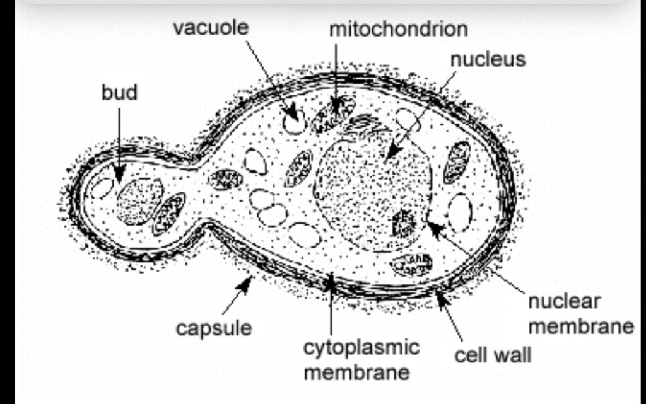

STRUCTURE OF A UNICELLULAR FUNGUS
3.Sexual Reproduction in Filamentius form of fungi
i.Two mating types of hyphae grow in the same medium
ii.Chemical interactions between them causes growth perpendicular to the hyphae in opposite directions.
iii.The growth is delimited by a wall such that many nuclei are isolated in what is called a gametangium.
iv.The two gametangia fuse(plasgogamy) and a zygote is formed which may undergo prolonged dormancy or resting stage.
v.The nuclei in the zygotes fuse in twos and undergo meiosis independently.then the zygote germinates under favourable conditions to produce a fruiting which at maturity liberates the haploid spores.
4.Ways Bryophytes adapt to their environment
i.they have definite structures for water and nutrient absorption from the soil.Therefore the plant body is divided into two(an aerial portion and a subterranean portion)
ii.The aerial portion being exposed to the atmosphere demands some modifications that prevents excessive loss of water through the body surface.
iii.Some other modifications that permit elimination of excess water from the plant body and not only exchange of gasses between the internal parts of the atmosphere therefore openings are available on the aerial parts of the plant.
5.a.eusteles:This is a stele typical of dicotyledonous plants that consists of vascular bundles of xylem and phloem strands with parenchymal cells between the bundles.
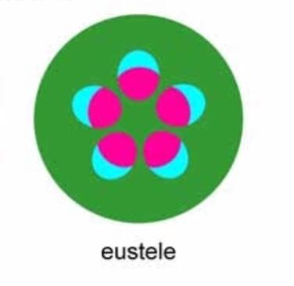
b.atactostele:A type of eustele found in monocots,in which the vascular tissues in the stem exists as scattered bundles.
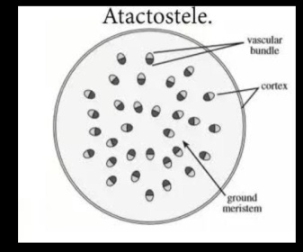
c.siphonostele:A stele consisting of a core of pith surrounded by concentric layers of xylem and phloem.
. 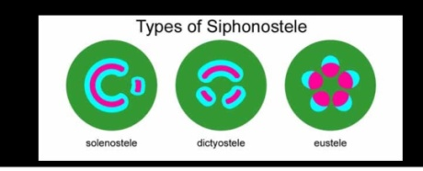

d.dictyostele:A stele in which the vascular cylinder is broken up into a longitudinal series or network of vascular strands around a central pith.
6.LIFE CYCLE OF PRIMITIVE VASCULAR PLANT