NAME: GBADAMOSI LATIFAH TEMIDAYO
MATRIC NO: 16/MHS06/023
COURSE: MLS 410 (BIOMEDICAL ENGINEERING)

QUESTION
1. Discuss the physics of the light microscope diagrams and illustrations needed 2. Write notes on the following biomedical equipment. Add notes on principle, brand, care and maintenance and cost A. Centrifuge B. Automatic Tissues Processor C. Microtome

ANSWER
1. LIGHT MICROSCOPY
Introduction
A microscope, in simple terms, is an instrument used to view objects that are not disable to the naked eye. The microscope is one of the most expensive and delicate instruments in the clinical laboratory. Because it can be easily misused, it is important for medical laboratory personnel to be conversant with the working principle of the commonly used light microscope and should know how to use and maintain it correctly.
Working principle of a microscope
The microscope magnifies the image of the object being viewed through it. An ordinary magnifying glass is referred to as a simple microscope, while a laboratory microscope is referred to as a compound microscope or a light microscope more appropriately a bright field microscope. The magnification of the object is produced by the combined action of two lenses, the objective lens near the object, and the eyepiece lens near the viewers eye.
Especially the bright field microscope consist of a light source, a condenser that focuses rays of light on the specimen, a stage on which a specimen is placed, an objective lens that's produces a magnified image of the object in the specimen, and an eyepiece all or ocular lens through which further magnified image of the objects can be directly viewed. The specimen to be viewed with the light microscope must be sufficiently thin So that light can pass through it. Some light is absorbed while passing through the specimen, and a contrast may be produced due to differences in light absorption by different parts of the specimen. However, the optical system of the bright light microscope does not reveal much contrast in the unstained preparation. Therefore, the contrast needs to be enhanced with staining.
Reflection
When a ray of light strikes a surface at an angle and it bounces back at an angle of equal size, it is said to be reflected. Reflection not only occurs when light passes through air and strikes an object, but it also when it strikes an interface between air and glass. Stray reflections inside the microscope interfere with the parts of light rays and degrade the sharpness of the image.
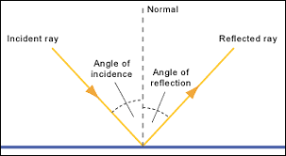
Reflection of light Rays.
Refraction
Refraction is simply depending of the light ray from the “normal” When is passes into a different optical medium. A “normal” line is the line perpendicular to the flat surface. Refraction is caused by changes in the speed of light while passing from one medium into another of different optical density. When light enters a denser medium, it bends towards the normal line; when entering a less dense field, light bends away from the normal line. Optical media include glass (such as lenses, filters, slides, coverslips), air, immersion oil, mounting medium etc.
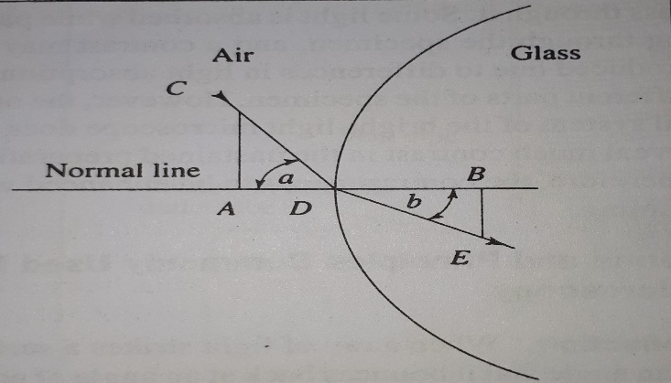
Refraction of light Rays and refractive index.
Lenses
In an optical system, the lens collects light rays from an object and redirects them to form a sharp, magnified image of the object in the object plane. There are two basic types of lenses used in microscopy- Converging or positive lenses and diverging or negative lenses. The converging lens is convex and directs light to a point. The diverging lens is concave, and it bends light outward. Several combinations of these two basic types are possible. However, double convex lens is the most common type used in microscopy.
Principle focus and optical centre
The centre of lens surface on either side of a biconcave lens is called a centre of curvature. A straight line joining these two centres is the principle axis. A ray of light entering the lens along the principle axis does not refract and travel along the same line. Rays of light entering a converging lens parallel to the principle axis, however, are refracted towards this axis. The point at which they meet is called the principle focus (F). A biconvex lens as a principle focus on each side of the lens. A ray of light entering the converging lens at an angle emerges parallel to the entering ray and will pass through the center of the lens. Another ray entering similarly from the other surface of the lens also passes through the center. The point at which these two rays cross is called the optical center of the lens. The distance between the optical center (O) and the principle focus is the focal length of the lens.
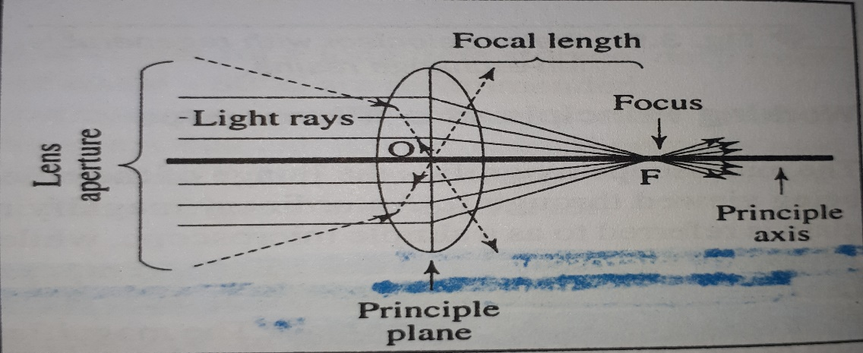
Optical center, principle focus and focal length.
Magnification
The magnification produced by a lens is defined as the ratio of distance between the lens and the image plane (b), and the distance between the lens and the object (a).
Magnification = $\frac{b}{a}$
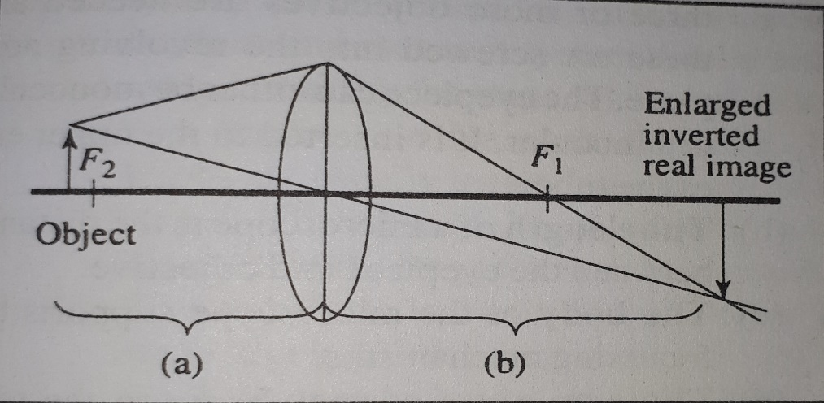
Magnification produced by a convex lens.
In simple words, magnification is obtained by dividing the size of the image by the size of the objects. In case of a convex lens, the magnification is maximum when the object is placed just outside the principle focus of the lens.

2.
A.) CENTRIFUGE
The centrifuge is a machine used to rapidly sediment particles such as cells, which may be suspended in a fluid. There are two types of centrifuges based on their rotor type:
- Fixed angle rotor centrifuge
- Swing-out rotor centrifuge.
Centrifuge can also be classified based on their model:
- Hand centrifuge
- Battery operated bench centrifuge
- Microhematocrit centrifuge
- Ultracentrifuge
- Cytocentrifuge.
Principle
The principle is that the centrifuge exerts a centrifugal force (CF), which is greater than that of gravity, and causes particles in a fluid to sediment. The greater CF, the faster and more effective the sedimentation. This centrifugal force, which is the outward pull due to rotation, is relative to the speed of centrifuging in revolutions per minute (rpm). The actual sedimentation achieved, however, depends on the radius of the centrifuge. The radius of the centrifuges distance between the centre of the centrifuge shaft and the tip of the centrifuge tube. The relative centrifugal (RCF) is calculated from the knowledge of the rpm and the radius (r) as shown in the formula below:
RCF (g)= 1.12 × 10⁵ × r (in cm) × (rpm)²
Brand
1. Corning LSE™ Mini Microcentrifuge
2. Axygen Axyspin Refrigerated Microcentrifuge
3. NuWind Multi-Application Bench Top Ventilated or Refrigerated Centrifuges
4. Allegra 64R Refrigerated Benchtop Centrifuges
5. AVANTI J-15 High Performance Centrifuges
6. Spectrafuge™ 6C Compact Centrifuge
7. Frontier™ 5000 Series Centrifuges
Care and Maintenance
- Balance the centrifuge by ensuring that the buckets or tubes opposite to each other are of the same weight.
- Check that bucket is properly cushioned.
- When filling the tubes, make sure to leave the fluid level at least 2cms below the rim of the centrifuge bucket.
- Cap the tubes or bottles when using potentially infectious material.
- When using the swing out rotor head, check that the tubes are of proper length so that they will not break while centrifuging due to swinging out of buckets.
- Do not try to stop the centrifuge by hand while still rotating.
- Do not open a centrifuge until the rotor stops completely for buckets are at rest. A locking device is available on some models which prevents the centrifuge from being opened while in operation.
- Use a non-corrosive disinfectant to clean the centrifuge from time to time.
- Follow maintenance procedures as given in the manufacturer’s manual.
Cost
Ranging from prices of ₦25,000 – ₦107,000 depending on the brand and type.

B.) AUTOMATIC TISSUE PROCESSOR
A tissue processor is a device that prepares tissue samples for sectioning and microscopic examination in the diagnostic laboratory. Microscopic analysis of cells and tissues requires the preparation of very thin, high quality sections (slices) mounted on glass slides and appropriately stained to demonstrate normal and abnormal structures. The Automatic tissue processing machine plays a big role in the preparation of the tissue by passing them through various chemicals; a major process called TISSUE PROCESSING.
Principle
The tissue basket oscillates up and down in each station at three-second intervals to ensure thorough and even mixing of the reagents and optimum tissue infiltration. Infiltration time is separately programmable for each station. Up to nine programs may be run with immediate or delayed starting times. When it’s time for tissue to be transferred to the next beaker or jar, the cover of the machine is raised up, and the lifting mechanism carefully removes the tissue basket and gently transfers it to the next beaker. When the infiltration time for any station is exceeded, a warning message will display, indicating the station number and excess time. Controls are arranged by functionality with an LCD to indicate operational parameters. Reagent container lids have seals to minimize operator exposure to hazardous fumes. Tissue basket immediately immerses in a station in the event of power loss to protect samples from drying out. When power is restored, program will resume. In the event of long-term power failure, wax is liquified. Capacity of tissue basket is 80 cassettes. Vacuum configurations hasten infiltration, allowing pressure to be applied to any station in either manual or automatic operation. Fume control configurations extract fumes with a fan and pass them through an internal carbon filter. For added efficiency, these models feature a two-part containment shield surrounding the reagent container platform.
Brand
- Leica TP 1020 Automatic Tissue Processor
- Kedee-TS6B, Automatic Vacuum Tissue Processor
- Ssi 15 Tissue Processor
- Leica TP1020 Semi-enclosed Benchtop Tissue Processor
- Thermo Scientific™ Citadel 2000 Tissue Processor
- Excelsior™ AS Tissue Processor
Care and Maintenance
- While operating the instruments, no liquid may enter in contacts with any of the electrical connections or the interior of the instrument.
- Make sure to observe the level indicators on the reagents and paraffin stations
- Warning! Use caution when handling solvent! Make sure the premises are adequately ventilated! Explosion Hazard!
- Before cleaning the instruments, disconnect the main switch.
- When cleaning the instruments, no liquid may enter in contact with any of the electrical connection or the interior of the instrument.
- Spilled regions must be wiped away immediately. In case of long-term exposure, the instrument surfaces are only conditionally resistant to solvents.
- When transporting the instrument, do not lift it up by the carousel cover!
- Also, when transposing the instruments keep it upright.
- The instruments must not be operated in hazardous location.
Cost
Ranging from prices of $6,550.00 -$14,800 depending on the brand and type.

C.) MICROTOME
Microtome is an instrument with the help of which sections of tissues are cut and the process of cutting thin sections is known as Microtomy. The thickness of sections produced during microtomy may be between fractions of 50-100 nm, in ultramicrotomy, to several 100 microns. The common range is between 5-10m but both the maximum and minimum thickness is limited by the consistency of relation of the thickness of sections to the nature of tissues. These sections are stained using suitable staining techniques followed by observing them under the microscope. Types of microtome are:
- Sliding or Base Sledge Microtome
- Rotary microtome
- Sliding or Base Sledge Microtome
- Freezing microtome
- Cryostat microtome
- Laser microtome
- Ultramicrotome.
Principle
A microtome is a sectioning instrument that allows the cutting of extremely thin slices of a material known as section. Microtome are used in microscopy, allowing for the preparation of sample for observation under transmitted light or electrons radiation. It is a method for the preparation of thin section for materials such as bones, minerals, and teeth. This device operates with a staged rotary action such that the cutting is part of the rotary motion. In a rotary microtome, blade is fixed in horizontal position. Through the motion of the sample holder, the sample is cut by the knife position, at which point the fresh section remains on the knifes, at the highest point of the rotary motion, the sample holders is advanced by the same thickness as the section that is to be made, allowing for the next section to be made.
Brand
- Leica microtomes.
- Leica microtome cryostats.
- Thermo Scientific laboratory shakers.
- AGD Biomedicals microtomes
- Alltion (Wuzhou) microtomes
- Amos scientific microtomes
- ANA-MED microtomes
- Auxilab S.L. microtomes
- Boeckeler Instruments, Inc. microtomes
10. Breukhoven microtomes
11. Bright Instruments microtomes.
Care and Maintenance
- DO NOT leave the microtome unattended with an exposed knife/blade in position. Remove the knife/blade or cover with the guards or visor provided.
- DO NOT leave unboxed knives/blades lying around. Place knives/blades that are not in use in their boxes or packets.
- DO NOT carry knives/blades unless secure in the box or packet provided.
- Routine daily care consists of removing sectioning debris from the working area, brushing debris from the knife and cleaning as appropriate.
- In the event of a breakdown, a qualified person should be called. For electrical and mechanical problems contact either your local agent/distributor.
- Take particular care to clean the contact surfaces of disposable blade holders. A build-up of debris can prevent the blade from seating properly and causes instability during section cutting.
- Spray or brush any household oil on your knife to prevent rust when not in use.
Cost
Ranging from prices of $1500 - $10,300 depending on the brand and type.

