NAME: ISOKARIARI ALMA OWAPIRITE
DEPARTMENT: DENTISTRY
MATRIC NUMBER:19/MHS09/011
BIO 102 ASSIGNMENT

1.Direct utilization of fungi as food:
Many Agaricales and Helvellales are directly used as food. There is a non-poisonous edible toadstool, i.e., Coprinus sp. found in lawns in the rainy season. Agaricus campestris is edible mushroom and cultivated for its fructifications. The fruiting bodies are quite fleshy and eaten directly as” vegetable or with rice as ‘pulao’.

2. Processing of food:
A few species of Penicillium are being used in processing of food. Penicillium camemberti involved in ripening of Camembert cheese and P. roqueforti in ripening of Roquefort cheese. Danish blue cheese and the Italian Gorgonzola are also ripened with Penicillium. In Java, Aspergillus wentii is employed in processing soyabeans, because of its ability to loosen the hard tissues of the bean.

3. Production of antibiotics:
Penicillium is best known to the non-botanist because it is the source from which the antibiotic penicillin is extracted. Penicillin was first discovered in Penicillium notatum Westling and for a time this was the species from which penicillin was extracted. Later investigation has shown P. chrysogenum Thom to be better for this purpose, and irradiation of it with X-rays and ultraviolet light has induced mutants with an even higher content of penicillin. In India at Pimpri and Rishikesh there are big factories of antibiotics
- Structure of a Filamentous fungus
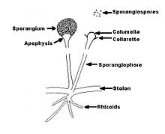
2Schematic diagram of Rhizopus spp.

3 Sexual reproduction
Sexual reproduction, an important source of genetic variability, allows the fungus to adapt to new environments. The process of sexual reproduction among the fungi is in many ways unique. Whereas nuclear division in other eukaryotes, such as animals, plants, and protists, involves the dissolution and re-formation of the nuclear membrane, in fungi the nuclear membrane remains intact throughout the process, although gaps in its integrity are found in some species. The nucleus of the fungus becomes pinched at its midpoint, and the diploid chromosomes are pulled apart by spindle fibres formed within the intact nucleus. The nucleolus is usually also retained and divided between the daughter cells, although it may be expelled from the nucleus, or it may be dispersed within the nucleus but detectable.
Sexual reproduction in the fungi consists of three sequential stages: plasmogamy, karyogamy, and meiosis. The diploid chromosomes are pulled apart into two daughter cells, each containing a single set of chromosomes (a haploid state). Plasmogamy, the fusion of two protoplasts (the contents of the two cells), brings together two compatible haploid nuclei. At this point, two nuclear types are present in the same cell, but the nuclei have not yet fused. Karyogamy results in the fusion of these haploid nuclei and the formation of a diploid nucleus (i.e., a nucleus containing two sets of chromosomes, one from each parent). The cell formed by karyogamy is called the zygote. In most fungi the zygote is the only cell in the entire life cycle that is diploid. The dikaryotic state that results from plasmogamy is often a prominent condition in fungi and may be prolonged over several generations. In the lower fungi, karyogamy usually follows plasmogamy almost immediately. In the more evolved fungi, however, karyogamy is separated from plasmogamy. Once karyogamy has occurred, meiosis (cell division that reduces the chromosome number to one set per cell) generally follows and restores the haploid phase. The haploid nuclei that result from meiosis are generally incorporated in spores called meiospores.
Fungi employ a variety of methods to bring together two compatible haploid nuclei (plasmogamy). Some produce specialized sex cells (gametes) that are released from differentiated sex organs called gametangia. In other fungi two gametangia come in contact, and nuclei pass from the male gametangium into the female, thus assuming the function of gametes. In still other fungi the gametangia themselves may fuse in order to bring their nuclei together. Finally, some of the most advanced fungi produce no gametangia at all; the somatic (vegetative) hyphae take over the sexual function, come in contact, fuse, and exchange nuclei.
4 Multicellular plant body and conservation of water:
A compact multicellular plant body was formed which helped in the conservation of water by reducing cell surface are exposed to dry land conditions.
Absorption of CO2:
Modification of photosynthetic tissues for the absorption of carbon dioxide without losing much water and exposure to light.
Absorption of water:
Special structures like rhizoids were developed for absorption of water and anchorage.
Heterogamy:
Heterogamy was evolved, forming non-motile egg containing stored food and motile sperms.
Protection of gametes:
Gametes were produced and protected by the special multicellular organs.
Embryo formation:
Multicellular embryo was formed which was retained inside the female reproductive body during its development.
Alternation of generation:
Alternation of spore producing generation (sporophyte) with gamete producing generation (gametophyte) enables the plant to produce and test the best genetic combinations for adapting to the versatile (multipurpose) terrestrial conditions.

5 eustele
: a stele typical of dicotyledonous plants that consists of vascular bundles of xylem and phloem strands with parenchymal cells between the bundles
Atactostele: (botany) A type of eustele, found in monocots, in which the vascular tissue in the stem exists as scattered bundles.
Siphonostele a stele consisting of a core of pith surrounded by concentric layers of xylem and phloem.
Dictyostele a stele in which the vascular cylinder is broken up into a longitudinal series or network of vascular strands around a central pith (as in many ferns)
6)
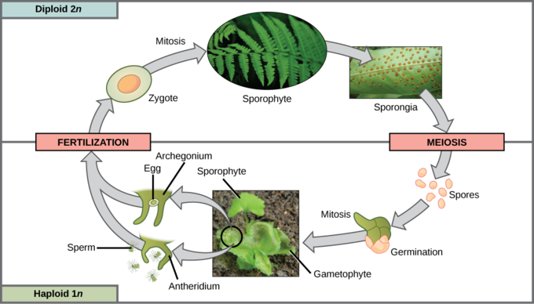
Life cycle of a fern: This life cycle of

