NAME: Aladejana, Victory Abiodun.
DEPARTMENT: M.B.B.S.
MATRICULATION NUMBER: 19/MHS01/082.
COURSE CODE: BIO 102

- How are fungi important to mankind?
- It is very important to the entire terrestrial ecosystem in material cycling and to man.
- It is responsible for the mediation of decay of organic matter.
- Fungi example, yeast can be used in the food industry like in the production of bread.
- Mushroom are eaten by human societies.
- Some species (example, Penicillum notatum) produce important antibiotics.
- Some fungi are parasites to some certain horrible obnoxious (offensive, unbearable) pests e.g houseflies, grasshoppers and therefore constitute important biological control agents in regard to such pests.

- Illustrate the cell structure of a unicellular fungus with a well labeled diagram.
Answer: The cell structure of a unicellular fungus is very simple, though the organism is one of the most advanced fungal forms from the point of view of its spore-producing structures.
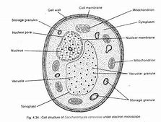
Cell structure of saccharomyces cerevisiae

- Outline the sexual reproduction in a typical filamentous form of fungi.
Sexual reproduction in a typical filamentous form of fungi (Rhizopus stolonifer) goes as follows: it occurs when the hyphae grow in the same medium. Chemical interaction in the two mating types of hyphae induces growth perpendicular to the hyphae in opposite directions. These growths are delimited by a wall such that many nuclei are isolated in what is called a gametangium. The two gamentangia fuse(plasmogamy) and a zygote is formed which may undergo prolonged dormancy or resting stage. The nuclear in the zygotes fuse in two and undergo meiosis independently. The zygote germinates under favorable conditions to produce a fruiting which at maturity liberates the haploid spores.

- How do bryophytes adapt to their environment?
- They have definite structures for water and nutrient absorption from the soil. Therefore, the plant body is divided into two (an aerial portion and a subterranean portion). The subterranean portion is the rhizoid and is not a true root as the case of land plants that are advanced.
- The aerial portion being exposed to the atmosphere requires some modifications to prevent desiccation and some other modification that permits climination of excess water from the plant body and not only the exchange of gases between the internal parts of the plant and the atmosphere. Therefore, openings are available on the aerial parts of the plant.

- Describe with illustration the following terminologies:
- Eusteles: this type of stele is found in herbaceous dicotyledonous plants in which the vascular bundles are discrete, concentric collateral bundles of the xylem and phloem.
- Atactostele: this type of stele is found in grasses and monocotyledonous plants in which the vascular bundles are scattered. They are random and have no pattern.
- Siphonostele : this is a type of stele in which the vascular tissue is in the form of a cylinder surrounding the pith, as in the stems of most ferns and other seedless vascular plants.
- Dictyostele: this is a type of stele in which the vascular cylinder is broken up into a longitudinal series or network of vascular strands around a central pith(as in many ferns).
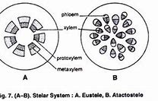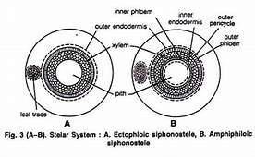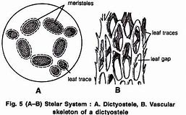
- Illustrate the life cycle of a primitive vascular plant(psilotum).
- The psilotum body is a sporophyte (diploid 2n).
- Synangium is the pore bearing structure.
- In synangium, diploid spore mother cells undergo meiosis forming haploid spores (1n).
- Spores germinate forming gametophyte or prothallus (monoecious: both antheridia and archegonia are present).
- Antheridium produces sperms. The sperms are multiflagellate. The archegonia produces eggs.
- The fertilization is oogamous.
- The zygote divides to form embryotic sporophyte and later forms a mature plant body (diploid psilotum sporophyte).
